To find out Apple’s current intrinsic Company value, we first find WACC which serves as the rate of return. Apple’s current stock price is $ 201.43 (U.S) with $ 4,745.39 million outstanding stocks reported in Apple’s Annual Report 2018[1]. We multiply these terms to get *Total Equity.* Further, it is noted that Apple has issued only *Common Stocks* and there details can be found in the *Annual Report*[2]. The yield (= 2.9) is average of all the long term bonds( maturity between 2043-47) according to their’s *face value* weights and is used as Rd in Cost of Debt calculation.

From Apple’s Balance Sheet[3] we note down the *Total debt( Short term + Long Term).* While Net Income, Income without tax have been noted from the companies Income statement[4][5].

Govt. of U.S.A long term bond yield is 2.06[11] . Value of unlevered Beta = 1.09 is reported by Bloomberg and Yahoo Finance[12]. Further *Market Risk Premium* is that taken as 5% which 50 years market average rate.

Detailed WACC calculation is as follow:

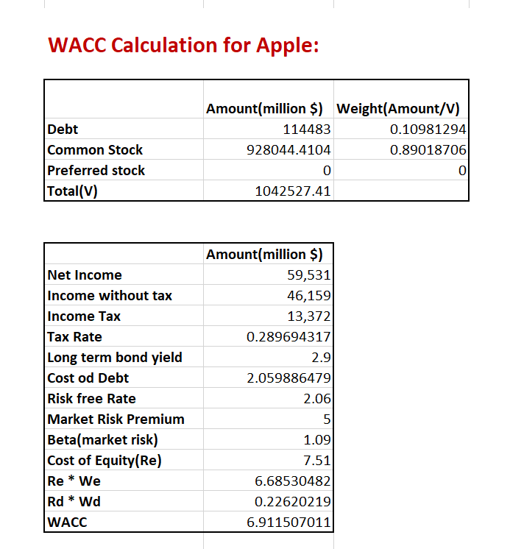

Next step is to determine CapEx/Revenue and EBITDA/revenue Average. Data required is taken from Income Statement [4] and Financial Statement Analysis [6][7]

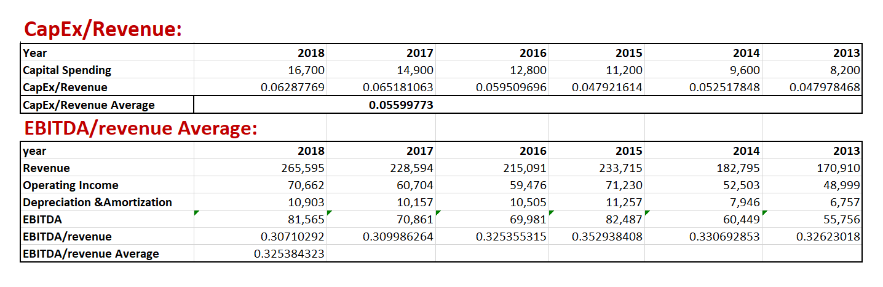

Using past data future *Depreciation & Amortization* have been prediction. Again we assume net change working capital to been zero.

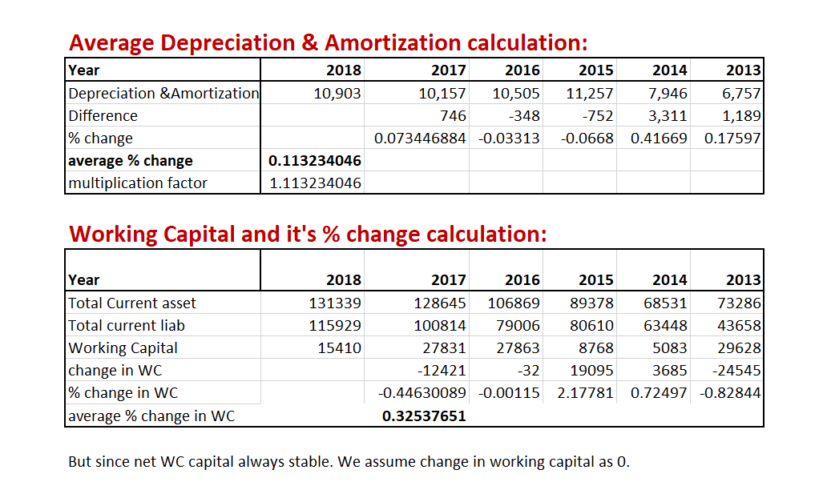

To predict Company’s value we need Net Present value. The electronics market is highly volatile hence we cannot use revenue growth average to predict future sale. So, we have considered NASDAQ’s[10] growth model which is highly based on market sentiment (e.g declining iPhone sales but increasing watch sales).

Working Capital = Total Current Assets[8] – Total Current Liabilities[9]

NPV we have calculated :

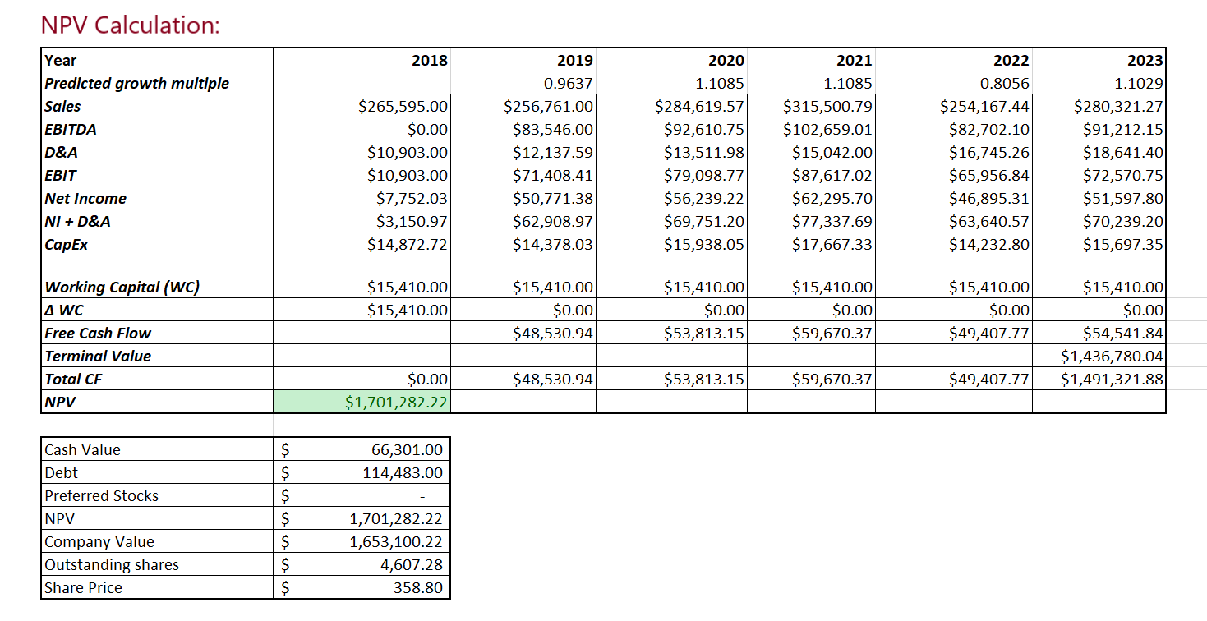

Apple is among few companies to have crossed enterprise value of 1 Trillion Dollars. From the Share price calculated it is clear that Apple’s stock is pretty much undervalued.