1. Apple Inc’s Annual Report 2018 Pg-2

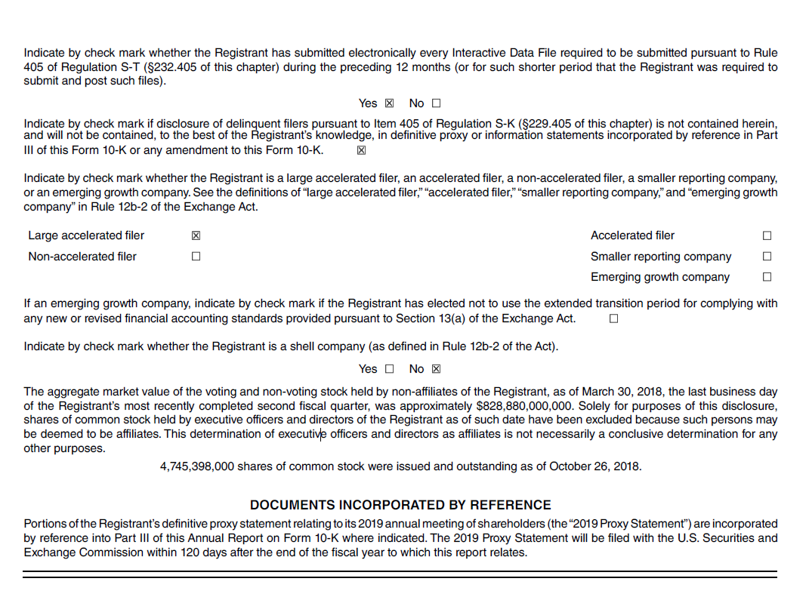

1. Apple Inc’s Annual Report 2018 Pg-59

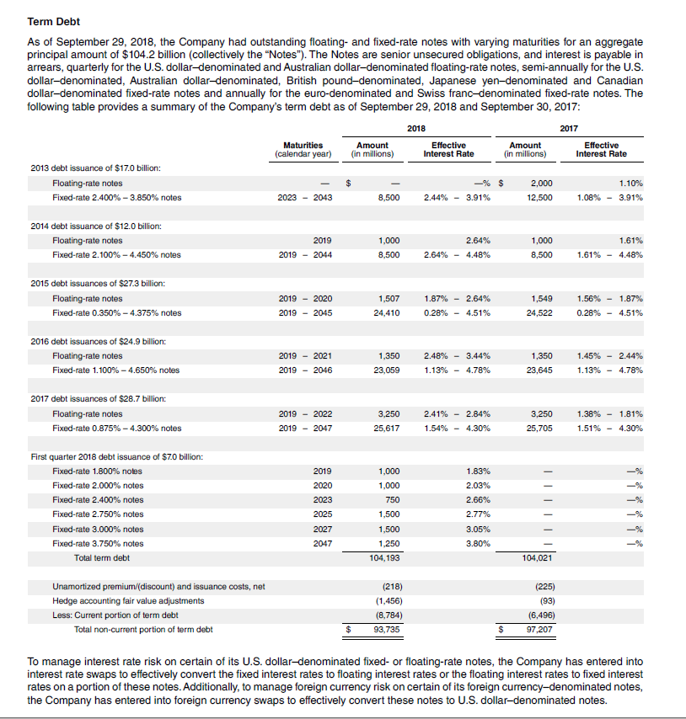

1. Apple Inc., Balance Sheet Pg- 1

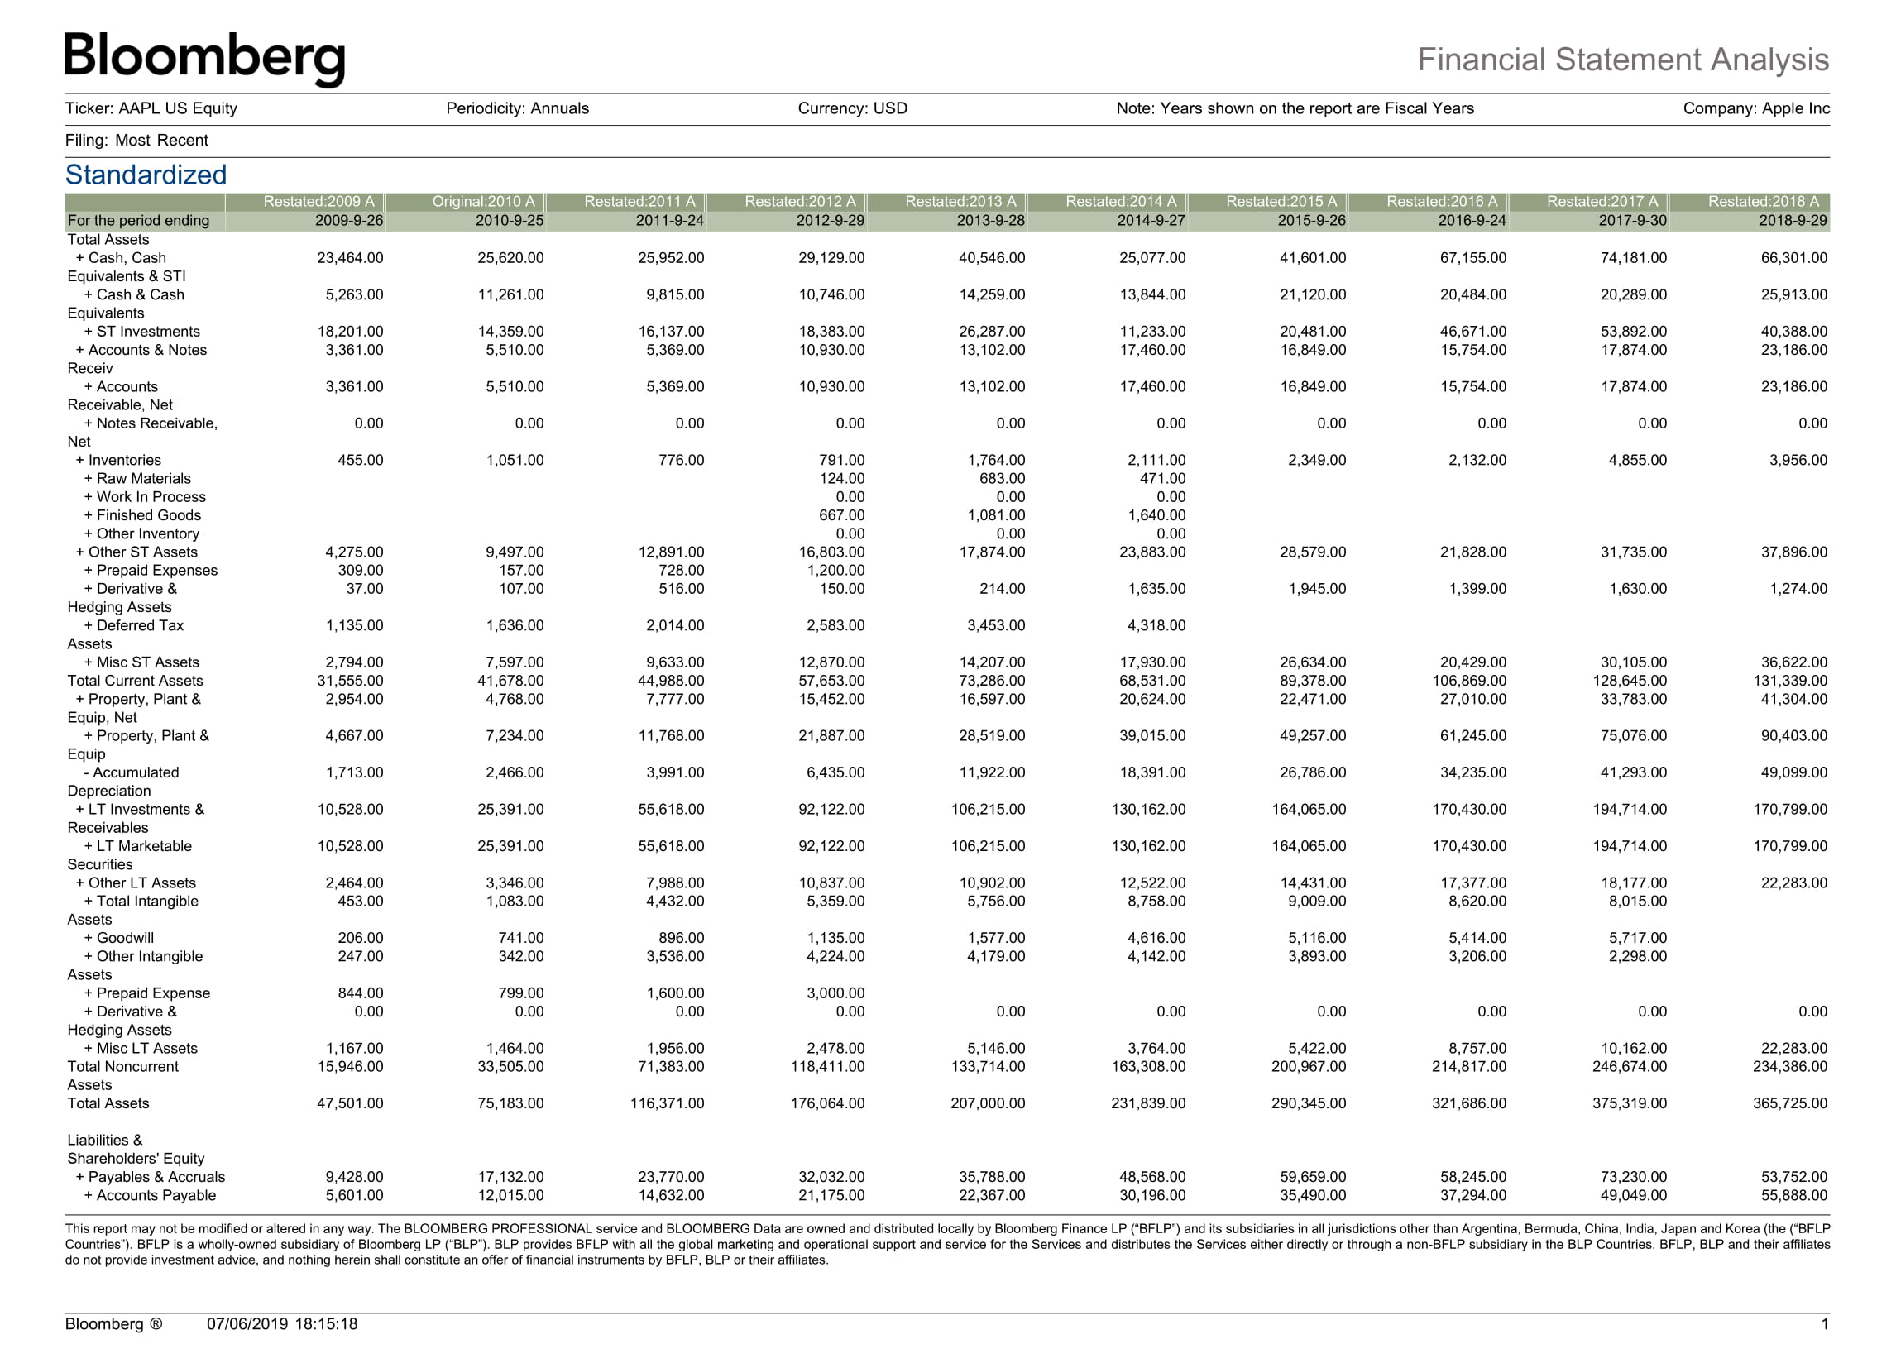

4. Apple Inc., Income Statement pg-1

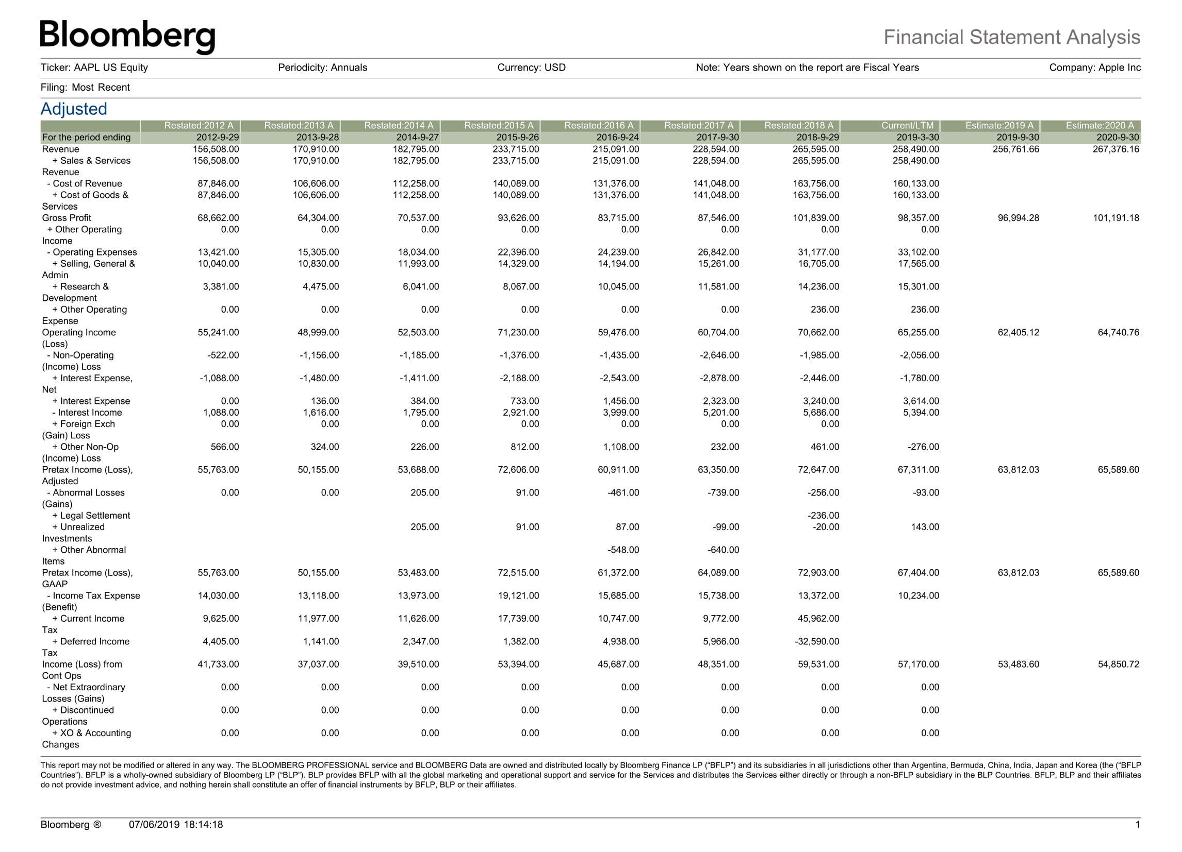

5. Apple Inc., Income Statement pg-2

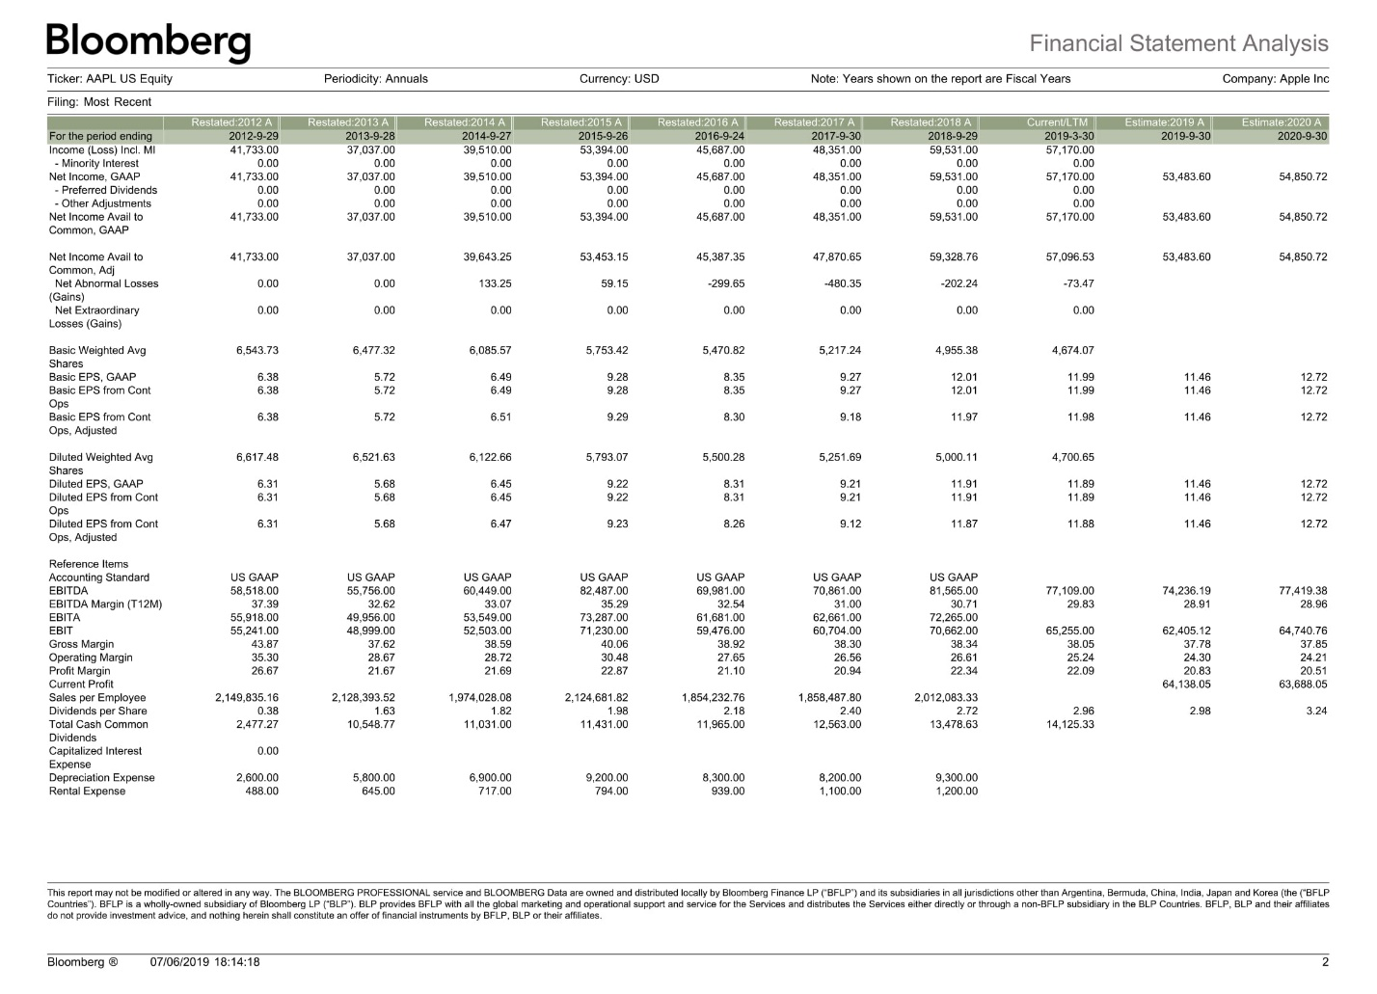

6. Apple Inc., All data pg- 12

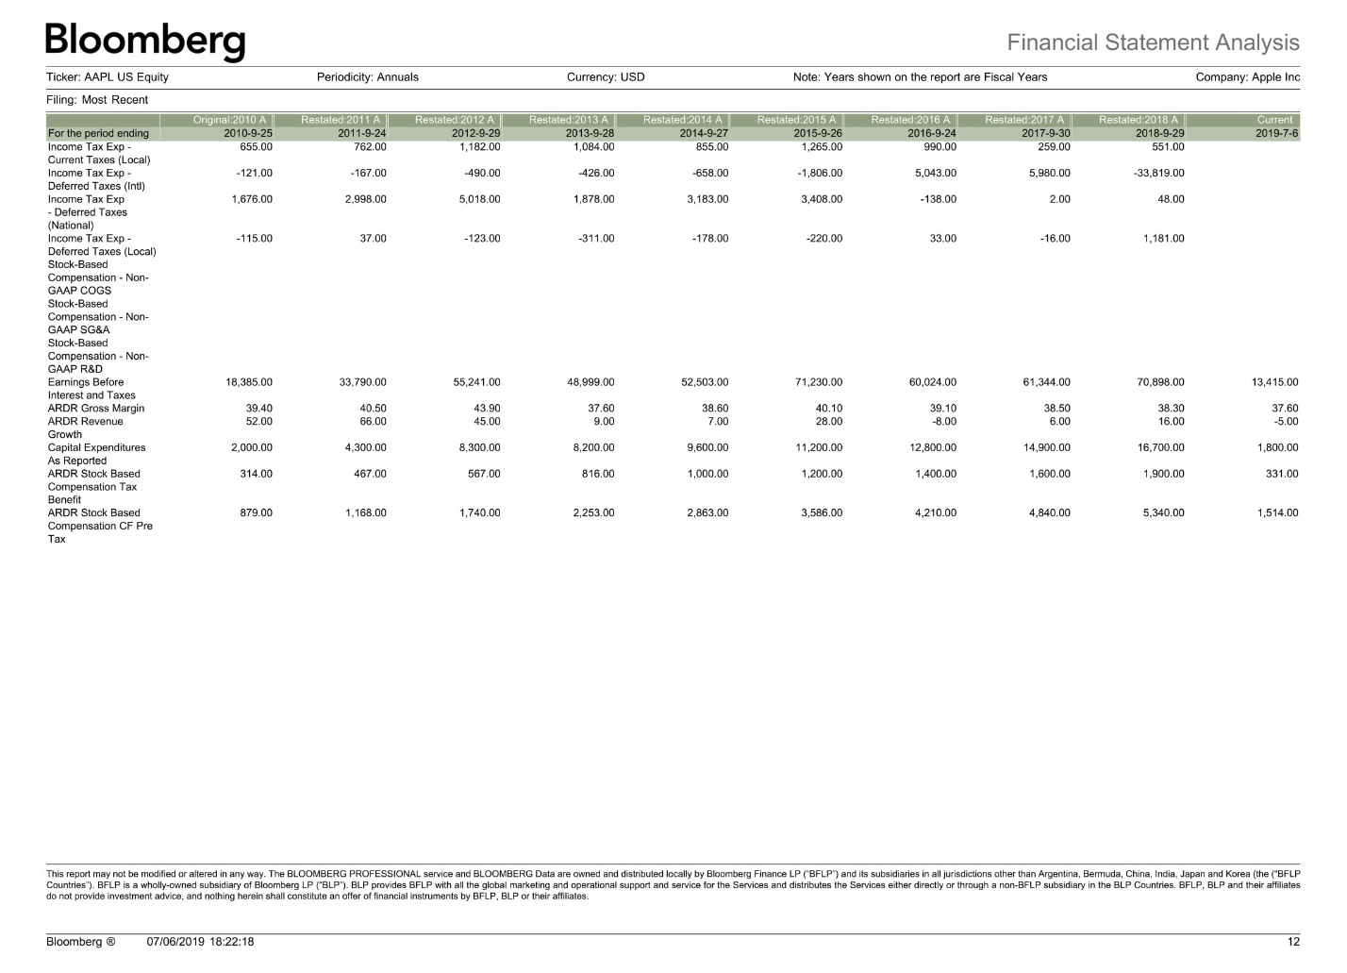

7. Apple Inc., All data pg- 13

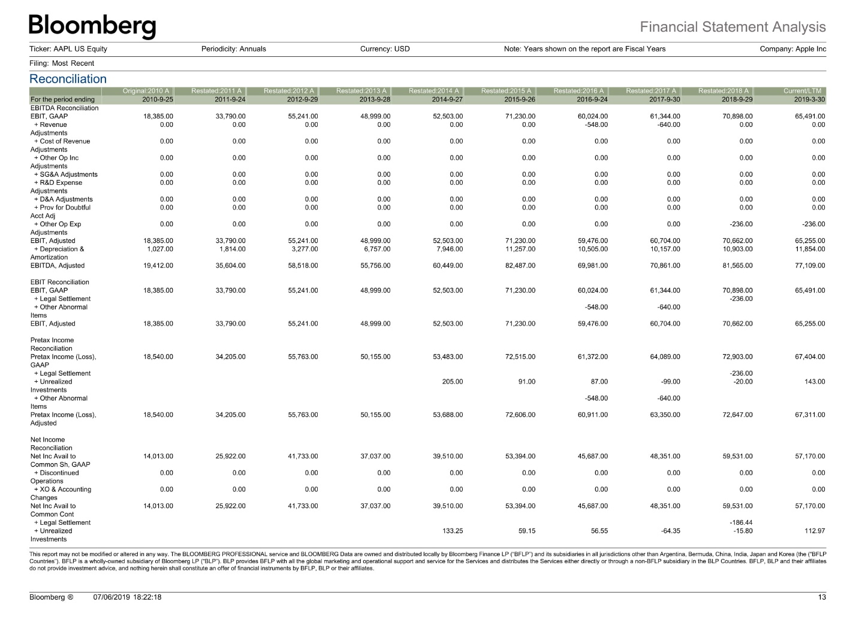

8. Apple Inc., All data pg- 19

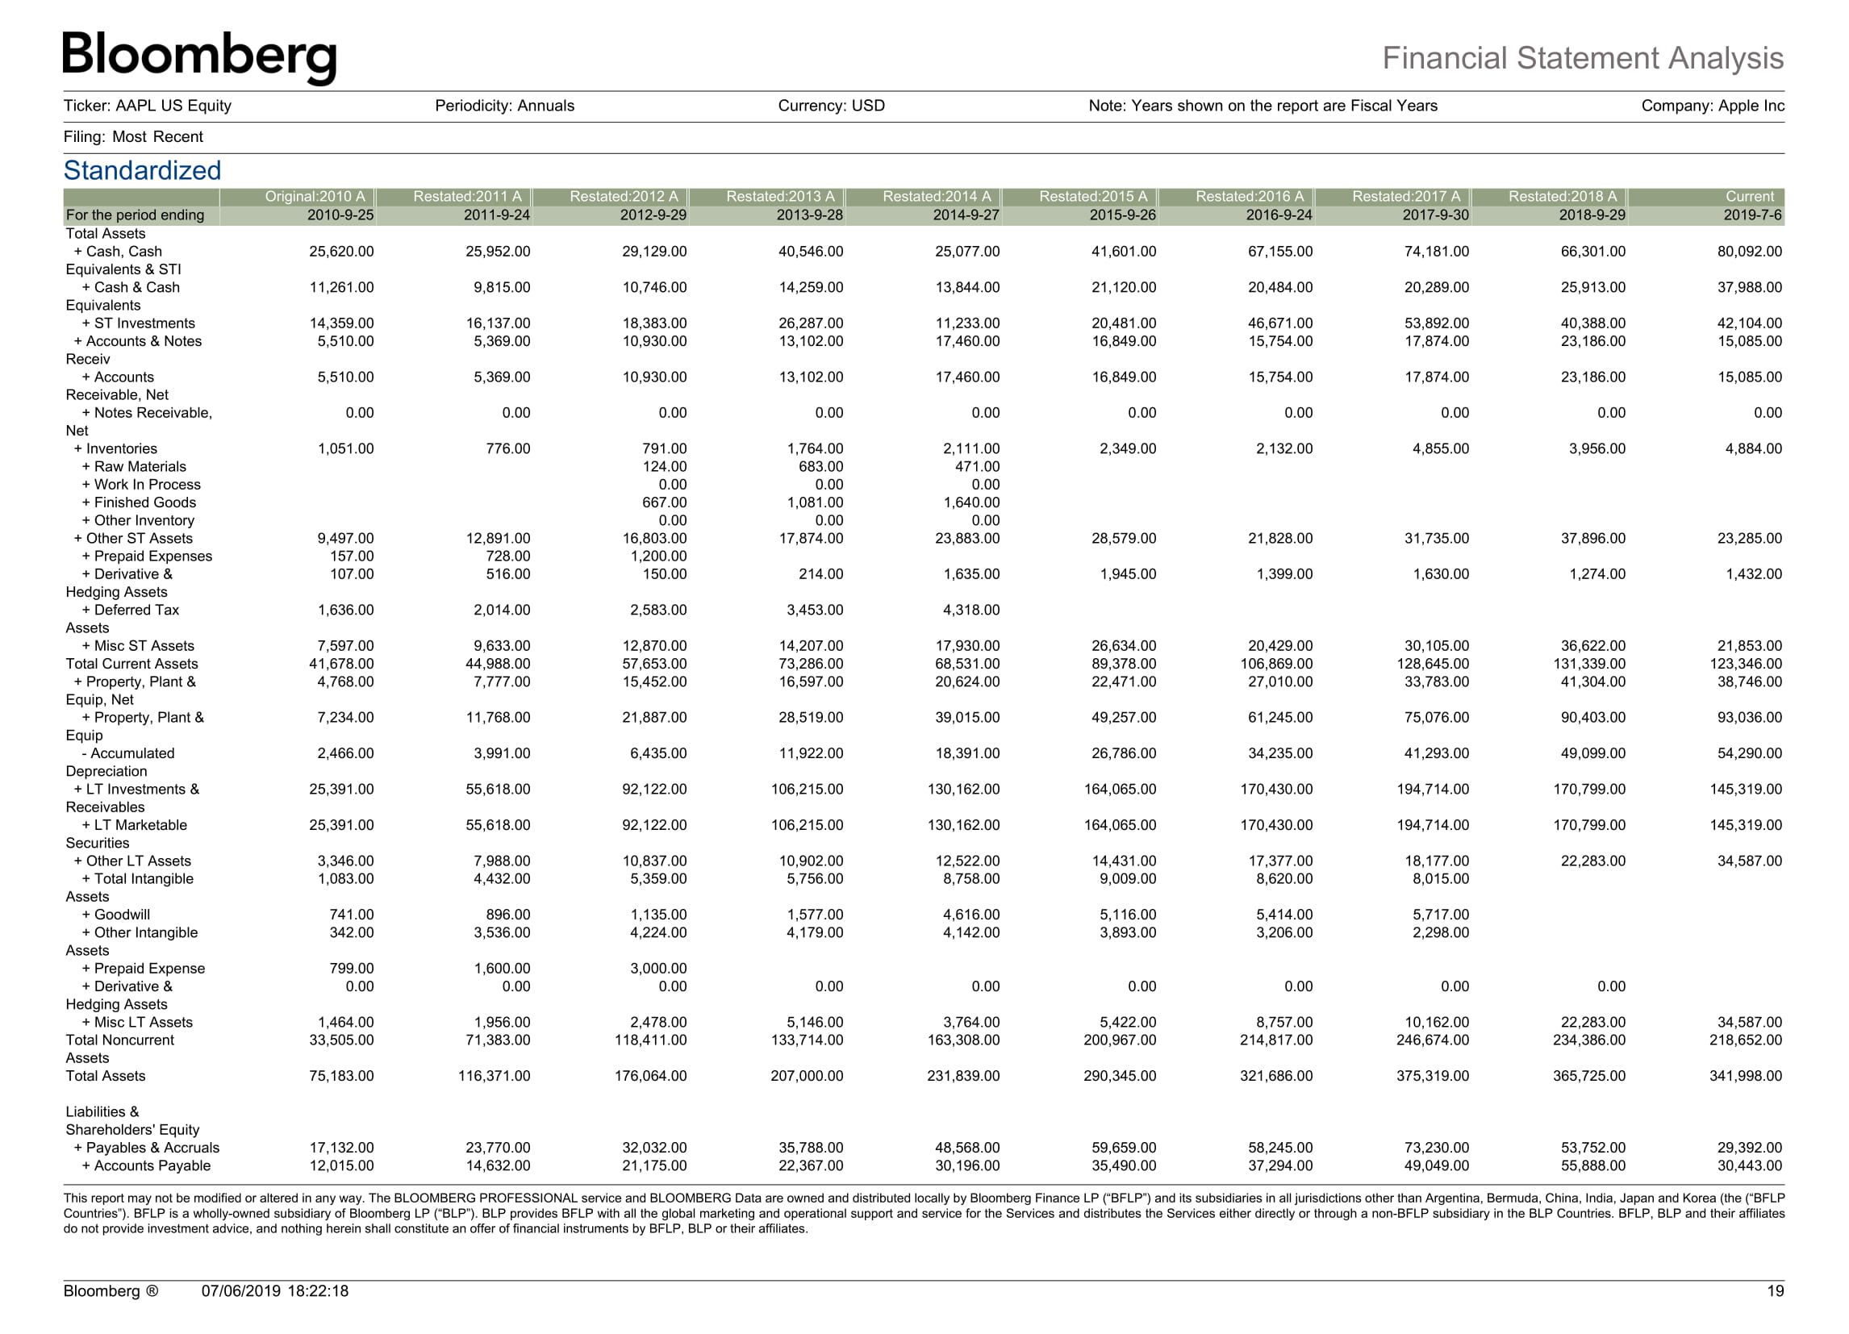

9. Apple Inc., All data pg- 20

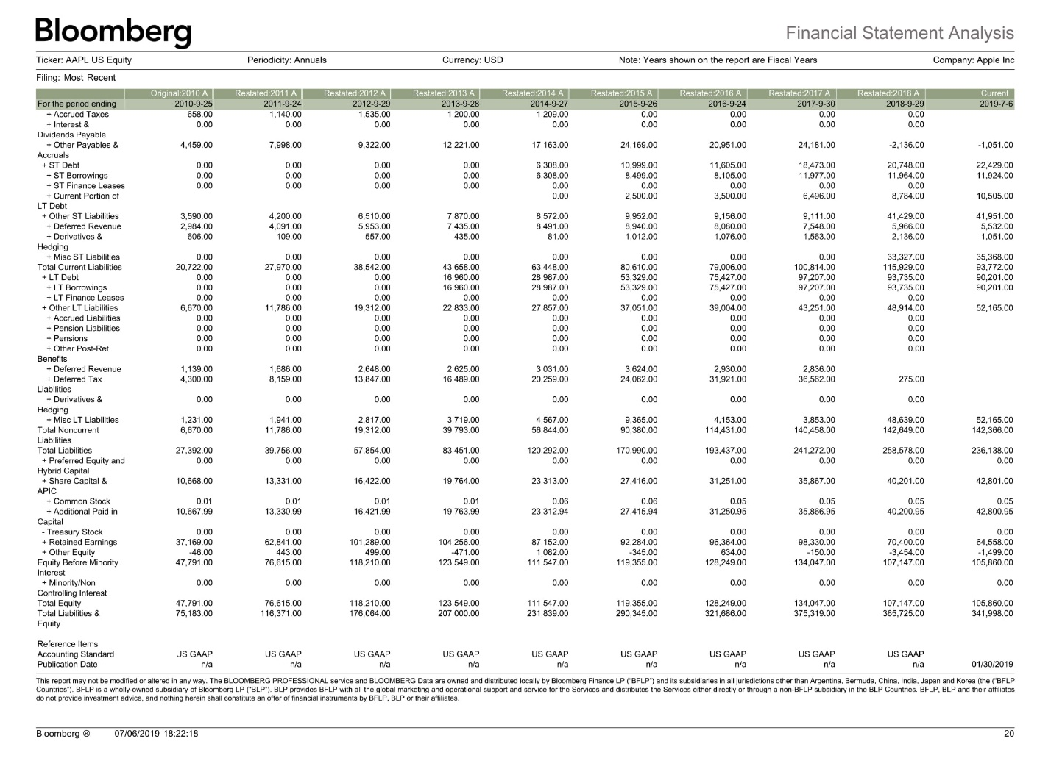

10. <https://www.nasdaq.com/symbol/aapl/earnings-growth>

11. <https://www.bloomberg.com/quote/USGG10YR:IND>

12. <https://finance.yahoo.com/quote/AAPL/key-statistics/>