What is SDLC?

It is a process used by development teams to design software. It includes Planning, Design, Implementation,Testing, maintenance.

Why SDLC?

Because it helps in the holistic development of the software and helps with scalability and maintainability of the software while being frugal with time.

Steps in SDLC:

Planning: It involves discussing with stakeholders/clients and gathering requirements, planning manpower.

Design: Designing a working software model with all inputs and ouputs that were planned.

Implementation: Coming out with a model based on the design and implementing it with software tools.

Testing: Testing for bigs,defects and loopholes in the software through Testing ,methods

Maintenance: After everything is working, long term maintenance of the software is required.

SDLC Models:

1.Waterfall model: when req are well defined and are small

Advantages: Clear Structure, Easy to Manage, Reduced Risk

Disadvantages: Lack of Flexibility, Limited Client Involvement, Can be Time-Consuming

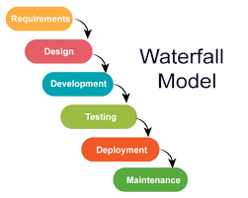

2.v model: small projects

Advantages: verification and validation activities early, Emphasis on Testing, Better Communication

Disadvantages: High risk and uncertainty, time-consuming-lot of documentation and testing, linear and sequential model, which can make it difficult to adapt to changing

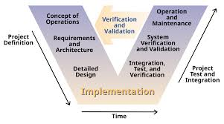

3.Spiral model: large projects with risk

Advantages: Risk is reduced as it is focused on testing

Disadv: Expensive , time consuming

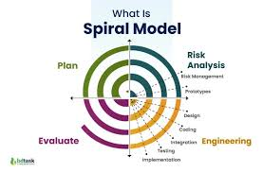

4.Agile model: Customer centric fast delivery of software

Advantages: Flexibility and Adaptability, Faster Delivery, Improved Team Morale

Disadv: Difficulty in Planning. Lack of Documentation, Challenges in Scaling

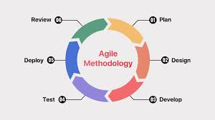

5.Iterative: large complex projects

Adv: Flexibility and Adaptability, Early feedback, Collaboration

Disadv: Increased Management Overhead, Rigidity Within Iterations, may cause delays

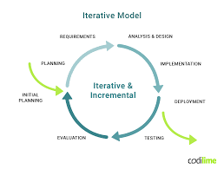

What is SCRUM?

It is an agile methodology where large process are broken down into smaller bits and accomplished through team effort and collaboration, where each bit is called a Sprint.

Sprint-short, time-boxed period during which a Scrum team works to complete a specific set of tasks from the project.

Dos: Involving the entire team in planning, focusing on the sprint goal, estimating effort accurately, and utilizing automation

Donts: ignoring the team's velocity, overloading the sprint

Stories: Are user defined tasks/features that are to be implemented

Backlogs: Are prioriritised works that are pending/to be done

SCRUM Artifacts:

Product Backlog: Client defined goals which are dynamic and are to be completed

Sprint Backlog: Team defined static goals

Burn-Down Chart: Maps how much work if left wrt time

Increment: A short progress towards the end goal which is an improvement

NETWORKING.

Ports: are virtual communication channel used to transfer data

Protocols: A protocol is a set of rules that governs how data is transmitted and received over a network

Network types:

LAN,WAN

Types of servers:

1. Application server: Used to manage applications
2. Database server: Used to database applications
3. Catalog server: Used to hold information tables
4. Communication server: maintain an environment needed for one communication endpoint to find other endpoints

Domain Name System (DNS): It is the process of resolution of Ip address to the domain name.

Network Topologies.

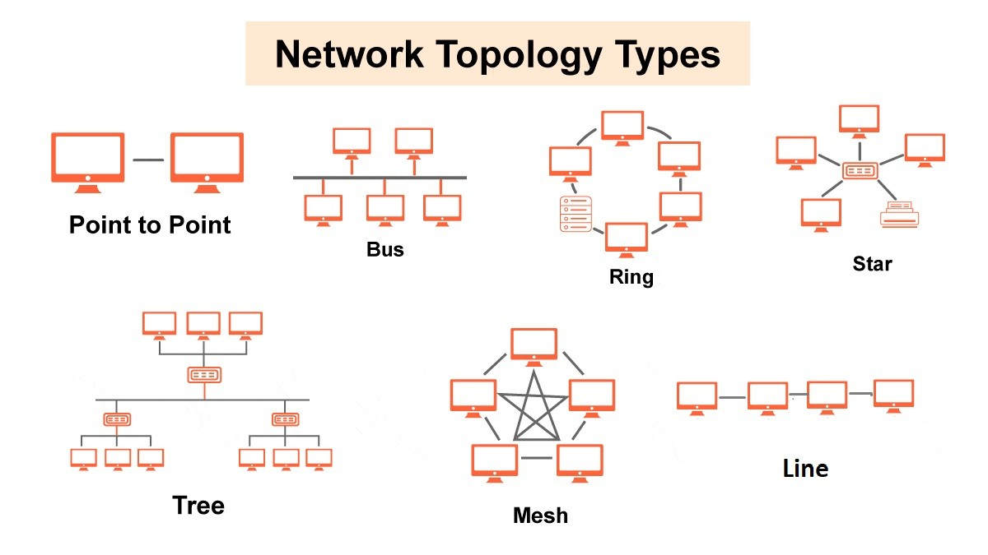

OSI Model

1.Physical layer

2.Data link layer

3.Network

4.Transport

5.Session

6.Presemtation

7.Application