Task 10

RMDIR   
removes Blank Directories alone

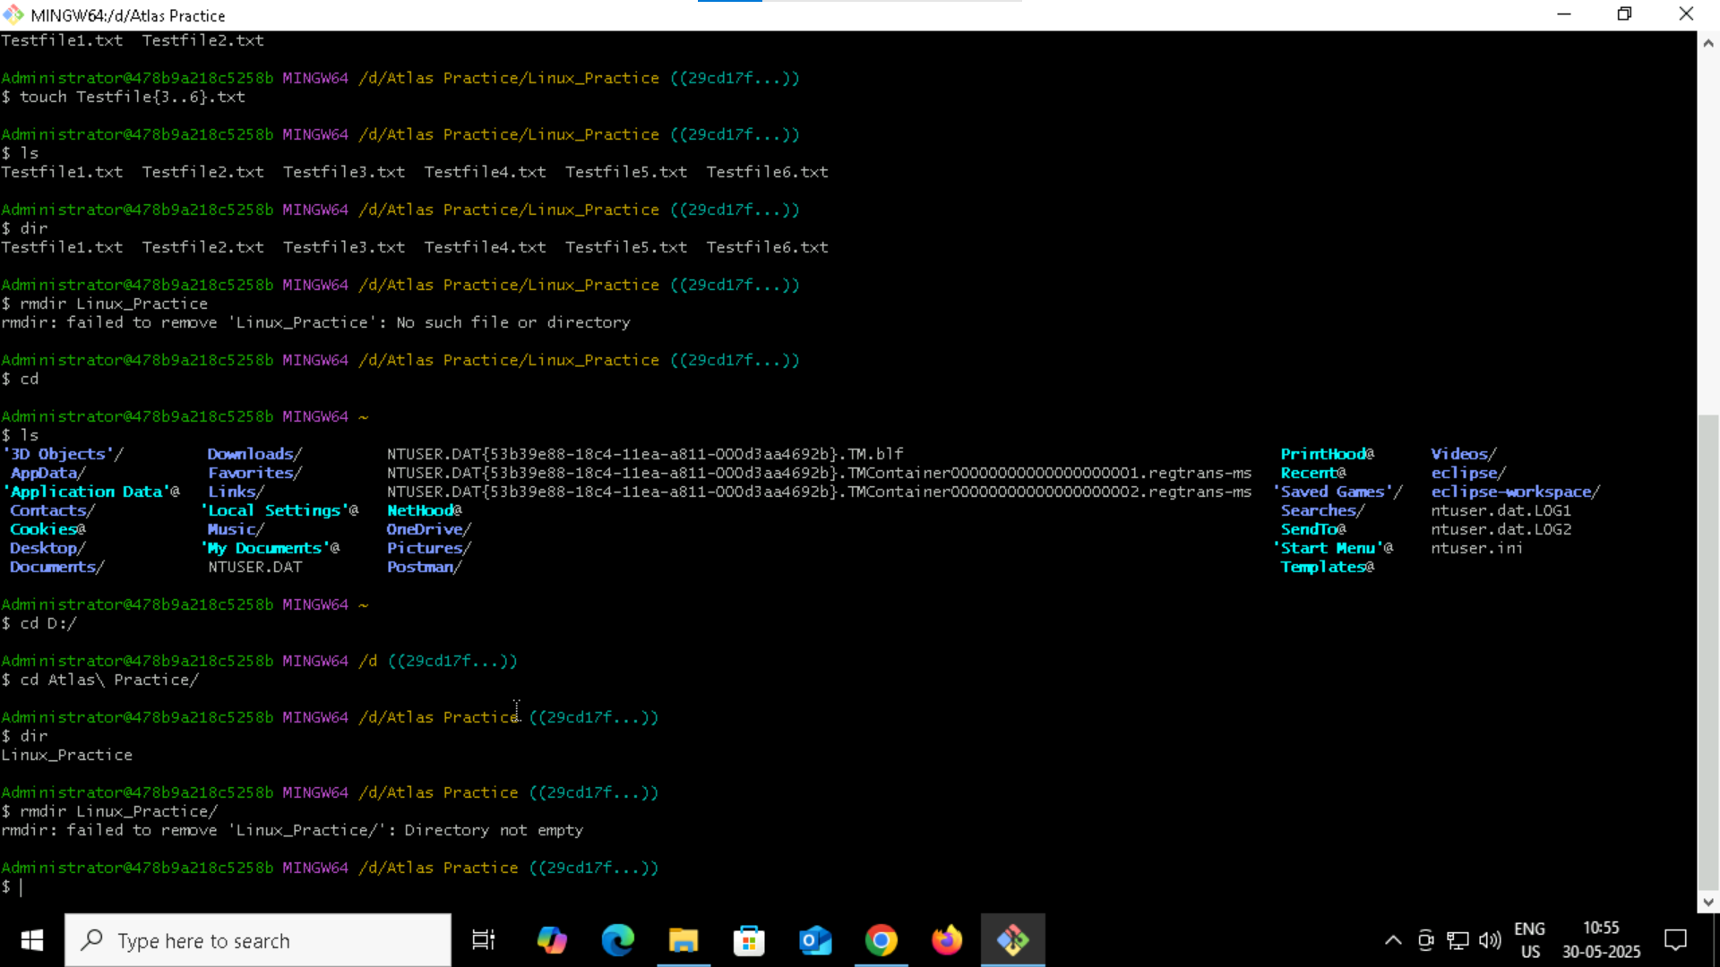

Rm  
Removes the mentioned files and directories even if they are not empty

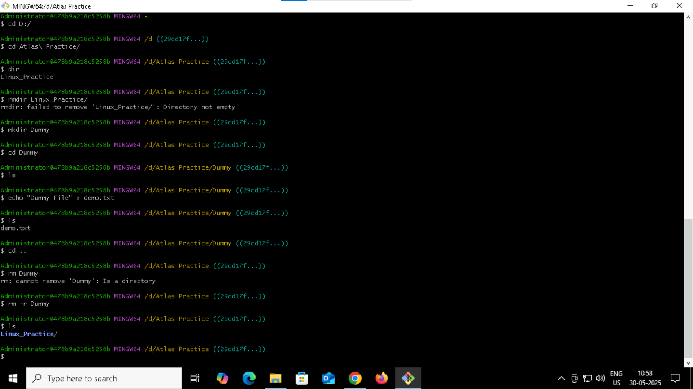

Escape Sequences -e

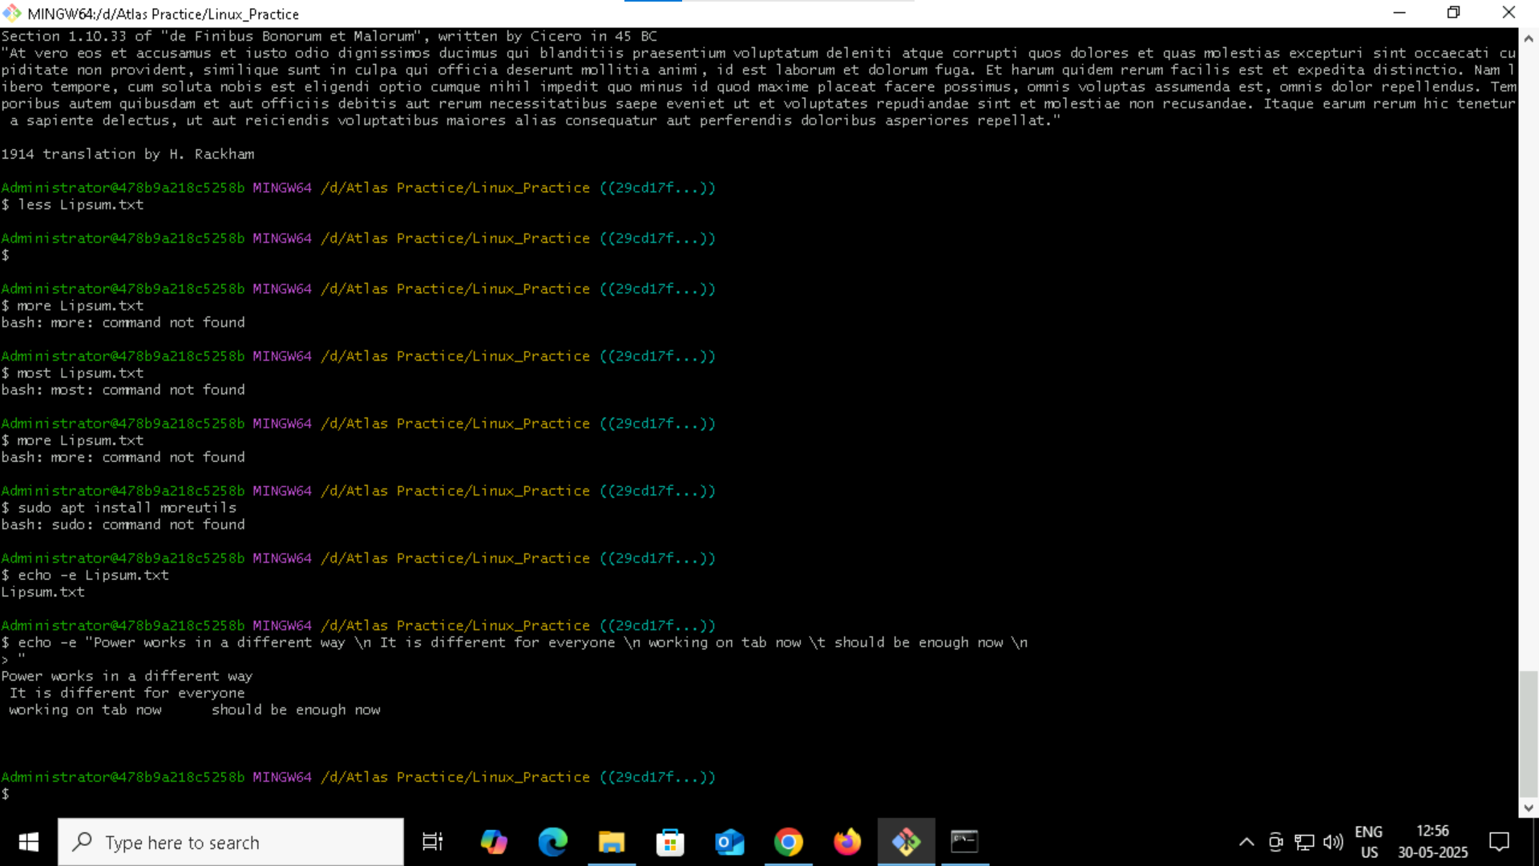

Ls displays the files   
ls -l displays the read and write permissions as well for the files

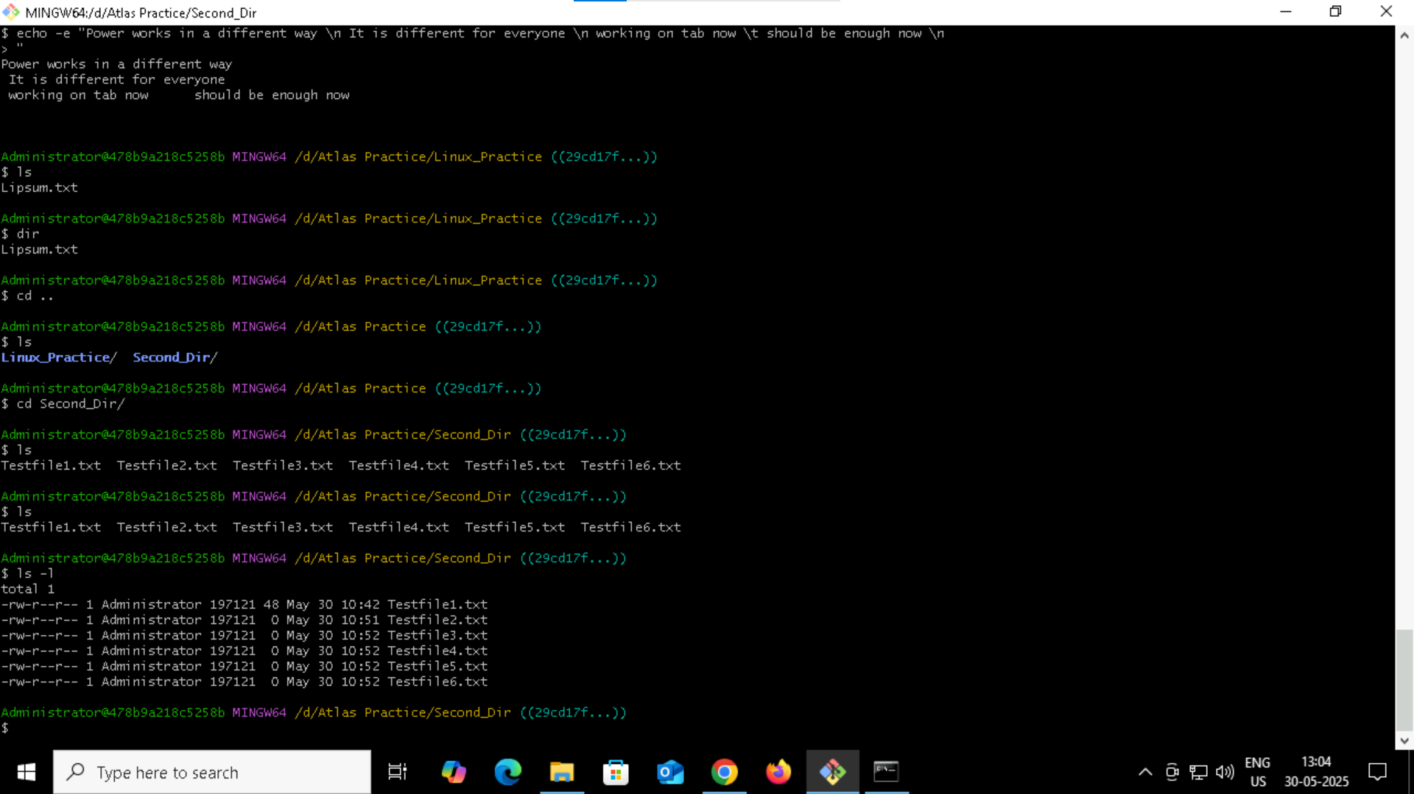

Task 20 :   
Go back 1 directory at a time

cd ..

Task 27

Cd . stays in the same directory

Cd .. Move up one level( to the parent directory)

Task 28 :

