Regex Expressions  
[a-z]

Matches any lowercase letter from a to z.

[A-Za-z0-9]

Matches any alphanumeric character or underscore.

[^0-9]

Matches any character that is not a digit.

a*

Matches zero or more occurrences of "a".

a+

Matches one or more occurrences of "a".

a{3}

Matches exactly three "a" characters.

a{2,4}

Matches between 2 and 4 "a" characters.

\d

Matches any digit (0–9).

\w

Matches any word character (alphanumeric + underscore).

\s

Matches any whitespace character (space, tab, newline).

**Features of Linux OS**

Free and Open Source

Linux doesn’t cost anything to use, and the code behind it is open — meaning anyone can view or modify it. This makes it flexible

Secure by Design

Linux is built with security in mind. It’s less prone to viruses and malware, and regular updates keep it protected.

Stable and Reliable

It doesn’t crash easily and can run for a long time without needing a restart — that’s why many servers use Linux.

Highly Customizable

Users can change almost everything — from the look and feel to the tools running in the background — depending on their needs.

Multi-user Capable

Multiple users can access the same system with different accounts, each with separate files and permissions, without affecting each other.

Command-Line Power

While it has a graphical interface, Linux has it’s own terminal — allowing power users to automate tasks and manage the system more efficiently.

Great for Developers

Linux supports most programming languages and offers tools and environments developers need for software creation.

Lightweight Options Available

There are versions (called "distros") that are very lightweight, ideal for older machines or minimal setups.

Strong Community Support

It has a large, active community. If you run into issues, chances are someone has already solved it and shared the fix online.

Kernel Definition  
  
Kernel is like the CPU of the Linux System. Just like the peripherals of the PC connected to your CPU.  
Kernel acts like a bridgeway between Hardware resources and the virtual machine.  
it is responsible for distributing CPU time , allocating memory, Providing a interface for data , setting up the network and the process communications.

Bash in Linux  
  
Bash is a command line shell used in Linux Systems.   
We can run commands like copying files , installing packages.  
Syntax is user friendly .

We can automate tasks like backups, software setups etc.

Difference between Linux and Microsoft

**Microsoft**

It’s easy to use, with a familiar interface that works well for non-technical users.

Most popular software and games are designed to work best on Windows (like Microsoft Office, Adobe tools, and many PC games).

It is a paid OS, meaning you usually need to buy a license when using it.

Windows is a closed-source system — only Microsoft controls how it's built or updated.

It gets automatic updates and sometimes installs them whether you want it or not.

While it has improved in recent years, Windows is still more prone to viruses and usually needs antivirus software.

The command line (PowerShell or Command Prompt) exists, but most users don’t use it much.

**Linux**

Highly Customizable

Free to use

Open source, anyone to edit

Does not support Modern games and apps

Less targeted by malware and viruses

It has a learning Curve

Parts of Linux OS

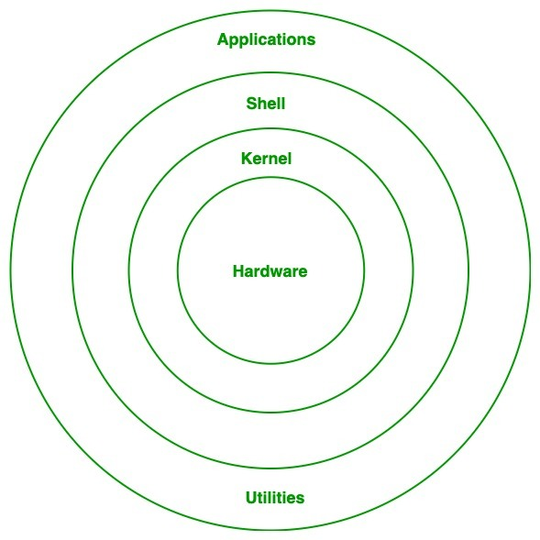

First, there’s the kernel — this is like the heart of Linux. It’s the part that talks directly to your computer’s hardware (like your memory, processor, and keyboard). It handles all the low-level stuff, like making sure the right app gets the right amount of memory or sending your typed input to the correct place.

Next, we have the shell, which is basically the program that lets you talk to Linux by typing commands. When you open the terminal and type something like ls to list files, it’s the shell that reads your command and makes it happen. The most common shell is called Bash, and it’s super useful once you get the hang of it.

Then, there are the file system and directories. Linux organizes everything — apps, settings, documents — into a clean folder structure. You’ll see folders like /home for user files, /etc for settings, and /bin for basic programs. Everything, even devices like your mouse or USB, is treated like a file here.

Another important piece is the system libraries. These are collections of code that apps reuse to do common tasks. Instead of every app writing its own way to open a file or connect to the internet, they just use these shared tools. It keeps things light and efficient.

Finally, there are user programs — the apps and tools you interact with. These include text editors, browsers, and software installers. Some come pre-installed, others you add later using something called a package manager, which is just a handy tool for installing and updating apps.

Is it Legal to Edit kernel?

Yes. Since Linux is a open source distribution, we can download the code, make some changes , compile them and run your own custom version.

LILO?

Linux Loader(LILO) is a bootloader for Linux, just like windows , linux needs a boot loader so that the system has instructions on how to load the OS

BASH :  
It’s like a command line interface, just like command prompt for windows, it is used to communicate with the OS such as creating, deleting, updating directories and files.

Bash (Bourne Again SHell)

The most popular shell, used by default in many Linux systems. Easy to learn and widely supported.

Sh (Bourne Shell)

The original Unix shell. Simple and lightweight, often used in scripts.

Zsh (Z Shell)

Like Bash but with more features: better autocomplete, themes, and plugins.

Ksh (Korn Shell)

Combines features from sh and csh. Often used in enterprise environments.

Csh (C Shell)

A shell with C-like syntax. Less common now

Swap Space:

Emergency back up memory, it is to ensure that the system doesn’t crash when the RAM usage is 100%

Mount?  
Mounting means making a storage drive(hard disk/pendrive) accessible to the system

Mounting a file system

sudo mount /dev/sdX1 /mnt

unmounting a file system  
sudo umount /mnt/usb  
  
chmod   
change permissions for a file  
read write execute

-r

-w

-x

|  |  |
| --- | --- |
| 7 | read + write + execute (rwx) |

|  |  |
| --- | --- |
| 6 | read + write (rw-) |

|  |  |
| --- | --- |
| 5 | read + execute (r-x) |

|  |  |
| --- | --- |
| 4 | read only (r--) |

|  |  |
| --- | --- |
| 0 | no permissions (---) |

Numerical format

Create a user in different ways

Sudo adduser damo (interactive)

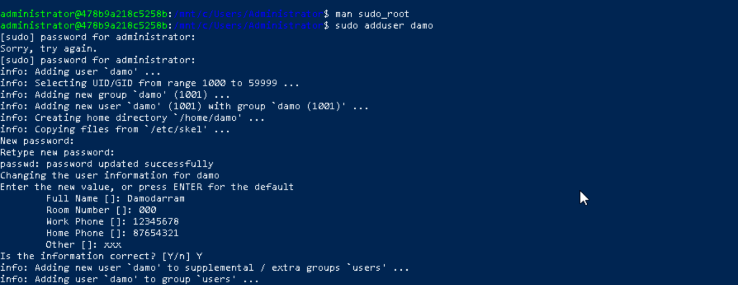

Sudo useradd -m -s /bin/bash demo1(Less interactive, More Manual)



-m creates a home directory

-s sets default shell

Changing password

Sudo passwd username

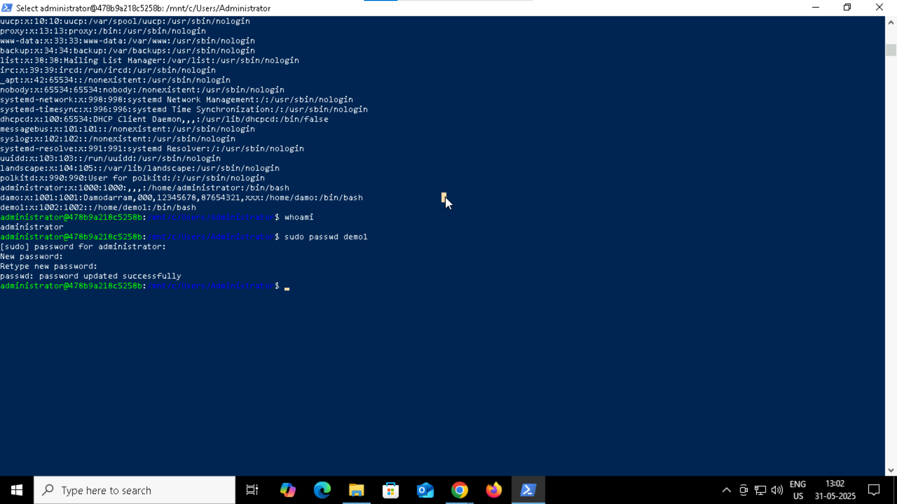

Process Vs Thread

Process is a whole program running individually, it takes up its own memory, CPU time and resource.  
If one process crashes, it won’t affect the other ones.

Ex(chrome, VLC player)

A thread is a small part of process . Multiple threads run in a process. They share the same memory

Ex A tab in chrome

Grep Command Usage

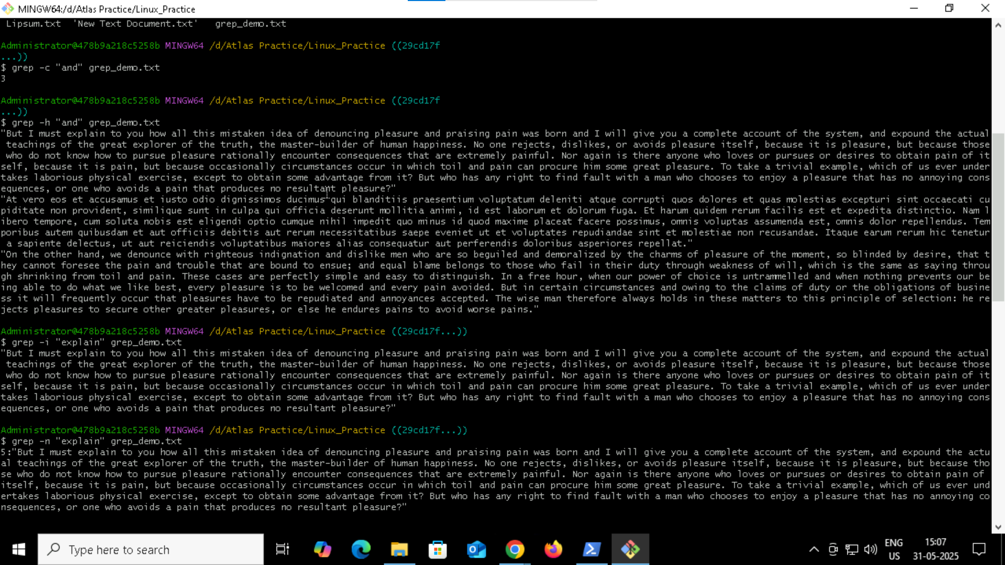

Grep -o ‘\<a[a-zA-Z]*e\>’ grep_demo.txt

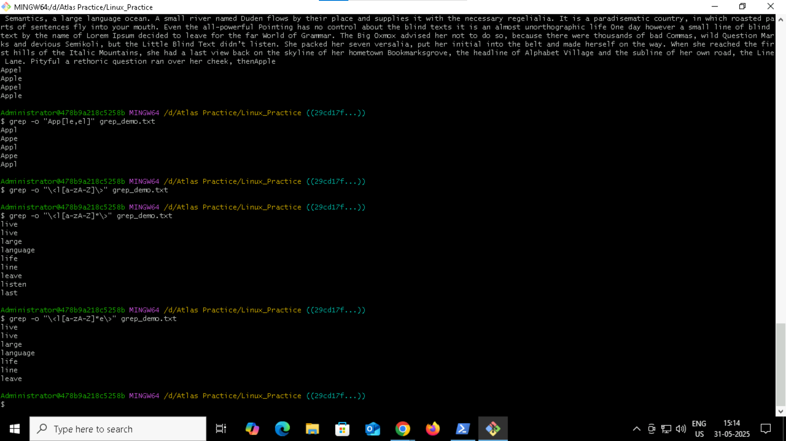

How to check file access permission in Linux?

Ls -l

What are the default permissions for a new file ?

Read and write for owner

Read only for other users

Change the file permissions to match the following:

owner: Read, Write and Execute

group: Read and Execute

other: Execute

chmod u=rwx, g=rx, o=x filename

Guys what will this command do?

chown -c master file1.txt

it will change the ownership to master for the file1.txt

Can you define what is  a process

Process is a whole program running individually, it takes up its own memory, CPU time and resource.  
If one process crashes, it won’t affect the other ones.

Ex(chrome, VLC player)

What will ps -f command do ?

It shows the detailed information (along with the user’s info) about the processes that are running

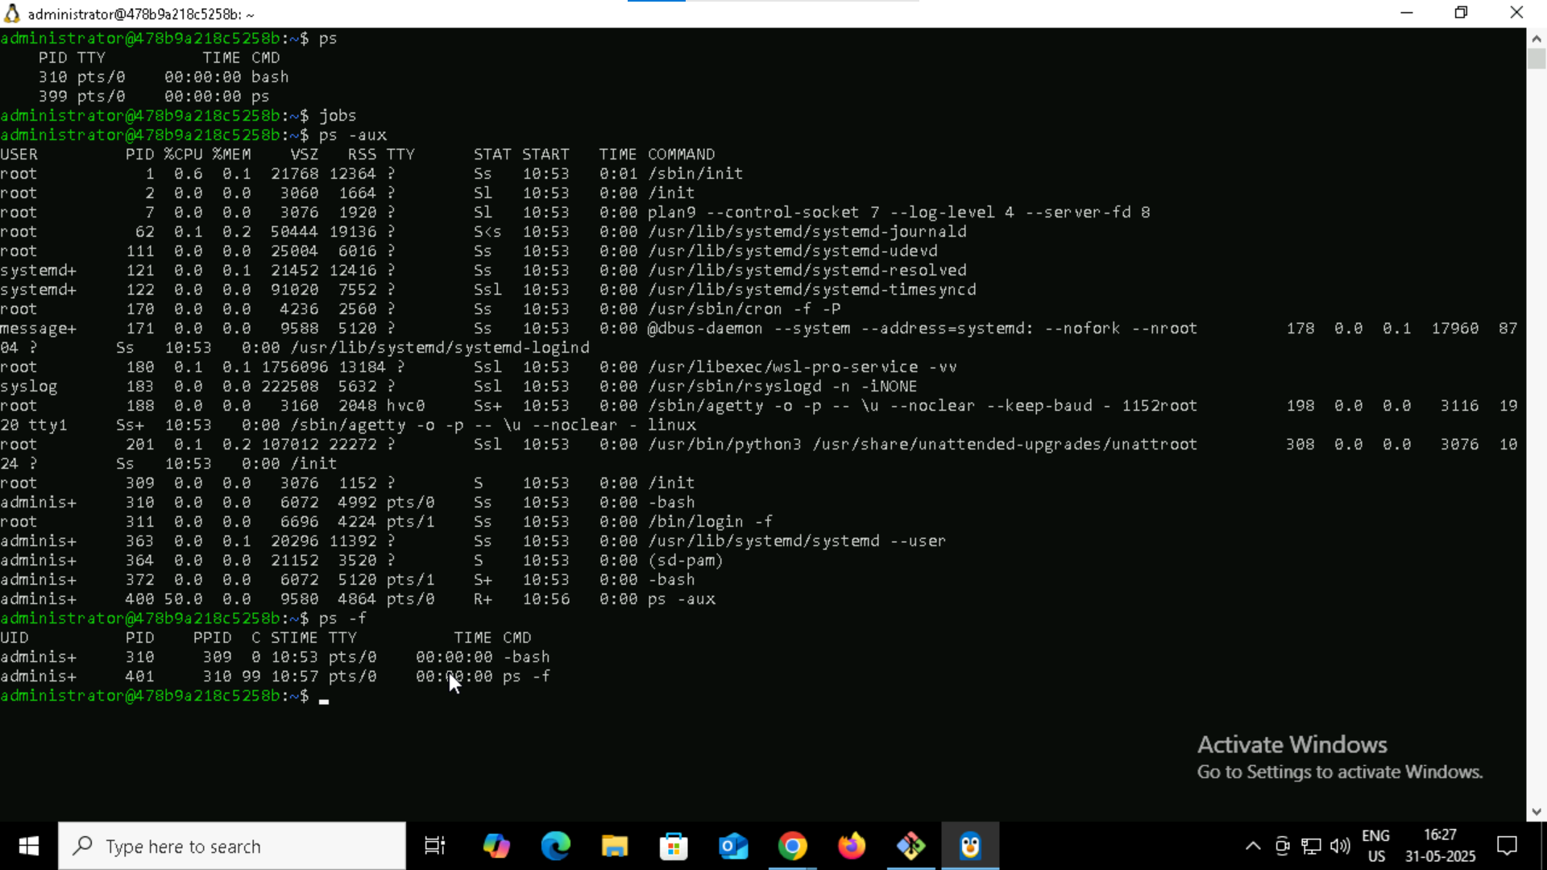

Can you make the above name variable read only?

Using Readonly command

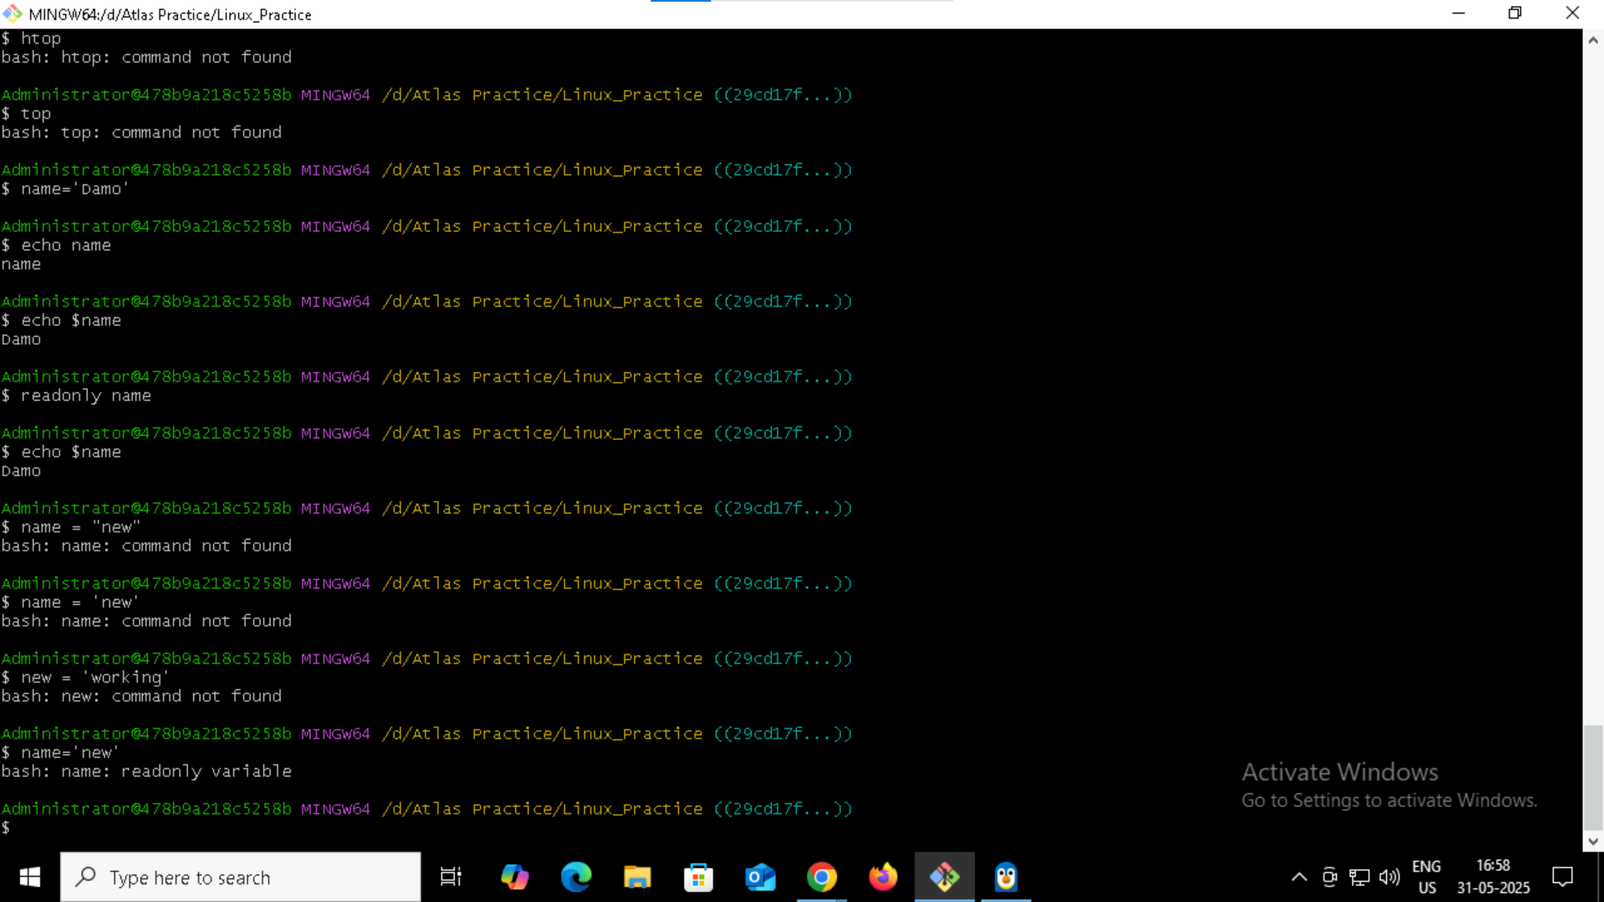

Symbolic Link

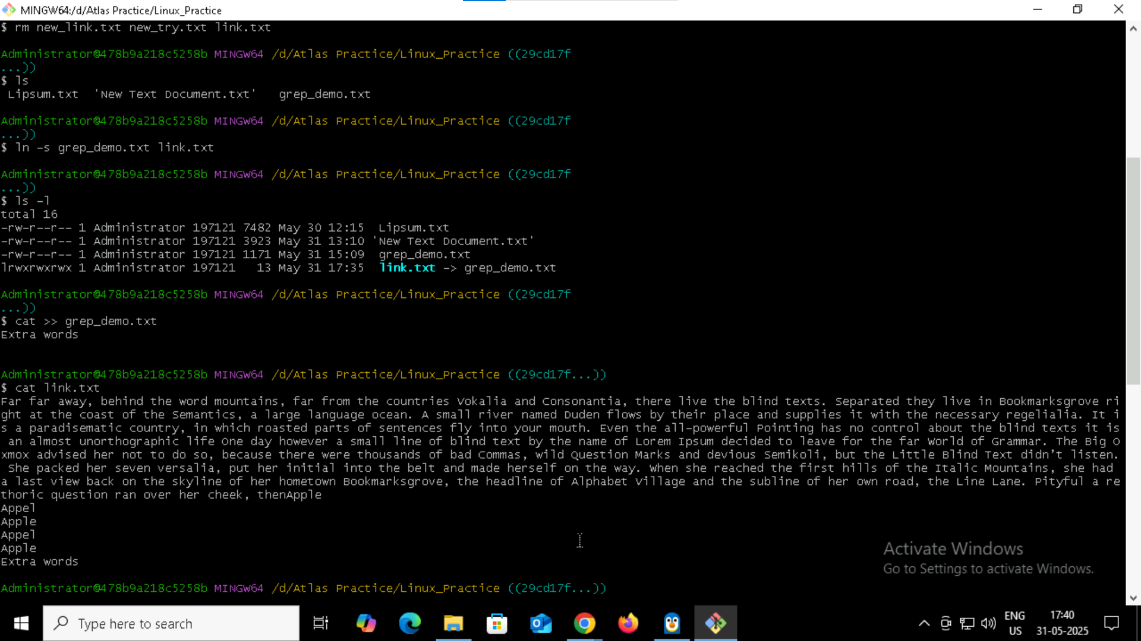

Use the below command and check

Unset Name : deletes the contents in that variable

