OUTCOME

* 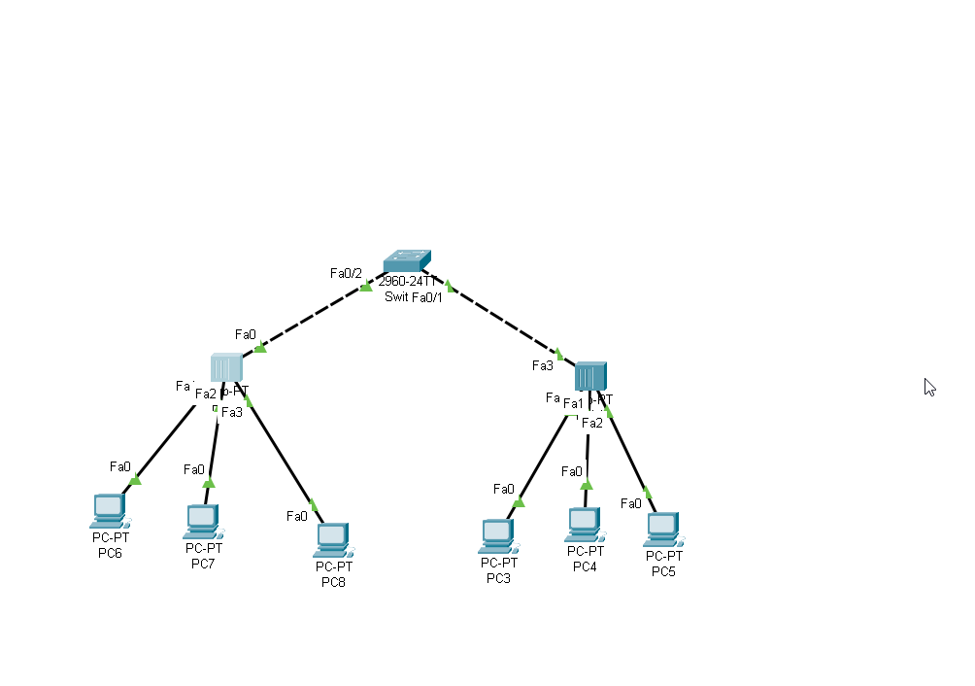We come across PDU which is a single unit of data transmitted across the peers. I understood the dataflow among end devices which are in the same network.