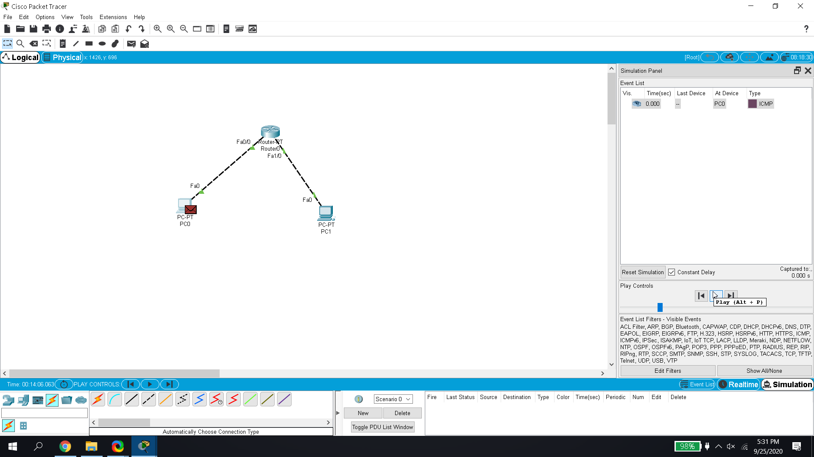OUTCOME

* Reply from pc1 were received when it was pinged from pc0.
* When the response to the ping was not receved a Request Error Prompt was given in the prompt.

