create user sumanthkv identified by sumanth04;

grant dba to sumanthkv;

create table person(

driver_id varchar(10) not null ,

name varchar(10) not null,

address varchar(50) not null,

primary key(driver_id)

);

create table car(

reg_num varchar(10) not null,

model varchar(100) not null,

year int not null,

primary key(reg_num)

);

create table accident(

report_num int not null,

accident_date date not null,

location varchar(100),

primary key(report_num)

);

create table owns(

driver_id varchar(10),

reg_num varchar(10),

primary key(driver_id,reg_num),

foreign key(driver_id) references person(driver_id),

foreign key(reg_num) references car(reg_num)

);

create table participated(

driver_id varchar(100) not null,

reg_num varchar(100),

report_num int,

damage_amount int,

primary key(driver_id,reg_num,report_num),

foreign key(driver_id) references person(driver_id),

foreign key(reg_num) references car(reg_num),

foreign key(report_num) references accident(report_num)

);

insert into person values('&driver_id','&name','&address');

insert into person values('A04','Venu','N.R.Colony');

insert into person values('A05','John','hanumanth Nagar');

commit;

select * from person;

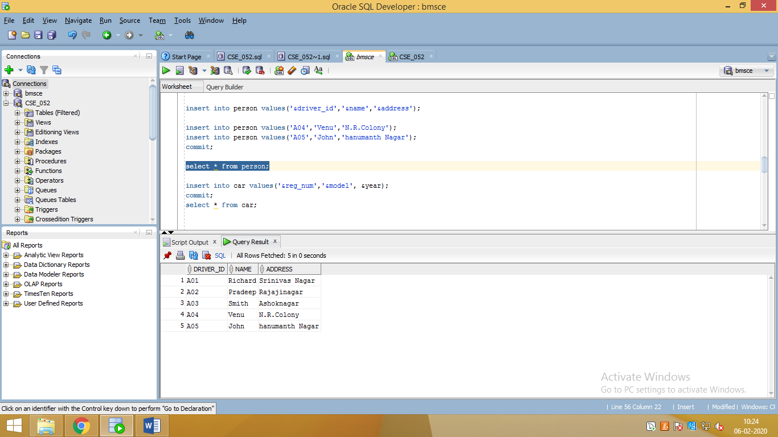

insert into car values('&reg_num','&model', &year);

commit;

select * from car;

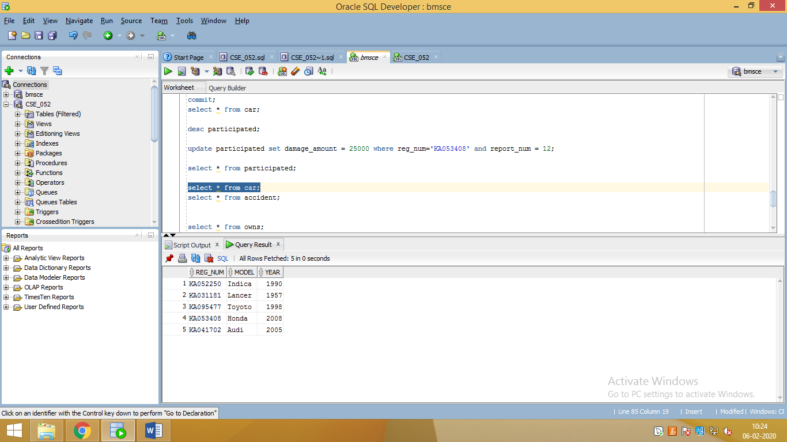

insert into accident values(&report_num,'&accident_date','&location');

commit;

select * from accident;

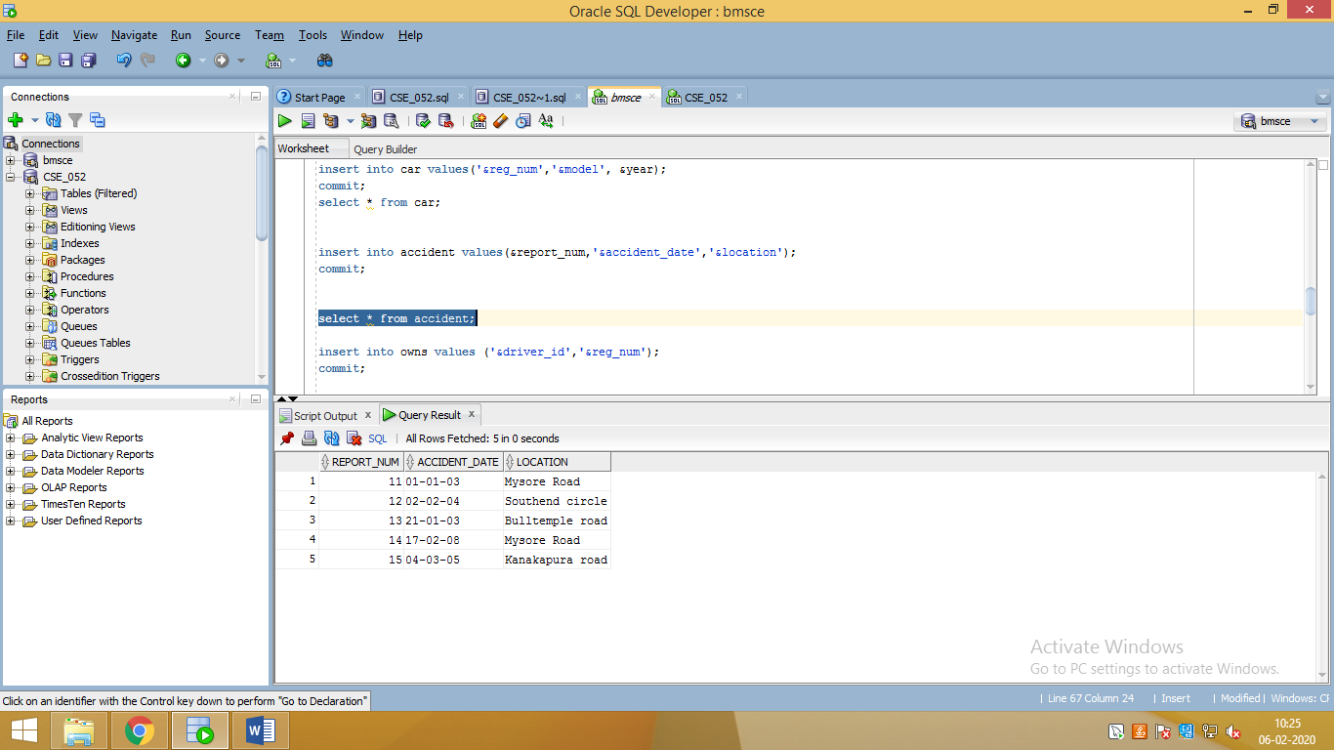

insert into owns values ('&driver_id','&reg_num');

commit;

select * from owns;

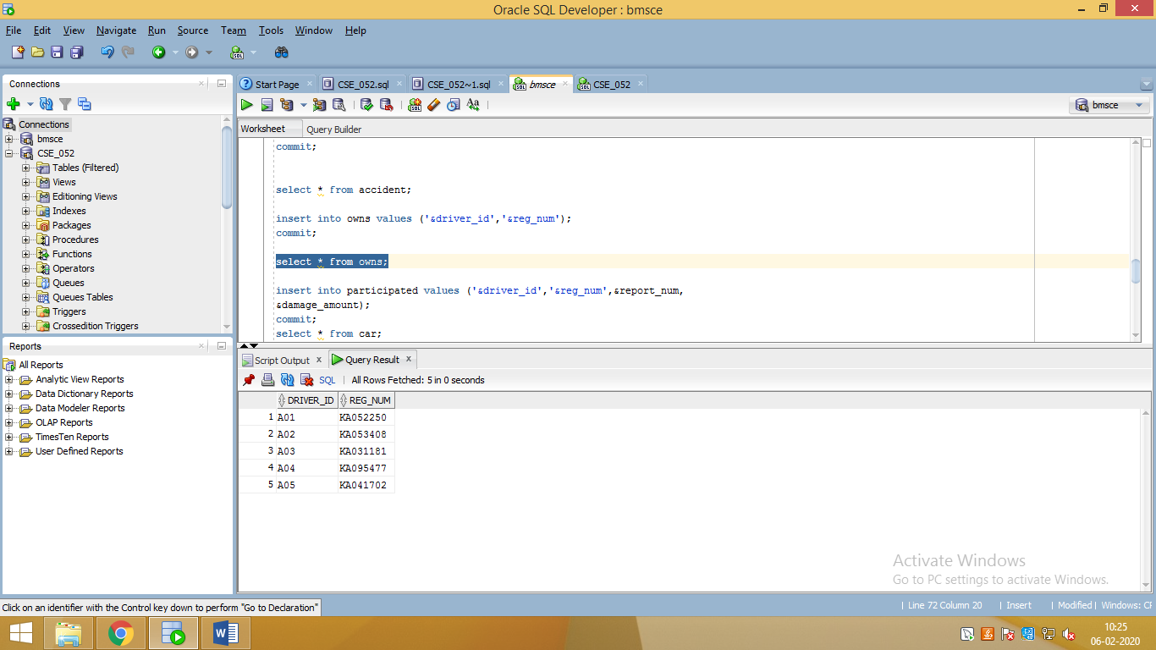

insert into participated values ('&driver_id','&reg_num',&report_num,

&damage_amount);

commit;

select * from car;

desc participated;

select * from participated;

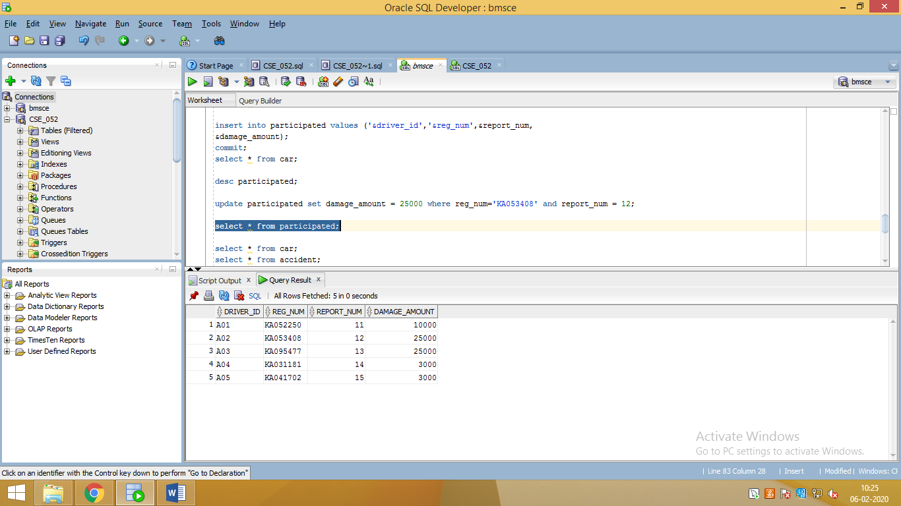

select * from car;

select * from accident;

select * from owns;

update participated set damage_amount = 25000 where reg_num='KA053408' and report_num = 12;

select count(*) as "total" from car where year like '%08';

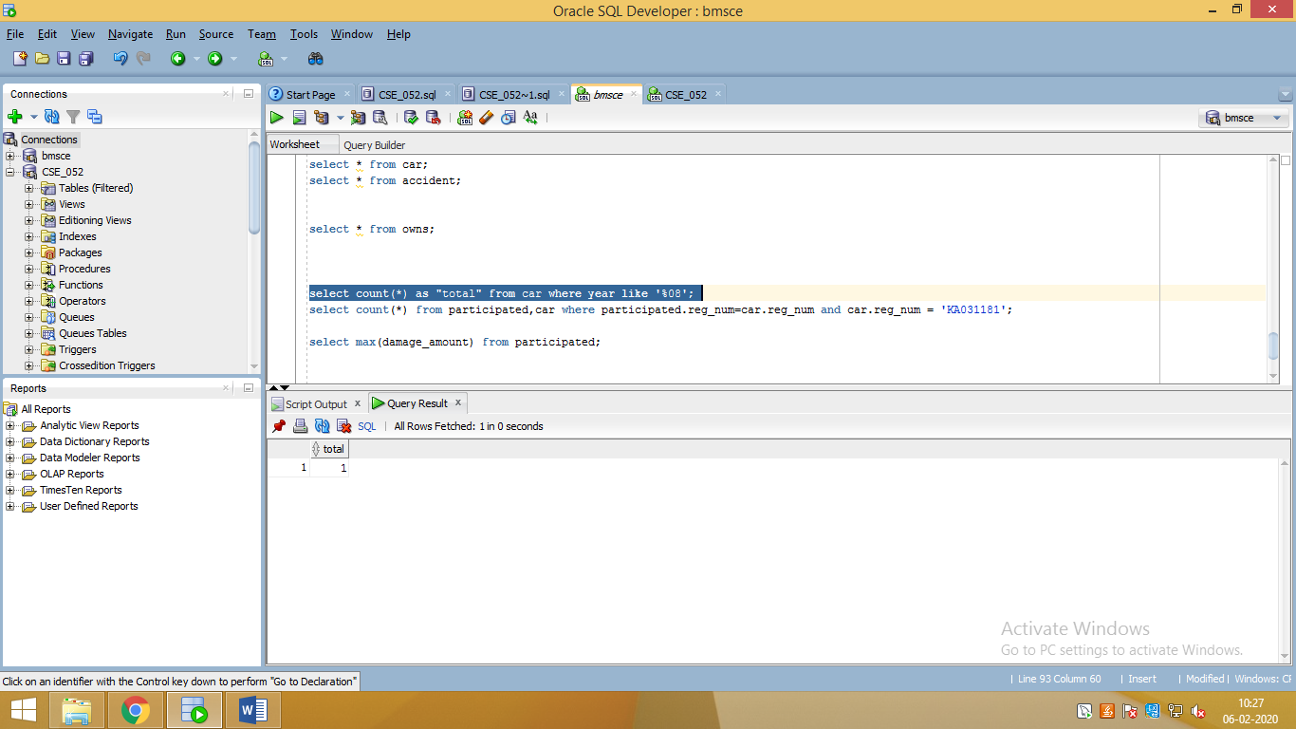

select count(*) from participated,car where participated.reg_num=car.reg_num and car.reg_num = 'KA031181';

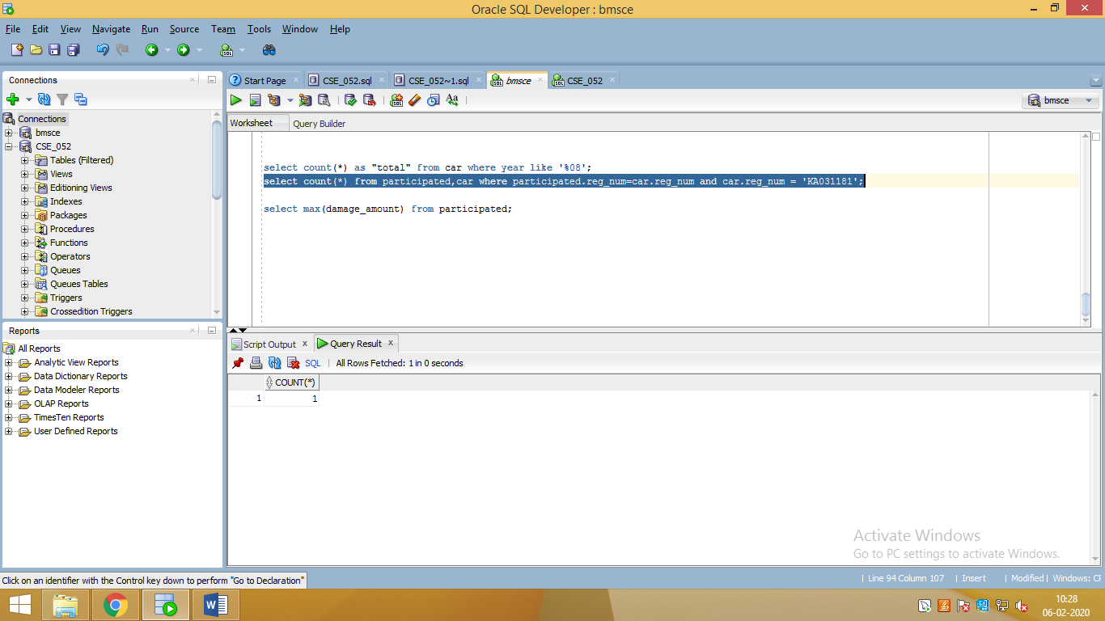

select max(damage_amount) from participated;

