Energy Inflation and the Two-Year Treasury
Investment memo | Data as of November 8, 2026 | Market prices as of November 6, 2026 | Generated from model run 2026-11-08T16:46:39

1. Recommendation and key numbers
Recommendation: No trade at current prices
Buying the 2-year note (91282CRU7, 4.625% due October 31, 2028) instead of the 6-month bill does not offer an attractive edge at current prices.
Held for 178 days from November 9, 2026 to May 6, 2027, the bill returns 2.08%. The note beats it only if the 1.5-year Treasury yield on May 6, 2027 is below 4.61%, which is the market's own forward rate. If the market has already priced EIA's gasoline forecast, the probability-weighted edge is -0.63% (-1.29% annualized). Even if the market prices flat gasoline, it is +0.00%.
Conditional entry. Switch from the bill to the note if either of these happens:
- The 2-year yield rises to 4.89% or higher (now 4.51%) with the gasoline outlook unchanged. At that price the expected edge reaches the 0.10% minimum even if EIA's forecast is priced in.
- Retail gasoline averages at least 5% below EIA's path for a full month while the 2-year yield has not fallen. That is evidence for the below-EIA path, where the note beats the bill by +0.63% under the same view.

Measure | Value | Note
6-month bill return | 2.08% | Bill 912797WX1: 4.12% discount, 4.26% bond-equivalent
Breakeven 1.5-year yield, May 2027 | 4.61% | Equals the market forward (4.61% from the full curve)
1.5-year yield if the curve does not move | 4.42% | Market prices the yield 19 bp above this
Expected edge vs bill, EIA forecast priced | -0.63% | Equal scenario probabilities (placeholder)
Expected edge vs bill, flat gasoline priced | +0.00% | Same probabilities
Entry 2-year yield (EIA forecast priced) | 4.89% | Now 4.51%
Headline CPI y/y, March 2027 | 2.7 / 3.2 / 3.7% | Falling / stable / rising gasoline (latest: 3.7%)
1-month CPI gasoline forecast error | 1.69 pp | vs 6.45 pp for no change; 308 real-time forecasts

2. Thesis: gasoline inflation is fading, but slowly in the data
Pump prices are already falling. The October 2026 average retail price was $4.31, below EIA's $4.40 forecast for that month, and the latest weekly price is $4.15 (November 2, 2026). EIA's October 2026 outlook takes the monthly average to $3.66 by March 2027, a 15% decline.
Gasoline now weighs 4.08% of the CPI, so a 10% move in pump prices moves headline inflation by about 0.41 pp. Holding core at its trailing pace of 2.56%, food at 2.48% and other energy at 7.84% (assumptions), headline inflation reaches 2.7% by March 2027 if gasoline follows EIA, 3.2% if it holds at today's price and 3.7% if it rises as much as EIA expects it to fall. The latest reading is 3.7% for September 2026.
The decline shows up late. In the stable case, year-over-year inflation peaks at 4.1% in January 2027 and falls only in March 2027, largely because the March 2026 gasoline jump (+24.9% in one month) drops out of the comparison. That base effect is public, so the market sees it too. A data caveat pushes the same way: BLS never published October 2025 CPI, and core prices changed -0.11% from September to November 2025 against +0.26% over the same months a year earlier, a low base that lifts measured year-over-year inflation.
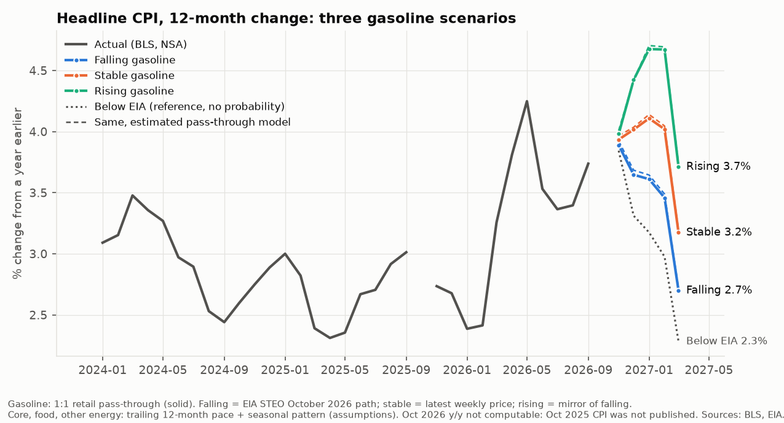

3. What the market has priced in
The forward rate is the market's price for the 1.5-year yield on May 6, 2027. Buying the note and financing it at the bill rate locks in 4.61%, so the note beats the bill exactly when the realized yield ends below that level: the breakeven and the forward are the same number. A cross-check from the whole par curve gives 4.61%.
Today's 2-year yield is 4.51%. If the curve did not move, the note would roll down to a 4.42% yield and beat the bill by 0.27%. The market instead prices the yield 19 bp higher: some expected tightening plus a term premium. The effective fed funds rate is 3.88%. The Federal Reserve Board's Kim-Wright model puts the 1-year and 2-year term premiums at 0.30% and 0.44% (October 30, 2026), so part of the forward is pay for bearing risk rather than an expected rate rise.
Scenario yields are assumptions: the forward plus or minus steps of 45 bp, half the interquartile range of 437 monthly forward errors since 1990. The two views differ only in which gasoline path the forward already contains: "market prices flat gasoline" puts today's price at the forward; "market prices EIA's forecast" puts EIA's path there.
Gasoline scenario | Gas, Mar | Headline y/y | Yield: flat priced | Edge | Yield: EIA priced | Edge
Below EIA (reference) | $3.22 | 2.3% | 3.71% | +1.27% | 4.16% | +0.63%
Falling (EIA) | $3.66 | 2.7% | 4.16% | +0.63% | 4.61% | +0.00%
Stable | $4.15 | 3.2% | 4.61% | +0.00% | 5.05% | -0.63%
Rising | $4.72 | 3.7% | 5.05% | -0.63% | 5.50% | -1.25%
Probability-weighted |  |  |  | +0.00% |  | -0.63%
Edge = note return minus bill return over the holding period, not annualized. Yields are 1.5-year yields at the horizon (assumptions). Below EIA has no probability.
History offers a small edge that has nothing to do with gasoline. The realized yield has tended to end below the forward (median error -19 bp, mean -28 bp), which would be worth +0.27% to +0.40% over the bill for this hold. That comes from term premium and past easing cycles, and it reversed sharply in tightening years.

4. Evidence: pass-through and the walk-forward test
Module A regresses the monthly change in the CPI gasoline index (not seasonally adjusted) on the change in EIA's weekly retail price averaged by month, with two lags and calendar-month dummies, 1990-12 to 2026-09 (430 months). The same-month coefficient is 0.937 (standard error 0.011); the lags add 0.071 and -0.021, for total pass-through of 0.988 (not distinguishable from 1, p = 0.27). R² is 0.984 and the typical monthly miss is 0.74 pp.
The fit has known flaws. Misses reverse the next month (Durbin-Watson 2.65; Ljung-Box p = 0.000), probably because BLS and EIA price on different days. Miss size varies over time (Breusch-Pagan p = 0.034), so standard errors are robust to both. Big misses are more common than a normal curve predicts (kurtosis 5.6). The same-month coefficient drifts: 0.89, 0.98 and 0.94 across 1990-2007, 2008-2019 and 2020-2026.
Module B re-estimates the model on each of 308 CPI release dates from 2001-01 to 2026-09, using only data published by that morning (release dates checked against ALFRED vintages; a test scrambles all later data and confirms the forecasts do not change).
Months ahead | Model RMSE, pp | No change (ratio) | Seasonal no change (ratio) | Retail 1:1 rule (ratio)
1 | 1.69 | 6.45 (0.26*) | 5.97 (0.28*) | 1.45 (1.16*)
2 | 7.02 | 10.90 (0.64*) | 9.84 (0.71*) | 6.95 (1.01*)
3 | 11.48 | 13.95 (0.82*) | 12.31 (0.93) | 11.29 (1.02*)
6 | 18.23 | 18.98 (0.96*) | 16.81 (1.08*) | 17.90 (1.02*)
RMSE of the cumulative change in CPI gasoline. Ratio = model RMSE / benchmark RMSE; below 1 = model better. * = Diebold-Mariano p < 0.05.
The model cuts the 1-month error by 74% against a no-change forecast, but only because it uses weekly prices already observed for the month in progress. By six months the gain is gone (ratio 0.96), and the seasonal benchmark wins from four months out. A simple rule, CPI gasoline moving one-for-one with retail prices, beat the estimated model at every horizon, so the scenarios use that rule and keep the estimated model as a sensitivity (headline paths differ by at most 0.04 pp). The largest 3-month misses came at oil turning points: Dec 2008 (-61 pp); Nov 2008 (-52 pp); Apr 2026 (+33 pp). Nothing here forecasts gasoline itself; the scenarios carry that risk.
Live check: with weekly prices through November 2, 2026, the 1:1 rule puts October 2026 CPI gasoline at -1.0% for the month (estimated model -0.4%).

5. Scenario returns and expected return vs the bill
The note's return falls about 0.35% for each 25 bp rise in the horizon yield (modified duration 1.87, convexity 4.47). It is priced at 100.214 clean (assumption: yield = Treasury's 2-year par yield, 4.51%).
Yield change vs unchanged curve | 1.5-year yield | Note return | Bill return | Edge | Edge, annualized
-100 bp | 3.42% | 3.78% | 2.08% | +1.70% | +3.49%
-50 bp | 3.92% | 3.06% | 2.08% | +0.98% | +2.01%
+0 bp | 4.42% | 2.35% | 2.08% | +0.27% | +0.55%
+50 bp | 4.92% | 1.64% | 2.08% | -0.44% | -0.90%
+100 bp | 5.42% | 0.94% | 2.08% | -1.14% | -2.34%

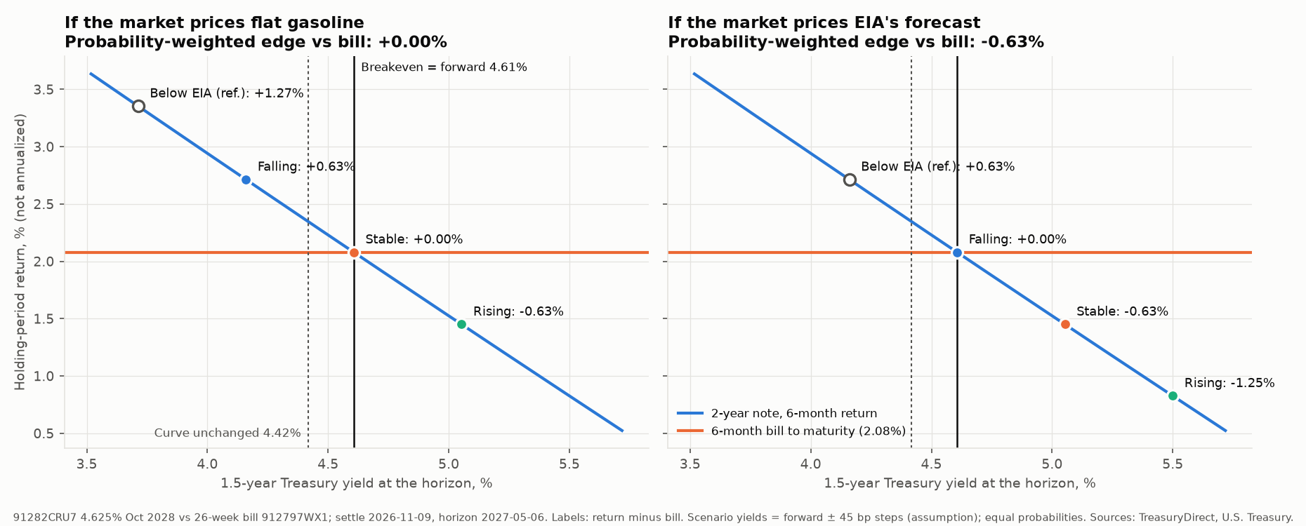
With equal scenario probabilities, the expected edge is +0.00% if the market prices flat gasoline and -0.63% if it prices EIA's forecast. The trade needs gasoline below EIA's path ($3.22 by March 2027) or a cheaper entry point.

6. Risks and what would invalidate the call
Trigger | Supports buying the note if | Argues against if | Latest
Retail gasoline, Nov 2026 monthly average | <= $3.90 (5% below EIA's $4.11) | > $4.15 (today's price) | $4.15 month-to-date (1 wk)
Retail gasoline, Dec 2026 monthly average | <= $3.59 (5% below EIA's $3.77) | > $4.15 (today's price)
Retail gasoline, Mar 2027 monthly average | <= $3.47 (5% below EIA's $3.66) | > $4.15 (today's price)
CPI gasoline (NSA) for Oct 2026 | within the band: pass-through assumption holds | outside -1.0% +/- 2.9 pp (2x the 1-month RMSE of the 1:1 rule) | 1:1 nowcast -1.0% m/m
Core CPI, 3-month annualized (SA) | < 2.6% | > 3.6% (assumption 2.6% + 1.0 pp) | 3.4% (to Sep 2026)
Brent spot, Nov 2026 average | < $104 (EIA path) | > $114 (EIA + $10) | $107.21 month-to-date
2-year Treasury yield (entry test) | >= 4.89% with gasoline outlook unchanged | falls toward 4.42% without gasoline falling below EIA | 4.51% (2026-11-06)

- Core momentum: core inflation is running at 3.4% annualized over the last three months, against the 2.6% assumption; above 3.6% the stable and rising cases become more likely regardless of gasoline.
- Oil supply: EIA's falling path depends on its oil outlook; if Brent runs $10 or more above EIA's path, the rising case is in play.
- Policy reacts to core, not gasoline: a gasoline-only decline may not move the forward if core stays firm.
- Data quality: the missing October 2025 CPI and low late-2025 base distort year-over-year comparisons.
- Assumption risk: the scenario-to-yield mapping, step size and probabilities are judgment calls, and no futures data were available to anchor the gasoline path.

7. Monitoring plan
Date | Release | What it tests
Tue Nov 10, 2026 | CPI for October 2026 (BLS, 8:30 ET) | Tests the 1:1 gasoline nowcast, core assumption and the headline path
Tue Nov 10, 2026 | EIA Short-Term Energy Outlook | Moves the falling (EIA) gasoline path and the below-EIA trigger
Wed Dec 9, 2026 | FOMC decision (December 8-9), with projections | Policy decision; resets the front end of the curve and the forward
Thu Dec 10, 2026 | CPI for November 2026 (BLS, 8:30 ET) | Tests the 1:1 gasoline nowcast, core assumption and the headline path
Wed Jan 27, 2027 | FOMC decision (January 26-27) | Policy decision; resets the front end of the curve and the forward
Wed Mar 17, 2027 | FOMC decision (March 16-17), with projections | Policy decision; resets the front end of the curve and the forward
Wed Apr 28, 2027 | FOMC decision (April 27-28) | Policy decision; resets the front end of the curve and the forward
Recurring | EIA weekly retail gasoline (every Monday) | Tracks the gasoline path against the EIA, stable and below-EIA levels
Recurring | Treasury daily par yield curve and bill rates (each business day) | Moves the forward, breakeven and the entry-level test

Each release is picked up by rerunning the pipeline (python run_all.py). It rewrites this memo, the deck and outputs/changes_since_last_run.md, which lists new data and any change in the recommendation.

8. Appendix

Data sources
Source | Series / contents | Last obs. | Retrieved
CPI indexes (BLS via FRED) | CPIAUCNS, CPIAUCSL, CPILFENS, CPILFESL, CPIUFDNS, CPIENGNS, CUUR0000SETB01, CUSR0000SETB01 | 2026-09-01 | 2026-11-08
Retail gasoline (EIA via FRED; BLS average price) | GASREGW, APU000074714 | 2026-11-02 | 2026-11-08
Brent spot (EIA via FRED) | DCOILBRENTEU | 2026-11-03 | 2026-11-08
Treasury yields, bills, SOFR, fed funds (Fed H.15 / NY Fed via FRED) | DGS2, DGS1, DGS6MO, DTB6, SOFR, DFF | 2026-11-05 | 2026-11-08
Breakevens and Kim-Wright term premiums (FRED) | T5YIE, THREEFYTP1, THREEFYTP2 | 2026-11-06 | 2026-11-08
U.S. Treasury par yield curve | Daily par yields (home.treasury.gov) |  | 2026-11-08
U.S. Treasury daily bill rates | 26-week bank discount and coupon-equivalent rates |  | 2026-11-08
TreasuryDirect auction results | Note and bill terms (CUSIP, coupon, maturity) |  | 2026-11-08
EIA STEO | Short-Term Energy Outlook, October 2026 (table 2) |  | 2026-11-08
ALFRED CPI release dates (release id 10) | CPI release dates for the real-time test |  | 2026-11-08
Federal Reserve FOMC calendar | Meeting dates |  | 2026-11-08
BLS API v1; ALFRED vintages | NSA CPI cross-check and revision checks
BLS relative importance | BLS, Relative importance of components in the CPI, U.S. city average, December 2025, Table 1 (2024 weights) | Dec 2025 | 2026-11-08

Assumptions
Assumption | Value | Basis
Core / food / other energy pace | 2.56% / 2.48% / 7.84% a year | Trailing 12-month change; ±0.5 pp core sensitivity: 3.0-3.4% (stable)
Gasoline to CPI | 1:1 retail pass-through | Estimated Module A model as sensitivity
Gasoline scenarios | EIA October 2026 path; today's price; mirror of EIA | Below-EIA path is a reference with no probability
Note yield | 4.51% (Treasury 2-year par yield) | No quoted price available (FedInvest blocked)
Rate scenarios | Forward ± steps of 45 bp | Half the IQR of historical forward errors
Probabilities | falling 0.33 / stable 0.33 / rising 0.33 | Placeholder in config.yaml
Minimum edge to buy | 0.10% over the hold | Judged under the EIA-priced view

Method limits
- Only one inflation channel is modeled (retail gasoline to CPI gasoline); core, food and other energy are assumptions.
- No federal funds rate forecast: rate paths are scenario assumptions anchored to Treasury forwards. SOFR and fed funds futures, and gasoline or Brent futures, were not available from free sources.
- The note's price is derived from Treasury's par curve, not a dealer quote; bid-ask costs are ignored.
- Relative-importance weights are rolled forward from December 2025; update them when BLS publishes the December 2026 table (www.bls.gov blocks scripted downloads, so this is a manual step).
- Walk-forward results cover gasoline CPI only; the headline path has no out-of-sample test.

