**LOGIN**

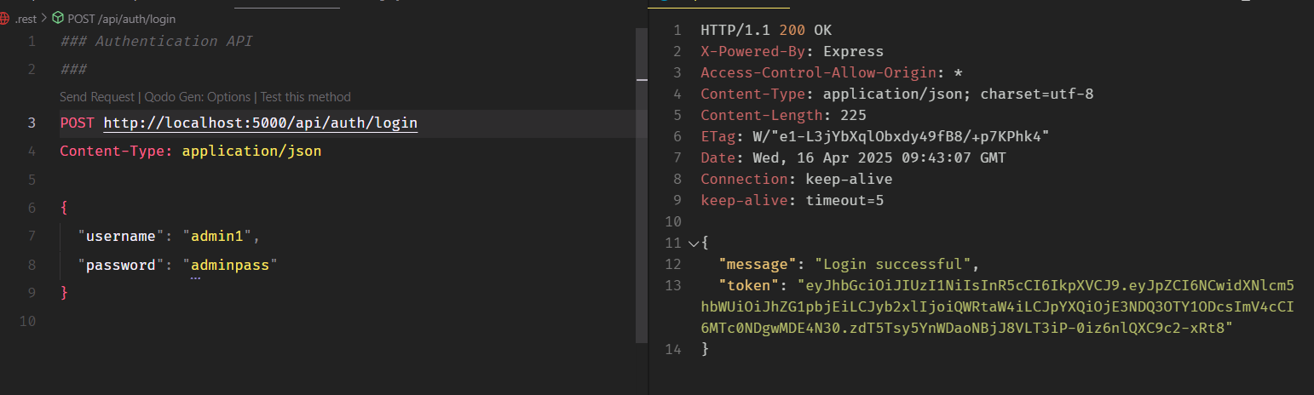

**USER**

GET USER BY ID

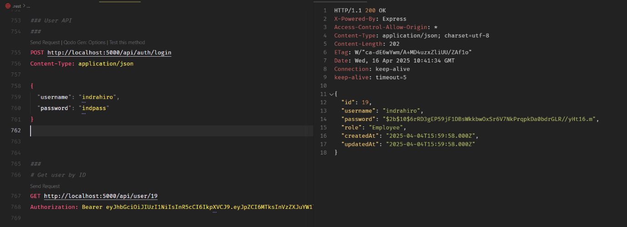

**EMPLOYEE**

ADD

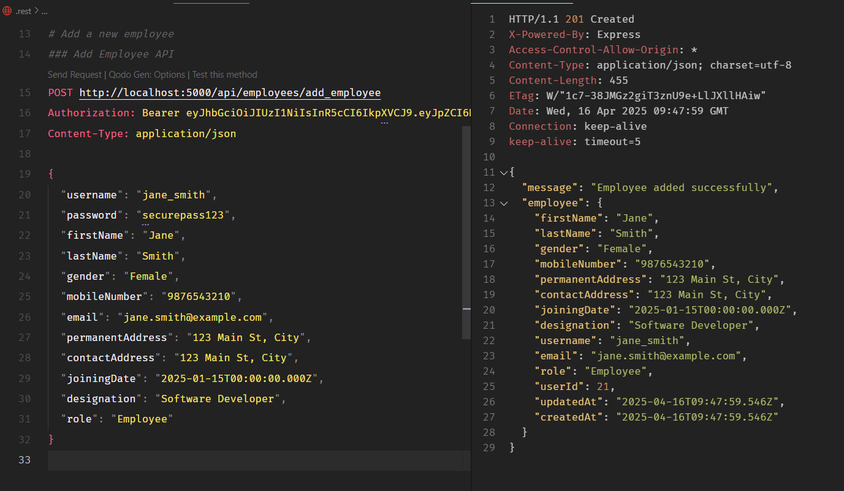

GET ALL EMPLOYEE

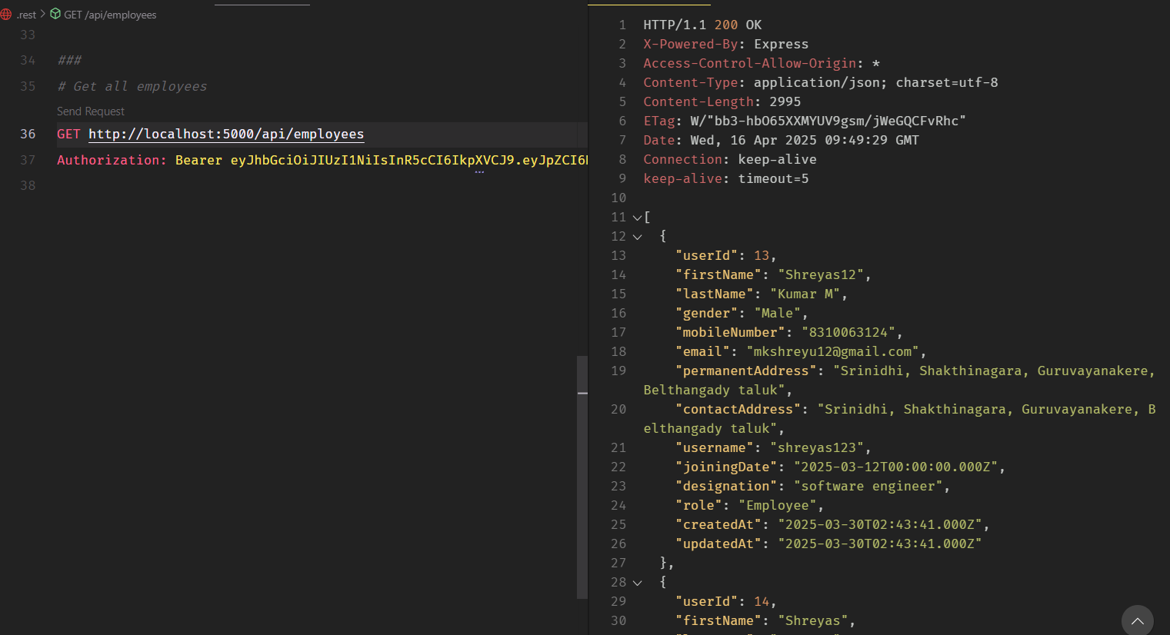

**CLIENTS**

GET ALL CLIENTS

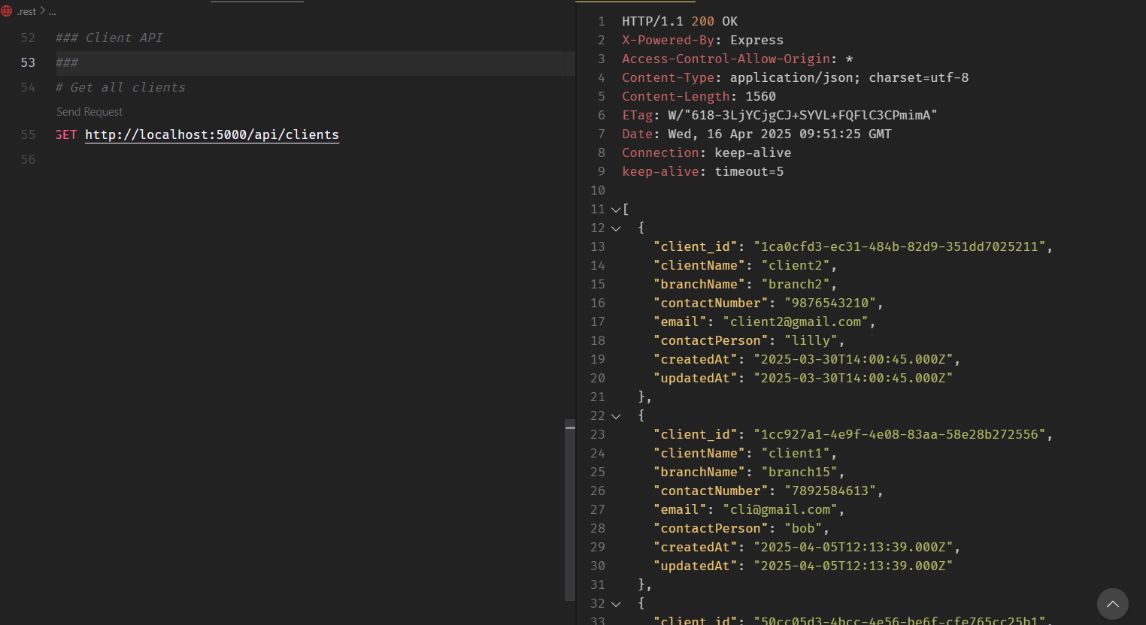

ADD CLIENT

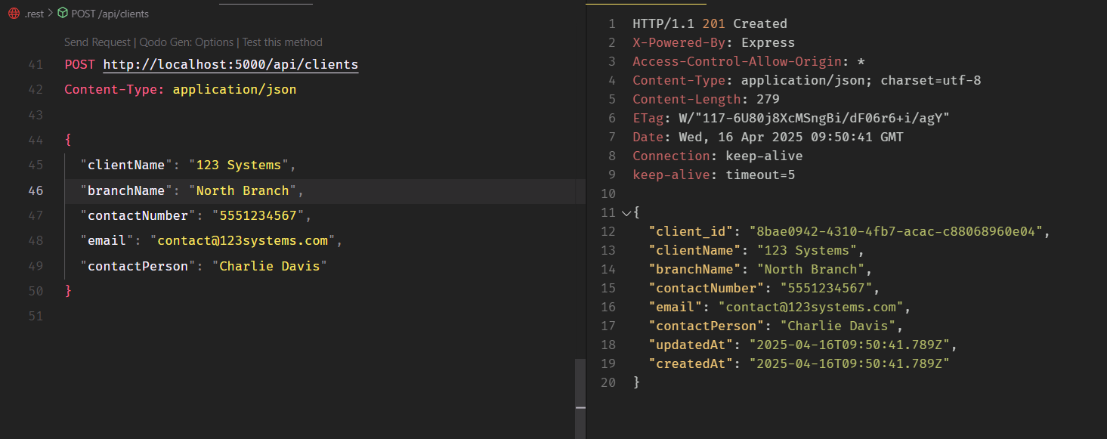

GET CLIENT BY ID

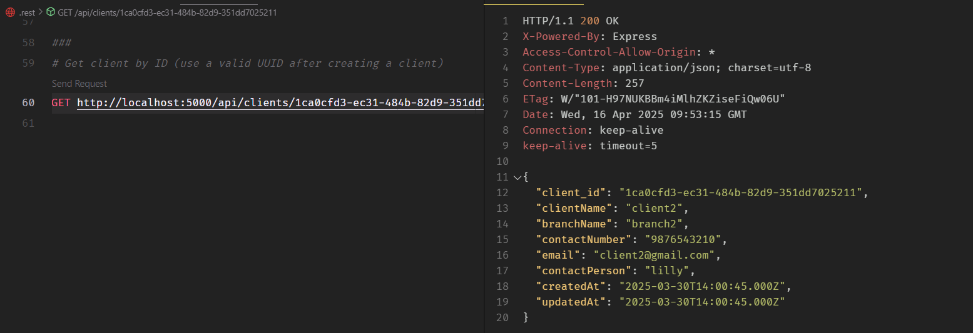

UPDATE CLIENT

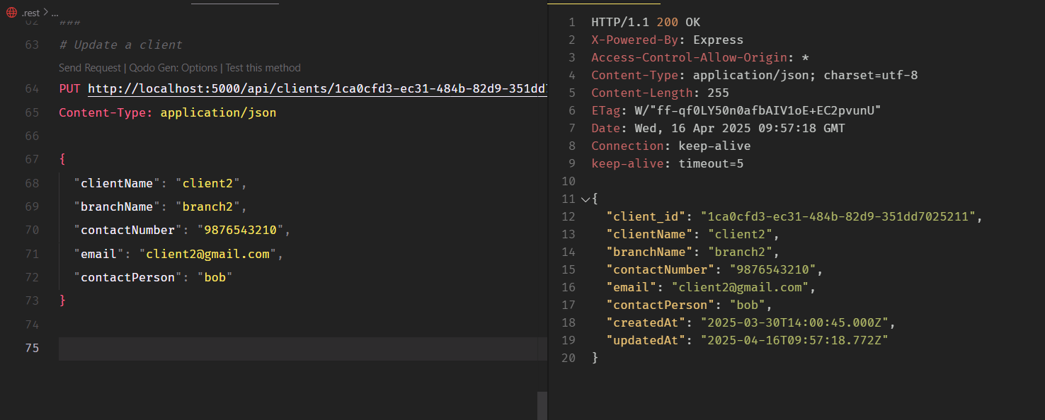

DELETE CLIENT

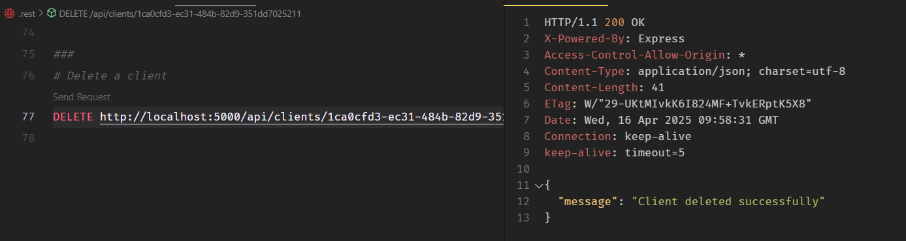

**PROJECT**

GET ALL PROJECTS

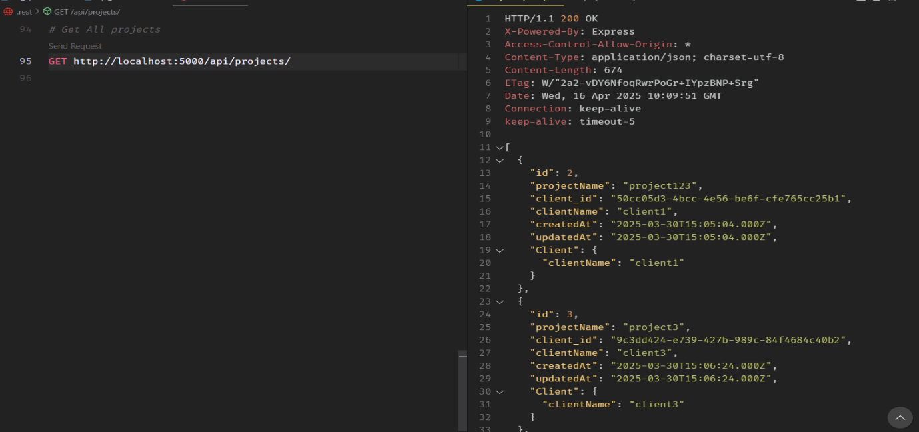

ADD PROJECT

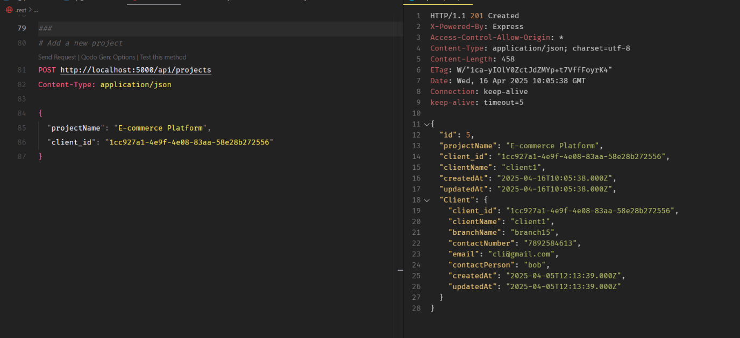

GET PROJECT BY CLIENT ID

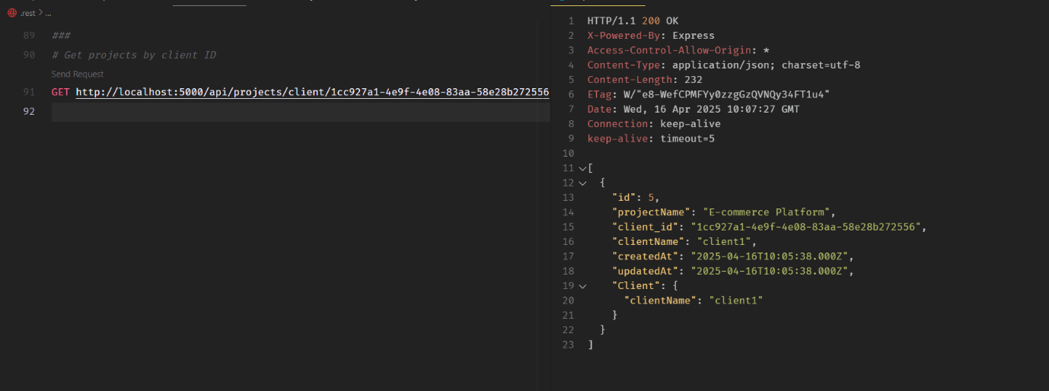

**MODULE**

GET ALL MODULES

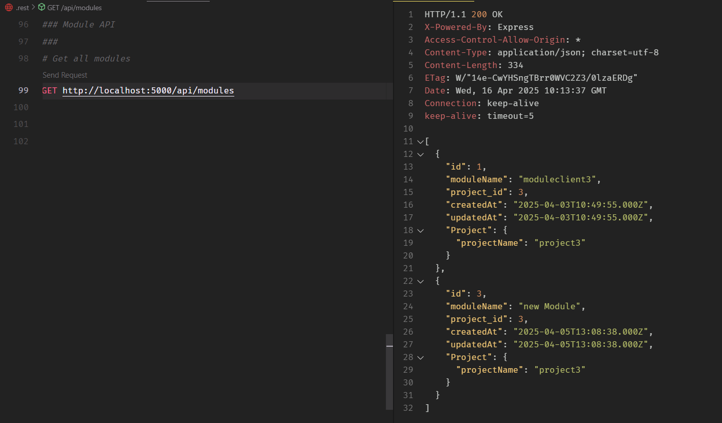

ADD A NEW MODULE

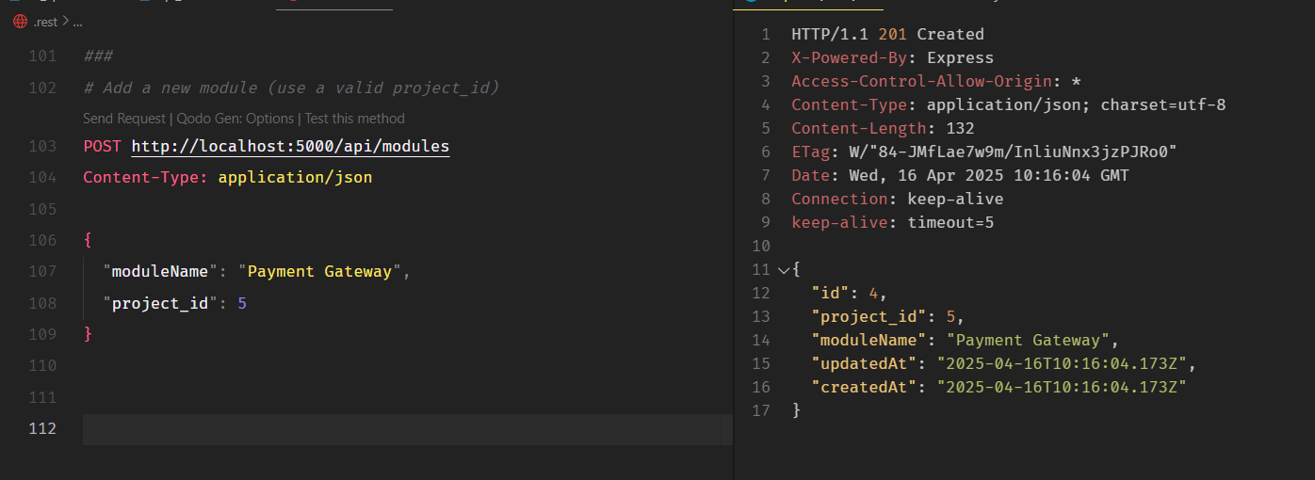

GET MODULE BY PROJECT ID

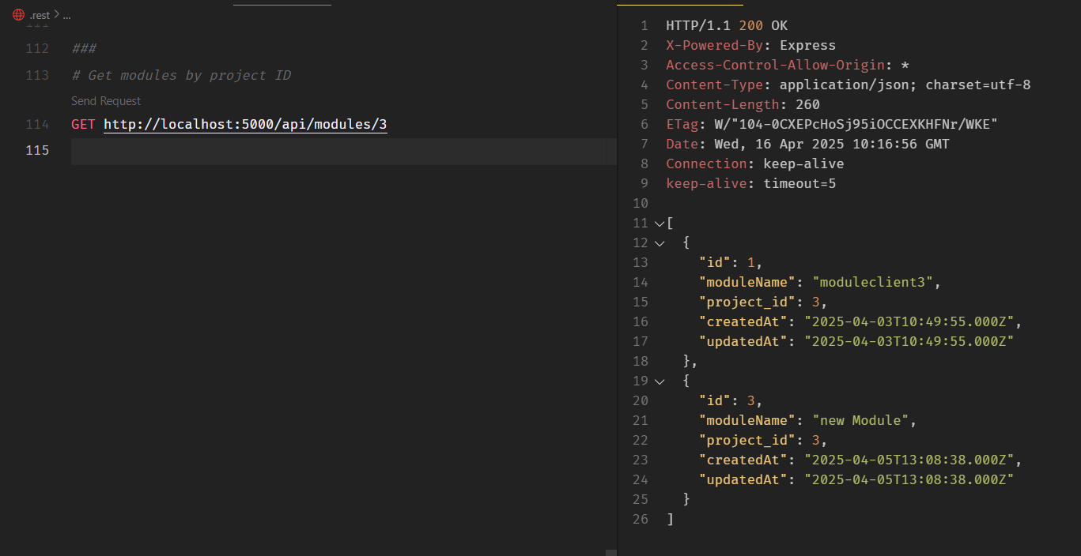

**WORKASSIGN**

ASSIGN WORK TO AN EMPLOYEE

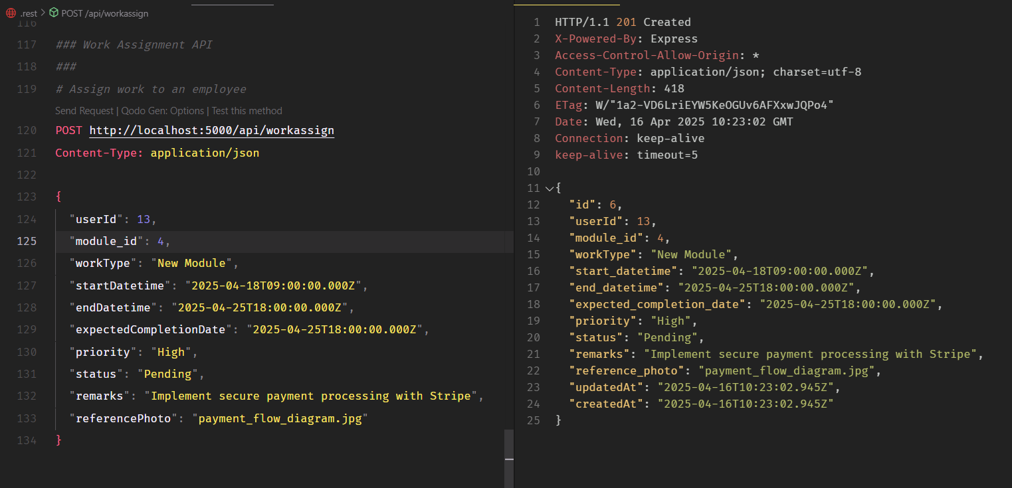

GET ALL ASSIGNMENTS

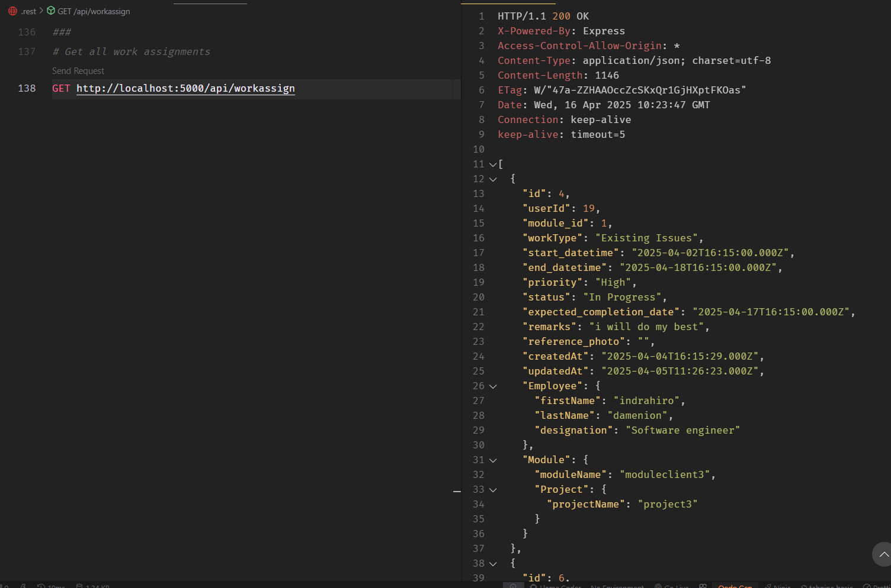

UPDATE ASSIGNMENTS

