Birla Institute of Technology

Topic
Spatiotemporal assessment of carbon-dioxide and its relationship with land use/land cover over the south – Eastern region of karnataka

SUBMITTED BY
SHREYAS R C
MGI/10004/21
UNDER THE SUPERVISION OF
Dr. N. PATEL

DEPARTMENT OF REMOTE SENSING
BIRLA INSTITUTE OF TECHNOLOGY MESRA, RANCHI
Contents:
- Introduction
- Carbon dioxide and topics
- Why Carbon dioxide is important.
- Past and further of Carbon dioxide
- Research Objective
- Research Questions
- Research Gaps
- Software Used
- Hardware used.
- Data
- Study Area
- Methodology
- Discussion
- Time Frame
- Results
- References

Introduction:
…….

…..
Research Objectives:
The objective of the study is to:
- To assess the spatiotemporal dynamics of CO₂ over the south-eastern Karnataka region and to determine the impact of Land cover classes on CO₂ concentration in time and space, over the study area.
- To learn the change in spatiotemporal dynamics of CO₂ over the period 2014 – present, in the study area.
- To determine the regions of carbon sources and sinks.
Research Questions:
The study will answer the following research questions:
- What are the pattern and magnitude of CO₂ dynamics over the southern Karnataka region during the study period?
- How does the change in Land cover class affect the CO₂ over the study area.
- What is the correlation between the CO₂ values and different LU/LC classes?
Research Gaps:
- A very few studies have been conducted on the spatio-temporal distribution of CO₂ in India in relation to the LULC.
- Application of the various geostatistical tools in predicting the concentration of CO₂

Data:
LU/LC data:
The real world is as dynamic as the people and natural processes that shape it. Dynamic World is a near real time 10m resolution global land use land cover dataset, produced using deep learning, freely available and openly licensed. It is the result of a partnership between Google and the World Resources Institute, to produce a dynamic dataset of the physical material on the surface of the Earth.
Key innovations of Dynamic World
- Near real time data. Over 5000 Dynamic World image are produced every day, whereas traditional approaches to building land cover data can take months or years to produce. As a result of leveraging a novel deep learning approach, based on Sentinel-2 Top of Atmosphere, Dynamic World offers global land cover updating every 2-5 days depending on location.
- Per-pixel probabilities across 9 land cover classes. A major benefit of an AI-powered approach is the model looks at an incoming Sentinel-2 satellite image and, for every pixel in the image, estimates the degree of tree cover, how built up a particular area is, or snow coverage if there’s been a recent snowstorm, for example.
- Ten-meter resolution. As a result of the European Commission’s Copernicus Program making European Space Agency Sentinel data freely and openly available, products like Dynamic World are able to offer 10m resolution land cover data. This is important because quantifying data in higher resolution produces more accurate results for what’s really on the surface of the Earth.
Dynamic World is produced using the Google Earth Engine and AI Platform. We developed the Dynamic World dataset in alignment with Google's AI Principles. [2]

Carbon-dioxide data:
NASA missions of OCO-2, an independent satellite measurement instrument, and OCO-3 on board the ISS, measures the Column-averaged CO₂ over the entire globe.
Orbiting Carbon Observatory (OCO)-2 will be NASA’s first dedicated Earth remote sensing satellite to study atmospheric carbon dioxide from Space. OCO-2 will be collecting space-based global measurements of atmospheric CO₂ with the precision, resolution, and coverage needed to characterize sources and sinks on regional scales. OCO-2 will also be able to quantify CO₂ variability over the seasonal cycles year after year.
OCO-2 employs a dedicated spacecraft with a single instrument. It was launched on July 2, 2014, into a near-polar orbit on an expendable launch vehicle. OCO-2 joined the A-Train formation of satellites on August 3, 2014. The OCO-2 instrument incorporates three high-resolution spectrometers that make coincident measurements of reflected sunlight in the near-infrared CO2 near 1.61 and 2.06 μm, and in molecular oxygen (O2) A-Band at 0.76 μm.
Concerning the spectral domain, high spectral resolving power (λ/δλ > 20,000) is needed to resolve the CO2 and O2 lines from the adjacent continuum to maximize the sensitivity to small (< 0.3%) variations in total column CO2.
In the spatial domain, the OCO-2 instrument have a narrow swath - it collects 8 soundings over its 0.8-degree wide swath every 0.333 seconds, yielding surface footprints with along-track dimensions < 2.25 km and cross-track dimensions that vary from 0.1 to 1.3 km at nadir.
Temporal resolution being 16 days.[3]
OCO - 3 Instrument is similar to the OCO – 2 mission, because it is made from the components of the OCO -2 mission and the instrument is mounted on the International Space Station.[4]

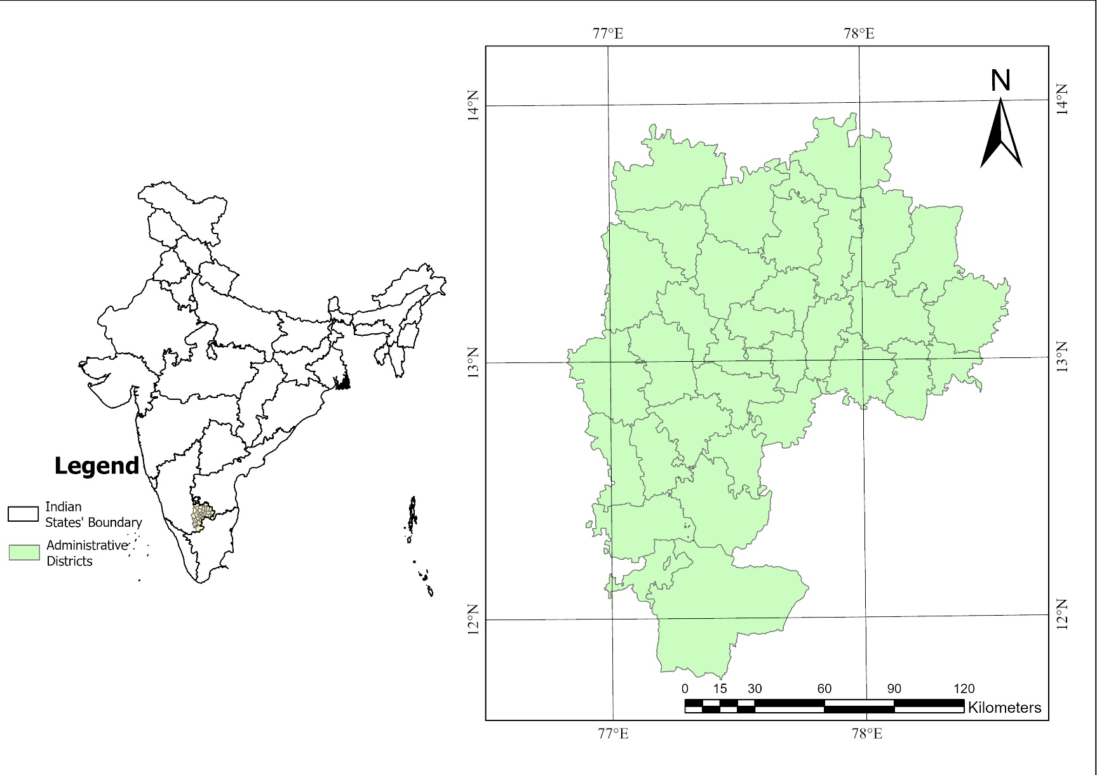
Study Area:
***Like advised I’ve taken a smaller study area, compared to previous study area, where I had taken the entire southern Karnataka, but now I’m considering only the districts of Bengaluru urban, rural and nearby districts, that may have an immediate effect on Bengaluru.***

Month | Value (in PPM) | 2015 | 2016 | 2017 | 2018 | 2019 | 2020 | 2021 | 2022
January | Maximum -  Minimum -  Average- | 399.511 | 404.195 | 406.433 | 411.705 | 411.255 | 412.94 | 416.302 | 415.729
January | Maximum -  Minimum -  Average- | 391.523 | 391.032 | 399.102 | 394.732 | 404.987 | 408.415 | 396.758 | 408.258
January | Maximum -  Minimum -  Average- | 397.495 | 400.154 | 403.194 | 405.490 | 408.259 | 411.240 | 411.484 | 413.054
February | Maximum -  Minimum -  Average-
March | Maximum -  Minimum -  Average-
April | Maximum -  Minimum -  Average-
May | Maximum -  Minimum -  Average-
June | Maximum -  Minimum -  Average-
September | Maximum -  Minimum -  Average-

Month | Value (in PPM) | 2015 | 2016 | 2017 | 2018 | 2019 | 2020 | 2021 | 2022
October | Maximum -  Minimum -  Average-
November | Maximum -  Minimum -  Average-
December | Maximum -  Minimum -  Average-

***The table above will be filled, there was a problem with sorting the values, the query for select by attribute did work, but while saving the values it’s showing values of January itself. I’ll do this task as well.***

***Also, I wanted to ask if I can fill the table with values of Interpolated values (such as Kriging), because for the recent years, for the given study area, starting 2018, there is no values from July, it’s null completely. (But there are lot of values around the study area, which can be used for interpolation) I’ll verify the values against the values of OCO-3 sensor, which are also not much, but can act as a enough test sample.***

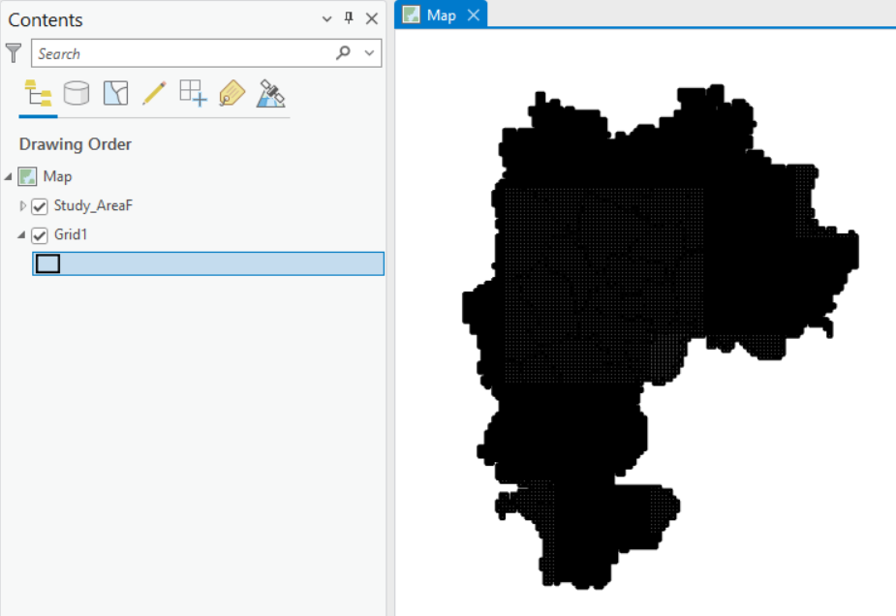
*** Also, I’m trying the GRID level analysis, GRID size is the average of swath of OCO-2 sensor, which has a swath between 1.29-2.25km – so that gives the GRID size as 1.77km.***

The findings for the GRID level analysis for one single year is as follows for the year 2021:
Month | Value (in PPM) | Water Body | Trees | Grass, Crops and Shrubs/Scrubs | Built - up
February  March | Maximum - | 417.1 | 408.1 | 432.3 | 420.2
February  March | Minimum - | 407.7 | 421.0 | 402.4 | 411.1
February  March | Average- | 415.0 | 415.2 | 415.1 | 414.9
 | Maximum -
 | Minimum -
 | Average-
 | Maximum -
 | Minimum -
 | Average-
 | Maximum -
 | Minimum -
 | Average-

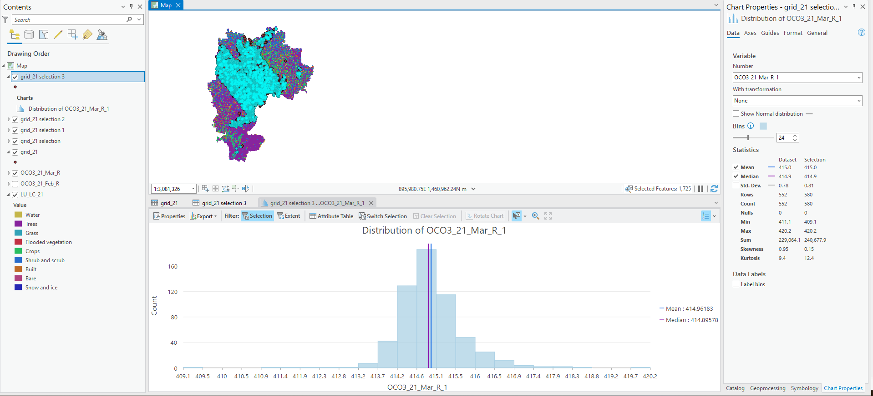
*** Similarly I’ll show for the rest of the months, for other years as well, in order to find a trend or relation between the various LU/LC classes with the CO2 value. Will try to find the level of significance for each classes for various years.***

***Example of analysis for each LU/LC category for each month, using grid size of 1770 meters, for the year 2021.***
*** With respect to LU/LC, I’ve downloaded the LU/LC rasters starting 2014, with an interval of 6 months, till 2022.***

