**5.6** Import python script in shell script.

**Objectives:**

To learn shell programming and use it for write effective programs.

**Theory:**

The shell provides you with an interface to the UNIX system. It gathers input from you and executes programs based on that input. When a program finishes executing, it displays that program's output.

A shell is an environment in which we can run our commands, programs, and shell scripts. There are different flavors of shells, just as there are different flavors of operating systems. Each flavor of shell has its own set of recognized commands and functions.

**Flowchart:**

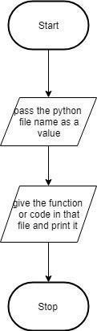

**Data Variables:**

|  |  |  |  |
| --- | --- | --- | --- |
| no | Variable | Type | use |
|  |  |  |  |
| 1 | value | any | import python |
|  |  |  |  |

**Program:**

5f.sh

echo "This is shell script"

value=$(python p1.py)

echo $value

p1.py

def function():

return "This is python script"

if __name__ == "__main__":

print(function())

**Output:**

it@it-OptiPlex-3sk046:~/Uos$ ./5f.sh

This is shell script

This is python script

it@it-OptiPlex-3sk046:~/Uos$

**Conclusion:**

Python script is imported using shell script

**References:**

http://www.tutorialspoint.com/unix/unix-shell.htm/