**5. Shell Programming**

**5.5** Shell script to determine whether given file exists or not.

**Objectives:**

To learn shell programming and use it for write effective programs.

**Theory:**

The shell provides you with an interface to the UNIX system. It gathers input from you and executes programs based on that input. When a program finishes executing, it displays that program's output.

A shell is an environment in which we can run our commands, programs, and shell scripts. There are different flavors of shells, just as there are different flavors of operating systems. Each flavor of shell has its own set of recognized commands and functions.

**Flowchart:**

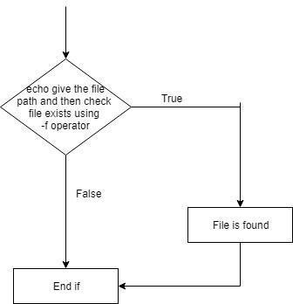

**Data Variables:**

|  |  |  |  |
| --- | --- | --- | --- |
| **No** | **Variable** | **Type** | **Use** |
|  |  |  |  |
| 1 | file | file | Pathname |
|  |  |  |  |

**Program:**

echo "Enter file path to check it is available or not"

read file

if [ -f "$file" ]

then

echo "$file found."

else

echo "$file not found."

**Output:**

it@it-OptiPlex-3sk046:~/Uos$ ./5e.sh

Enter file path to check it is available or not

/home/it/Uos/5atheory

3/home/it/Uos/5atheory found.

it@it-OptiPlex-3sk046:~/Uos$ ./5e.sh

Enter file path to check it is available or not

/home/it/5atheory

/home/it/5atheory not found.

**Conclusion**:

File path verified using shell programming

**References:**

[1] http://www.tutorialspoint.com/unix/unix-shell.htm/