**3.1** Write the program to show file statistics using the stat system call.

Take the filename / directory name from user including path.

**Objectives:**

1. To learn about File system Internals.

**Theory:**

Name:

stat, fstat, lstat - get file status

Syntax:

#include <[sys/types.h](https://linux.die.net/include/sys/types.h)>

#include <[sys/stat.h](https://linux.die.net/include/sys/stat.h)>

#include <[unistd.h](https://linux.die.net/include/unistd.h)>

int stat(const char \**path*, struct stat \**buf*);

int fstat(int *fd*, struct stat \**buf*);

int lstat(const char \**path*, struct stat \**buf*);

Description:

These functions return information about a file. No permissions are required on the file itself, but-in the case of stat() and lstat() - execute (search) permission is required on all of the directories in *path* that lead to the file.

stat() stats the file pointed to by *path* and fills in *buf*.

lstat() is identical to stat(), except that if *path* is a symbolic link, then the link itself is stat-ed, not the file that it refers to.

fstat() is identical to stat(), except that the file to be stat-ed is specified by the file descriptor *fd*.

All of these system calls return a *stat* structure, which contains the following fields:

struct stat {

|  |  |  |  |
| --- | --- | --- | --- |
| dev_t | st_dev; | /* ID of device containing file */ | |
| ino_t | st_ino; | /* inode number */ | |
| mode_t | st_mode; | | /* protection */ |
| nlink_t | st_nlink; |  | /* number of hard links */ |
| uid_t | st_uid; | /* user ID of owner */ | |
| gid_t | st_gid; | /* group ID of owner */ | |
| dev_t | st_rdev; | /* device ID (if special file) */ | |
| off_t | st_size; /* total size, in bytes */ | | |
| blksize_t st_blksize; /* blocksize for file system I/O */ | | | |
| blkcnt_t st_blocks; | | | /* number of 512B blocks allocated */ |
| time_t | st_atime; |  | /* time of last access */ |
| time_t | st_mtime; | | /* time of last modification */ |
| time_t | st_ctime; |  | /* time of last status change */ |

};

**Data Dictionary:**

|  |  |  |  |
| --- | --- | --- | --- |
| Sr Number | Variable/Function | Datatype | Use |
|  |  |  |  |
| 1 | fileStat | struct stat | Store information about files. |
|  |  |  |  |

**Flowchart:**

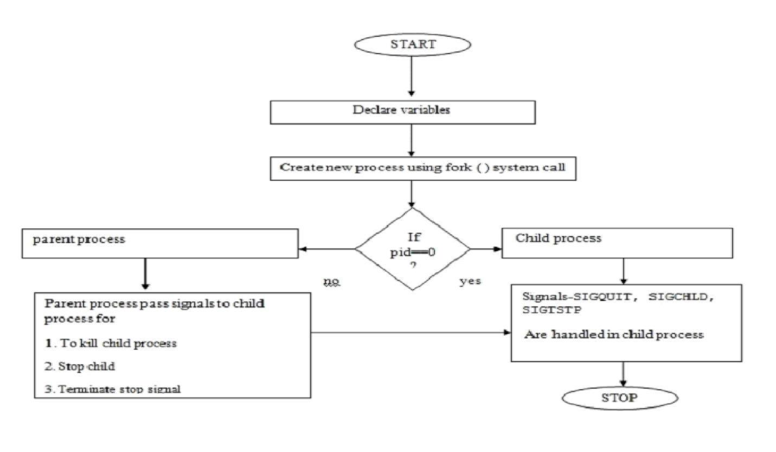

**Program:**

#include<stdio.h>

#include<unistd.h>

#include<sys/types.h>

#include<sys/stat.h>

int main(int argc, char **argv)

{

struct stat fileStat;

stat("/home/it/Sarita/UOS/Demo.txt",&fileStat)

if(stat("/home/it/Sarita/UOS/Demo.txt",&fileStat) < 0)

{

printf("Failed\n");

return 1;

}

printf("---------------------------\n");

printf("File Size: \t\t%ld bytes\n",(long)fileStat.st_size);

printf("Number of Links: \t%ld\n",(long)fileStat.st_nlink);

printf("File inode: \t\t%ld\n",(long)fileStat.st_ino);

printf("File Permissions: \t");

printf( (S_ISDIR(fileStat.st_mode)) ? "d" : "-");

printf( (fileStat.st_mode & S_IRUSR) ? "r" : "-");

printf( (fileStat.st_mode & S_IWUSR) ? "w" : "-");

printf( (fileStat.st_mode & S_IXUSR) ? "x" : "-");

printf( (fileStat.st_mode & S_IRGRP) ? "r" : "-");

printf( (fileStat.st_mode & S_IWGRP) ? "w" : "-");

printf( (fileStat.st_mode & S_IXGRP) ? "x" : "-");

printf( (fileStat.st_mode & S_IROTH) ? "r" : "-");

printf( (fileStat.st_mode & S_IWOTH) ? "w" : "-"); printf( (fileStat.st_mode & S_IXOTH) ? "x" : "-"); printf("\n\n");

printf("The file %s a symbolic link\n", (S_ISLNK(fileStat.st_mode)) ? "is" : "is not"); return 0;

}

**Output:**

sarita@sarita-HP-Laptop-15g-dr0xxx:~/Sarita/UOS$ ./a.out

---------------------------

File Size: 6299 bytes

Number of Links: 1

File inode: 15736649

File Permissions: -rw-rw-r--

The file is not a symbolic link

**Conclusion:**

Stats of file like file size,links, permissions, inode number and type of link can be retrieved using stat() and stored in a structure.

**References:**

https://www.lix.polytechnique.fr/~liberti/public/computing/prog/c/C/FUNCTIONS/stat.html