2017BTEIT00050

Assingment No 1

Title: Processing Environment fork(),vfork(),wait(),waitpid(),exec(all variations exec)&exit.

Subtitle: Write the program to use fork/vfork system call. Justify the difference by using suitable application of fork/vfork system calls.

Objectives:

- To learn about Processing Environment.

- To know the difference between fork/vfork and various execs variations.

- Use of system call to write effective program

Theory:

fork():

The fork() is a system call use to create a new process. The new process created by the fork() call is the child process, of the process that invoked the fork() system call. The code of child process is identical to the code of its parent process. After the creation of child process, both process i.e. parent and child process start their execution from the next statement after fork() and both the processes get executed simultaneously.

vfork():

The modified version of fork() is vfork(). The vfork() system call is also used to create a new process. Similar to the fork(), here also the new process created is the child process, of the process that invoked vfork(). The child process code is also identical to the parent process code. Here,the child process suspends the execution of parent process till it completes its execution as both the process share the same address space to use.

Comparison Chart:

Basis for | fork() | vfork()
Comparis | fork() | vfork()
on
Basic | Child process and parent process has | Child process and parent process
Basic | separate address spaces. | shares the same address space.
 | Parent and child process | Parent process remains suspended
Execution | Parent and child process | till child process completes its
Execution | execute simultaneously. | till child process completes its
 | execute simultaneously. | execution.
 | If the child process alters any page in | If child process alters any page in
 | If the child process alters any page in | the address space, it is visible to
Modificatio | the address space, it is invisible to the | the address space, it is visible to
Modificatio | the address space, it is invisible to the | the parent process as they share the
n | parent process as the address space are | the parent process as they share the
n | parent process as the address space are | same address space.
 | separate. | same address space.
 | fork() uses copy-on-write as an
Copy-on- | alternative where the parent and child | vfork() does not use copy-on-write.
Copy-on- | shares same pages until any one of them | vfork() does not use copy-on-write.
write | shares same pages until any one of them
write | modifies the shared page.

Flowchart:
int main(int argc,char argv)

int a=5,b=8

int v

v=fork()

V==0
a=10

true

a=a+5

false
b=0

b=b-2

exit(0)
Parent code

waitNull()
line a

printf(“value of v is %d\n”,v);

line b

Printf(“sum is %d\n”,a+b);

exit(0)

Data Dictionary:

Sr | Variable/Function | Datatype | Use
Number
1 | Counter | int | Used to increment number of child and parent
 |  |  | processes.
2 | pid | int | Process ID

Program 1 (fork()):

#include<stdio.h>

#include<unistd.h>

int main()

{

printf("Beginning\n");

int counter = 0;

int pid = fork();

if(pid==0)

{

for(int i=0;i<5;i++)

{

printf("Child process = %d\n",++counter);

}

printf("Child Ended\n");

}

else if(pid>0)

{

for(int i=0;i<5;i++)

{

printf("Parent process = %d\n",++counter);

}

printf("Parent Ended\n");

}

else

{

printf("fork() failed\n");

return 1;

}

return 0;

}
Output:

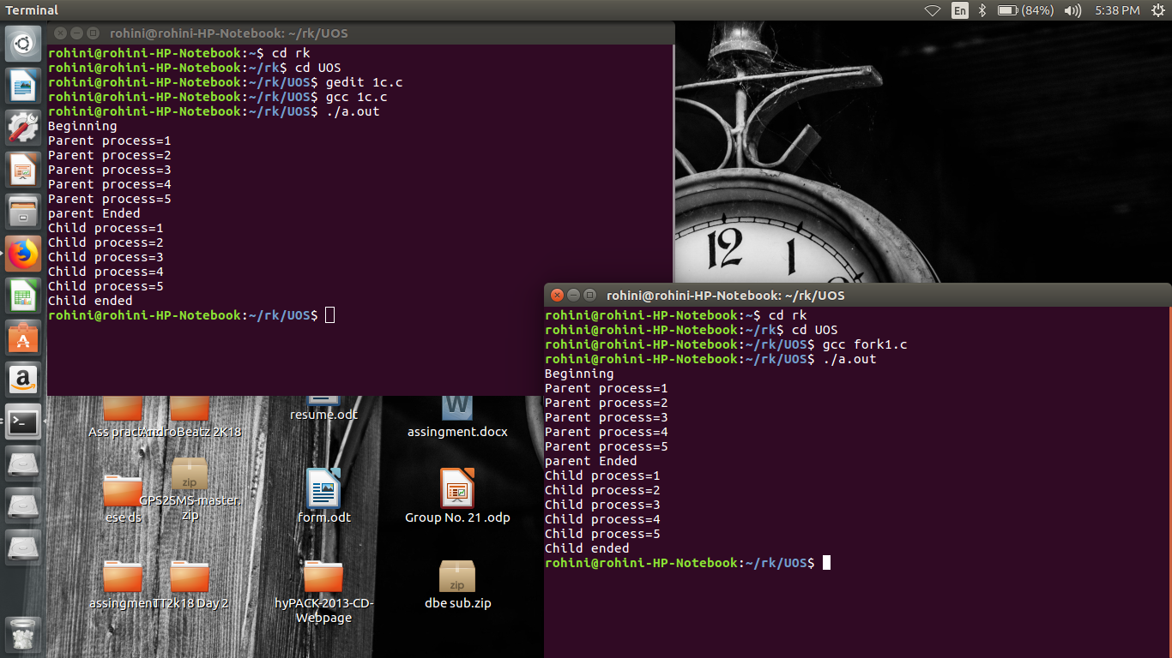

Program 2 vfork()

#include<stdio.h>
#include<stdlib.h>
#include<unistd.h>
void main()
{
pid_t p=vfork();
if(p<0)
{
printf("vfork() failed\n");
}
else if(p==0)
{
printf("In Child Process Started with pid=%d\n",getpid());
for(int i=1;i<=5;i++)
{
printf("In Child :%d\n",i);
}

printf("Child finished\n");
_exit(0);
}
else
{
printf("Parent Process Started with pid=%d\n",getpid());
for(int i=1;i<=5;i++)
{
printf("In Parent :%d\n",i);
}
printf("Parent Finished\n");
}
}

Output:

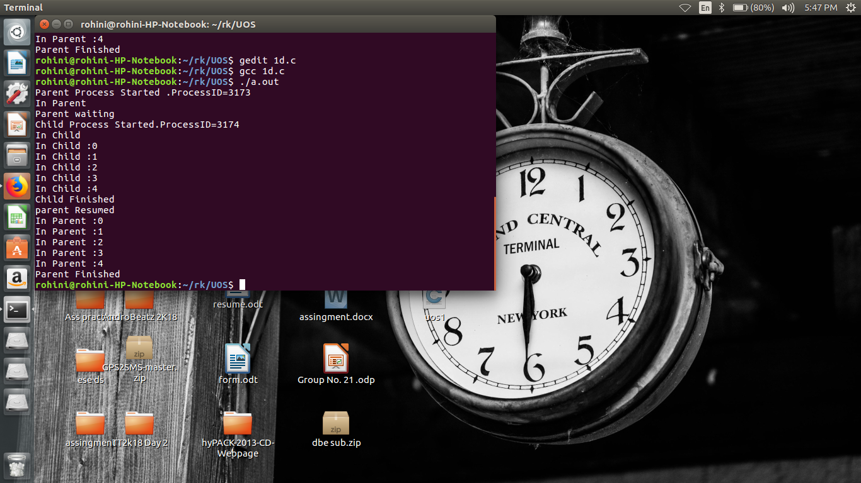

Conclusion:

fork() and vfork() system calls have some differences which allows different type of execution of child processes.

References:

References: www.tutorialspoint.com/unix_system_calls/

