Assingment No. 1d

Title: Processing Environment: fork(),vfork(),wait(),waitpid(),exec(all variations exec) and exit.

Subtitle: Write the program to use wait/waitpid system call and explain what it do when call in parent and called in child().Justify the difference by using suitable application.

Objectives:

- To learn about Processing Environment.

- To know the difference between fork/vfork and various execs variations.

- Use of system call to write effective programs.

Theory:
Name
Wait,waitpid-basic process management.
Synopsis:
pid=fork()
ret=waitpid()
ret=wait()

Declarations:

#include <sys/types.h>

#include <sys/wait.h>

pid_t wait(int *statloc);

/* returns process ID if OK, or -1 on error */

pid_t waitpid(pid_t pid, int *statloc, int options);

/* returns process ID : if OK,

- 0 : if non-blocking option && no zombies around

- -1 : on error

*/

wait() | waitpid()

wait blocks the caller until a child process terminates

if more than one child is running then wait() returns the first time one of the parent's offspring exits

waitpid can be either blocking or non-blocking:

- If options is 0, then it is blocking

- If options is WNOHANG, then is it non-blocking

waitpid is more flexible:

- If pid == -1, it waits for any child process. In this respect, waitpid is equivalent to wait

- If pid > 0, it waits for the child whose process ID equals pid

- If pid == 0, it waits for any child whose process group ID equals that of the calling process

- If pid < -1, it waits for any child whose process group ID equals that absolute value of pid

Flowchart:
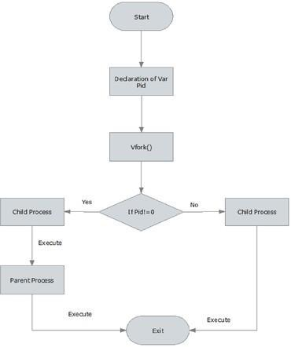

Data Dictionary:

Sr Number | Variable/Function | Datatype | Use
1 | id | pid_t | Process ID
2 | i | int | Iterating for loop.

Program:

#include<stdlib.h>

#include<stdio.h>

#include<unistd.h>

#include<sys/wait.h>

void main()

{

pid_t id=fork();

if(id==0)
{

printf("Child Process Started..ProcessID = %d\n", getpid()); printf("In Child\n");

for(int i=0;i<5;i++)

{

printf("In Child : %d\n",i);

}

printf("Child Finished\n");

exit(0);

}

else

{

printf("Parent Process Started..ProcessID = %d\n", getpid());

printf("In Parent\n");

printf("Parent waiting\n");

wait(NULL);

printf("Parent Resumed\n");

for(int i=0;i<5;i++)

{

printf("In parent : %d\n",i);

}

printf("Parent Finished\n");

}

}

Output:

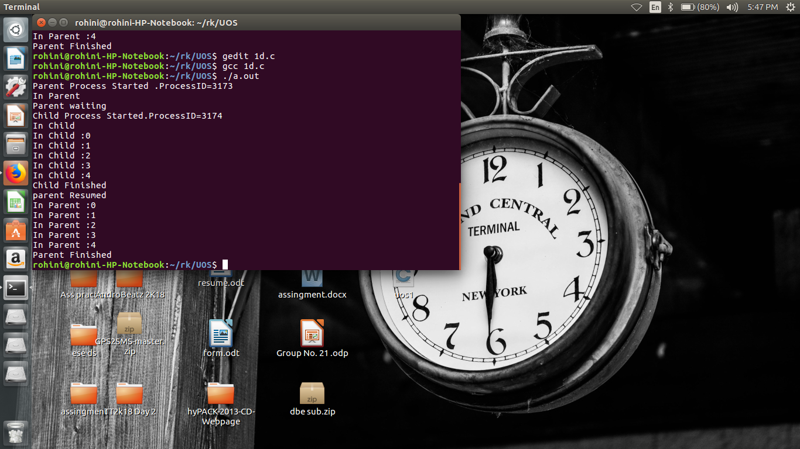

Conclusion:

The waitpid() call is more flexible than wait() system call as wait() would block the parent until child processes complete, while waitpid() can be implemented in blocking or unblocking ways.

References:

www.tutorialspoint.com/unix_system_calls/

