As a member of the Newport Rocketry Club, I worked with my team and our mentor (Retired NASA Engineer, Bruce Buswell) to develop a rocket that satisfied the competition requirements set by The American Rocketry Challenge (TARC). The competition required that we launch a rocket to 835 feet within 41-44 seconds. In total, there were 10 people on my team: Arthur Gwozdz, Samuel Chen, Rita Liu, Rose Liu, Brandon Luo, Ethan Luo, Kavin Manivasagam, Vanu Rao, and me. On my team, I primarily worked on the development of the payload and booster sections.

* 1. We used a simulator called OpenRocket to design our rocket **(Figure 10)**.

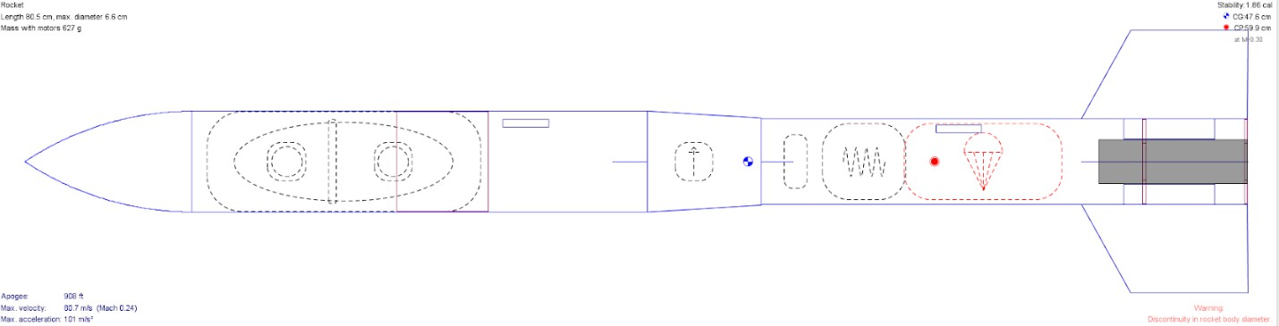

**Figure 10:** OpenRocket Design of our model rocket

* 1. I worked with teammates to CAD model and 3D print our fins and nose cone. The 3D prints start off rough, so we sand each component to reduce drag **(Figure 11)**.

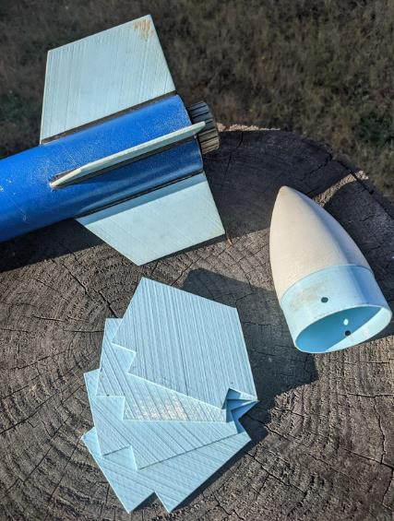

**Figure 11:** 3D Printed Rocket Components (Fins, Nose cone)

I also spent much of my time building the physical components of the rocket.

* 1. We used epoxy to create fillets between the fins and the booster tube.
  2. Our payload section was a BT80, painted cardboard tube, and our booster section was a BT70, painted cardboard tube **(Figure 12)**.
  3. Both parts were connected by a 3D printed transition section which housed the altimeter **(Figure 12)**.
  4. We also mounted a rail guide on both the payload and booster sections using epoxy

# (Figure 12).

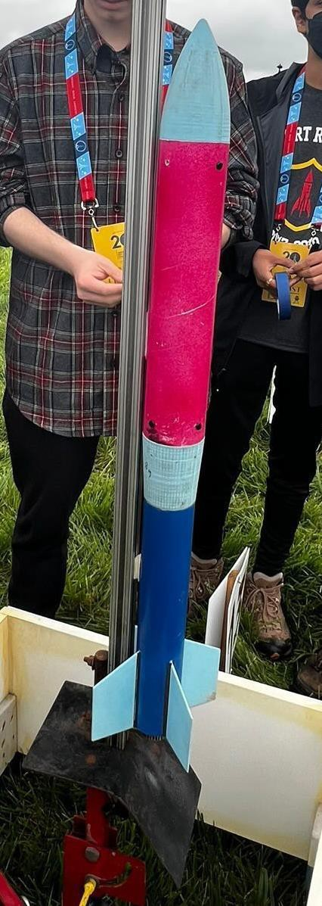

**Figure 12:** Physical Rocket Based Off of OpenRocket Specifications

* 1. Within the booster section, we used epoxy to connect two centering rings and components for a motor retainer to a 24-millimeter tube to create a motor mount that housed the 24-millimeter motor casing.
  2. For the payload section, we used foam egg casings to house 2 chicken eggs, as mandated by the competition rules. We placed ballast, as needed, between the two separate egg casings.

One of the biggest issues we had to troubleshoot was stability issues. We originally launched our rockets with an AeroTech F32T-6 motor but we were consistently experiencing 15–20-degree tilt during launches **(Clip 3)**. Reviewing launch footage, we noticed that the rocket would initially tilt but then stabilize at a certain angle. This helped us determine that the F36-6T motor was not providing enough thrust off the rail, causing a slow exit velocity. Looking at the thrust curve for an F36-6T motor **(Figure 13)**, it was providing less initial thrust but had a longer burn time. This wasn’t what we needed. So, we switched to a Cessaroni F70-14A motor. This helped fix our exit velocity issues as the motor provided more thrust after ignition and had a shorter burn time **(Clip 4, Figure 13)**.

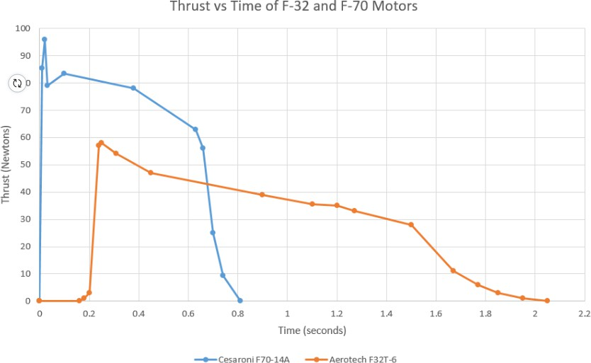

**Figure 13:** Cesaroni F70-14A and the AeroTech F32T-6 Thrust Curve Comparison

As we launched, we used linear regressions to plot our data. The more we launched, the more useful our data became, which helped us find the ideal mass of our rocket to reach specific altitudes. Having an ideal mass estimate enabled us to measure an accurate amount of ballast to place in the payload section of our rockets.

Overall, this project was extremely engaging as I was able to continually work through the design, build, and launch process. Working collaboratively with my peers, I was able to play into both my teammates’ and my strengths to challenge ourselves to be better. We ended up winning The American Rocketry Challenge (first place among 724 participating teams) and placed second representing the United States at the International Rocketry Competition.