Exercise 15

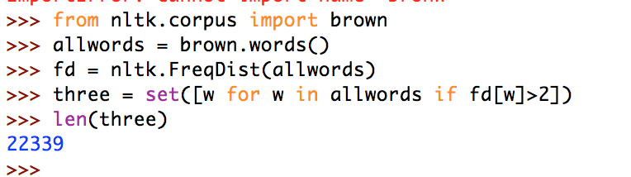

In exercise 15, the task was to find all words in the Brown Corpus that occurred more than three times. We did this by creating a frequency distribution of all the words in the Brown Corpus and then placing them into a list if their frequency was more than 2. The set was used to make sure that there were no duplicates of words. The program found that there were 22,339 words that occurred more than 3 times in the Brown Corpus. We simply printed the number because there were too many words to print.