Exercise 23

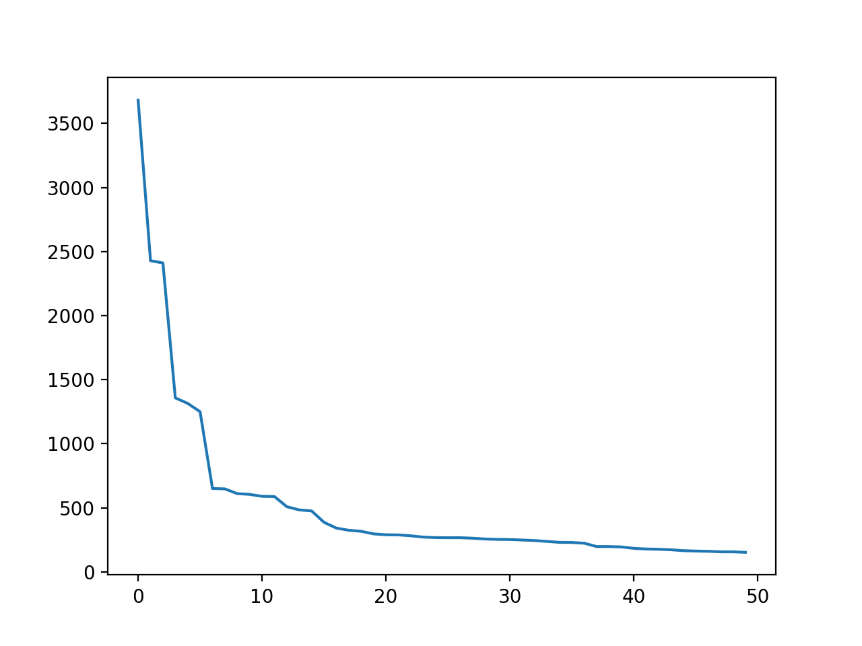

In our first plot, we plotted text3, The Book of Genesis. In this case the curve shows a relatively logarithmic relationship which is an inverse relationship. On the right end, the graph approaches infinity while on the right it approaches zero, a clear inverse relationship that upholds Zipf’s Law.

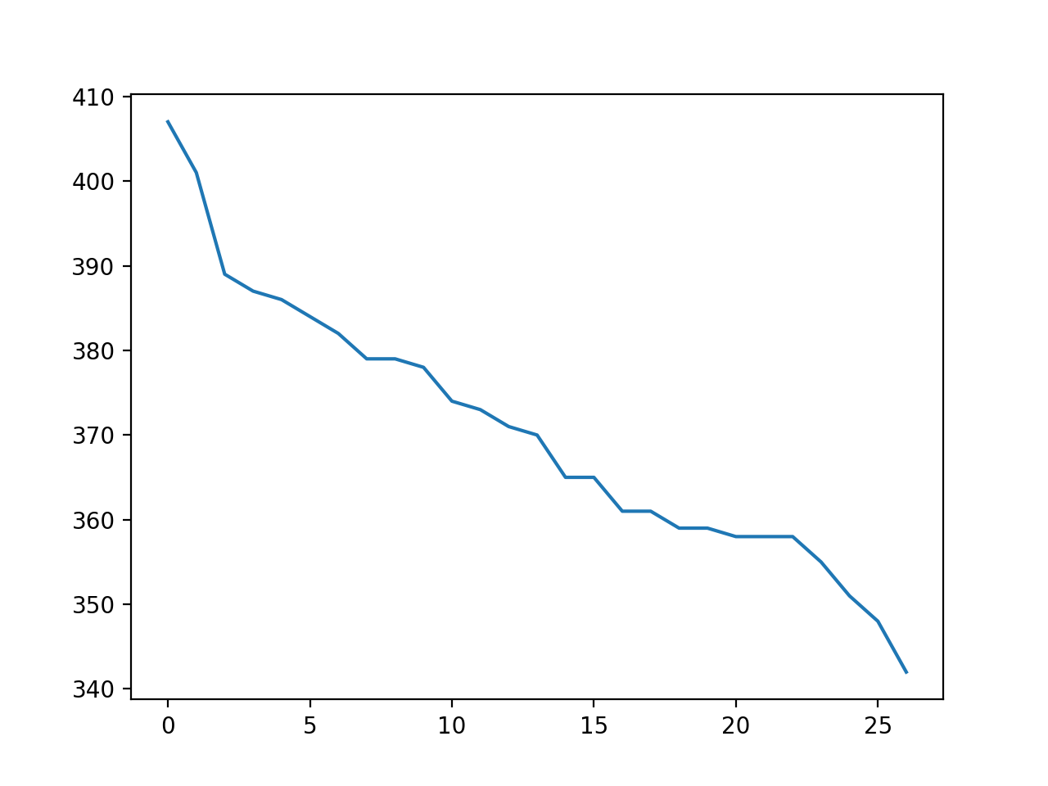

In the second plot, we use a randomely generated text with 10000 characters. In this case also, we see an inverse relationship between rank and frequency of word type, upholding Zipf’s Law again.