
A Report on
Data Centre Cooling and Power Control System

For the course
PLC and SCADA(23EI62)
Submitted to the

DEPARTMENT OF ELECTRONICS AND INSTRUMENTATION
ENGINEERING
Bachelor of Engineering in Electronics and Instrumentation
Engineering
By
M P Subbaiah | 1MS23EI030
Shreyas R | 1MS23EI049
Yashas B R | 1MS23EI064

Under the guidance of

Dr. Nishi Shahnaj Haider
Professor
Ramaiah Institute of Technology,
(Autonomous Institute, Affiliated to VTU)
Vidya Soudha, MSR Nagar, MSRIT post, Bengaluru - 560054, India.
May 2026

1. Objective

This report documents a Programmable Logic Controller (PLC) ladder logic program designed to automate and safeguard an industrial facility's thermal management, power continuity, and fire-suppression systems. The program was developed in Rockwell Automation Studio 5000 Logix Designer and is intended for deployment on an Allen-Bradley ControlLogix or CompactLogix processor.
The primary objectives of the program are:
- Monitor and control cooling fans and secondary cooling equipment based on temperature sensor inputs.
- Detect and respond to overtemperature conditions at multiple severity tiers, escalating from warning through critical shutdown.
- Manage automatic switchover to a backup power source when main power fails, including generator warm-up sequencing.
- Provide smoke and fire detection with a timed gas-based fire-suppression response.
- Protect personnel and equipment through interlocked shutdowns, indicator lights, and alarms.
The program employs a sealed Control Relay (CR) bit as the master enable, ensuring all outputs are inhibited whenever the system is in a stopped or faulted state.

2. System Overview

2.1 Hardware Configuration
The system uses an Allen-Bradley PLC with the following I/O modules visible in the ladder program:
- Local:1 – Digital Input Module (DI): Start button (Data.0), Stop button (Data.1), Temperature-high sensor (Data.2), Temperature-overheat sensor (Data.2 on slot 2), Power-fail signal (Data.4), Critical-temp sensor (Data.3), Smoke detector (Data.1 on slot 2:1).
- Local:1:O / Local:2:O – Digital Output Modules (DO): Cooling fans (Data.2), Secondary cooling fan (Data.5), AC unit (Data.6), Overheat indicator, Critical shutdown relay, Critical light (Data.6), Mains contactor (Data.2), Generator output (Data.3), Yellow warning light, Gas-based fire suppression (Data.1).
- Local:2 – Analog/Digital I/O expansion for temperature and fire-detection channels.

2.2 Software Environment
The program was captured running live (13:33, 11-05-2026) in Studio 5000 Logix Designer. The status bar shows "Rung 6 of 21", confirming a 21-rung program within a single routine named MainRoutine under MainProgram. The Program Control instruction group houses TON (Timer On Delay) function blocks used for timed safety responses.

2.3 Control Philosophy
The program follows a hierarchical layered-safety control philosophy:
- Layer 1 – Normal Operation: Start/stop interlocking with a latched Control Relay (CR).
- Layer 2 – Thermal Management: Multi-level temperature monitoring with staged cooling activation.
- Layer 3 – Critical Shutdown: Timer-confirmed critical temperature response with dedicated alarm outputs.
- Layer 4 – Power Backup: Automatic generator switchover with warm-up delay and mains management.
- Layer 5 – Fire Safety: Smoke detection with a delayed gas-suppression system release.

3. How the Ladder Logic Works

3.1 Ladder Logic Fundamentals
Ladder logic is a graphical programming language standardized under IEC 61131-3. It simulates the relay-contact diagrams used in electromechanical control panels. Each horizontal line is a rung; contacts (inputs) on the left determine if power flows to the coil (output) on the right. The PLC scans rungs sequentially from top to bottom in each scan cycle.
Key symbols used in this program:
- –| |– Normally Open (NO) contact: closes when the referenced bit is TRUE (1).
- –|/|– Normally Closed (NC) contact: passes power when the referenced bit is FALSE (0).
- –( )– Output coil: sets the referenced bit TRUE while rung conditions are TRUE.
- TON Timer On Delay: accumulates time when rung is energized; sets .DN when Accum >= Preset.

3.2 Master Control Relay Pattern
Rung 0 implements a classic seal-in circuit: the start push-button momentarily energizes the CR coil; the CR NO contact in parallel latches the coil on after the button is released. The normally-closed stop contact breaks the path to de-energize CR. All subsequent rungs include the CR contact as the first series element, creating a single-point master enable.

3.3 Staged Temperature Response
Rungs 1–5 implement a multi-tier temperature response. Rung 1 activates primary cooling fans when power and CR are present. Rung 2 adds secondary cooling when temp_high is detected. Rung 3 handles overheat condition, driving both the overheat internal coil and the AC unit.

3.4 Critical Temperature Shutdown with Timer Confirmation
Rung 6 detects a critical_temp input and starts a TON timer (critical_T1, Preset = 5000 ms). This 5-second confirmation window prevents nuisance shutdowns from transient sensor spikes. Once critical_T1.DN is TRUE, Rung 7 sets the critical_shutdown coil. Rung 8 drives the critical_light indicator output.

3.5 Backup Power and Generator Sequencing
Rung 9 monitors power_fail and starts backup_timer (5000 ms) unless critical_shutdown is active. Rungs 10–11 set power_backup_mode and activate the yellow warning light. Rung 12 de-energises the mains contactor. Rung 13 runs the generator warm-up delay (5000 ms). Rungs 14–15 set generator_ready and energise the generator output once warm-up completes.

3.6 Smoke Detection and Fire Suppression
Rung 19 monitors the smoke_detector input and starts fire_suppression_del timer (5000 ms). Rung 20 releases gas suppression once the timer completes, providing a pre-discharge alarm period for personnel evacuation.

4. Program Description

The program, named MainRoutine within MainProgram, is a 21-rung ladder logic routine executed cyclically by the PLC processor. It integrates five functional groups into a single coherent sequence:
- Group A (Rung 0): System Start / Stop and master CR latch.
- Group B (Rungs 1–5): Cooling fan and overheat management.
- Group C (Rungs 6–8): Critical temperature shutdown with timer confirmation and alarm.
- Group D (Rungs 9–15): Power failure detection, backup mode, generator warm-up, and generator enable.
- Group E (Rungs 16–20): Smoke detection and gas-based fire suppression.
All control actions are conditional on the CR master enable bit, ensuring that no outputs are active unless the system has been explicitly started. The use of TON timers for critical shutdown, generator warm-up, and fire suppression introduces deliberate time delays that improve reliability and safety.

5. Tag Table

The following table lists all identifiable tags extracted from the ladder diagrams.

Tag Name | Description | Type | Address | Function
CR | Master Control Relay latch bit | BOOL (Internal) | — | Master enable for all rungs
start | Start push-button input | BOOL (DI) | Local:1:I.Data.0 | Energises CR coil on press
stop | Stop push-button input | BOOL (DI) | Local:1:I.Data.1 | NC – breaks CR seal-in path
power_relay | Mains power relay contact feedback | BOOL (DI) | — | Confirms mains power presence
temp_high | High temperature sensor input | BOOL (DI) | Local:1:I.Data.2 | Activates secondary cooling
temp_overheat | Overheat temperature sensor input | BOOL (DI) | Local:2:I.Data.2 | Sets overheat status bit
overheat | Overheat status internal bit | BOOL (Internal) | — | Latches overheat condition
critical_temp | Critical temperature threshold sensor | BOOL (DI) | Local:1:I.Data.3 | Starts critical_T1 timer
critical_T1 | Critical temperature confirmation timer | TIMER | — | TON, Preset=5000 ms
critical_T1.DN | critical_T1 Done bit | BOOL (Internal) | — | Sets critical_shutdown coil
critical_shutdown | Critical shutdown command bit | BOOL (Internal) | — | Initiates emergency shutdown
critical_light | Critical alarm indicator light | BOOL (DO) | Local:2:O.Data.6 | ON during critical shutdown
power_fail | Mains power failure input signal | BOOL (DI) | Local:1:I.Data.4 | Starts backup_timer
backup_timer | Power backup delay timer | TIMER | — | TON, Preset=5000 ms
backup_timer.DN | backup_timer Done bit | BOOL (Internal) | — | Sets power_backup_mode
power_backup_mode | System in backup power mode status bit | BOOL (Internal) | — | Switches from mains to gen
yellow_light | Yellow warning indicator light | BOOL (DO) | Local:2:O.Data.0 | ON in backup mode
mains | Mains supply contactor output | BOOL (DO) | Local:2:O.Data.2 | De-energised in backup mode
generator_warmup_del | Generator warm-up delay timer | TIMER | — | TON, Preset=5000 ms
generator_warmup_del.DN | Generator warm-up Done bit | BOOL (Internal) | — | Sets generator_ready
generator_ready | Generator ready status bit | BOOL (Internal) | — | Enables generator output
generator | Generator output contactor | BOOL (DO) | Local:2:O.Data.3 | Energises generator supply
cooling_fans | Primary cooling fan output | BOOL (DO) | Local:1:O.Data.2 | ON with CR and power_relay
secondary_cooling_fa | Secondary cooling fan output | BOOL (DO) | Local:1:O.Data.5 | ON temp_high condition
AC_unit | Air conditioning unit output | BOOL (DO) | Local:1:O.Data.6 | Controlled by overheat chain
smoke_detector | Smoke detector sensor input | BOOL (DI) | Local:2:I.Data.1 | Triggers fire suppression timer
fire_suppression_del | Fire suppression delay timer | TIMER | — | TON, Preset=5000 ms
fire_suppression_del.DN | Fire suppression Done bit | BOOL (Internal) | — | Releases gas suppression
gas_based_fire_suppression | Gas-based fire suppression output | BOOL (DO) | Local:2:O.Data.1 | Releases suppression agent

LADDER DIAGRAM

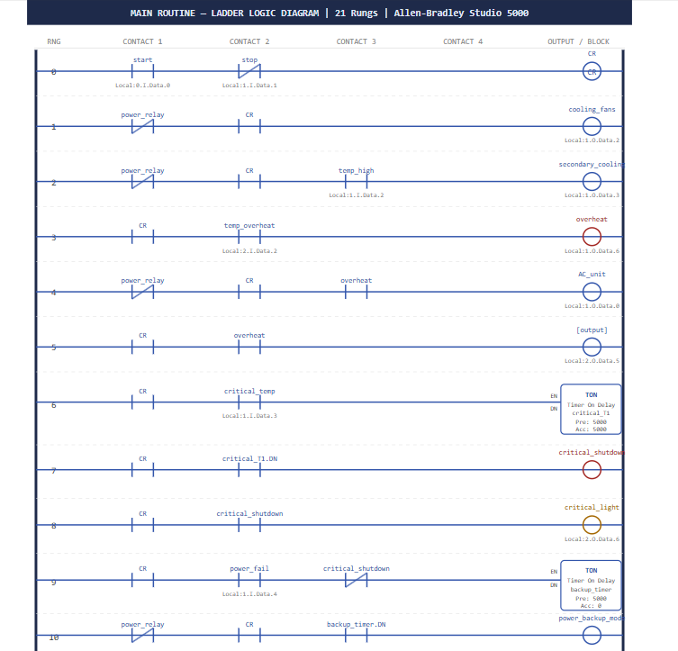

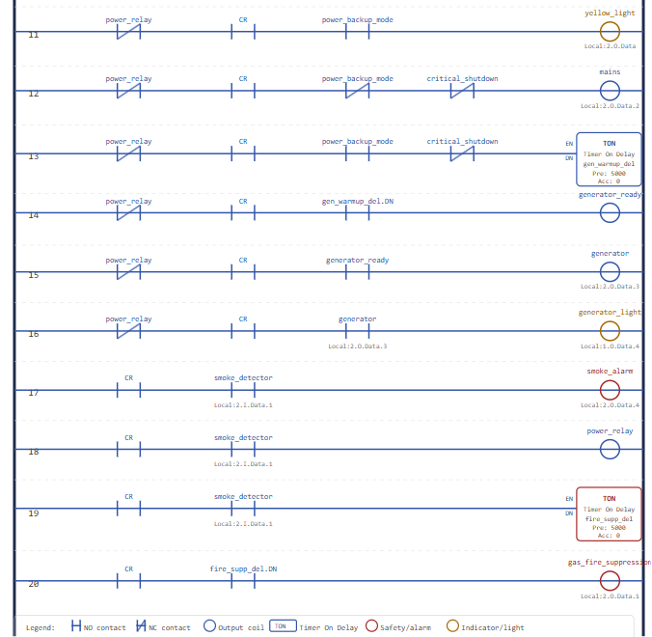

6. Rung-by-Rung Explanation

6.1 Summary Table

Rung | Tag(s) | Condition Logic | Output / Action
0 | start, stop, CR | start NO || CR NO (seal-in), series stop NC | CR output coil — master enable latch
1 | power_relay, CR | power_relay NC series CR NO | cooling_fans (Local:1:O.Data.2)
2 | power_relay, CR, temp_high | power_relay NC, CR NO, temp_high NO | secondary_cooling_fa (Local:1:O.Data.5)
3 | CR, temp_overheat | CR NO, temp_overheat NO | overheat (internal coil), AC_unit (Local:1:O.Data.6)
4 | power_relay, CR, overheat | power_relay NC, CR NO, overheat NO | Feeds downstream overheat logic
5 | CR, overheat | CR NO, overheat NO | Output to Local:2:O.Data.5
6 | CR, critical_temp | CR NO, critical_temp NO | TON: critical_T1, Preset=5000 ms
7 | CR, critical_T1.DN | CR NO, critical_T1.DN NO | critical_shutdown (internal coil)
8 | CR, critical_shutdown | CR NO, critical_shutdown NO | critical_light (Local:2:O.Data.6)
9 | CR, power_fail, critical_shutdown | CR NO, power_fail NO, critical_shutdown NC | TON: backup_timer, Preset=5000 ms
10 | power_relay, CR, backup_timer.DN | power_relay NC, CR NO, backup_timer.DN NO | power_backup_mode (internal coil)
11 | power_relay, CR, power_backup_mode | power_relay NC, CR NO, power_backup_mode NO | yellow_light (Local:2:O.Data)
12 | power_relay, CR, power_backup_mode, critical_shutdown | ...power_backup_mode NO, critical_shutdown NC | mains (Local:2:O.Data.2)
13 | power_relay, CR, power_backup_mode, critical_shutdown | ...power_backup_mode NC, critical_shutdown NC | TON: generator_warmup_del, 5000 ms
14 | power_relay, CR, generator_warmup_del.DN | ...generator_warmup_del.DN NO | generator_ready (internal coil)
15 | power_relay, CR, generator_ready | ...generator_ready NO | generator (Local:2:O.Data.3)
16–18 | (Intermediate rungs) | Partially visible — status/alarm rungs | Additional alarm or status outputs
19 | CR, smoke_detector | CR NO, smoke_detector NO | TON: fire_suppression_del, 5000 ms
20 | CR, fire_suppression_del.DN | CR NO, fire_suppression_del.DN NO | gas_based_fire_suppr (Local:2:O.Data.1)

6.2 Detailed Rung Narratives

Rung 0 – Start/Stop Master Latch
The start contact (Local:1:I.Data.0) is wired in parallel with the CR contact to form a seal-in circuit. When start is momentarily pressed, CR energises. The CR contact then holds CR energised after the operator releases the start button. The stop contact (Local:1:I.Data.1) is normally closed; pressing stop breaks the circuit and drops CR, disabling the entire program.

Rung 1 – Primary Cooling Fans
The normally-closed power_relay contact passes current when no external relay override is active, in series with the normally-open CR bit. Output: cooling_fans energises the primary cooling fan array, providing baseline cooling whenever the system is started.

Rung 2 – Secondary Cooling Fan
Same base conditions as Rung 1, with the addition of temp_high in series. Secondary cooling activates only when the temperature crosses the high-temperature threshold, conserving energy under normal thermal conditions.

Rung 3 – Overheat Latch and AC Unit
CR in series with temp_overheat drives the overheat internal coil and the AC_unit output simultaneously. The overheat coil acts as an internal status flag consumed by subsequent rungs.

Rungs 4–5 – Overheat Downstream Conditioning
These rungs gate further overheat-dependent outputs, ensuring that overheat responses only propagate when both power is confirmed and CR is set.

Rung 6 – Critical Temperature Timer
When CR is set and critical_temp (Local:1:I.Data.3) goes TRUE, the TON instruction accumulates time towards 5000 ms. The 5-second confirmation window prevents nuisance shutdowns from transient sensor spikes.

Rung 7 – Critical Shutdown Coil
Once critical_T1.DN is TRUE, this rung sets the critical_shutdown internal bit, which propagates to multiple downstream rungs triggering alarm outputs and inhibiting mains switching.

Rung 8 – Critical Alarm Light
CR and critical_shutdown in series drive the critical_light output (Local:2:O.Data.6), providing a visible indication that a critical thermal shutdown is in effect.

Rung 9 – Power Failure Backup Timer
CR and power_fail in series, with NC critical_shutdown, activate backup_timer TON (5000 ms). The 5-second delay prevents generator start on momentary power flickers.

Rungs 10–11 – Power Backup Mode and Warning Light
backup_timer.DN sets power_backup_mode and drives the yellow_light indicator, alerting operators that the facility has switched to backup power.

Rung 12 – Mains Contactor De-energise
De-energises the mains contactor when power_backup_mode is TRUE and critical_shutdown is FALSE, implementing a break-before-make switching scheme.

Rung 13 – Generator Warm-Up Timer
A TON (generator_warmup_del, 5000 ms) is started when power_backup_mode is active. The warm-up period allows the generator to reach stable operating speed, voltage, and frequency before load is applied.

Rungs 14–15 – Generator Ready and Enable
generator_warmup_del.DN sets generator_ready, which then energises the generator output contactor (Local:2:O.Data.3). Generator power is applied to the load bus only after successful warm-up.

Rung 19 – Smoke Detection and Suppression Timer
CR and smoke_detector start the fire_suppression_del TON timer (5000 ms). The 5-second delay provides evacuation time and filters false triggers.

Rung 20 – Gas Suppression Release
CR and fire_suppression_del.DN energise gas_based_fire_suppression (Local:2:O.Data.1), releasing the suppression agent. This is the final rung of the routine.

7. System Functional Block Summary

Block | Rungs | Key Inputs | Key Outputs
A – Start/Stop | 0 | start, stop | CR (master enable)
B – Thermal Mgmt | 1–5 | power_relay, temp_high, temp_overheat | cooling_fans, secondary_cooling_fa, overheat, AC_unit
C – Critical Shutdown | 6–8 | critical_temp, critical_T1.DN | critical_shutdown, critical_light
D – Power Backup | 9–15 | power_fail, backup_timer.DN, generator_warmup_del.DN | power_backup_mode, yellow_light, mains, generator
E – Fire Safety | 16–20 | smoke_detector, fire_suppression_del.DN | gas_based_fire_suppr

8. Safety and Design Observations

8.1 Good Practices Identified
- Seal-in latch on Rung 0 prevents accidental restart after a stop command.
- All outputs are gated through the CR bit, ensuring a clean controlled shutdown propagates through the entire program.
- Timer confirmation before critical_shutdown prevents spurious shutdowns from transient sensor signals.
- The generator warm-up delay prevents load application to an unstable generator supply.
- The 5-second fire suppression delay satisfies typical safety standards requiring a pre-discharge alarm period.
- The NC critical_shutdown contact in Rung 9 prevents the backup power sequence from initiating during a critical thermal event.

8.2 Recommendations for Enhancement
- Add fault/alarm coils for sensor failures if temp_high remains ON beyond an expected duration.
- Implement an OTL (Output Latch) for the overheat coil to prevent the coil from dropping out on transient sensor resets.
- Add a manual reset rung requiring operator acknowledgement before clearing critical_shutdown.
- Consider adding a watchdog timer rung to detect PLC processor faults and force a safe state on the output module.
- Document rungs 16–18 fully; undocumented rungs in a safety-critical program represent a documentation gap.
9. Conclusion

This 21-rung PLC ladder logic program implements a comprehensive industrial safety and utility management system. It correctly applies foundational PLC programming practices — seal-in latches, timer-confirmed safety actions, master enable interlocks — to address five distinct functional requirements: manual start/stop control, multi-stage thermal management, critical temperature shutdown with alarm, automatic backup power switchover with generator sequencing, and smoke-activated gas suppression.
The program is structured logically, with each functional group clearly delineated by rung grouping. The staged timer delays embedded in the critical shutdown, backup power, and fire suppression paths demonstrate sound safety engineering judgment.
Section 10 contains the reconstructed ladder diagram drawn directly from the reference images, showing all 21 rungs with tags, addresses, contact types, and output instructions.

