CUSTOMER CHURN DATA PREPROCESSING
& EXPLORATORY DATA ANALYSIS

Python for Machine Learning & Data Preprocessing

Internship | AI Pioneers Machine Learning Internship
Task | Week 1 — Python for Machine Learning & Data Preprocessing
Intern | Shreyas
Institution | YuvaIntern
GitHub Repository | https://github.com/shreyas04100/ai2
Language / Tools | Python 3.x | Pandas | NumPy | scikit-learn | Matplotlib | Seaborn

1. Introduction
This report documents the complete data preprocessing and exploratory data analysis (EDA) pipeline for a synthetic Customer Churn dataset, developed as part of the AI Pioneers Machine Learning Internship (Week 1 Task). The project demonstrates Python-based machine learning preprocessing fundamentals using industry-standard libraries.

Customer churn — the rate at which customers stop doing business with an organisation — is a critical business metric. Accurate churn prediction models require clean, well-preprocessed data. This project illustrates every step of that preprocessing journey from raw, messy data to a structured dataset suitable as a preprocessed input for downstream machine learning tasks.

1.1 Dataset Overview
A synthetic customer churn dataset was generated using src/generate_dataset.py to simulate realistic Telco-style records. The dataset intentionally contains real-world data quality problems to demonstrate each preprocessing technique:
- Missing values — 93 explicit NaN values across 5 columns (Gender=24, SeniorCitizen=15, TenureMonths=18, PaymentMethod=16, MonthlyCharges=20)
- Blank strings — 25 TotalCharges cells stored as whitespace strings (simulating new customer records)
- Invalid values — MonthlyCharges=−150.0 and TenureMonths=−12.0 (physically impossible; converted to NaN)
- Total missing-like cells handled by imputation: 120 (93 NaN + 25 blank strings + 2 invalid negatives)
- Duplicate records — 10 exact duplicate rows injected
- Outliers — extreme MonthlyCharges (9,999.0 and 4,500.0) and TenureMonths (350 months)
- Type mismatches — TotalCharges stored as object (string) dtype instead of float64
- Categorical inconsistencies — Gender encoded as 'female', 'F', 'M', 'male'
- Redundant columns — RandomNoiseScore, SystemLogCode (no predictive value)

2. Python Fundamentals for Machine Learning
This project leverages core Python programming concepts relevant to data science and machine learning. The codebase is structured as a modular OOP pipeline using the ChurnDataPreprocessor class with stateful transformer management.

2.1 Key Python Concepts Demonstrated
Concept | Demonstration
NumPy | Array operations, random seed control, numerical type conversion, vectorised np.clip()
Pandas | DataFrame I/O, dtype inspection, groupby/value_counts, get_dummies, fillna, apply
OOP | Class-based pipeline (ChurnDataPreprocessor) with stateful scalers and encoders
Modular Code | Separate modules: generate_dataset.py, data_preprocessing.py, eda.py, utils.py
Error Handling | FileNotFoundError, errors='coerce' for type-safe numeric conversions
Type Annotations | Python type hints (Tuple, List, Dict) throughout the pipeline
Reproducibility | np.random.seed(42) ensures deterministic dataset generation

3. Data Loading
The raw dataset is loaded from a CSV file using pandas. Structural metadata is immediately inspected to understand schema, column types, and data shape before any transformation begins.

Property | Value
Total Rows | 1210
Total Columns | 19
Numeric Columns | 4 (float64)
Object Columns — Total | 15
• Predictor categorical cols | 13 (excluding CustomerID and Churn)
• CustomerID (primary key) | 1 (dropped in feature selection)
• Churn (target variable) | 1 (encoded to 0/1 during encoding step)
Explicit NaN (raw CSV) | 93
Blank TotalCharges strings | 25
Invalid negative values → NaN | 2
Total cells handled by imputation | 120
File Size (CSV) | ~156 KB
Memory Usage (in-memory) | ~1.12 MB

4. Data Cleaning

4.1 Missing Value Analysis
The raw dataset contains a total of 120 missing or invalid cells that must be handled before modelling. These are categorised into three distinct types:

Category | Count | Description
A — Explicit NaN (CSV) | 93 | Values read as NaN directly from the CSV file across 5 columns
B — Blank string TotalCharges | 25 | TotalCharges cells containing only whitespace (' '); coerced to NaN by pd.to_numeric()
C — Invalid negatives → NaN | 2 | MonthlyCharges=−150.0 and TenureMonths=−12.0 set to NaN (physically impossible values)
TOTAL handled by imputation | 120 | 93 + 25 + 2 = 120

Column | Type A NaN | Type B/C Additional NaN | Imputation Strategy
Gender | 24 | 0 | Mode → most frequent category
SeniorCitizen | 15 | 0 | Median → central tendency of binary 0/1
TenureMonths | 18 | +1 (negative → NaN) | Median → robust against skewed values
PaymentMethod | 16 | 0 | Mode → most frequent category
MonthlyCharges | 20 | +1 (negative → NaN) | Median → robust against outliers
TotalCharges | 0 | +25 (blank strings → NaN) | Median → after float64 conversion
TOTAL | 93 | +27 | All 120 handled

Strategy rationale: Median imputation is preferred over mean for numerical columns because median is resistant to the extreme outlier values (9,999.0, 4,500.0, 350) still present in MonthlyCharges and TenureMonths at the time of imputation. Mode imputation is used for categorical columns (Gender, PaymentMethod) to assign the most probable category.

4.2 Duplicate Row Removal
The raw dataset contains 10 duplicate rows injected during dataset generation. Deduplication is performed by checking for duplicate CustomerID values (keep='first'). After removal: 1210 rows → 1200 rows (1200 unique records).

4.3 Categorical Standardisation
Gender values contain case inconsistencies and abbreviations ('female', 'F', 'male', 'M'). A dictionary mapping normalises all variants to canonical 'Male' / 'Female' before encoding. TotalCharges blank strings are stripped and pd.to_numeric(errors='coerce') converts them to NaN, enabling subsequent median imputation and float64 type conversion.

5. Outlier Detection and Treatment
The pipeline handles abnormal numerical values in two distinct stages that must not be confused:

Stage A — Invalid Value Correction (clean_initial_formatting)
Physically impossible values are detected and set to NaN before any IQR analysis. These are NOT outlier-capped — they are treated as data entry errors and subsequently handled by median imputation:
- MonthlyCharges = −150.0 → set to NaN → imputed with column median
- TenureMonths = −12.0 → set to NaN → imputed with column median

Stage B — IQR-Based Outlier Capping (detect_and_cap_outliers)
After formatting and imputation, extreme but potentially real values are detected using the 1.5×IQR boundary rule and capped (Winsorised) to the boundary. This preserves all records while eliminating distorting extremes.

Column | IQR Lower | IQR Upper | Values Capped | Cap Count
MonthlyCharges | $5.57 | $147.12 | 9,999.0 → $147.12; 4,500.0 → $147.12 | 2
TenureMonths | -33.5m | 106.5m | 350 months → 106.50 months | 1
TotalCharges | $-3,174 | $8,264 | No values exceeded IQR bounds | 0
TOTAL | — | — | — | 3

Summary: 2 invalid negative values were corrected to NaN and subsequently imputed (Stage A). 3 extreme-but-real values were IQR-capped (Stage B). In total, 5 anomalous numerical values were addressed across the two stages.
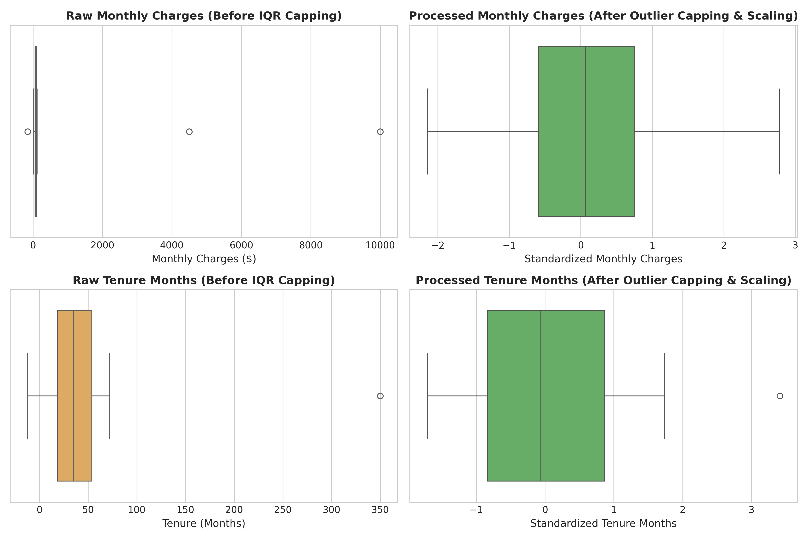
Figure 2. Box plots comparing MonthlyCharges and TenureMonths before and after preprocessing. Left panels show raw data with extreme outliers; right panels show values after IQR-based capping and StandardScaler normalisation. 3 values were IQR-capped; 2 negative values were removed and imputed.

6. Feature Selection
Non-informative and redundant features are removed before modelling. Feature selection reduces dimensionality, prevents overfitting, and improves model interpretability.

Column Dropped | Reason
CustomerID | Primary key — unique identifier with no predictive signal
SystemLogCode | Arbitrary internal system code — no business or predictive meaning
RandomNoiseScore | Explicitly random feature — injected to demonstrate noise removal

After feature selection: 19 columns → 16 columns remain for modelling.

7. Categorical Variable Encoding
Machine learning algorithms require numerical inputs. Categorical columns are encoded using two strategies depending on cardinality:

7.1 Binary Label Encoding (0/1)
Column | Encoding
Gender | Female → 0, Male → 1
SeniorCitizen | 0 → 0, 1 → 1 (already binary integer)
Partner | No → 0, Yes → 1
Dependents | No → 0, Yes → 1
PhoneService | No → 0, Yes → 1
PaperlessBilling | No → 0, Yes → 1
Churn (target) | No → 0, Yes → 1

7.2 One-Hot Encoding
Multi-category nominal columns are expanded using pd.get_dummies(drop_first=True) to avoid multicollinearity (dummy variable trap):
Column | Categories | New Indicator Columns
MultipleLines | No / No phone service / Yes | 2
InternetService | DSL / Fiber optic / No | 2
OnlineSecurity | No / No internet service / Yes | 2
TechSupport | No / No internet service / Yes | 2
Contract | Month-to-month / One year / Two year | 2
PaymentMethod | Bank transfer / Credit card / Electronic check / Mailed check | 3
TOTAL | — | 13 new columns

Final processed dataset: 23 columns (16 after feature selection → +13 OHE columns → 23 total).

8. Numerical Normalisation / Feature Scaling
StandardScaler (Z-score normalisation) is applied exclusively to the three continuous numerical features: TenureMonths, MonthlyCharges, and TotalCharges. StandardScaler transforms each feature to zero mean and unit variance.

Formula: z = (x − μ) / σ where μ = column mean, σ = column standard deviation

Feature | Pre-scaling Range | Post-scaling Mean | Post-scaling Std
TenureMonths | 1 – 72 months | ≈ 0.0000 | ≈ 1.0004
MonthlyCharges | $18.00 – $118.00 | ≈ 0.0000 | ≈ 1.0004
TotalCharges | $18.00 – ~$8,264 | ≈ 0.0000 | ≈ 1.0004

All three features now have mean ≈ 0 and std ≈ 1, confirming correct StandardScaler application. Binary-encoded and one-hot-encoded columns are already in the [0, 1] range and are not scaled.
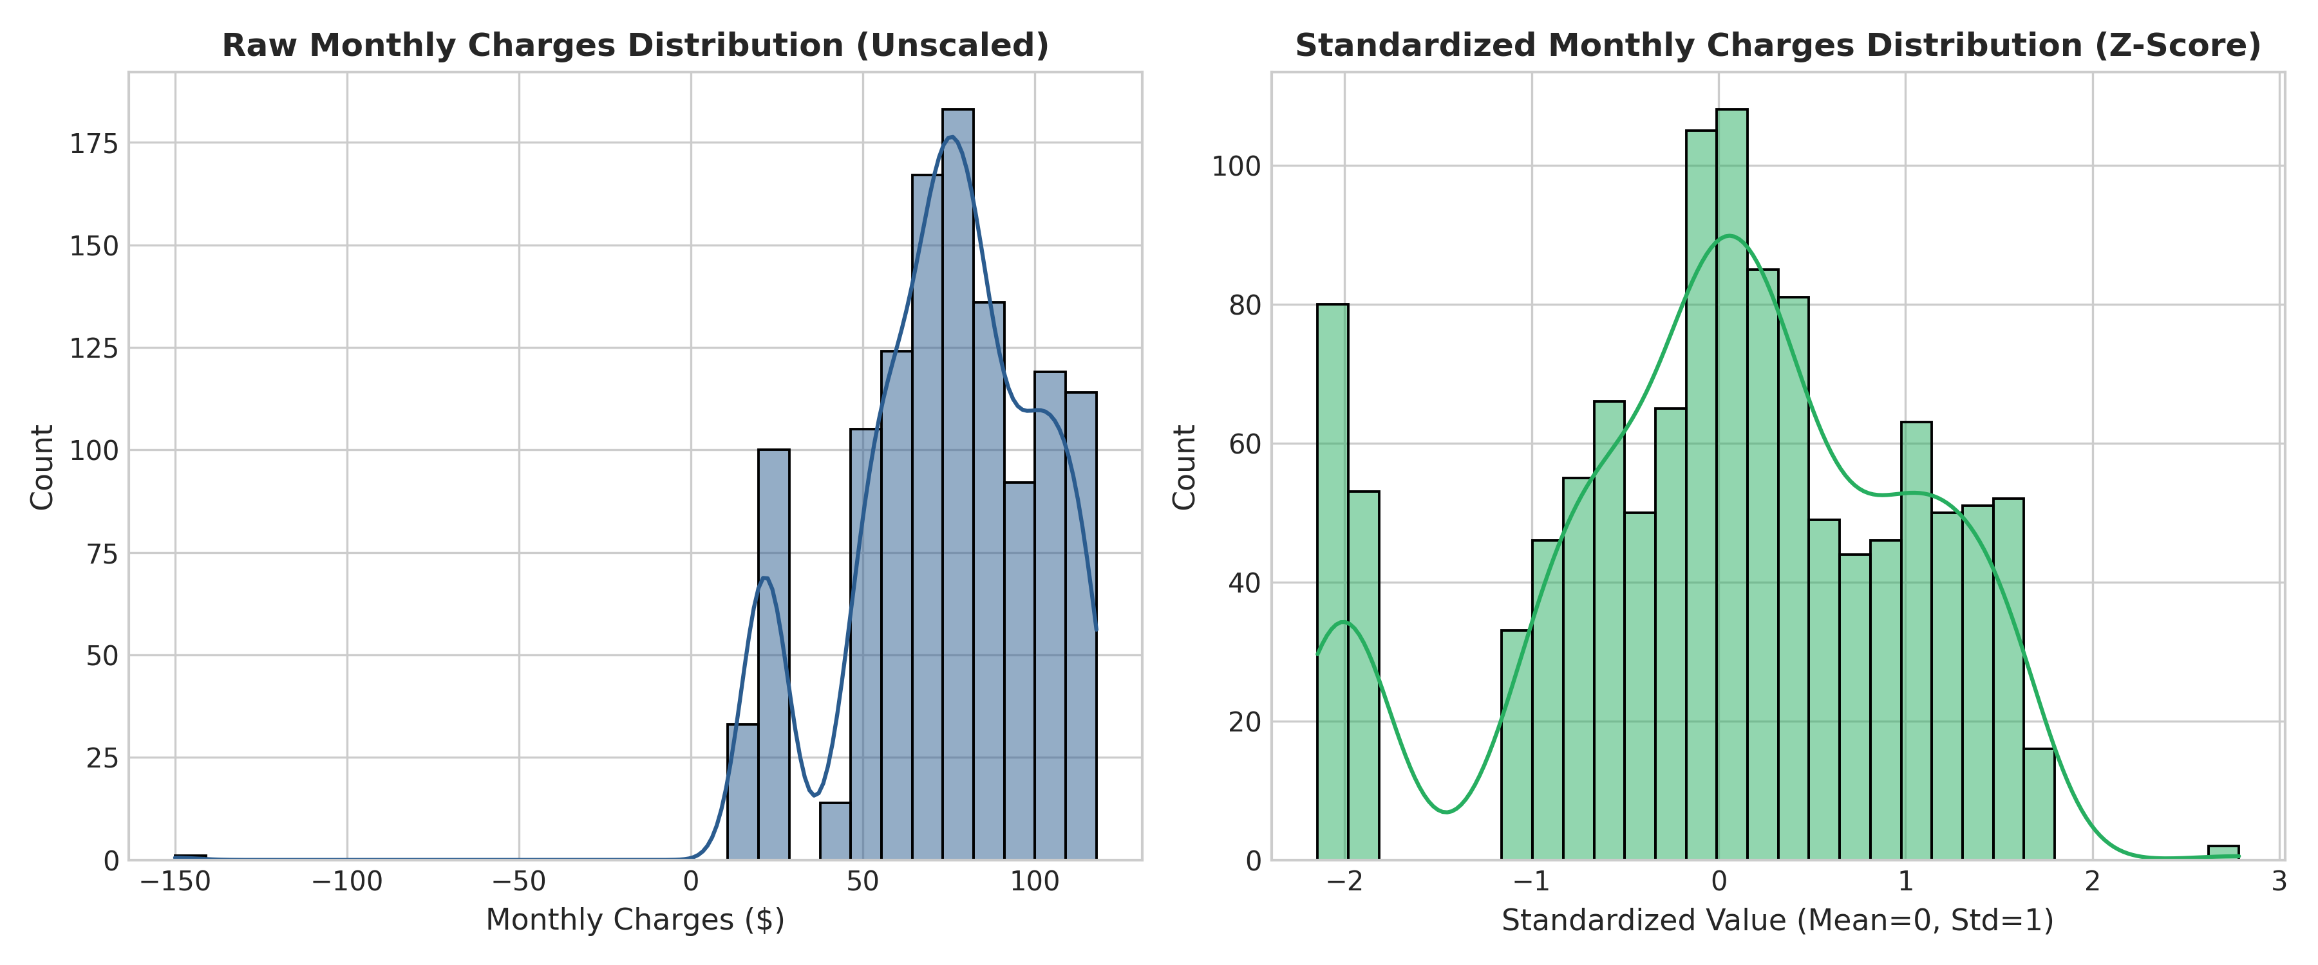
Figure 3. MonthlyCharges distribution before (left, raw $) and after (right) StandardScaler normalisation. Post-scaling values are centred at mean=0 with unit standard deviation.

9. Exploratory Data Analysis (EDA)
Exploratory analysis is performed on both raw and processed datasets to uncover distributional patterns, class balance, feature relationships, and the impact of preprocessing.

9.1 Target Variable Distribution
The raw dataset (1,210 rows) shows the following churn distribution:
Churn Status | Count (Raw) | Percentage (Raw)
No (Non-Churned) | 766 | 63.3%
Yes (Churned) | 444 | 36.7%
Total | 1210 | 100%

After preprocessing (removing 10 duplicate rows), the processed dataset (1,200 rows) shows: Non-Churned = 761 (63.42%), Churned = 439 (36.58%). The dataset has a moderate class imbalance (~63:37) which should be addressed during model training using techniques such as class weighting or SMOTE oversampling.

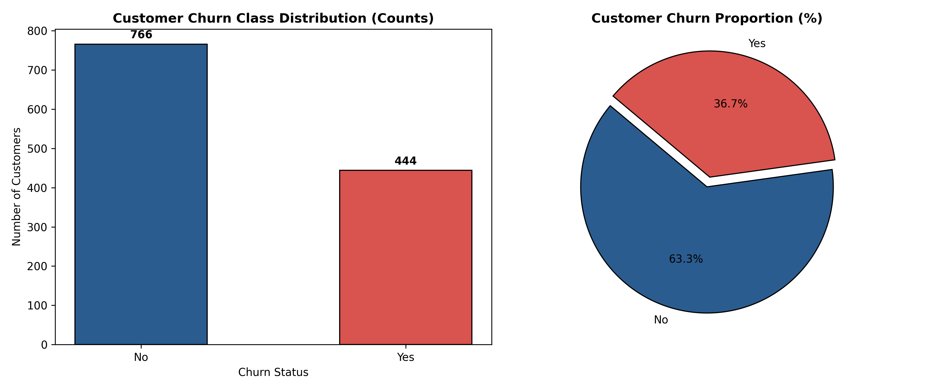
Figure 1. Customer churn class distribution in the raw dataset (1,210 rows). Left: bar chart showing Non-Churned=766, Churned=444. Right: pie chart showing 63.3% non-churned vs 36.7% churned.

9.2 Churn by Contract Type
Month-to-month contract customers exhibit significantly higher churn rates compared to one-year and two-year contract customers. This aligns with the dataset generation logic where month-to-month contracts carry a +0.25 churn probability boost.
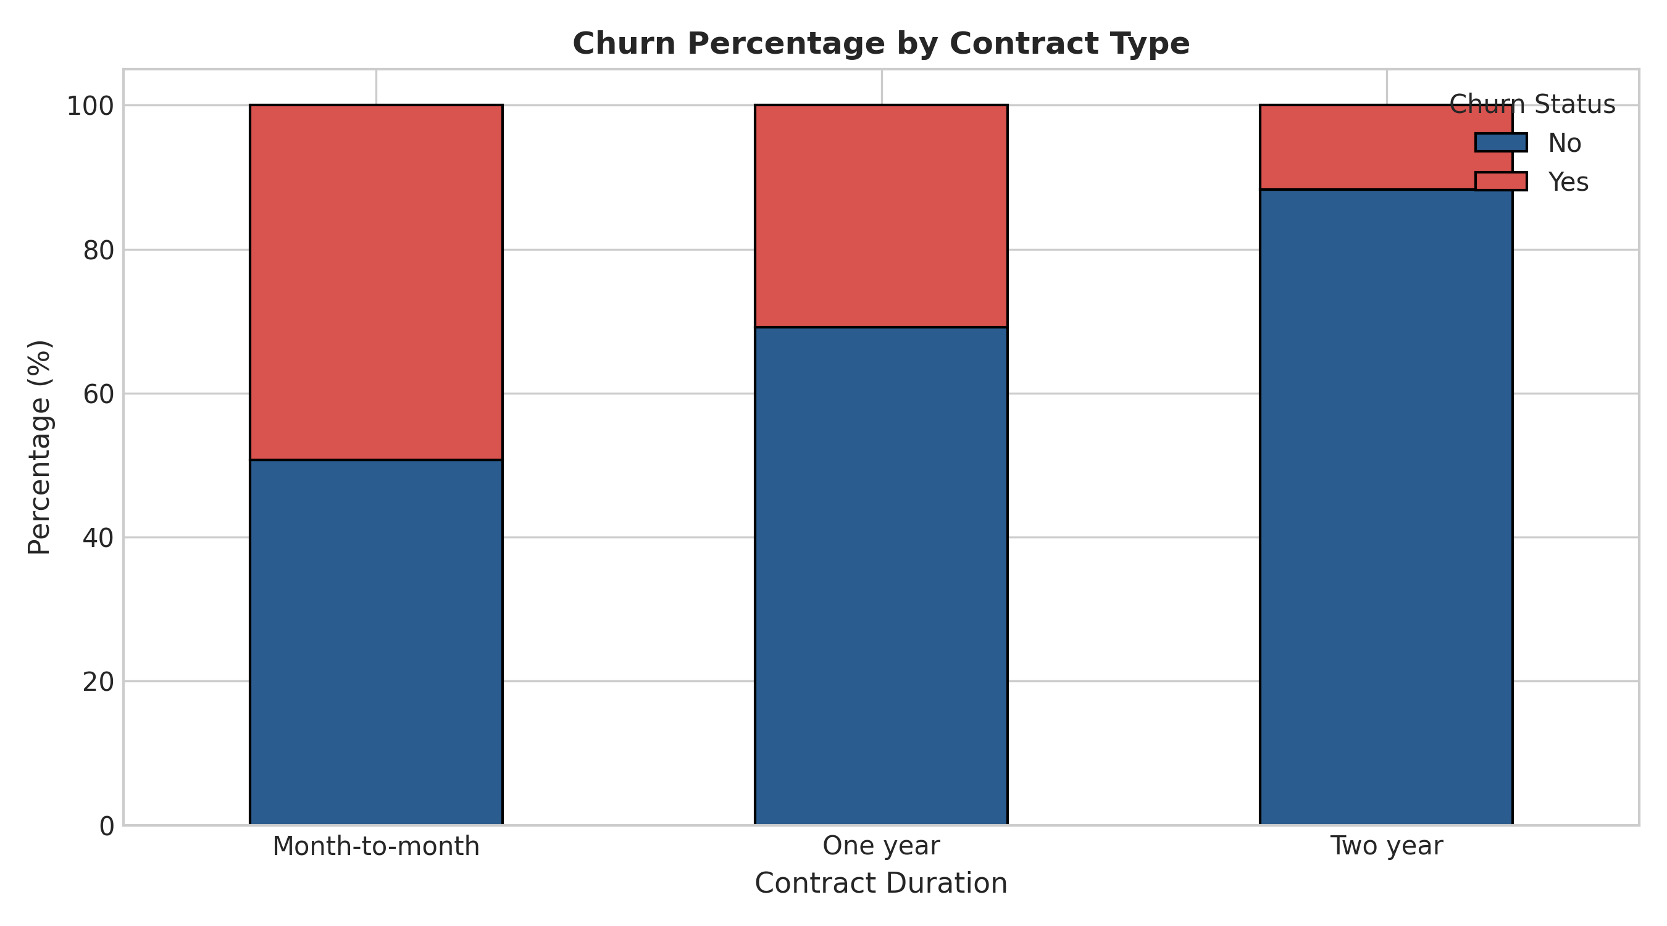
Figure 4. Stacked bar chart of churn percentage by contract type. Month-to-month customers show the highest churn rate.

9.3 Churn by Internet Service Type
Fibre optic internet service customers exhibit higher churn rates than DSL or no-internet customers, consistent with the +0.12 churn probability applied to fibre optic customers during dataset generation.
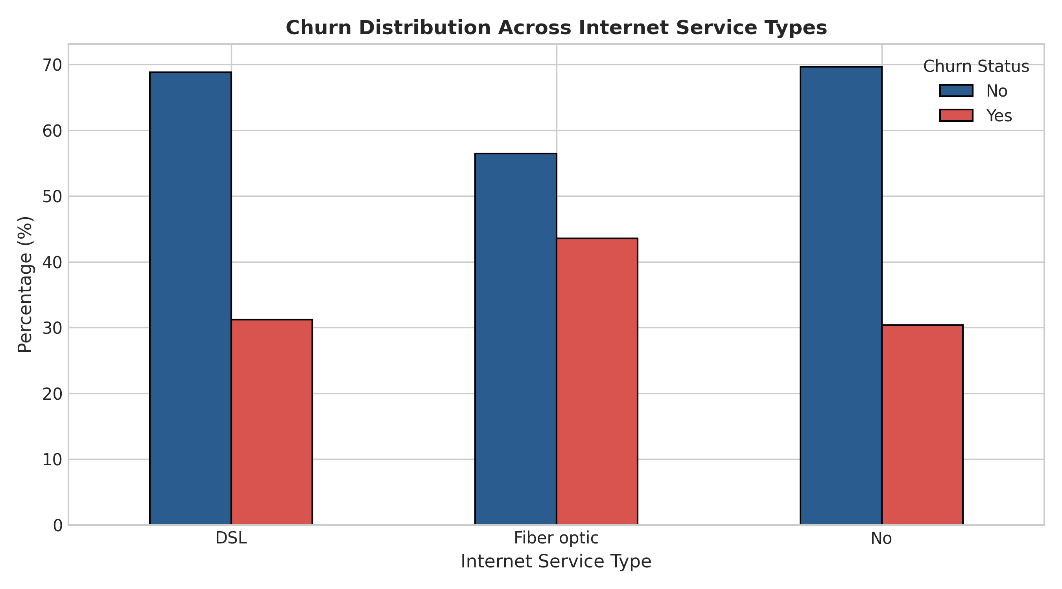
Figure 5. Churn distribution across internet service types. Fibre optic customers show noticeably elevated churn rates.

9.4 Feature Correlation Analysis
A correlation heatmap of the top 12 features most correlated with the Churn target reveals positive correlations with month-to-month contract and fibre optic service, and negative correlations with long tenure and two-year contracts.
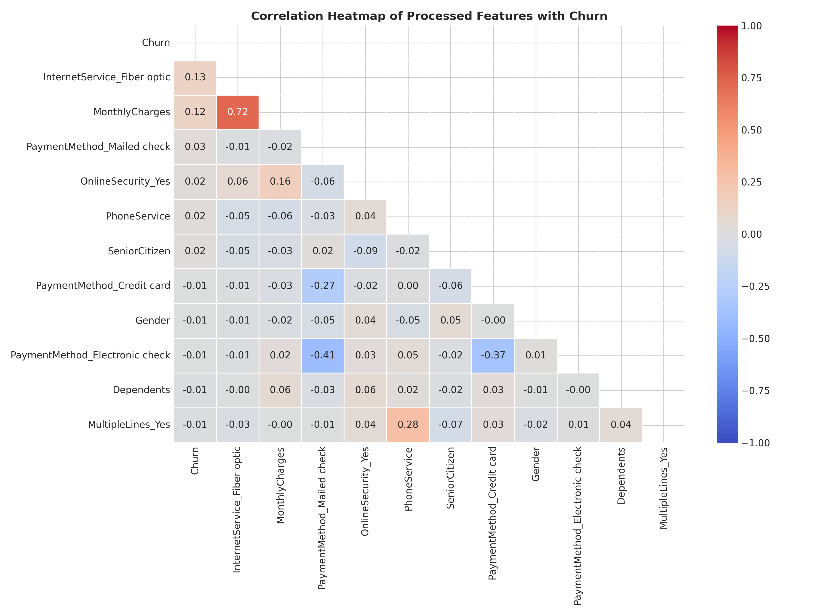
Figure 6. Correlation heatmap of processed features vs. Churn. Warmer colours = stronger positive correlation; cooler colours = negative correlation.

10. End-to-End Preprocessing Pipeline Summary
The table below summarises key quality metrics before and after preprocessing:

Metric | Raw Dataset | Processed Dataset
Rows | 1210 | 1200
Columns | 19 | 23
Explicit NaN values | 93 | 0
Blank TotalCharges strings | 25 | 0 (coerced → imputed)
Invalid negatives → NaN | 2 | 0 (imputed)
Total missing-like cells handled | 120 | 0
Duplicate Rows | 10 | 0
Values IQR-capped | 3 (MC: 2, TN: 1, TC: 0) | 0 (all within bounds)
Object (string) Columns | 15 total  (13 predictors + CustomerID + Churn) | 0 (all numeric)
Churn: Non-Churned | 766 (63.3%) | 761 (63.42%)
Churn: Churned | 444 (36.7%) | 439 (36.58%)
Scaled Numerical Cols | None | TenureMonths, MonthlyCharges, TotalCharges
Memory Usage | ~1.12 MB | ~0.21 MB (~81.1% reduction)

After completing all preprocessing stages, the processed dataset is suitable as a preprocessed input for downstream machine learning tasks. All features are numeric, missing cells have been imputed, outliers capped or corrected, and continuous features normalised. The dataset can be split into train/test sets and fed directly into scikit-learn estimators such as LogisticRegression, RandomForestClassifier, or XGBClassifier.

11. Documentation of Each Preprocessing Step
Step 1: Dataset Generation
src/generate_dataset.py — A synthetic dataset of 1,200 base records is generated with np.random.seed(42). Ten duplicate rows are appended, producing 1,210 raw rows. Intentional flaws (93 NaN, 25 blank TotalCharges strings, 2 negative values, outliers, inconsistent categories) are injected to simulate real-world data quality issues.

Step 2: Data Loading
ChurnDataPreprocessor.load_data() — pd.read_csv() loads the raw CSV from data/raw/customer_churn_raw.csv. Shape (1210, 19) and dtypes are verified immediately.

Step 3: Formatting & Invalid Value Correction
clean_initial_formatting() — (a) TotalCharges blank strings are stripped and pd.to_numeric(..., errors='coerce') converts 25 cells to NaN, then casts column to float64. (b) MonthlyCharges=−150.0 set to NaN (physically impossible). (c) TenureMonths=−12.0 set to NaN (physically impossible). These 2 invalid values are NOT IQR-capped — they are treated as data entry errors and subsequently imputed in Step 6.

Step 4: Duplicate Removal
remove_duplicates() — drop_duplicates(subset=['CustomerID'], keep='first') removes 10 duplicate records. Row count: 1210 → 1200.

Step 5: Categorical Standardisation
standardize_categorical_values() — A dictionary map normalises Gender variants ('female', 'F', 'male', 'M') to canonical 'Female' / 'Male' before encoding.

Step 6: Missing Value Imputation
handle_missing_values() — 120 missing or invalid cells are imputed: • 93 explicit NaN + 25 blank TotalCharges + 2 negative→NaN = 120 total. Numerical columns (SeniorCitizen, TenureMonths, MonthlyCharges, TotalCharges) use median imputation (robust against skewed values). Categorical columns (Gender, PaymentMethod) use mode imputation.

Step 7: Outlier Detection & Treatment (IQR-Based Capping)
detect_and_cap_outliers() via utils.compute_iqr_outliers() — IQR-based capping applied to MonthlyCharges (2 values capped: 9,999 and 4,500 → upper bound $147.12; bounds [$5.57, $147.12]) and TenureMonths (1 value capped: 350 → 106.5m; bounds [-33.5m, 106.5m]). TotalCharges had 0 values outside IQR bounds. Total IQR-capped: 3 values. Note: The 2 negative values (−150 and −12) were already corrected in Step 3 and are NOT counted here.

Step 8: Feature Selection
perform_feature_selection() — 3 non-predictive columns dropped: CustomerID (primary key with no predictive signal), SystemLogCode (arbitrary internal code), RandomNoiseScore (explicitly random noise feature).

Step 9: Categorical Variable Encoding
encode_categorical_variables() — 6 binary columns mapped to 0/1 integers (Gender, SeniorCitizen, Partner, Dependents, PhoneService, PaperlessBilling). Churn target encoded: No→0, Yes→1. 6 multi-category columns one-hot encoded via pd.get_dummies(drop_first=True) producing 13 new indicator columns. Final column count: 23.

Step 10: Feature Scaling (StandardScaler)
scale_numerical_features() — StandardScaler applied exclusively to TenureMonths, MonthlyCharges, and TotalCharges (the 3 continuous numerical features). All three columns transformed to mean ≈ 0, std ≈ 1. Binary and one-hot encoded columns are not scaled (already in the [0, 1] range).

12. Project Structure & Reproducibility
File / Directory | Purpose
src/generate_dataset.py | Generates synthetic raw dataset with intentional flaws
src/data_preprocessing.py | ChurnDataPreprocessor class — full 7-stage pipeline
src/utils.py | IQR outlier utilities (compute_iqr_outliers)
src/eda.py | EDA visualisation module — generates all 6 figures
notebooks/churn_preprocessing_eda.ipynb | Interactive narrative Jupyter Notebook
data/raw/customer_churn_raw.csv | Raw dataset (1210 rows × 19 cols)
data/processed/customer_churn_processed.csv | Processed dataset (1200 rows × 23 cols)
outputs/figures/ | 6 EDA and preprocessing visualisation PNGs
requirements.txt | Python dependency list
README.md | Project documentation and setup guide

GitHub Repository: https://github.com/shreyas04100/ai2
All file paths in the codebase are relative to the project root directory, ensuring the project runs correctly from any machine after cloning the repository.

13. Conclusion
This project provides a complete, well-documented demonstration of Python-based machine learning data preprocessing. Starting from a raw synthetic dataset with intentionally injected quality issues, a modular seven-stage preprocessing pipeline was developed using Pandas, NumPy, and scikit-learn.

The pipeline addressed 120 missing or invalid cells (93 explicit NaN, 25 blank TotalCharges strings, and 2 invalid negative values), removed 10 duplicate rows, and handled 5 anomalous numerical values (2 corrected to NaN and imputed; 3 IQR-capped). Memory footprint was reduced from ~1.12 MB to ~0.21 MB (~81.1% reduction) through dtype optimisation.

The exploratory analysis confirmed expected business insights: month-to-month contract customers and fibre optic internet users are significantly more likely to churn. These findings validate the synthetic data generation logic and provide actionable context for future predictive modelling.

The final processed dataset (1200 rows × 23 columns, Churn: 439 churned / 761 non-churned) is suitable as a preprocessed input for downstream machine learning tasks including binary classification models such as Logistic Regression, Random Forest, and Gradient Boosting.

