## CS-522 Homework 3:

How to Run:Download the **Sim3.html** and open/run it in any browser.

Experiment:The code for the experiment is written in HTML, JavaScript and D3 (JavaScript library). The input modality is mouse.In my experiment I followed the ISO9241-9 standard (2002) where I used 16 circular targets arranged in a circular manner. On startup, the user sees these 16 circular targets of a particular width arranged in a concentric circular manner. By default, 15 of the 16 targets are black and one is of a different color. The user is supposed to click the one target which is of a different color. This different color target is selected by generating a random number between 0 and 15.

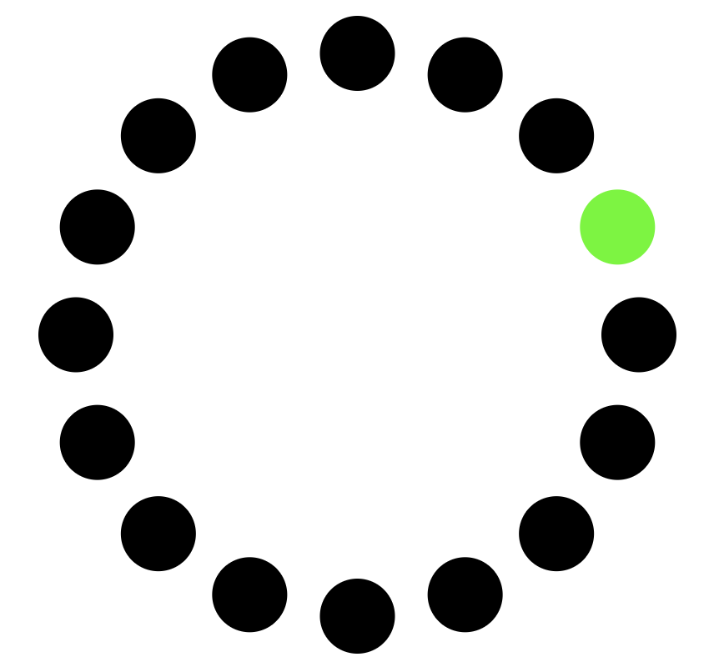

On Click of this different color target, the clicked target disappears and the target opposite to the clicked target becomes the different color, which the user has to click.

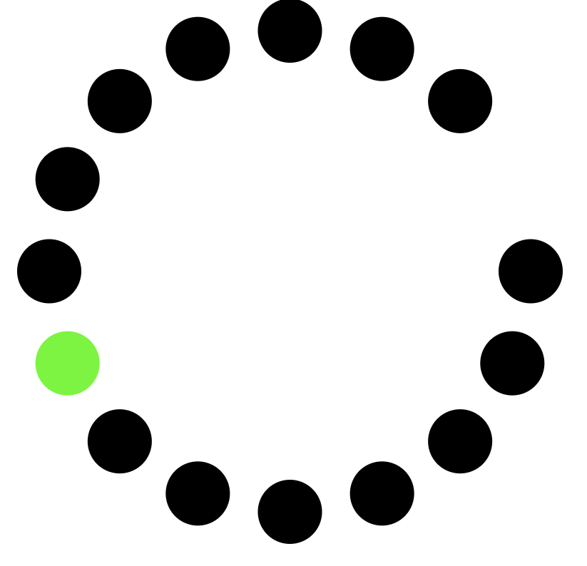

The user keeps clicking different color targets following a path to alternating targets clockwise around the circle until all the 16 targets are clicked (One Iteration).

On completion of one iteration, 16 concentric circular targets are drawn again having different width or having a different distance from the concentric center. As in the previous case one random target of the 16 targets is of a different color by default and the rest 15 targets are black.

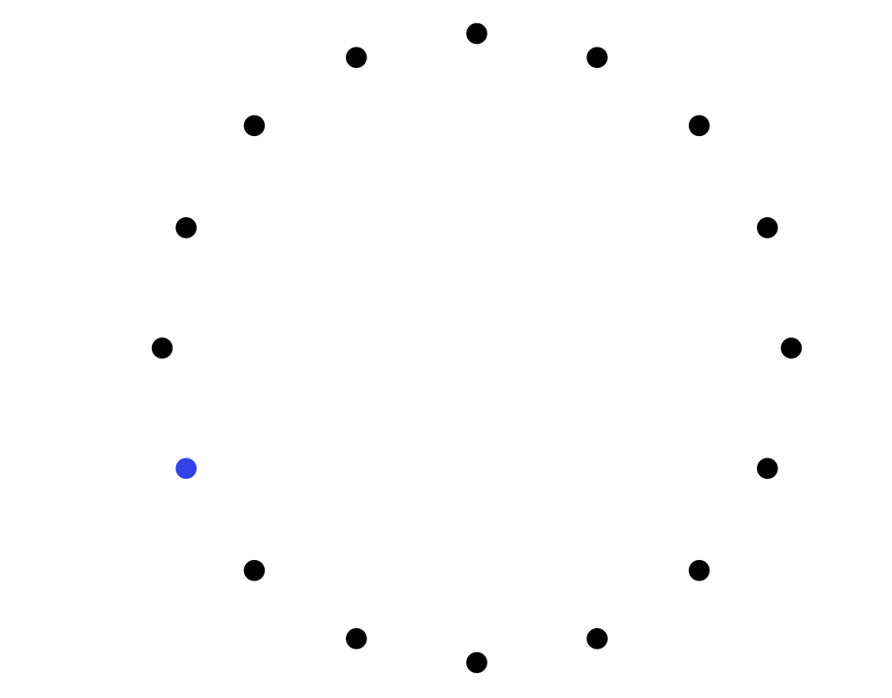

The user follows the same process by clicking the different color target by following alternating path to alternating targets clockwise around the circle. This entire process is repeated for 6 iterations.   
The iterations are designed such that there are two different target sizes and for each target size there are 3 different distances.

## Data Collection and Calculations made:

### While Performing Each Iteration:

#### Data Collection:

For each click on a target the user makes within one iteration the program collects the following data:

1. D = Distance between the starting point to the center of the target. Calculated using distance formula.
2. T = Time the user takes to complete the movement from start location to the target.
3. W (Width of Target) = 2*radius of the target.

#### Calculations Done:

Using the collected data, the following calculations are made:

1. ID (Index of Difficulty) = log ((D/W) + 1)

Each Distance(D) calculated for each click is pushed into a ‘distances’ array.   
Each times(T) calculated for each click on a target is pushed into a ‘times’ array.

The time taken and the distance moved to click the first target are ignored as the start of movement position is an outlier. This outlier position affects the users time taken to click the first target too.

Each Index of Difficulty(ID) calculated for each click (except click on first target) is pushed into an ‘IDs’ array.

#### Graphs Plotted:

1. The Time(T) Vs (Index of Difficulty) ID graph is plotted.

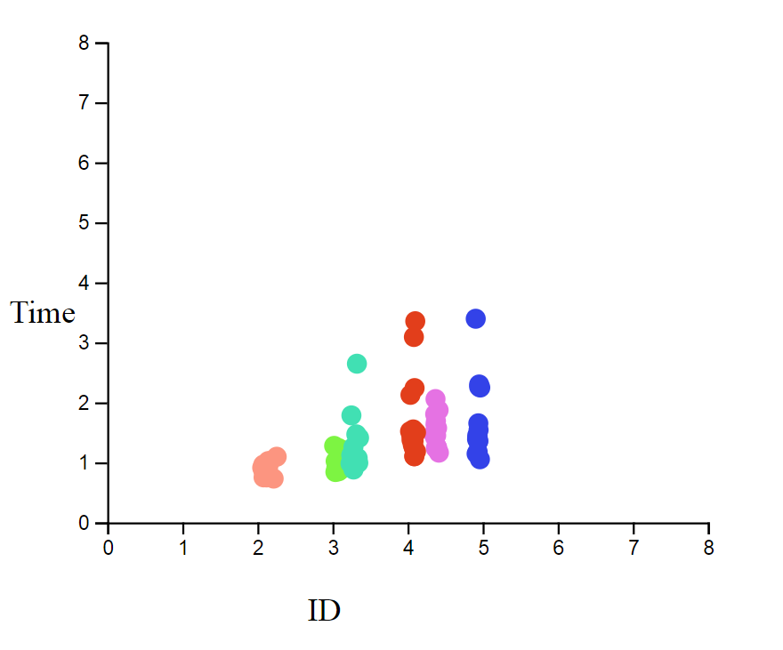

## On Completion of Each Iteration by user:

#### Calculations Done:

On completion of each iteration the following are calculated.

1. De = Average of all the distances(D). The mean movement distance from the start-of-movement position to the center of the target. This is calculated by taking average of all values in the ‘distances’ array.
2. MT= Average time to complete the movement. Average of all the times(T). This is calculated by taking average of all values in the ‘times’ array.
3. IDe = Index of Difficulty for the entire iteration = log((De/W) + 1)
4. W= 2*radius of the target.
5. Throughput (TP) = MT/IDe.
6. The regression coefficients ‘a’ and ‘b’ are calculated using the values in the ‘IDs’ array and the ‘times’ array

Equation: Y = a + bX.

Y: Time(T).   
X: Index of Difficulty (ID).

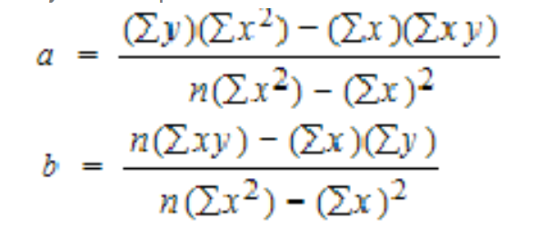

Each Index of Difficulty(IDe) calculated at the end of each iteration is pushed into an ‘IDeArray’ array.  
Each Average Time (MT) calculated at the end of each iteration is pushed into an ‘MTAarray’ array.

#### Graphs Plotted:

1. The MT Vs IDe graph is plotted.

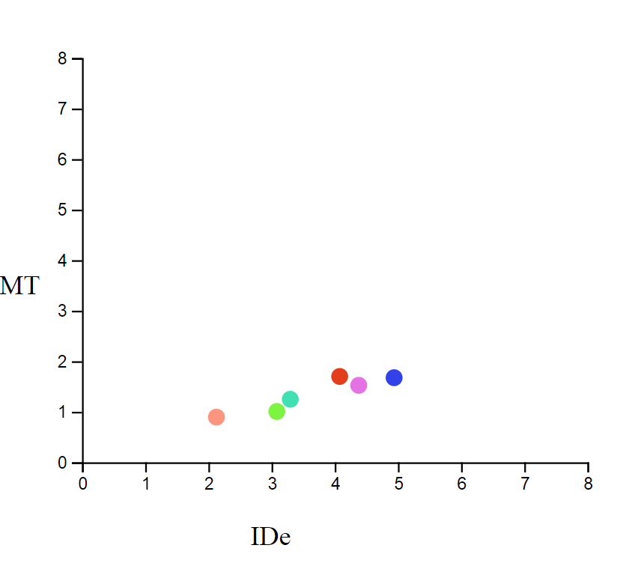

1. The Throughput vs IDe graph is plotted.

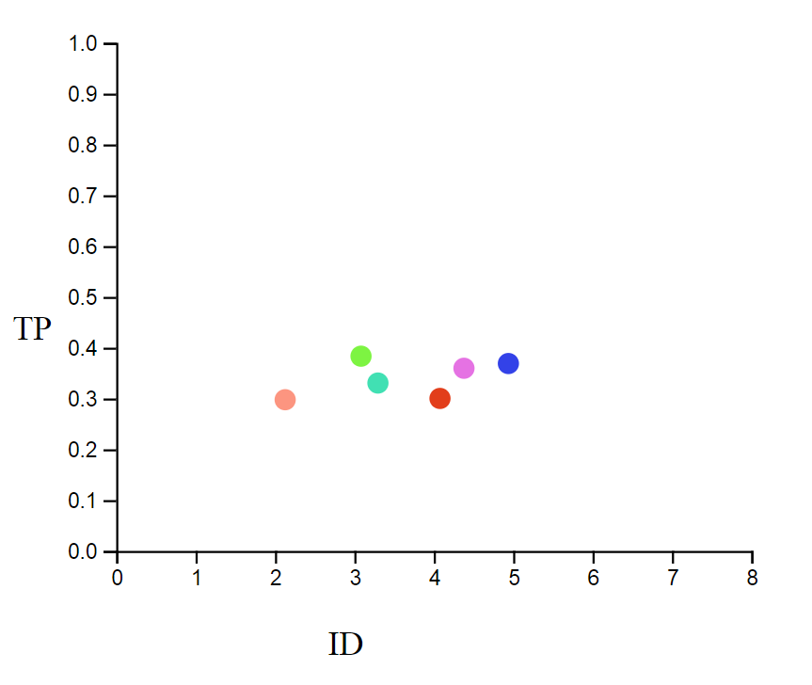

### End of Experiment (When User Completes 6 Iterations):

On completion of the experiment following is calculated:

1. The regression coefficients ‘a’ and ‘b’ using all the values in the ‘IDeArray’ (Each IDe calculated at the end of each iteration) and all the values in the ‘MTArray’ (Each MT calculated at the end of each iteration).

Equation: Y = a + bX.

Y: Time(MT).  
X: Index of Difficulty (IDe).

## Analysis of Data:

For each target click in an iteration, the movement time is noted and the distance from the start to the center of target is noted. Also the ID is calculated using the Shanon’s formula. The graph for ID vs Time is plotted. All the data dump can be found in the excel attached along with the submission.

### User 1:

1. Graph of ID Vs Time for each click on the target (The Clicks made by user in each iteration are noted in different colors.):

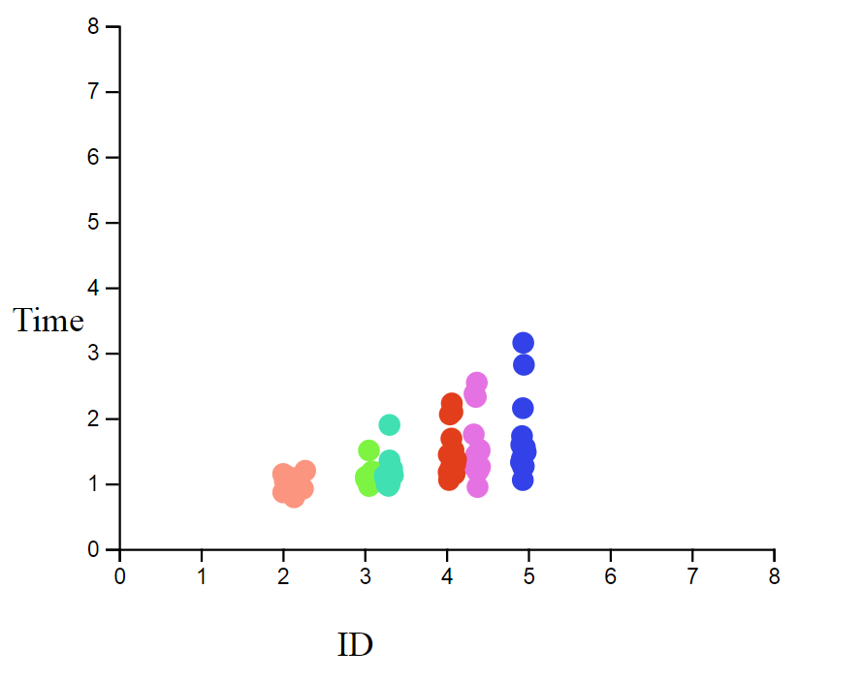

1. Following is the data gathered and calculated for user 1 at the end of each iteration.

|  |  |  |  |  |  |  |
| --- | --- | --- | --- | --- | --- | --- |
| **Iteration** | **Target Width** | **Ave Distance** | **IDe** | **MT** | **Coefficient a** | **Coefficient b** |
| 1 | 40 | 296.35 | 3.0719235 | 0.975 | -0.0004943 | 0.3125683 |
| 2 | 10 | 158.61 | 4.0756478 | 1.3535333 | 0.0002936 | 0.3294324 |
| 3 | 40 | 134.44 | 2.1247091 | 0.9786 | 0.0015898 | 0.4528126 |
| 4 | 10 | 198.32 | 4.3807603 | 1.2828 | -0.000112 | 0.2903712 |
| 5 | 10 | 297.89 | 4.9443718 | 1.8332667 | 0.0005554 | 0.369072 |
| 6 | 40 | 351.74 | 3.2918547 | 0.9979333 | -8.042E-05 | 0.2988713 |

1. Graph of IDe Vs MT for User 1:

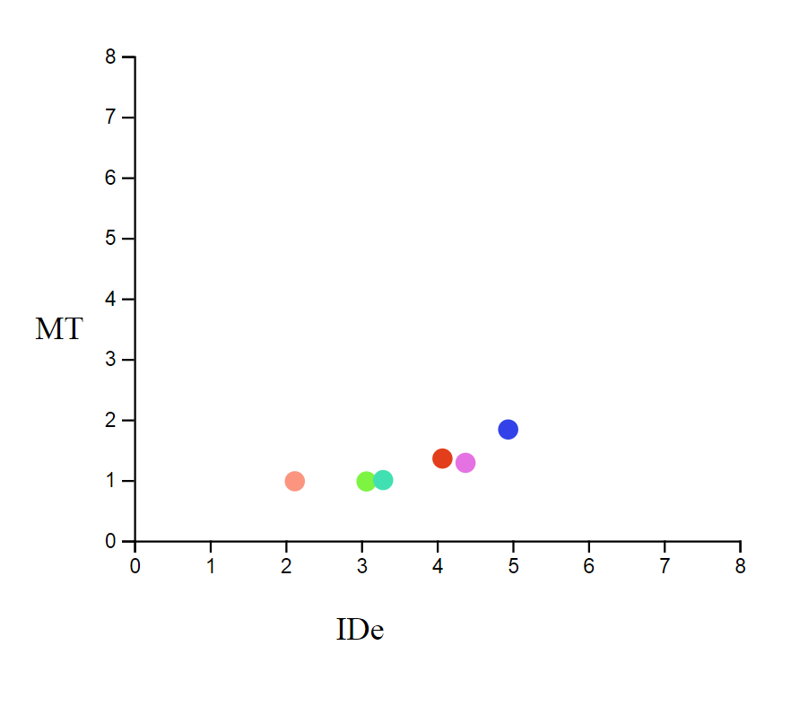

1. Fitting of the graph and calculating the regression coefficients for user 1:

**Coefficient a:** 0.1901358

**Coefficient b:** 0.2869131

1. Graph of IDe Vs Throughput for User 1:

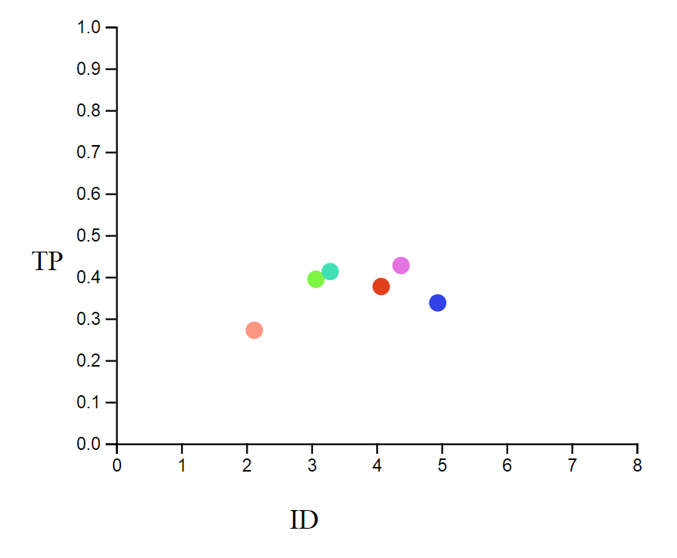

### User 2:

1. Graph of Time Vs ID for each click on the target (Different colors for each case/iterations):



1. Following is the data gathered and calculated for user 1 at the end of each iteration.

|  |  |  |  |  |  |  |
| --- | --- | --- | --- | --- | --- | --- |
| **Iteration** | **Target Width** | **Avg Distance** | **IDe** | **MT** | **Coefficient a** | **Coefficient b** |
| 1 | 40 |  | 3.074489 | 1.0993333 | -7.553E-05 | 0.353052 |
| 2 | 10 |  | 4.07283 | 1.4896667 | -0.0001845 | 0.363217 |
| 3 | 40 |  | 2.120469 | 0.9779333 | -0.0010146 | 0.4534817 |
| 4 | 10 |  | 4.378446 | 1.5356 | -0.0009828 | 0.3484553 |
| 5 | 10 |  | 4.942805 | 1.686 | 0.0001557 | 0.3393066 |
| 6 | 40 |  | 3.296385 | 1.1538667 | 0.0003033 | 0.3460624 |

1. Graph of IDe Vs MT for User 2 at the end of each Iteration:

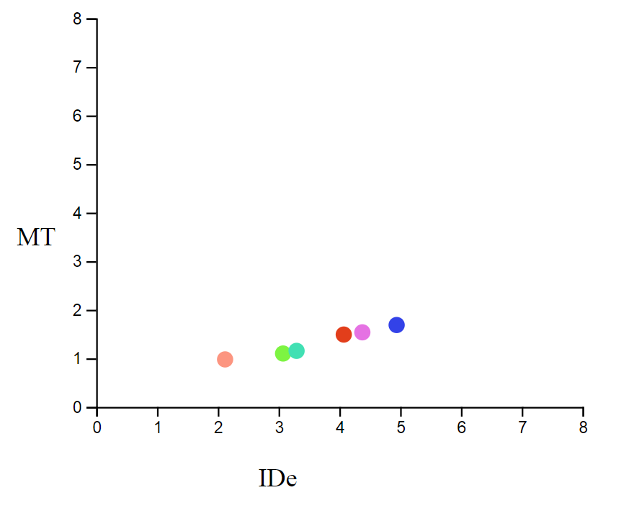

1. Fitting of the graph and calculating the regression coefficients for user 2:

**Coefficient a:** 0.3295

**Coefficient b:** 0.2725

1. Graph of IDe Vs Throughput for User 2 at the end of each Iteration:

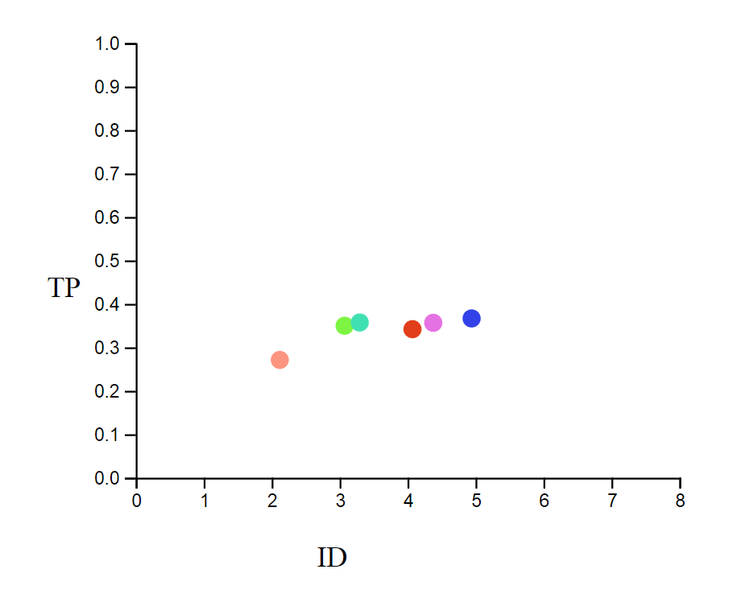

## Conclusion:

If the Distance increases for a constant target width and if the width decreases for a constant distance the Index of Difficulty increases.

From the experiment we see that as the ratio of the Distance and the Target increases, the Index of Difficulty also increases for both the users. This can also be supported by the higher average time required to hit the targets for the users when the above ratio is higher. The calculations and graphs support Fitt’s law.