- What is FastAPI?
FastAPI is a Python framework that allows developers to create APIs with minimal code while maintaining high performance and readability. It uses Python type hints to automatically validate incoming data and generate interactive API documentation.
Example applications:
- Web applications
- Mobile app backends
- Machine Learning model deployment
- Microservices
- Authentication systems
- CRUD applications

- Why FastAPI Over Other Frameworks?
Feature | FastAPI | Flask | Django
Performance | Very High (ASGI based) | Moderate | Moderate
Learning Curve | Easy | Easy | Medium
Automatic Validation | Yes | No | Limited
Interactive API Docs | Built-in | Requires extensions | Requires extensions
Async Support | Native | Limited | Available but heavier
Type Hint Support | Excellent | Basic | Basic
Best For | APIs & Microservices | Small Web Apps | Large Full-Stack Apps

Advantages of FastAPI
1. High Performance
FastAPI is one of the fastest Python frameworks because it uses asynchronous programming and the ASGI server architecture.
2. Automatic Data Validation
Using Pydantic, FastAPI automatically validates incoming JSON data, reducing bugs and improving reliability.
3. Automatic Documentation
FastAPI automatically generates API documentation using Swagger UI and ReDoc.
Example:
- Swagger Docs: http://127.0.0.1:8000/docs
- ReDoc: http://127.0.0.1:8000/redoc
4. Easy to Learn
Its syntax is clean, concise, and similar to standard Python.
5. Asynchronous Programming
FastAPI supports async and await, allowing multiple requests to be handled efficiently.
6. Better Developer Productivity
Less boilerplate code means faster development and easier maintenance.

- Conclusion
FastAPI is a powerful and modern Python framework for API development. It combines speed, simplicity, automatic documentation, and built-in validation, making it an excellent choice for modern backend development. Compared to Flask and Django, FastAPI offers better performance, easier API development, and native support for asynchronous programming.

Basic CRUD Operations Using JSON Data in FastAPI
Objective
Create a simple REST API using FastAPI that performs CRUD (Create, Read, Update, Delete) operations on predefined JSON data stored in memory.

What is CRUD?
CRUD represents the four basic database operations:
- Create – Add new data
- Read – Retrieve existing data
- Update – Modify existing data
- Delete – Remove existing data

Sample JSON Data
students = [
{"id": 1, "name": "Shreyas", "course": "Computer Engineering"},
{"id": 2, "name": "Rahul", "course": "AI & ML"}
]

Complete FastAPI Code
from fastapi import FastAPI, HTTPException
from pydantic import BaseModel

app = FastAPI()

# Predefined JSON Data
students = [
{"id": 1, "name": "Shreyas", "course": "Computer Engineering"},
{"id": 2, "name": "Rahul", "course": "AI & ML"}
]

# Request Model
class Student(BaseModel):
id: int
name: str
course: str

# READ - Get all students
@app.get("/students")
def get_students():
return students

# READ - Get one student
@app.get("/students/{student_id}")
def get_student(student_id: int):
for student in students:
if student["id"] == student_id:
return student
raise HTTPException(status_code=404, detail="Student not found")

# CREATE
@app.post("/students")
def add_student(student: Student):
students.append(student.dict())
return {"message": "Student added successfully"}

# UPDATE
@app.put("/students/{student_id}")
def update_student(student_id: int, updated_student: Student):
for index, student in enumerate(students):
if student["id"] == student_id:
students[index] = updated_student.dict()
return {"message": "Student updated successfully"}

raise HTTPException(status_code=404, detail="Student not found")

# DELETE
@app.delete("/students/{student_id}")
def delete_student(student_id: int):
for index, student in enumerate(students):
if student["id"] == student_id:
students.pop(index)
return {"message": "Student deleted successfully"}

raise HTTPException(status_code=404, detail="Student not found")

Showing all endpoints
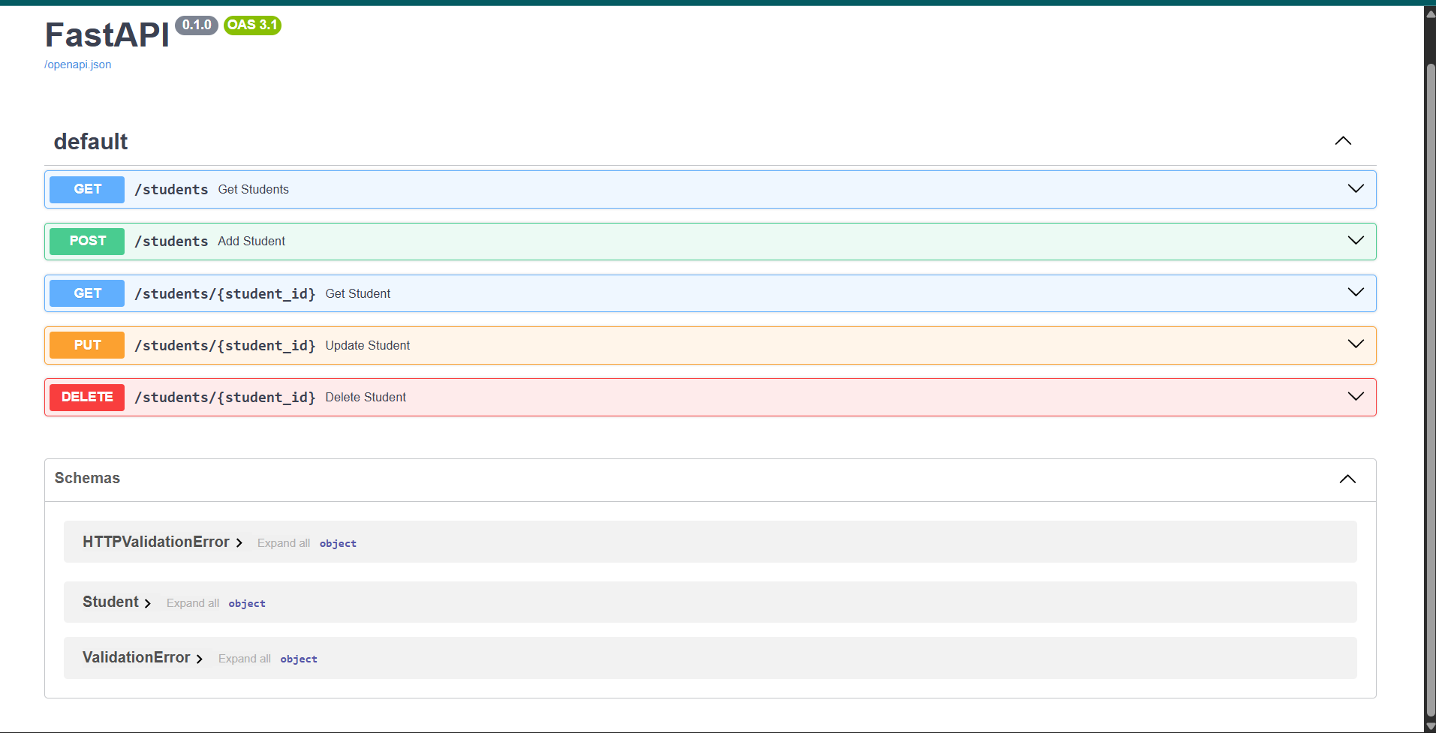
CREATE (adding user)
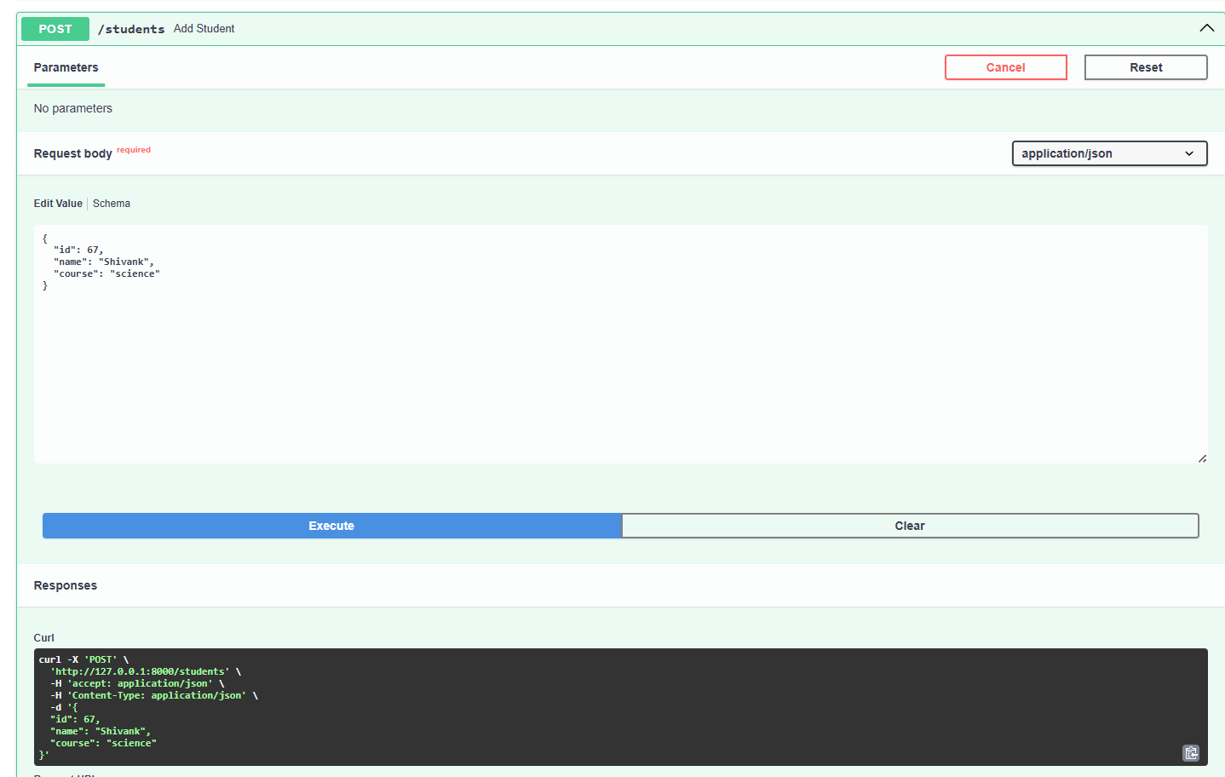
READ (Viewing users)
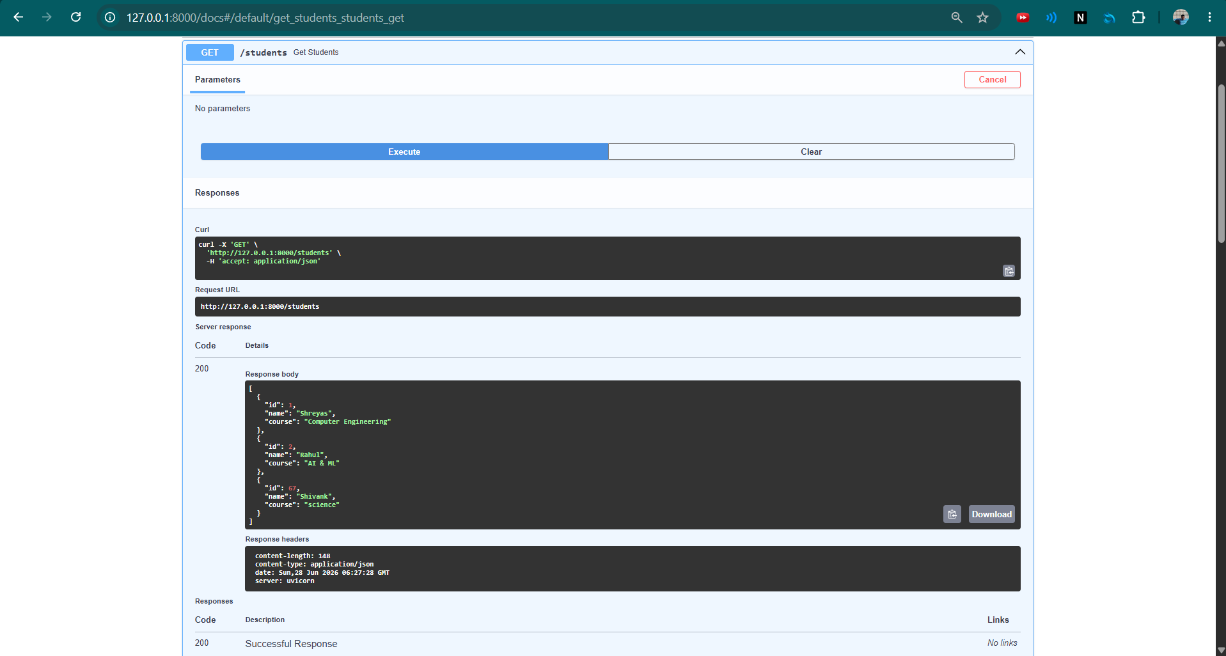
PUT (edit)
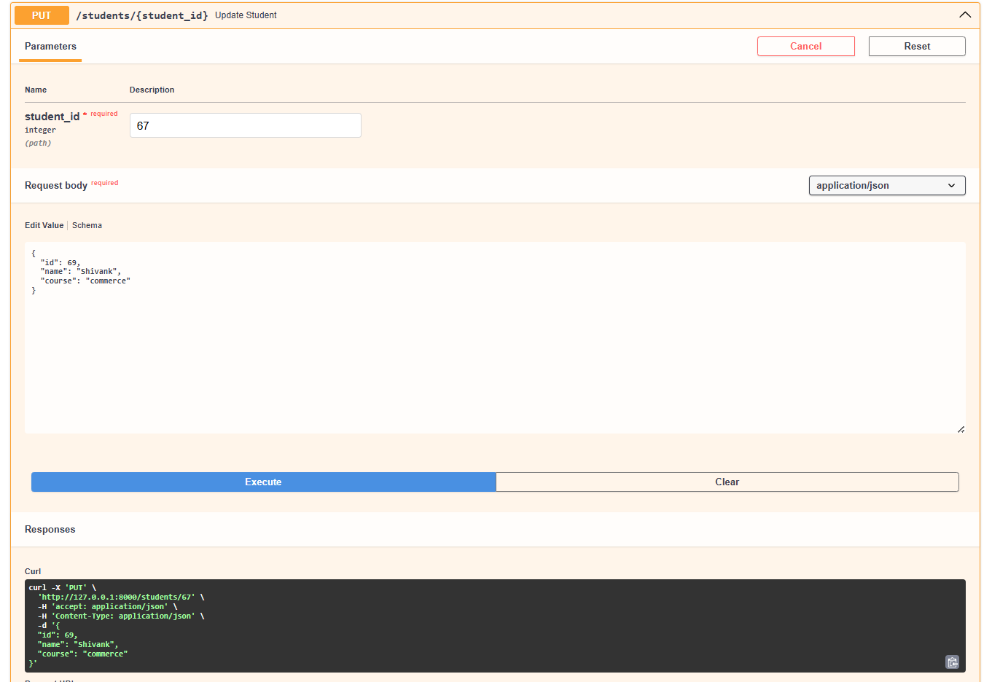
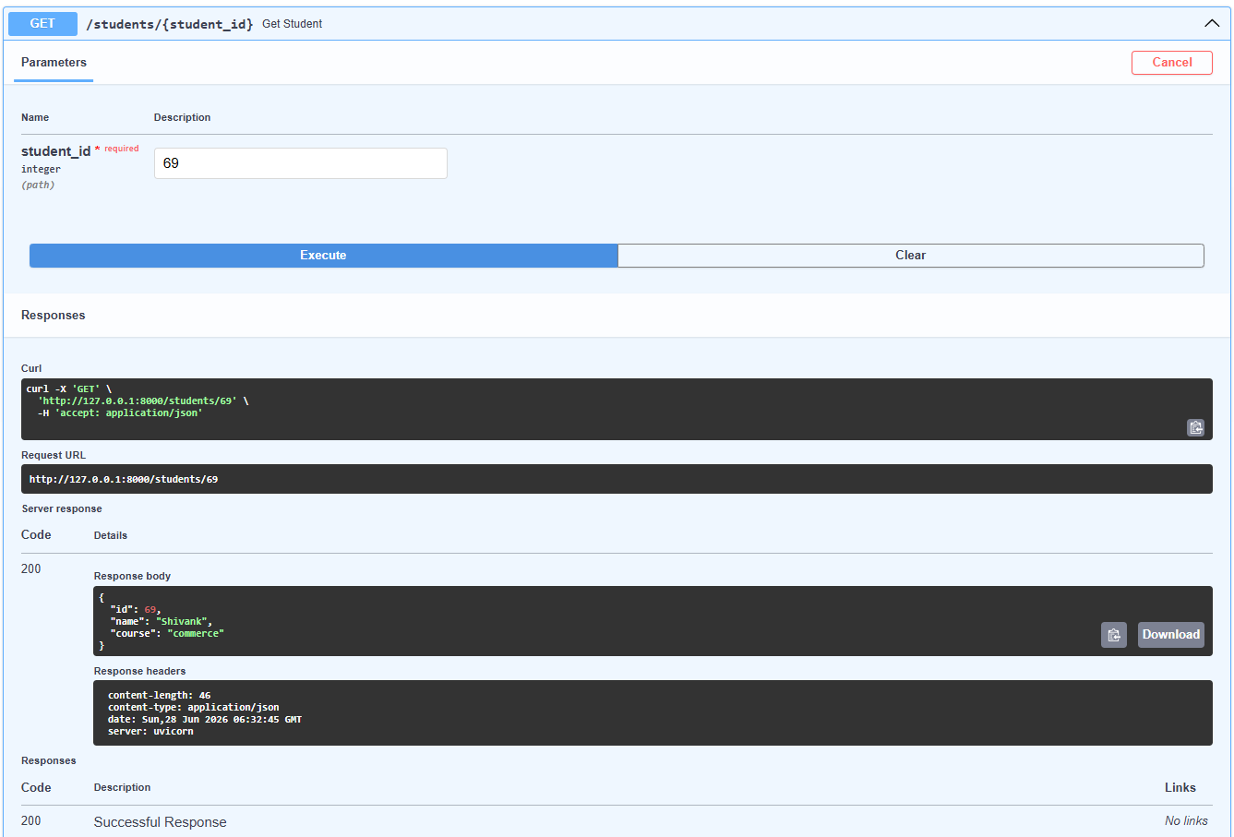
DELETE (remove entry)
