**Contents**

**Acknowledgement** iv

**Abstract**  1

1. **Introduction**  2
   1. Background . . . . . . . . . . . . . . . . . . . . . . . . . . . . . . . . . . . . . . .. 3
   2. Problem Definition. . . . . . . . . . . . . . . . . . . . . . . . . . . . . . . . ... 4
   3. Scope . . . . . . . . . . . . . . . . . . . . . . . . . . . . . . . . . . . . . . . . . . . . 4
   4. Objective . . . . . . . . . . . . . . . . . . . . . . . . . . . . . . . . . . . . . . . . . 4
   5. Summary . . . . . . . . . . . . . . . . . . . . . . . . . . . . . . . . . . . . . . . . . 4

**2. System Analysis**  5

2.1 Literature Survey . . . . . . . . . . . . . . . . . . . . . . . . . . . . . . . . 5

2.1.1 Need of Proposed System . . . . . . . . . . . . . . . . . 5

2.2 Proposed System . . . . . . . . . . . . . . . . . . . . . . . . . . . . . . . . 7

2.2.1 Illustration . . . . . . . . . . . . . . . . . . . . . . . . . . 9

2.3 Feasibility Study . . . . . . . . . . . . . . . . . . . . . . . . . . . . . . . . . 10

2.3.1 Economical Feasibility . . . . . . . . . . . . . . . . . . . . 10

2.3.2 Operational Feasibility . . . . . . . . . . . . . . . . . . . . 10

2.3.3 Technical Feasibility . . . . . . . . . . . . . . . . . . . . . . . . . . . 11

2.4 Summary . . . . . . . . . . . . . . . . . . . . . . . . . . . . . . . . . . . . . 11

**3. System Requirement Specification** 12

3.1 Hardware Requirement . . . . . . . . . . . . . . . . . . . . . . . . . . . . . ….. 12

3.2 Software Requirement: . . . . . . . . . . . . . . . . . . . . . . . . . . . . . . 12

3.3 Functional Requirement . . . . . . . . . . . . . . . . . . . . . . . . . . . . . 13

3.3.1 Input and Output . . . . . . . . . . . . . . . . . . . . . . . . . . . . . 13

3.3.2 Exception Handling . . . . . . . . . . . . . . . . . . . . . . . . . . . . 13

3.3.3 Database Requirement . . . . . . . . . . . . . . . . . . . . . . . . . . 13

3.4 Non Functional Requirement . . . . . . . . . . . . . . . . . . . . . . . . . . . 13

3.5 Summary . . . . . . . . . . . . . . . . . . . . . . . . . . . . . . . . . . . . . 14

**4. System Design**  15

4.1 System architecture . . . . . . . . . . . . . . . . . . . . . . . . . . . . . . . . 15

4.2 UML Diagrams . . . . . . . . . . . . . . . . . . . . . . . . . . . . . . . . . . 16

4.2.1 Use case diagram . . . . . . . . . . . . . . . . . . . . . . . . . . . . . 16

4.2.2 Class diagram . . . . . . . . . . . . . . . . . . . . . . . . . . . . . . . 17

4.2.3 Sequence diagram . . . . . . . . . . . . . . . . . . . . . . . . . . . . . 17

4.2.4 Activity diagram . . . . . . . . . . . . . . . . . . . . . . . . . . . . . 19

4.3 DFD-Data Flow Diagram 19

4.4 Summary . . . . . . . . . . . . . . . . . . . . . . . . . . . . . . . . . . . . . 20

**5. Implementation** 21

5.1 Implementation Details . . . . . . . . . . . . . . . . . . . . . . . . . . . . . . 21

5.2 Implementation Environment . . . . . . . . . . . . . . . . . . . . . . . . . . 22

5.3 Flow of System Development . . . . . . . . . . . . . . . .. . . . . . . . . . . 22

5.3.1 Algorithm . . . . . . . . . . . . . . . . . . . . . . . . . . . . . . . . . 22

5.4 System Testing . . . . . . . . . . . . . . . . . . . . . . . . . . . . . . . . . . 23

5.4.2 Test Cases . . . . . . . . . . . . . . . . . . . . . . . . . . . . . . . . . 24

5.5 Summary . . . . . . . . . . . . . . . . . . . . . . . . . . . . . . . . . . . . . 25

**6. Schedule Of Work** 26

6.1 Project Management . . . . . . . . . . . . . . . . . . . . . . . . . . . . . . . 26

**7. Conclusion And Future Scope**  28

7.1 Future Scope . . . . . . . . . . . . . . . . . . . . . . . . . . . . . . . . . . ..

7.2 Drawback. . . . . . . . . . . . . . . . . . . . . . . . . . . . . . . . . . . . . 28

7.3 Conclusion . . . . . . . . . . . . . . . . . . . . . . . . . . . . . . . . . . . . . 28

**A User Manual** 29

**Bibliography** 3

**Abstract:-**

Today, India ranks second worldwide in farm output. Agriculture might not be the first industry you think of when it comes to mobile app farming. Farming has a tremendous amount of potential for innovation and change. While manual labor is huge part of the work, a lot of crop farmer’s work is manual in nature. However, mobile app will be enabling them to become a little more hand-off. Agriculture app can make these processes much more efficient and even successful. Agricultures are the mainstay of the state of the main occupation of the people.

Thus we have decided to create this project “ the Intelligent Farmer” android application. This application will be design on agile development process that focuses on current market trade.

“The Intelligent Farmer” is a android based application which provides information to farmers regarding different crops and farming practices and other agricultural products. It is dynamic and interactive to take in the feedback and other input from the end users and can guide people regarding the different procedures that need to be adopted. This project shows a simulation of live environment which takes different aspects into consideration like market-demand and-supply, production forecast , fertilizer preferences etc.

1. INTRODUCTION

As the android is the current trend in the today’s world, each and every domain has android based applications. But it is relatively less advancement in the technology in the field of agriculture. In this silicon era, where everything is developed as a software and agriculture being the base of occupation of our nation, it is necessary that we have a software impact in this field as well. “The Intelligent Farmer” is a revolutionary android based agriculture mobile application, which helps user to take informed decisions by accessing customized agricultural information related to their need. Our agricultural app will also provide latest technology, tools, methods, price and fertilizer. This project facilitates dynamic updating and acts as guideline for farmers. This app shows a simulation of a live environment which takes different aspects into consideration like practices, technology, machinery and fertilizer preferences etc. An analysis of the current technical trend of our country clearly indicates that there will be many multimedia based gadgets which will be available at very affordable cost and so such products will enable even common people like farmers to stay connected. This is the intent with which this product has been developed. A strategically planned implementation of this product will have wide-spread benefits across the agricultural domain.

**1.1 Background:**

today’s the mobile phone is used worldwide. As the price of smart phone is decreasing, its popularity is increasing day by day. Moreover, android is the mobile operating system used in smart phone, most of its applications are freely available. The use of smart phone is increase in every sector of business, education, etc. “The Intelligent Farmer” system that will provide the detail information of fruits, vegetables and flowers in picture and textual format. This system can provide information using android smart phone from anywhere This explain about Android mobile use in Agriculture is as the core components to more helpful to increase productivity of crops and indirectly to increase GDP of India reduce poverty. The main challenges for crop selection traditional methods. This is android application which will be useful for farmers & agricultural institutes for cultivation of various kind of crops in various type of atmosphere. This smart phone app is easy to use and in affordable cost which will suggest most probable matching crops to people according to weather condition. This discusses about Indian agriculture based developing country. Information dissemination to the knowledge intensive agriculture sector is upgraded by mobile-enabled information services and rapid growth of mobile telephony. It bridge the gap between the availability of agricultural input and delivery of agricultural outputs and agriculture infrastructure. Apart from this, they are also useful in our day-to-day activities such as education, medical and agriculture. This paper explores how Android Apps of agricultural services have impacted the farmers in their farming activities.

1.2 Problem Definition:

“The Intelligent Farmer” is a  android based application which provides information to farmers regarding different crops rates and their scheduling.

And it provide different market rates of crops, Ask expert feature for asking

Various problem related to a farming. Also this app will help farmer for knowing

The various scheme, news of government related farming

**1.4 Scope of Work**

* This android application provides information about the Crops.
* Farmer registration is included in android application for farmer security. System provides OTP at the time of login.
* It also helps in case farmer forgot his password, he will be able to login just by entering his registered mobile number & the same number on the OTP received.
* This Application provides Daily News related to agriculture.
* Every day farmer get about daily rate of crop.
* Farmers have knowledge of new sophisticated technicians.
* Farmers can get advice from agricultural related consultants**.**
* The admin manages the backed side.
* Admin manage News details.
* Admin could manage daily rate about crops.
* Admin also manages question from farmer and answer it.
* Admin also generates reports.

**1.5 Objectives of System:**

* The first objective is to implement various mobile applications for farming that enable simple and efficient input of data during the execution of farmer’s daily activities. Based on our existing prototypes we will implement a scenario-oriented user interface which will enable farmers to have a sequenced order of daily activities.
* Provide online daily news about agriculture
* Implementing the quality application that gives farmer better experience.
* Provide location wise daily rate of crops.
* Farmer ask question to expert and get answer of their query.
* Provide knowledge about new technic related to agriculture.
* To generate reports.
* To store all information of farmer securely.
* Provide communication medium to farmer.

**2) SYSTEM ANALYSIS**

2.1 Literature Survey:

|  |  |  |  |
| --- | --- | --- | --- |
| **Sr. no** | **Title** | **Authors name** | **Year** |
| 1 | **Smart farming system using sensors for agricultural task automation** | [Chetan Dwarkani M](https://ieeexplore.ieee.org/author/37085635008),  [Ganesh Ram R](https://ieeexplore.ieee.org/author/37085639489) | 17 December 2015 |
| 2 | **IOT Based Monitoring System in Smart Agriculture** | [S. R. Prathibha](https://ieeexplore.ieee.org/author/37085521801),  [Anupama Hongal](https://ieeexplore.ieee.org/author/37086238870),  [M. P. Jyothi](https://ieeexplore.ieee.org/author/37086240189) | 26 October 2017 |

2.1.1 Need of Proposed System

* There is no computerized system for the farmer to sell their product. Currently, the farmer goes to nearest market handover his crops to a particular agent, agent ask the farmer to visit the market after a specific time to collect the cash earned out of the sold crops.
* Agent sells the crops to another agent or a dealer at the cost of that market. Every Agent tries to cuts his commission out of that. There is no way for farmer to know about the deal and the exact amount at which their crops was sold. There is no transparency.
* No facility is present for the farmers to know the crops rates at different markets

2.2 Proposed System:

The proposed system is to be designed in such manner that it eliminates all problems, limitations and shortcoming of the existing system. The proposed system will have the following features:

* Farmer Authorization-

This feature will allow Farmer to register for the system. After inserting all registration details display successful message.

* Maintain Farmer details-

This Feature will allow the maintain Farmer Details.

* Admin Panel
* Manage farmers
* Manage News
* Manage Daily Rate
* Manage Question from farmer and answer it
* Manage Report
* Manage notification
* Farmer
* Registration
* View NEWS
* View Daily Rate of Crops
* Ask Question to expert
* Update profile and view order history
* Communication

2.2.1 Illustration:

“The Intelligent Farmer” is a native Android application.

A native application is a software program that is developed for use on a platform or device.

The two main mobile OS platforms are Android Studio and Google's Android. Native apps are written in the code preliminarily used for the device and its OS. For example, developers write Android applications in Android Studio, while they create Android-native apps in Java.

Because a native app is built for use on a device and its OS, it can use device-specific hardware and software. Native apps can provide optimized performance and take advantage of the latest technology, such as a GPS, compared to web apps or mobile cloud apps developed to be generic across multiple systems.

Native applications are apps developed with a specific platform in mind. For example, you could have a native mobile application that is intended to run exclusively in Android, the operating system used by Android mobile devices. Native apps have a tendency to take full advantage of the features of a given operating system, but it can take more time and effort to keep them up to date. For example, an Android app must continuously evolve to make use of new hardware features on Android mobile handsets. Native mobile app development is great for products targeted to specific types of mobile users.

**Native application pros and cons**

Advantages of native applications include:

* Broad functionalities due to using the capabilities of the underlying device;
* Fast and responsive software performance;
* Push notifications;
* A UI that better matches with user experiences of the OS; and
* Quality assurance though ratings in application stores.

Disadvantages of native applications include:

* Multiple code bases because each device has its own version of the app;
* The cost for additional developers to build and manage a code base for each

platform

* Time spent on multiple builds for separate platforms in each feature update.

2.3 Feasibility Study:

Feasibility of the project goes into much more detail

And instead of approximation, we actually sample document and more refined estimate. In this we trace the flow of information through the

System and spend time with various individual who originate and

Process the data. Feasibility deals with issue of what is practicable and

And possible. Feasibility study and risk analysis are related in many

ways.

I f project risk is great, the feasibility of producing quality software

is reduced. During software engineering we concentrate on the following

primarily areas as given below.

2.3.1 Economical Feasibility:

Cost and be benefit of our project is more as there is no

Special hardware or software requirement.

2.3.2 Operational Feasibility:

2.3.3 Technical Feasibility:

The following points can be covered under technical feasibility.

1. Resource Risk: as we are using the easily available and existing

resources risk is very less.

1. Development Risk: in our project less development risk, as the

elements of the project can be design in such way what the necessary

function and performance are achieved within the constraints undercover

2.4 Summary

**3)** **System Requirement Specification**

3.1 Hardware Requirement:

Android tablet:-

Android OS- 4.0 and above

RAM-512MB

Internal Storage 10mb

Wi-Fi or Mobile Internet Connection

Computer:-

RAM:- 2GB

Processor:-Core2 duo

Operating System:- Windows OS

Internet Connection

Hard Disk:- 40GB

3.2 Software Requirement:

Android Studio

C#.net

SQLite Manager

3.3 Functional Requirement

3.3.1 Input and Output

3.3.2 Exception Handling

3.3.3 Database Requirement

3.4 Non Functional Requirement

3.5 Summary

**4) System Design**

4.1 System architecture:

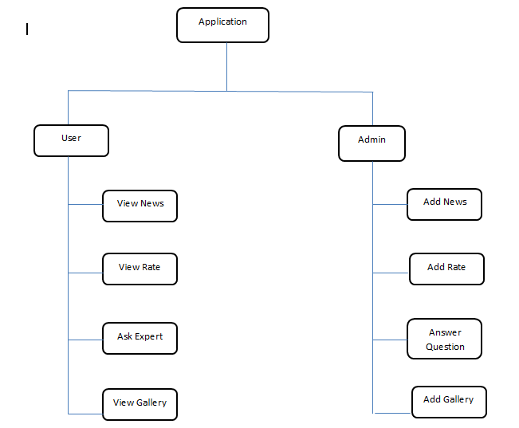

In the system there are 6 Modules:

1. Registration
2. Daily News
3. Daily Rates of Crops
4. Ask Experts
5. Gallery
6. Scheduling

**1).Registration:**

1. Task :

To Give Registration Facility

1. Process :

In this Module, The new user has to register his/her contact and Login through the OTP and then use the facility of the App.

**2).Daily News:**

1. Task :

To Show the News

1. Process :

In this Module, Daily news related to agriculture and keep updating The news list

3.**Daily Rates of Crops:**

1. Task :

To Show the Crops daily rate

1. Process:

In this Module, Shows location wise daily rates of crops and That location shows the minimum rate of crops and maximum Rate of crops

4. **Ask Experts:**

1. Task:

To ask questions to the expert

1. Process:

In this Module, Ask any question to experts related to agricultureAnd get answer from them

1. **Gallery:**

1. Task:

To show Gallery of Crops

1. Process:

In this Module, Shows gallery related to Expert quality crops.

**6). Scheduling**

1. Task:

To show the Information about Different Crops.

1. Process:

In this Module, Show detailed information about crops.

4.2 UML Diagrams

4.2.1 Use case diagram

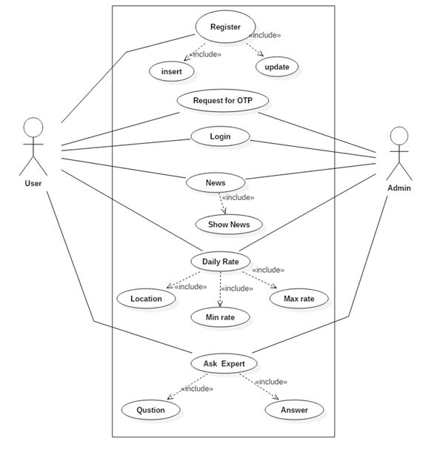

4.2.2 Class diagram

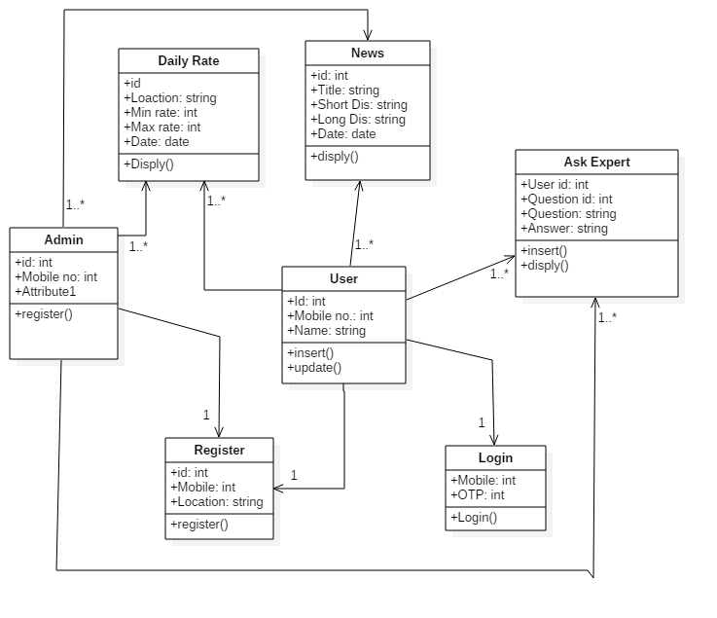

4.2.3 Sequence diagram

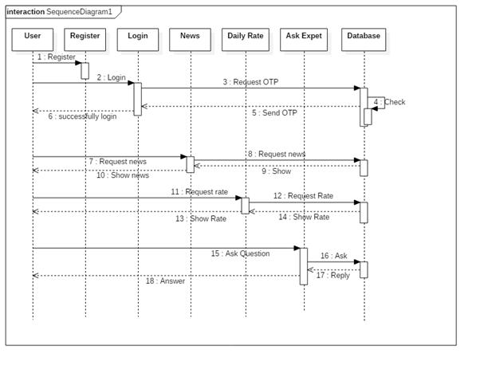

4.2.4 Activity diagram

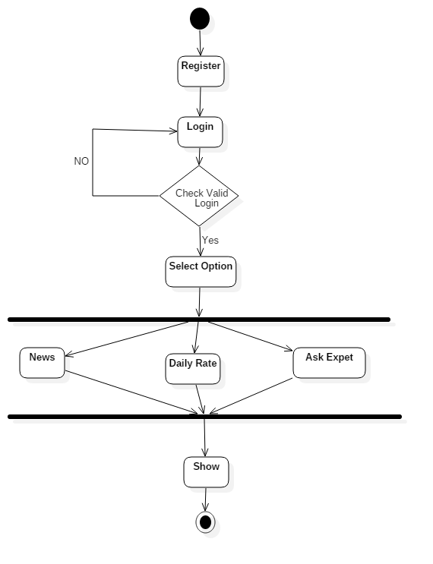

**High Level Activity Diagram**

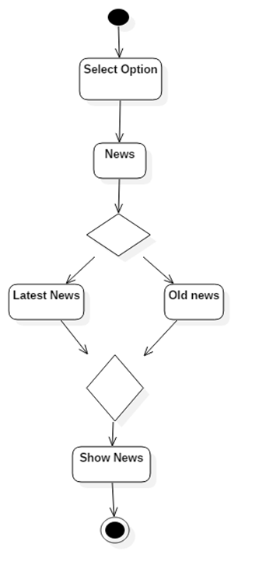

**Activity diagram for News**

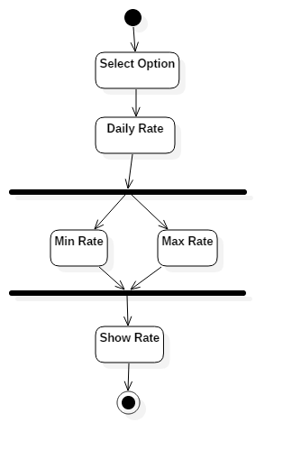

**Activity diagram for Daily rate**

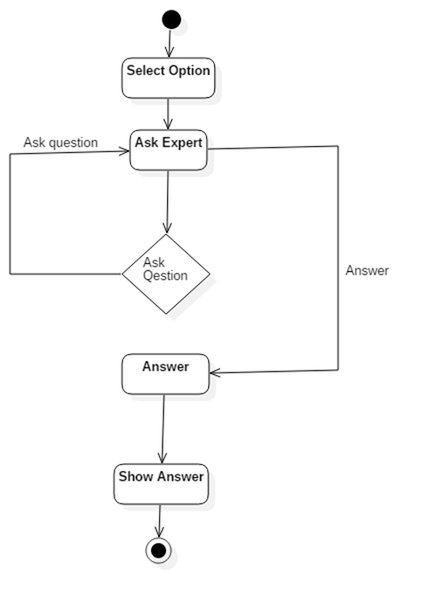

**Activity diagram for Ask Expert**

4.3 Summary

**5) Implementation**

5.1 Implementation Details:

The third phase of the project management life cycle. The implementation phase involves putting the project plan into action. It’s here that the project leader will coordinate and direct project resources to meet the objectives of the project plan. As the project unfolds, it’s the project leader job to direct and manage each activity, every step of the way. That’s what happens in the implementation phase of the project life cycle: you follow the plan you’ve put together and handle any problems that come up.

The implementation phase is where our team actually do the project work to produce the deliverables. The word “deliverable” means anything our project delivers. The deliverables for our project include the android application “The intelligent farmer”.

For the Implementation of project we divide project into six modules.

This is a dynamic application that’s why for providing interface between application and database we used rest API ( Application programming Interface).The all rest API is developed in Asp.net

5.2 Implementation Environment:

**Android: -**

Android powers hundreds of millions of mobile devices in more than 190 countries around the world. It's the largest installed base of any mobile platform and growing fast—every day another million farmers power up their Android devices for the first time and start looking for apps, games, and other digital content.

Android gives you a world-class platform for creating apps and games for Android farmers everywhere, as well as an open marketplace for distributing to them instantly.

Android’s openness has made it a favorite for consumers and developers alike, driving strong growth in app consumption. Android farmers download more than 1.5 billion apps and games from Google Play each month.

**Android Framework:-**

Android gives us everything we need to build best-in-class app experiences. It gives us a single application model that lets we deploy our apps broadly to hundreds of millions of farmers across a wide range of devices—from phones to tablets and beyond.

Android also gives us tools for creating apps that look great and take advantage of the hardware capabilities available on each device. It automatically adapts our UI to look its best on each device.

**SQLITE:-**

SQLITE is used to manage the backend for database. SQLite Database has methods to create, delete, execute SQL commands, and perform other common database management tasks.

SQLite is an Open Source database. SQLite supports standard relational database features like SQL syntax, transactions and prepared statements. The database requires limited memory at runtime (approx. 250 KByte) which makes it a good farmer did ate from being embedded into other runtimes.

SQLite supports the data types TEXT (similar to String in Java), INTEGER (similar to long in Java) and REAL (similar to double in Java). All other types must be converted into one of these fields before getting saved in the database. SQLite itself does not validate if the types written to the columns are actually of the defined type, e.g. you farmer write an integer into a string column and vice versa.

SQLite allows use of the database management classes that an application would use to manage its own private database. Applications use these classes to manage private databases. While creating a content provider, probably these classes will be used to create and manage your own database to store content. Android ships with SQLite version 3.4.0

While working with data sent by a provider, these SQLite classes are not used but instead the generic android. Database classes are used.

Android ships with the sqlite3 database tool in the tools/ folder. Which farmer be used to browse or run SQL commands on the device by typing sqlite3 in a shell window.

**C#.net:-**

C# is an elegant and type-safe object-oriented language that enables developers to build a variety of secure and robust applications that run on the .NET Framework. You can use C# to create Windows client applications, XML Web services, distributed components, client-server applications, database applications, and much, much more. Visual C# provides an advanced code editor, convenient user interface designers, integrated debugger, and many other tools to make it easier to develop applications based on the C# language and the .NET Framework.

C# syntax is highly expressive, yet it is also simple and easy to learn. The curly-brace syntax of C# will be instantly recognizable to anyone familiar with C, C++ or Java. Developers who know any of these languages are typically able to begin to work productively in C# within a very short time. C# syntax simplifies many of the complexities of C++ and provides powerful features such as null able value types, enumerations, delegates, lambda expressions and direct memory access, which are not found in Java. C# supports generic methods and types, which provide increased type safety and performance, and iterators, which enable implementers of collection classes to define custom iteration behaviors that are simple to use by client code. Language-Integrated Query (LINQ) expressions make the strongly-typed query a first-class language construct.

As an object-oriented language, C# supports the concepts of encapsulation, inheritance, and polymorphism. All variables and methods, including the Main method, the application's entry point, are encapsulated within class definitions. A class may inherit directly from one parent class, but it may implement any number of interfaces. Methods that override virtual methods in a parent class require the override keyword as a way to avoid accidental redefinition. In C#, a struct is like a lightweight class; it is a stack-allocated type that can implement interfaces but does not support inheritance.

In addition to these basic object-oriented principles, C# makes it easy to develop software components through several innovative language constructs, including the following:

* Encapsulated method signatures called *delegates*, which enable type-safe event notifications.
* Properties, which serve as accessory for private member variables.
* Attributes, which provide declarative metadata about types at run time.
* Inline XML documentation comments.
* Language-Integrated Query (LINQ) which provides built-in query capabilities across a variety of data sources.

If you have to interact with other Windows software such as COM objects or native Win32 DLLs, you can do this in C# through a process called "Interop." Interop enables C# programs to do almost anything that a native C++ application can do. C# even supports pointers and the concept of "unsafe" code for those cases in which direct memory access is absolutely critical.

The C# build process is simple compared to C and C++ and more flexible than in Java. There are no separate header files, and no requirement that methods and types be declared in a particular order. A C# source file may define any number of classes, struts, interfaces, and events.

5.3 Flow of System Development

5.3.1 Algorithm

5.4 Software Testing:

Software Testing is a process of running the program with intent of finding errors in Software.

Software testing assures the quality of software and represents final review of other phases of software like specification, design, code generation etc.

**Unit Testing:**

Unit Testing emphasizes on the verification of the smallest unit of software Design i.e. a software component or Module. Unit Testing is a dynamic method for verification , where program is actually compiled and executed. Unit testing is performed in parallel with the coding phase. Unit testing tests units not the whole software.

We have tested the modules of the applications individually. As the modules were built up testing was carried out simultaneously. Tracking out each and every kind of input and checking the corresponding output until module is working correctly The functionality of the modules was also tested as separate units. In admin section, admin login form and product master form and in farmer section, farmer login form, shopping cart, and farmer profile functionality is tested.

**Integration Testing:**

In Integration Testing a system consisting of different modules is tested for problems arising from the component interaction. Integration Testing

Should be developed from the System Specification. Firstly a Minimum Configuration must be Integrated and tested.

Firstly we have tested small units such as Product Master form, Login functionality of farmer, Shopping cart then tested entire system

**System Testing:**

It is a level of the software testing process where a complete, integrated system is tested. The purpose of this test is to evaluate the system’s compliance with the specified requirements.

Firstly we have tested application for load testing in which we tested how system will Performed in their expected workload.

Later we have tested application for Stress testing in which we tested how system will Performed in their unexpected workload. That is how system will performed

When the no user will interacts with application at a time.

* + 1. Test Cases:

1. Registration/Login Module

|  |  |  |  |
| --- | --- | --- | --- |
| Test Case Id | TEST TO BE  CARRIED  OUT | EXPECTED  RESULT | TEST RESULT |
| TC1 | Enter Mobile number  more  than 10 digits | Error message  about mobile  number | Error message  show |
| TC2 | Enter state and district  And Taluka field  Blank | Should be Enter  all field to fill | Cannot Empty field |
| TC3 | Click on Submit Button without fill any  Details | All field should be  Enter except  village name | Cannot Empty field |
| TC4 | Enter Mobile Number to  Login form | Should display  “Enter OTP” | Enter OTP |

1. News Module

|  |  |  |  |
| --- | --- | --- | --- |
| Test Case Id | TEST TO BE  CARRIED  OUT | EXPECTED  RESULT | TEST RESULT |
| TC1 | Click on News Option | Shows Updated News  List | Show News  List |
| TC2 | Click on any news field | Shows news And details | Show news |

1. Daily Rate

|  |  |  |  |
| --- | --- | --- | --- |
| Test Case Id | TEST TO BE  CARRIED  OUT | EXPECTED  RESULT | TEST RESULT |
| TC1 | Click on Daily Rate Option | Shows Updated Crops  Daily  Rate List | Show Crops  List |
| TC2 | Click on any Crop field | Shows list of location ,  Minimum rate, maximum rate | Show Daily  Rates of crops |

1. Ask Experts

|  |  |  |  |
| --- | --- | --- | --- |
| Test Case Id | TEST TO BE  CARRIED  OUT | EXPECTED  RESULT | TEST RESULT |
| TC1 | Click on Ask Expert Option | Shows form to  ask question | Show Ask  Expert form |
| TC2 | Click submit Button  Without Enter Question | Should display error massage “Enter Question” | Show Error |
| TC3 | Enter multiple Images  To question | Should display error  Massage ”Cannot take more than 1 image” | Show Error |

1. Admin Module

|  |  |  |  |
| --- | --- | --- | --- |
| Test Case Id | TEST TO BE  CARRIED  OUT | EXPECTED  RESULT | TEST RESULT |
| TC1 | Enter Username and  Password wrong | Shows Error  “Invalid Username or Password” | Shows Error |
| TC2 | Enter Username and password blank | Shows Error  “Enter username” | Show Error |
| TC3 | Enter password and username blank | Shows Error  “Enter password” | Show Error |

5.5 Summary

**6) Schedule Of Work**

6.1 Project Management

**7) Conclusion And Future Scope**

7.1 Conclusion:

7.2 Future Scope:

* In this application farmer ask question to expert/admin .it will be farmer can ask question to each other and get answer.
* At present it is design for only one farmer. It has to be design for multiple farmers.
* It is restricted to be used only in Maharashtra. It will be extended to India also.
* It is based on only one platform. It will be support to other platform for ex. iOS
* In this application there is no any feature available for the farmer to sell

Their crops online(E-marketing).

7.3 **Drawbacks and Limitations**

As we know the Software or Applications are developed by Humans. Humans make errors. No System Is Perfect System.

* Internet:- Application run on the internet. To run the application farmer need Wi-Fi or Mobile Internet. It cannot be used if farmer is offline.
* Older version: The application run on version 4.0 (IceCreamSandwich) and above. The older version mobile farmer cannot use the application.
* Restricted to Maharashtra only.
* This application not support other platform for ex.IOS

**A User Manual** :

**User:**

* User /farmer need to register for use this application.
* After register login though OTP.
* User can see Daily updated news and daily crop rate location wise.
* User/farmer can ask question to expert and get answer

**Admin:**

* Admin need to login to use the admin panel.
* Admin can Add news and daily rate about crops location wise.
* Admin answer question ask by farmer.

**Operations Manual / Menu Explanation**

**Admin:**

1. Dashboard

Dashboard is the Home Page of The Admin Panel

2) Farmer

* View Farmer
* Send Mails

The Admin farmer View All The farmers and Update The Details of farmer. He Also send mails , sms to farmer.

1. News

Add daily updated news and showing it.

1. Daily rate

Add Daily rate of crops and shows location wise minimum rate and maximum rate.

1. Ask Expert

Farmer Ask question to expert or admin and expert gives answer to questions.

**Farmer :**

1. News

Shows daily news about agriculture

.

1. Daily Rate

Shows daily rate about crops and minimum and maximum rate location wise.

1. Ask Expert

Farmer can ask question to expert and get answer query about farming

**Bibliography**:

* www.developer.android.com
* www.stackoverflow.com
* www.github.com
* www.php.net
* [www.androidhive.com](http://www.androidhive.com)