Title
Problem Statement | You have a vector of sales figures (in thousands) for a company over 12 months: sales <- c(12, 15, 10, 18, 20, 22, 25, 28, 30, 35, 40, 45). Write an R script to perform the following tasks:1. Calculate the total sales for the year.2. Find the average mont
Program | #creating vector with sales figures in thousands  sales<-c(12,15,10,18,20,22,25,28,30,35,40,45)  #total sales for the year  total_sales<-sum(sales)  #average monthly sales  avg_sales<-mean(sales)  #months_sales_above25k  months_above_25k<-which(sales>25)  #print results  cat("total sales for the year:",total_sales,"\n\n")  cat("avg monthly sales for the year:",avg_sales,"\n\n")  cat("months with sales above 25k:",months_above_25k,"\n\n")
Output Snapshots | 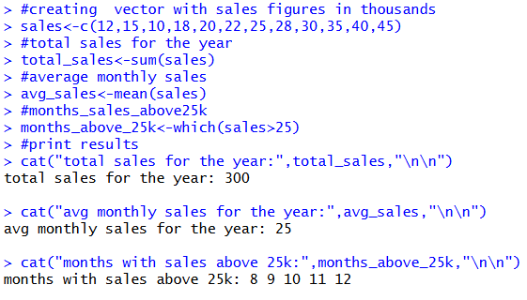  Figure 19: Analysis of sales figures (in thousands) for a company
Explanation/  Observations | The program creates a numeric vector sales representing monthly sales figures in thousands over a year. The total yearly sales are computed using the sum() function and stored in total_sales. The average monthly sales are calculated using the mean() function and stored in avg_sales. To identify the months where sales exceeded 25, the which() function is applied to the logical condition sales > 25, and the resulting indices are stored in months_above_25k. The cat() function prints the computed results to the console with appropriate labels and spacing. Overall, the output displays the total yearly sales, the average monthly sales, and the months in which sales figures went above 25k.
References

