Title
Problem Statement | You have a vector of temperatures in Celsius: temps_celsius <- c(0, 20, 25, 30, 35, 40).  Write an R script to perform the following tasks:  1. Convert the temperatures to Fahrenheit using the formula  F = C * 9/5 + 32.  2. Identify whi
Program | # creating vector for temp in Celsius  temps_celsius <- c(0, 20, 25, 30, 35, 40)  # count the number of elements in the vector  len_vec <- length(temps_celsius)  # convert each temp to Fahrenheit  for(i in 1:len_vec){  temps_celsius[i] <- (temps_celsius[i] * (9/5)) + 32  }  # printing the converted vector  temps_celsius
Output Snapshots | 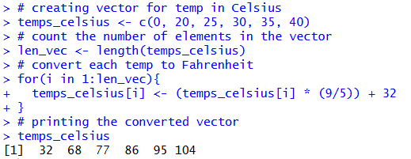  Figure 20: Convert vector of temperatures in Celsius to Fahrenheit
Explanation/  Observations | The program creates a vector temps_celsius that stores temperature values in Celsius. The number of elements in the vector is calculated using the length() function and stored in len_vec. A for loop is used to convert each Celsius temperature into Fahrenheit using the formula $F=C×\frac{9}{5}+32$. The converted temperatures are stored back into the same vector. Finally, the updated vector is printed, displaying the temperature values in Fahrenheit.
References

