Title
Problem Statement | You have a vector of names: names <- c("Alice", "Bob", "Charlie", "David"). Write an R script to perform the following tasks:  1. Convert all names to uppercase.  2. Count the number of characters in each name.  3. Check if any names contain the letter "a".
Program | #creating a vectors to store names  names<-c("Alice","Bob","Charlie","David")  #changing all the names to uppecase  names<-toupper(names)  #print the new vector  names  len_vec<-length(names)  #count the number of characters in each namne  for(i in 1:len_vec){  x=names[i]  xx=unlist(strsplit(names[i],""))  cat("the length of name ", names[i]," is ",length(xx),"\n")  }  #check if any names contain letter a  grep("A", names, value = TRUE)
Output Snapshots | 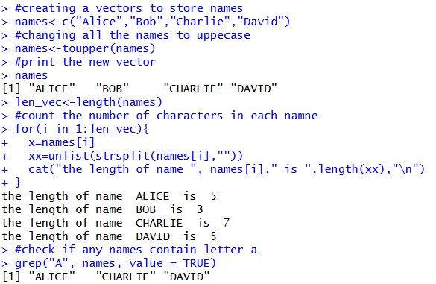  Figure 21: Perform simple string operations on vector of names
Explanation/  Observations | The program creates a character vector names and converts all elements into uppercase using the toupper() function. The updated vector is printed to the console. The number of characters in each name is computed by iterating over the vector using a for loop, splitting each name into individual characters with strsplit(), and counting them using length(). The grep() function with value = TRUE is used to identify and return names containing the letter "A". Overall, the output confirms that the vector is successfully converted to uppercase, character lengths are accurately computed, and matching names are correctly detected.
References

