Title
Problem Statement | You have two vectors of different lengths: vec1 <- c(1, 2, 3, 4, 5) and vec2 <- c(10, 20, 30). Write an R script to perform element-wise addition, subtraction, and multiplication using recycling, and print the results.
Program | # creating vectors  vec1 <- c(1, 2, 3, 4, 5)  vec2 <- c(10, 20, 30)  # element-wise operations using recycling  add_result <- vec1 + vec2  sub_result <- vec1 - vec2  mul_result <- vec1 * vec2  # printing results  cat("Addition result:", add_result, "\n")  cat("Subtraction result:", sub_result, "\n")  cat("Multiplication result:", mul_result, "\n")
Output Snapshots | 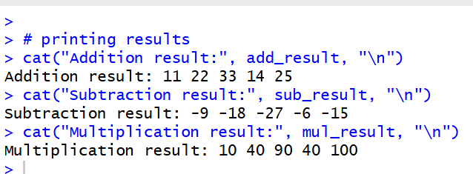
Explanation/  Observations | The program creates two numeric vectors vec1 and vec2 of different lengths. When arithmetic operations are performed between them, R applies the recycling rule, where elements of the shorter vector are reused to match the length of the longer vector. Element-wise addition, subtraction, and multiplication are computed and stored in add_result, sub_result, and mul_result respectively. The cat() function is used to print the results to the console. Overall, the output demonstrates how R automatically handles vector recycling during arithmetic operations.
References

