Title
Problem Statement | You have a vector of numbers with some duplicates: numbers <- c(5, 3, 8, 3, 9, 5, 2, 8). Write an R script to perform the following tasks:  1. Find the unique elements in the vector.  2. Identify the duplicated elements.  3. Remove the duplicates and keep on
Program | # given vector  numbers <- c(5, 3, 8, 3, 9, 5, 2, 8)  # 1. find the unique elements  unique_elements <- unique(numbers)  # 2. identify duplicated elements  duplicated_elements <- numbers[duplicated(numbers)]  # 3. remove duplicates and keep only one occurrence  numbers_no_duplicates <- unique(numbers)  # printing results  cat("Unique elements:", unique_elements, "\n")  cat("Duplicated elements:", duplicated_elements, "\n")  cat("Vector without duplicates:", numbers_no_duplicates, "\n")
Output Snapshots | 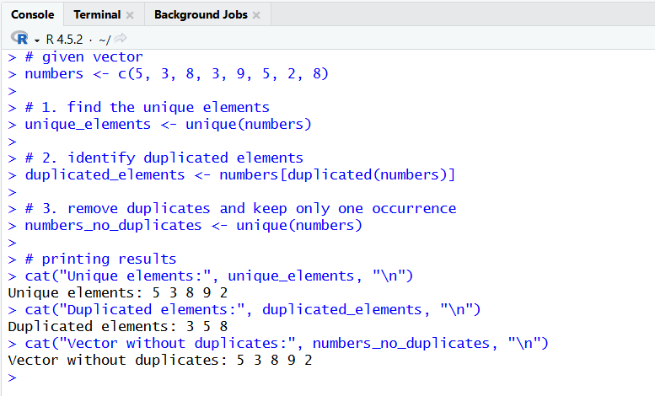
Explanation/  Observations | The program creates a numeric vector numbers containing repeated values. The unique() function is used to extract distinct elements from the vector, which are stored in unique_elements. The duplicated() function identifies which elements occur more than once, and the repeated values are extracted into duplicated_elements. To remove duplicate values while preserving the first occurrence, the unique() function is again applied and stored in numbers_no_duplicates. The cat() function prints the results to the console. Overall, the output confirms that unique values are identified, duplicate values are detected, and a duplicate-free version of the vector is produced.
References

