Title
Problem Statement | You have a vector representing the daily closing prices of a stock over a month: closing_prices <- c(120, 122, 118, 121, 119, 117, 123, 125, 126, 124, 128, 130, 129, 131, 135, 134, 136, 137, 140, 138, 139, 141, 142, 144, 143, 145, 146, 148, 147, 149). Write an R script to perform the following tasks:  - Calculate the daily returns (percentage change) of the stock.  - Identify the days with the highest and lowest returns.  - Calculate the cumulative return over the month.
Program | # closing price vector  closing_prices <- c(120, 122, 118, 121, 119, 117, 123, 125, 126, 124, 128, 130, 129, 131, 135, 134, 136, 137, 140, 138, 139, 141, 142, 144, 143, 145, 146, 148, 147, 149)  # 1. calculate daily percentage returns  daily_returns <- (diff(closing_prices) / closing_prices[-length(closing_prices)]) * 100  # 2. identify days with highest and lowest returns  highest_return_day <- which.max(daily_returns)  lowest_return_day <- which.min(daily_returns)  # 3. calculate cumulative return over the month  cumulative_return <- ((closing_prices[length(closing_prices)] / closing_prices[1]) - 1) * 100  # printing results  cat("Daily returns (%):", daily_returns, "\n\n")  cat("Day with highest return:", highest_return_day + 1, "(Return:", daily_returns[highest_return_day], "%)\n\n")  cat("Day with lowest return:", lowest_return_day + 1, "(Return:", daily_returns[lowest_return_day], "%)\n\n")  cat("Cumulative monthly return:", cumulative_return, "%\n")
Output Snapshots | 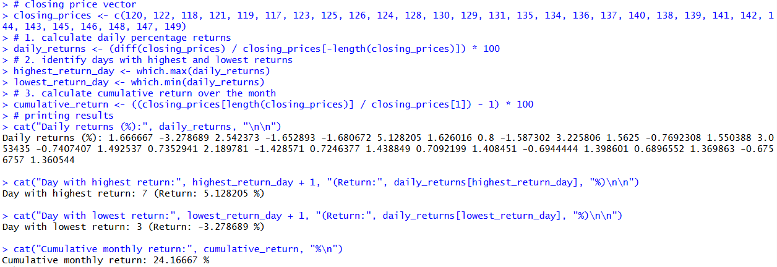  Figure 24: Stock Price Analysis
Explanation/  Observations | The program defines a numeric vector closing_prices representing daily stock closing values over a month. The daily returns in percentage form are computed using the formula:  $$\text{return}=\frac{P_{t}-P_{t-1}}{P_{t-1}}×100$$  implemented through the diff() function and division by the previous day's prices. The highest and lowest returns are identified using which.max() and which.min() applied to daily_returns, and the corresponding trading days are reported. The cumulative return for the entire month is computed by comparing the final closing price with the initial one. The cat() function is used to print the results to the console. Overall, the output displays daily return values, the extreme return days, and the total growth of the stock over the month.
References

