Title
Problem Statement | You have vectors representing sensor readings (temperature, humidity, and pressure) taken every minute over an hour. Write an R script to perform the following tasks:  - Calculate the average reading for each sensor.  - Identify the time intervals (in minutes) where the temperature was above 30°C and the humidity was below 40%.
Program | # sample sensor readings (60 readings, one per minute)  set.seed(10) # for reproducibility  temperature <- runif(60, min = 20, max = 40) # °C  humidity <- runif(60, min = 30, max = 70) # %  pressure <- runif(60, min = 900, max = 1100) # hPa  # time in minutes (1 to 60)  time <- 1:60  # 1. calculate average reading for each sensor  avg_temp <- mean(temperature)  avg_humidity <- mean(humidity)  avg_pressure <- mean(pressure)  cat("Average Temperature:", avg_temp, "\n")  cat("Average Humidity:", avg_humidity, "\n")  cat("Average Pressure:", avg_pressure, "\n\n")  # 2. identify time intervals with conditions  high_temp_low_humidity <- time[temperature > 30 & humidity < 40]  cat("Minutes with Temp > 30°C and Humidity < 40%:", high_temp_low_humidity, "\n")
Output Snapshots | 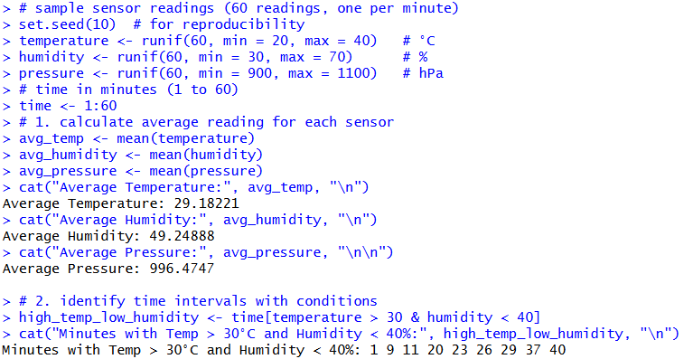  Figure 25: Sensor Data Analysis
Explanation/  Observations | The program defines three numeric vectors representing temperature, humidity, and pressure readings recorded every minute for an hour. The average value for each sensor is computed using the mean() function and printed to the console. A logical condition (temperature > 30 & humidity < 40) is applied to determine the time intervals where the temperature exceeded 30°C while the humidity dropped below 40%, and the corresponding minute indices are extracted using indexing with the time vector. The results display the average values for all sensors and list the specific minutes that satisfy the environmental condition.
References

