Title
Problem Statement | Create a shopping list program that allows users to add, remove, and view items in their shopping list.  Details  - Create a list: Initialize an empty list to store the shopping items.  - Add items: Create a function to add items to the list.  - Remove items: Create a function to remove items from the list.  View list: Create a function to display all items in the list.
Program | # Initialize an empty shopping list  shopping_list <- list()  # Function to add items to the shopping list  add_item <- function(item) {  shopping_list <<- c(shopping_list, item)  }  # Function to view the shopping list  view_list <- function() {  print(shopping_list)  }  # Example usage  add_item("Milk")  add_item("Bread")  #print the list  view_list()  #remove an item  shopping_list[-1]  #print the list again after deletion  view_list()
Output Snapshots | 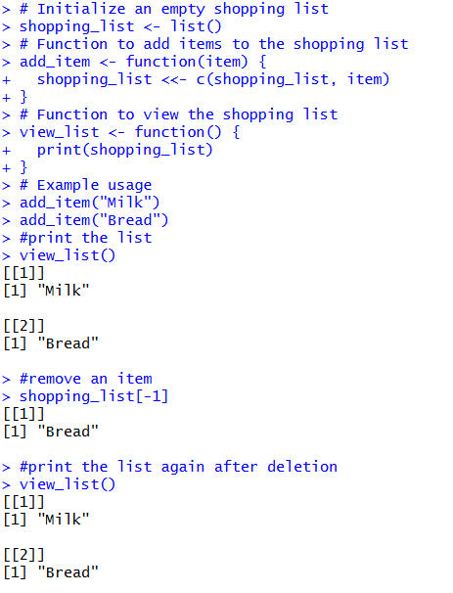  Figure 26: Shopping List Application
Explanation/  Observations | The program initializes an empty list and provides a function add_item() that uses the super-assignment operator <<- to append new items to the global shopping_list. The view_list() function prints the current items in the list. After adding "Milk" and "Bread", the list is displayed. The expression shopping_list[-1] generates a copy of the list with the first element removed, but since it is not reassigned back to shopping_list, the original list remains unchanged. Assigning the modified list back to shopping_list correctly updates the list for subsequent operations.
References

