Title
Problem Statement | Create a program to manage student grades, allowing for adding, removing, and calculating the average grade of students.  - Create a list: Initialize an empty list to store student names and their grades.  - Add grades: Create a function to add student names and grades to the list.  - Remove grades: Create a function to remove student names and grades from the list.  Calculate average: Create a function to calculate the average grade of the students.
Program | # Initialize an empty list for student grades  student_grades <- list()  # Function to add student grades  add_grade <- function(student, grade) {  student_grades[[student]] <<- grade  }  # Function to remove student grades  remove_grade <- function(student) {  student_grades[[student]] <<- NULL  }  # Function to calculate average grade  average_grade <- function() {  return(mean(unlist(student_grades)))  }  # Example usage  add_grade("Alice", 85)  add_grade("Bob", 90)  remove_grade("Alice")  print(average_grade())  print(student_grades)
Output Snapshots | 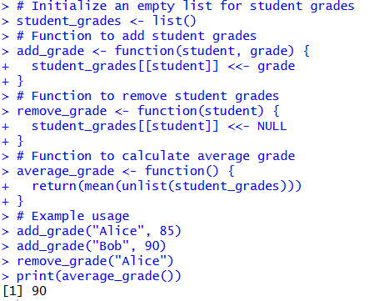  Figure 27: Student Grades Management
Explanation/  Observations | The program initializes an empty list student_grades intended to store student names and their corresponding grades. The function add_grade(student, grade) uses the student name as a list index and assigns a grade to it using the super-assignment operator <<-, allowing updates to the global list. The remove_grade(student) function removes an entry by assigning NULL to the corresponding element within the list. The function average_grade() computes the average of all stored grades by first applying unlist() to convert the list of numeric values into a vector and then applying the mean() function. In the example usage, grades are added for "Alice" and "Bob", and then "Alice" is removed. The program prints the average grade of the remaining entries and displays the final contents of the student_grades list. Overall, the output verifies that grades can be added, removed, and averaged successfully using list operations.
References

