Title
Problem Statement | Create a to-do list application that allows users to add tasks, mark tasks as completed, and view all tasks.  - Create a list: Initialize an empty list to store tasks.  - Add tasks: Create a function to add tasks to the list.  - Mark tasks as completed: Create a function to mark tasks as completed.  View tasks: Create a function to display all tasks.
Program | # Initialize an empty to-do list  to_do_list <- list()  # Function to add tasks to the to-do list  add_task <- function(task) {  to_do_list <<- c(to_do_list, list(list(task = task, completed = FALSE)))  }  # Function to mark tasks as completed  mark_completed <- function(task) {  for (i in seq_along(to_do_list)) {  if (to_do_list[[i]]$task == task) {  to_do_list[[i]]$completed <<- TRUE  break  }  }  }  # Function to view the to-do list  view_tasks <- function() {  print(to_do_list)  }  # Example usage  add_task("Finish report")  add_task("Call client")  mark_completed("Finish report")  view_tasks()
Output Snapshots | 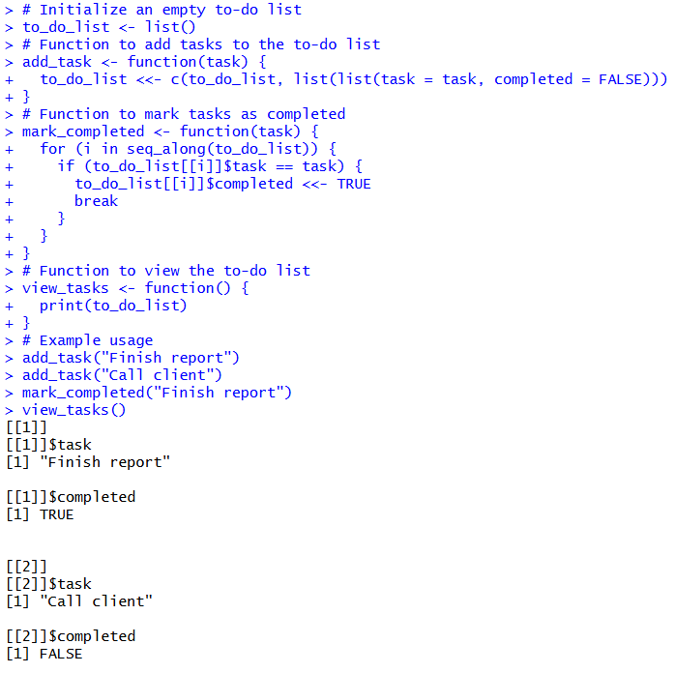  Figure 28: To-Do List Application
Explanation/  Observations | The program initializes an empty list to_do_list intended to store tasks and their status. The function add_task(task) appends a new element to the list using c() and wraps each task inside its own inner list containing two fields: task, which stores the task description, and completed, which indicates whether the task has been finished. The super-assignment operator <<- is used to update the global to_do_list from within the function.  The function mark_completed(task) iterates through the stored tasks using seq_along() and compares the input task to each task entry. When a match is found, the completed field for that entry is updated to TRUE, and the loop terminates.  The function view_tasks() displays the current state of the to-do list. In the example usage, two tasks are added, one task is marked as completed, and the updated to-do list is printed. Overall, the program demonstrates basic list manipulation, task updating, and viewing capabilities for a simple to-do list system in R.
References

