Title
Problem Statement | You have a list of customers and their purchase amounts. Write a program to:  Add new customers and their purchases.  Remove customers from the list.  Calculate the total purchase amount for each customer.  Find the customer with the highest and lowest total purchases.  Sample Data
  Customer | Purchases
  Alice | 200, 150, 300
  Bob | 100, 80, 150
  Charlie | 250, 300, 100
Program | # Initialize customer purchase list  customers <- list(  Alice = c(200, 150, 300),  Bob = c(100, 80, 150),  Charlie = c(250, 300, 100)  )  # Function to add a new customer and their purchases  add_customer <- function(name, purchases) {  customers[[name]] <<- purchases  }  # Function to remove a customer  remove_customer <- function(name) {  customers[[name]] <<- NULL  }  # Function to calculate total purchases per customer  total_purchases <- function() {  sapply(customers, sum)  }  # Function to find highest and lowest purchasing customer  find_extremes <- function() {  totals <- total_purchases()  list(  highest = names(which.max(totals)),  lowest = names(which.min(totals))  )  }  # Example usage  add_customer("David", c(400, 220))  remove_customer("Bob")  totals <- total_purchases()  extremes <- find_extremes()  # Display results  cat("Total purchases:\n")  print(totals)  cat("\nHighest purchaser:", extremes$highest, "\n")  cat("Lowest purchaser:", extremes$lowest, "\n")
Output Snapshots | 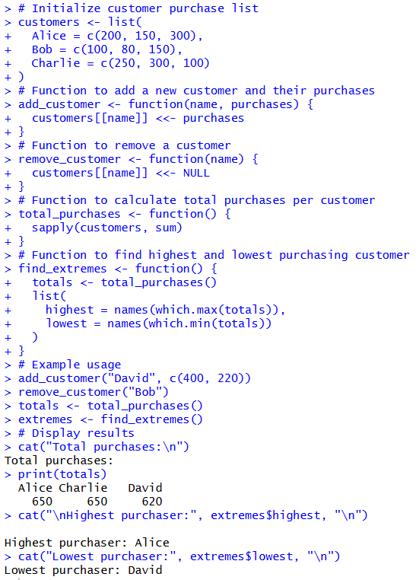  Figure 29: Customer Purchase Analysis
Explanation/  Observations | The program creates a list customers where each element represents a customer and stores their purchase amounts as numeric vectors. The function add_customer(name, purchases) allows a new customer and their purchase history to be added to the list, while the remove_customer(name) function removes a specified customer by assigning NULL to their entry.  The function total_purchases() computes the total purchase amount for each customer by applying the sum() function across all list elements using sapply(). The find_extremes() function identifies the customers with the highest and lowest total spending by locating the maximum and minimum values in the computed totals.  In the example usage, a new customer ("David") is added, "Bob" is removed, and the totals are recalculated. Finally, the program prints the total purchase amounts and displays the highest and lowest spending customers. Overall, the code demonstrates list-based data management and summarization techniques for customer purchase analysis.
References

