Title
Problem Statement | Create a system to track book borrowing in a library. Your program should:  - Add new books with their borrowers.  - Remove books from the system.  - Calculate the total number of borrowers for each book.  - Find the book with the highest and lowest number of borrowers.  Sample Data
  Book | Borrowers
  The Hobbit | Alice, Bob
  1984 | Charlie, Alice
  Moby Dick | Bob
Program | # Initial library data  library_system <- list(  "The Hobbit" = c("Alice", "Bob"),  "1984" = c("Charlie", "Alice"),  "Moby Dick" = c("Bob")  )  # Function to add a new book with borrowers  add_book <- function(book, borrowers) {  library_system[[book]] <<- borrowers  }  # Function to remove a book from the system  remove_book <- function(book) {  library_system[[book]] <<- NULL  }  # Function to calculate total number of borrowers for each book  total_borrowers <- function() {  sapply(library_system, length)  }  # Function to find book with highest and lowest number of borrowers  find_extremes <- function() {  totals <- total_borrowers()  list(  highest = names(which.max(totals)),  lowest = names(which.min(totals))  )  }  # Example usage  add_book("Dune", c("Eve", "Frank", "Bob"))  remove_book("Moby Dick")  totals <- total_borrowers()  extremes <- find_extremes()  # Display results  cat("Total borrowers per book:\n")  print(totals)  cat("\nBook with highest borrowers:", extremes$highest, "\n")  cat("Book with lowest borrowers:", extremes$lowest, "\n")
Output Snapshots | 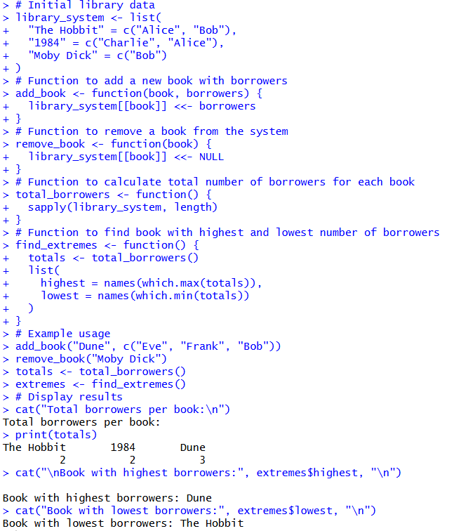  Figure 30: Library Book Borrowing System  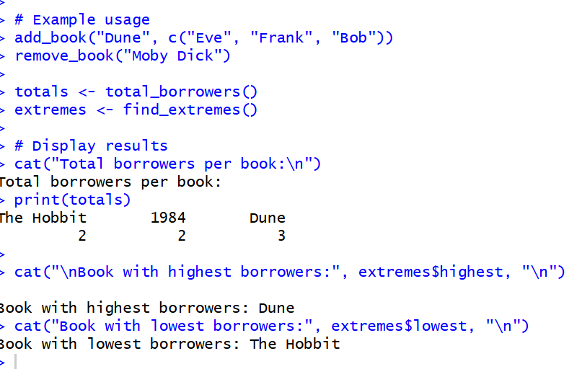  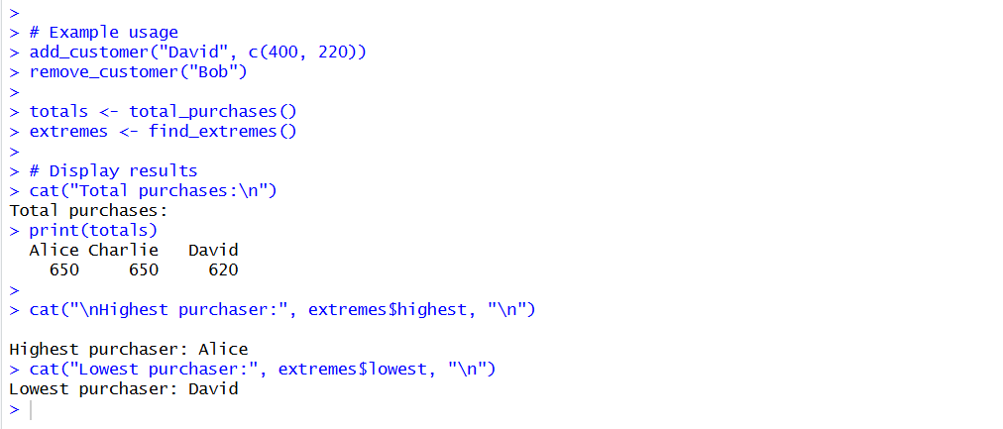
Explanation/  Observations | The program creates a list library_system that stores books as list elements and their corresponding borrowers as character vectors. The function add_book(book, borrowers) inserts a new book entry along with its borrower names, while the function remove_book(book) deletes a specified book from the system by assigning NULL to it.  The function total_borrowers() computes the total number of borrowers for each book by applying the length() function to each list element via sapply(). The function find_extremes() identifies the books with the highest and lowest number of borrowers by finding the maximum and minimum values in the total borrower counts.  In the example usage, a new book titled "Dune" is added with three borrowers, and "Moby Dick" is removed from the system. The program then prints the total number of borrowers for each remaining book and displays which book has the highest and lowest borrowing counts. Overall, the output confirms that books can be added, removed, summarized, and compared based on their borrowing activity.
References | https://github.com/Rohan311203/Programming-for-data-science-in-R--Part-1.git

