Title
Problem Statement | Develop a program to track the performance of sports teams. Your program should:  - Add new teams with their scores.  - Remove teams from the list.  - Calculate the average score for each team.  - Rank teams based on their average scores.  Sample Data
  Team | Scores
  Team A | 90, 85, 88
  Team B | 78, 82, 79
  Team C | 88, 92, 90
Program | # Initial team performance data  teams <- list(  "Team A" = c(90, 85, 88),  "Team B" = c(78, 82, 79),  "Team C" = c(88, 92, 90)  )  # Function to add new teams with scores  add_team <- function(team, scores) {  teams[[team]] <<- scores  }  # Function to remove a team  remove_team <- function(team) {  teams[[team]] <<- NULL  }  # Function to calculate average score per team  average_scores <- function() {  sapply(teams, mean)  }  # Function to rank teams based on average score (descending)  rank_teams <- function() {  avg <- average_scores()  sort(avg, decreasing = TRUE)  }  # Example usage  add_team("Team D", c(95, 91, 94))  remove_team("Team B")  team_avg <- average_scores()  team_ranks <- rank_teams()  # Display results  cat("Average Scores per Team:\n")  print(team_avg)  cat("\nTeam Rankings (Highest to Lowest):\n")  print(team_ranks)
Output Snapshots | 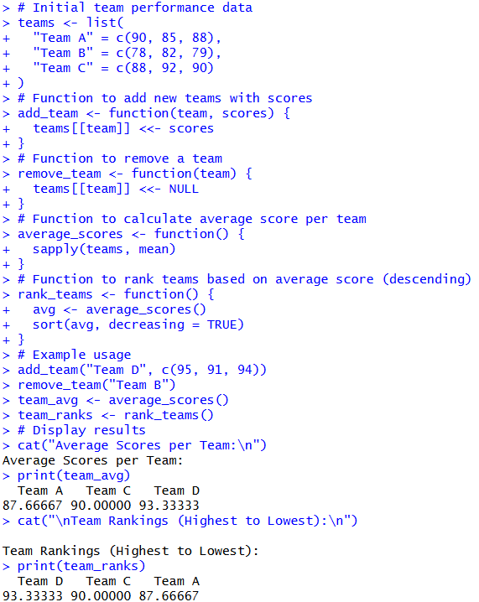  Figure 31: Sports Team Performance Tracking
Explanation/  Observations | The program defines a list teams in which each element corresponds to a sports team, and the associated numeric vector contains the team’s performance scores. The function add_team(team, scores) adds a new team to the data structure, whereas remove_team(team) removes the specified team by assigning NULL to its list entry.  The function average_scores() computes the mean score for each team using sapply() combined with the mean() function. To rank the teams based on their performance, the function rank_teams() sorts the computed averages in descending order using the sort() function. In the example usage, a new team is added, another team is removed, and the final averages and rankings are printed to the console. Overall, the program successfully demonstrates addition, removal, performance summarization, and ranking of sports teams based on their average scores.
References | https://github.com/Rohan311203/Programming-for-data-science-in-R--Part-1.git

