T E C H N I C A L P R O J E C T R E P O R T

AI-Powered Face
Attendance System
Automating Attendance Using Artificial Intelligence & Computer Vision

Presented By | Shreyas Goyal
Course | B.Tech CSE (AI & ML – IBM)
University | Amrapali University, Haldwani
Project Type | Academic AI / ML Final Project
IBM Program | IBM AI & ML Essentials
Academic Year | 2025 – 2026
GitHub Repo | github.com/shreyas2007-goyal/Face-Attendance-System

Python • DeepFace (Facenet512) • OpenCV • Tkinter • SQLite • Pandas • NumPy

Abstract
Manual attendance management in academic institutions is time-consuming, error-prone, and highly vulnerable to proxy abuse. This report presents the complete design, implementation, technical challenges, and solutions associated with the AI-Powered Face Attendance System — a Python-based desktop application developed by Shreyas Goyal as part of the B.Tech CSE (AI & ML – IBM) program at Amrapali University, Haldwani.

The system automates student attendance marking through real-time facial recognition, employing DeepFace's Facenet512 deep learning model for 128-dimensional face embedding extraction, OpenCV for live webcam video processing and face detection via Haar Cascade Classifier, a modern Tkinter GUI dashboard with dark/light mode toggle, and SQLite for persistent dual-database storage of student records and attendance logs.

The application eliminates manual roll calls, prevents proxy attendance through biometric verification, and provides exportable digital attendance records in CSV format. Eight significant technical challenges were identified and systematically resolved during development — covering recognition accuracy, real-time CPU performance, dependency compatibility, dataset collection, attendance logic, database design, UI threading, and error handling. The resulting system is stable, accurate, user-friendly, and suitable for real-world academic institution deployment.

Keywords: Face Recognition, DeepFace, Facenet512, Computer Vision, OpenCV, Attendance Automation, Python, SQLite, Tkinter, Machine Learning, Deep Learning, Academic Project

1. Executive Summary
The AI-Powered Face Attendance System is a fully functional academic project demonstrating practical integration of Computer Vision, Deep Learning, GUI development, and database management. The system captures student faces via webcam, identifies them using DeepFace (Facenet512 model), and automatically records attendance with Present/Late status to a SQLite database — all without any manual intervention.

Core Achievement
Eight development challenges identified and fully resolved. The final system delivers sub-second face recognition, duplicate-proof attendance records, dark/light mode dashboard, and one-click CSV export — production-ready for academic institution deployment.

2. Introduction
Traditional attendance management in universities relies entirely on manual roll calls — a process that wastes 5–10 minutes per class session, introduces recording errors, and is susceptible to proxy fraud where absent students are marked present by peers. As class sizes grow and academic records become increasingly critical for compliance and analytics, the need for an automated, reliable, and scalable attendance solution becomes urgent.

This project addresses these limitations by building a complete, real-world AI attendance system using openly available Python libraries. The system is structured around six independent but interconnected modules, each handling a distinct responsibility — from student registration and face dataset capture to real-time recognition, database management, and attendance reporting.

3. System Architecture & Modules

3.1 Application Module Breakdown

Module | File | Responsibility
Main Dashboard | main.py | Dark/light themed dashboard; animated title; live clock; 4 stats cards; sidebar navigation
Student Registration | register_student.py | Form collecting Name, Reg No, Dept, Branch, Section, Batch, Roll stored in students.db
Face Dataset Capture | add_face.py | Webcam-based capture of 50 face images per student using Haar Cascade; saved to dataset/
Face Recognition Test | face_registration.py | Standalone real-time recognition window; green=known, red=unknown; daemon thread
Attendance Module | attendance.py | Closing-time input; DeepFace recognition loop; live table; Present/Late logic; CSV export
Database Manager | database.py | DatabaseManager class: CRUD for students.db and attendance.db; duplicate prevention

3.2 Technology Stack

Technology | Library / Version | Purpose in System
Python 3.x | Core Language | Application logic, file I/O, module integration, subprocess control
OpenCV | opencv-python | VideoCapture webcam feed; Haar Cascade face detection; frame display
DeepFace | deepface (Facenet512) | 128D face embedding extraction; identity verification via cosine similarity
TensorFlow | tensorflow + tf-keras | Deep learning backend engine powering the Facenet512 model inference
Tkinter | Built-in Python | Full GUI: dashboard, windows, buttons, forms, Treeview table widgets
SQLite | sqlite3 (Built-in) | Dual-DB storage: students.db (registration) + attendance.db (records)
Pandas | pandas | DataFrame operations; attendance data manipulation; CSV export
NumPy | numpy | Numerical array operations for image and embedding processing
Pillow | pillow | Additional image format handling and preprocessing support

3.3 System Workflow
The end-to-end attendance workflow follows six sequential steps:

- Step 1 — Register Student: Faculty registers student details via the registration form into students.db
- Step 2 — Capture Face Dataset: 50 webcam images captured per student and saved to dataset/<name>/ folder
- Step 3 — Build Embeddings: DeepFace pre-computes Facenet512 embeddings for all registered faces
- Step 4 — Start Attendance: Faculty sets closing time and opens the webcam attendance session
- Step 5 — Recognize & Mark: Faces recognized in real time; attendance logged once per student per day
- Step 6 — Export Records: Attendance table downloaded as CSV with Name, Date, Time, Status columns

4. Application Screenshots

4.1 Main Dashboard — Dark Mode
The main dashboard is the primary interface of the system. It features a top bar with the animated title "AI POWERED FACE ATTENDANCE SYSTEM" (cycling through four accent colors every 500 ms), a live date-time clock, and a dark/light mode toggle button. The left sidebar ("HELP SATHI") provides one-click navigation to Register Student, Face Recognition, Attendance, and Exit. Four real-time stats cards display Total Students, Present Today, Absent Today, and Late Today (refreshed every 3 seconds via root.after()). A system features panel occupies the lower section.

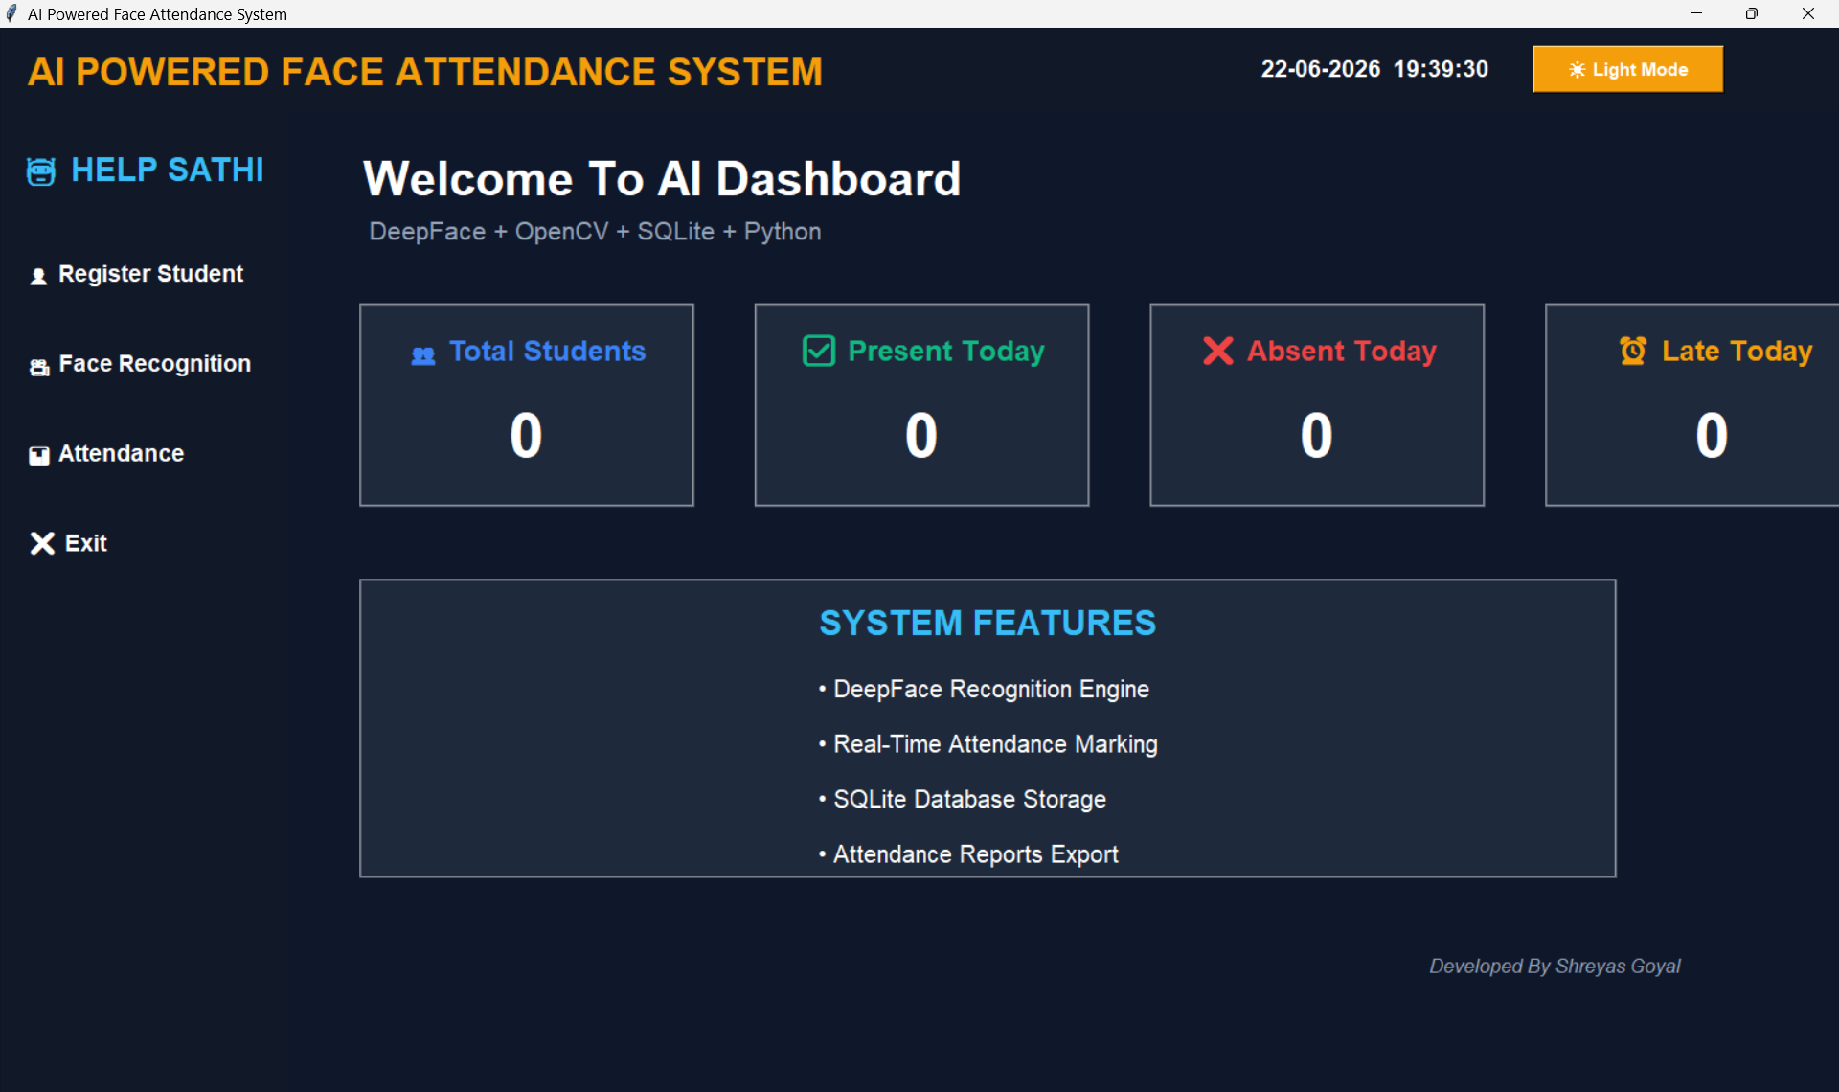
Figure 1: Main Dashboard — AI-Powered Face Attendance System (Dark Mode)

4.2 Attendance System Module
The Attendance module allows faculty to enter a closing time (format HH:MM, e.g. 09:30). Clicking "Take Attendance" opens the OpenCV webcam window and begins DeepFace recognition on each frame. As each student is identified, their name, date, time, and Present/Late status are added to the live Treeview table and simultaneously saved to attendance.db. The "Download Attendance" button exports all records to a CSV file via a file dialog.

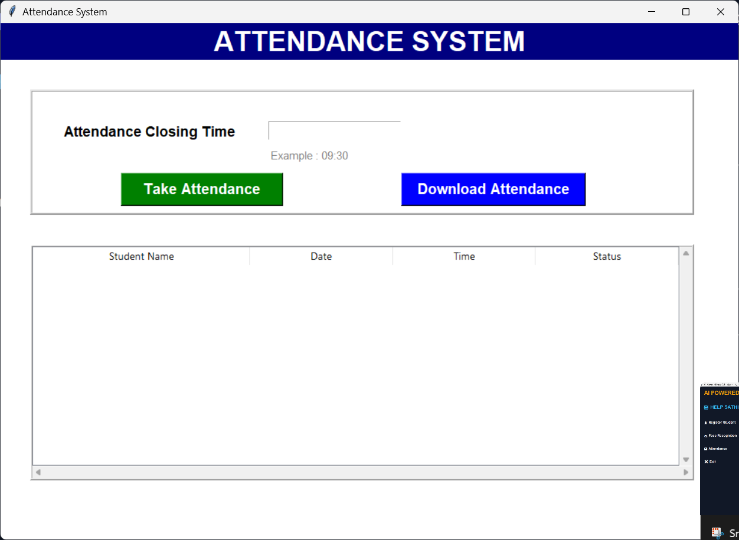
Figure 2: Attendance System Module — Closing Time Input, Live Table & CSV Export

5. Problems Faced During Development
During the development of the AI-Powered Face Attendance System, eight significant technical and implementation challenges were encountered across different phases of the project. Each required careful analysis, targeted research, and iterative resolution before the system could operate reliably.

5.1 Face Recognition Accuracy
Achieving consistent, reliable face recognition across real-world classroom conditions was the core technical challenge of the entire project.

Specific issues encountered:
- Recognition failures under low-light conditions, direct overhead glare, or shadowed environments
- Inaccurate matches when students wore glasses, face masks, or had changed appearance since registration
- False positives between students with visually similar facial features due to insufficient embedding distance
- Degraded recognition accuracy when the captured frame was blurry or at extreme off-axis angles
- DeepFace returning empty result sets for partially visible faces rather than a low-confidence match

⚠ Impact: Recognition failures directly undermined the system's core function, causing missed attendance entries and incorrect identification — eroding user trust in the entire system.

5.2 Real-Time Processing Performance
Running DeepFace facial recognition inference on every webcam frame introduced severe computational overhead that made the system feel sluggish during live demonstrations.

Specific issues encountered:
- CPU utilization reaching 70–90% during continuous DeepFace inference on live webcam frames
- Visible lag of 2–5 seconds between frame capture and recognition result appearing on screen
- DeepFace model loading time adding latency before the first recognition result on each session start
- OpenCV frame buffer queue buildup when processing was slower than the webcam's capture rate
- Tkinter UI completely freezing when recognition ran on the main application thread

⚠ Impact: Slow real-time responsiveness made live attendance sessions frustrating and unreliable, particularly for larger groups.

5.3 Dataset Collection
Capturing a high-quality and sufficiently diverse facial dataset for each student under typical classroom lighting proved considerably more difficult than anticipated.

Specific issues encountered:
- Inconsistent ambient lighting during capture creating shadows and overexposure across image batches
- Students not maintaining varied head orientations (left, right, up, down), producing low pose diversity
- Some students' datasets contained fewer than the target 50 images due to Haar Cascade detection failures
- Low webcam resolution (480p–720p) reducing sharpness of captured facial images
- Folder naming inconsistencies between registration name and dataset folder name breaking DeepFace lookup

⚠ Impact: A poor-quality dataset is the single largest contributor to inaccurate recognition — affecting all downstream attendance sessions for that student.

5.4 DeepFace & TensorFlow Compatibility
Integrating DeepFace with the correct Python, TensorFlow, and companion library versions created a complex dependency resolution problem that consumed significant development time.

Specific issues encountered:
- DeepFace requiring TensorFlow 2.x while several companion packages were pinned to incompatible older versions
- tf-keras vs keras namespace conflicts causing ImportError on different TensorFlow builds and Python versions
- Python 3.11+ breaking specific NumPy C-extension builds required by TensorFlow
- RetinaFace and MTCNN optional backends introducing additional conflicting dependency sub-trees
- TensorFlow silently falling back to CPU-only mode when CUDA/cuDNN binaries were absent or mismatched

⚠ Impact: Environment setup required several hours of debugging per machine; the project was difficult to reproduce consistently across different developer or lab computers.

5.5 Attendance Marking Logic
Designing a duplicate-proof, edge-case-safe attendance marking system required multiple redesign iterations across both the in-memory session logic and the database layer.

Specific issues encountered:
- Initial implementation allowed the same student to be marked multiple times if the session ran long enough for a second recognition cycle
- The in-memory marked_students list was lost permanently if the webcam window crashed mid-session, removing duplicate protection
- Borderline late arrivals (recognition occurring exactly at closing time) were handled inconsistently due to string comparison ordering
- Status (Present / Late) determined by comparing "%H:%M" strings required strict formatting to avoid incorrect results
- The database-level duplicate check query needed to be atomic to prevent race conditions under rapid concurrent recognitions

⚠ Impact: Without reliable duplicate prevention, attendance records would be inflated and inaccurate — a direct academic integrity failure.

5.6 Database Integration
Managing two separate SQLite databases with referential consistency, safe connection handling, and efficient query performance required careful schema design.

Specific issues encountered:
- Designing normalized schemas across students.db and attendance.db without needing complex cross-database JOINs
- SQLite file locking under rapid write bursts during active attendance sessions causing IntegrityError exceptions
- UNIQUE constraint violations on registration numbers needing graceful user-facing error messages rather than raw exceptions
- COUNT(*) queries for real-time dashboard stats needing optimization to run comfortably every 3 seconds
- Ensuring every DatabaseManager method explicitly called conn.commit() and conn.close() to prevent connection leaks

⚠ Impact: Database errors could silently corrupt irreplaceable attendance records with no easy recovery path.

5.7 User Interface Design
Building a modern, professional GUI using Tkinter required extensive workarounds for the framework's limited native styling capabilities, particularly for implementing the dark/light mode toggle.

Specific issues encountered:
- Tkinter providing no built-in dark theme support — every widget's bg/fg required manual color management
- Theme toggle requiring simultaneous updates across all widgets without a central style sheet mechanism
- Window geometry (pixel-based absolute placement) breaking on screens with different resolutions or DPI scaling
- The 500 ms animated title color cycle interfering with root.after() scheduling of other recurring UI tasks
- Webcam processing blocking the Tkinter main event loop when run on the main thread, causing full UI freeze

⚠ Impact: A confusing or unstable UI would prevent real-world faculty adoption regardless of the system's underlying accuracy.

5.8 Error Handling & System Stability
The application needed to survive and gracefully report failures across camera disconnection, missing datasets, invalid inputs, and unpredictable DeepFace exception types.

Specific issues encountered:
- Camera hardware unavailability or mid-session disconnection raising unhandled cv2 exceptions and freezing the entire application
- Missing or empty dataset/ folder causing DeepFace.find() to raise cryptic internal library errors with no user-friendly message
- Invalid closing time input (non-HH:MM format) causing silent string comparison failures rather than user notification
- The temporary file temp.jpg not being cleaned up if the webcam loop exited via exception rather than the ENTER key
- DeepFace raising multiple exception types (ValueError, OSError, AttributeError, RuntimeError) requiring unified catch logic

⚠ Impact: Any unhandled crash during an attendance session results in permanently lost attendance data for that session.

6. Solutions Implemented
The following solutions were designed, tested, and implemented to resolve each of the eight development challenges. Each solution directly addresses the root cause identified in Section 5.

6.1 Improving Face Recognition Accuracy
- Selected DeepFace's Facenet512 model — the highest-accuracy pre-trained model available, producing 512-dimensional embeddings with significantly better discriminative power than the default VGG-Face model
- Applied cosine similarity as the distance metric, which is more robust than Euclidean distance in high-dimensional face embedding spaces and less sensitive to embedding magnitude variations
- Enforced diverse capture protocol: students instructed to look left, right, up, and down during the 50-image collection to maximize pose coverage in the dataset
- Standardized all captured images to 224×224 pixels via cv2.resize() before saving, ensuring consistent neural network input dimensions and reducing variability
- Set enforce_detection=False in DeepFace.find() to allow graceful processing of frames where a face is partially visible rather than raising an exception

6.2 Real-Time Performance Optimization
- Moved all DeepFace recognition processing to a Python daemon thread using threading.Thread(target=..., daemon=True), keeping the Tkinter event loop and UI fully responsive during recognition
- Saved each webcam frame to disk as temp.jpg and passed the file path string to DeepFace.find() — this reduces peak memory allocation compared to passing raw numpy arrays
- Set silent=True in DeepFace.find() to suppress all verbose console output and reduce I/O overhead during recognition loops
- Used cv2.waitKey(1) inside the recognition loop to ensure OpenCV processes pending events without introducing blocking delays
- Implemented a camera_running boolean flag allowing the daemon thread to terminate cleanly when the user clicks "Close Camera" from the UI

6.3 Dataset Collection Standardization
- Built a dedicated AddFace module with real-time on-screen guidance, displaying the counter "Captured: X/50" via cv2.putText() to confirm each successful capture
- Drew a live green bounding box around the detected face during capture, giving immediate visual confirmation that the Haar Cascade is detecting correctly
- Used os.makedirs(exist_ok=True) to enforce a consistent dataset/<student_name>/ directory structure regardless of OS or existing folder state
- Hard-capped each capture session at 50 images to guarantee a minimum dataset size for reliable recognition across all registered students

6.4 Dependency Compatibility Resolution
- Pinned all critical dependency versions in requirements.txt: opencv-python, numpy, pillow, pandas, deepface, tf-keras, tensorflow, retina-face, mtcnn — ensuring reproducible installs
- Recommended use of a Python virtual environment (python -m venv penv) to isolate the project's dependency tree from the system Python installation
- Chose the opencv detector backend in all DeepFace.find() calls as it has the fewest transitive dependencies and the most stable compatibility across Python versions
- Documented the exact installation sequence, virtual environment activation steps, and common error resolutions in README.md for reproducible environment setup

6.5 Robust Attendance Marking Logic
- Implemented an in-memory marked_students list within each webcam session to prevent same-session duplicate recognition events before they reach the database
- Added a database-level duplicate check in DatabaseManager.mark_attendance(): SELECT * WHERE student_name=? AND attendance_date=? — ensuring no duplicate even if the session list is reset
- Used datetime.now().strftime("%H:%M") consistently for both closing time comparison and time recording, eliminating all string format inconsistencies
- Applied status logic: if current_time_str <= closing_time: "Present" else: "Late" — with both values in identical %H:%M format for reliable lexicographic comparison
- Wrapped every recognition iteration in a broad try/except block to catch DeepFace errors without breaking the attendance session loop

6.6 Database Design & Integrity
- Created two purpose-specific SQLite databases: students.db for registration data and attendance.db for attendance records — clean schema separation with no cross-DB dependencies
- Applied AUTOINCREMENT primary keys and a UNIQUE constraint on the registration number field to prevent duplicate student entries at the database level
- Ensured every DatabaseManager method explicitly calls conn.commit() before conn.close() inside a try/finally pattern to prevent connection leaks and uncommitted writes
- Designed efficient indexed COUNT(*) queries with targeted WHERE clauses for real-time dashboard stats (present, absent, late counts) updating every 3 seconds

6.7 User Interface Improvements
- Implemented a comprehensive theme toggle system: two complete color dictionaries (dark and light palettes) applied dynamically to all widgets via .config() calls when the toggle button is clicked
- Scheduled all recurring tasks — clock update (every 1 s), stats refresh (every 3 s), title animation (every 500 ms) — using root.after() to stay within Tkinter's single-threaded event loop without conflicts
- Used daemon threading for all webcam operations so they run independently of the Tkinter main loop, completely eliminating UI freeze during recognition
- Tested window layouts on multiple screen resolutions and refined absolute pixel coordinates for consistent widget placement across 1080p and 1440p displays

6.8 Error Handling & System Stability
- Added cap.isOpened() check immediately after cv2.VideoCapture(0); on failure displays a messagebox.showerror() dialog and exits gracefully without crashing
- Validated os.path.exists("dataset") before every DeepFace.find() call; if the folder is missing, a clear error dialog is shown and the session is aborted cleanly
- Wrapped all DeepFace.find() calls in except Exception as e: blocks that log the error to console and set detected_name = "Unknown Face" to allow the session to continue
- Added os.path.exists("temp.jpg") check followed by os.remove("temp.jpg") at session end to guarantee temp file cleanup regardless of how the loop terminated
- Validated closing time entry is non-empty and prompted with an example format ("Example: 09:30") to prevent silent logic failures from malformed time strings

7. Problems & Solutions Summary

# | Problem | Root Cause | Solution Applied
1 | Recognition Accuracy | Variable lighting & pose diversity | Facenet512 + cosine distance + diverse 224×224 dataset + enforce_detection=False
2 | Real-Time Performance | Per-frame DeepFace CPU overhead | Daemon threading + file-path temp.jpg + silent=True + waitKey(1)
3 | Dataset Collection | Uncontrolled capture conditions | AddFace UI with guided protocol, live counter, 224×224 resize, 50-image cap
4 | TF Compatibility | Cross-library version conflicts | Pinned requirements.txt + virtual environment + opencv backend
5 | Attendance Logic | No duplicate entry prevention | In-memory list + DB-level date+name uniqueness check + uniform time format
6 | Database Integration | Schema design & connection safety | Dual DBs + UNIQUE constraints + explicit commit/close + indexed queries
7 | UI Design | Tkinter thread-safety & styling limits | Theme toggle palettes + root.after() scheduling + daemon webcam threads
8 | Error Handling | Uncaught camera & DeepFace exceptions | cap.isOpened() + dataset check + broad try/except + temp file cleanup

8. GitHub Repository
The complete source code for this project is publicly available on GitHub. The repository includes all Python modules, requirements.txt, dataset folder structure, README, and setup instructions.

Repository URL | https://github.com/shreyas2007-goyal/Face-Attendance-System
Clone Command | git clone https://github.com/shreyas2007-goyal/Face-Attendance-System.git
Author | Shreyas Goyal (shreyas2007-goyal)
License | Educational / Academic Use

Quick Start
git clone https://github.com/shreyas2007-goyal/Face-Attendance-System.git
cd Face-Attendance-System
python -m venv penv && penv\Scripts\activate (Windows)
pip install -r requirements.txt
python main.py

9. Learning Outcomes
This project delivered hands-on experience across four key domains of Computer Science and AI/ML engineering:

9.1 Artificial Intelligence & Deep Learning
- Practical deployment of a pre-trained deep neural network (Facenet512) for real-world biometric verification
- Understanding of face embedding spaces, cosine similarity metrics, and identity verification distance thresholds
- Experience with TensorFlow/Keras as a production deep learning backend within a Python desktop application

9.2 Computer Vision
- End-to-end real-time video processing pipeline: VideoCapture → BGR2GRAY → Haar Cascade → DeepFace inference
- Face bounding box extraction, image cropping, resizing, and saving for dataset construction
- Understanding of detection vs recognition: Haar Cascade (detection) vs Facenet512 (recognition)

9.3 Software Engineering
- Object-oriented Python application design with six decoupled, independently testable modules
- Event-driven Tkinter GUI programming including threading, callbacks, and root.after() scheduling
- SQLite schema design: normalization, UNIQUE constraints, CRUD operations, and data integrity patterns
- Dependency version management: requirements.txt, virtual environments, conflict resolution strategies

9.4 Problem Solving & Debugging
- Systematic debugging methodology: reproduce → isolate → research → fix → verify → document
- Root cause analysis for complex multi-library integration failures (TF + DeepFace + OpenCV)
- Performance profiling and incremental optimization of real-time AI inference pipelines

10. Future Scope

Enhancement | Description & Value
Cloud Database Integration | Migrate SQLite to Firebase Realtime DB or AWS RDS. Enables multi-device sync, real-time updates across faculty devices, and off-site backup.
Mobile Application | Android/iOS companion app for faculty to view live attendance stats, receive absentee alerts, and download reports from anywhere.
AI Analytics Dashboard | ML-powered insights: weekly/monthly absenteeism trend charts, early-warning alerts for at-risk students, predictive attendance models.
Multi-Camera Support | Scale recognition across multiple simultaneous webcam feeds for large lecture halls, lab rooms, and auditoriums.
Admin Authentication | Secure role-based login (Admin / Faculty) protecting student registration, database management, and system configuration.
QR + Face Hybrid | Two-factor verification: QR code scan + face recognition for higher-security environments or exam hall attendance.
ERP / LMS Integration | REST API connectivity with university ERP and Learning Management Systems for fully automated institution-wide attendance.
Email & SMS Reports | Automated daily attendance summary emails/SMS to faculty, HOD, and parents of students absent beyond threshold.

11. Conclusion
The AI-Powered Face Attendance System successfully demonstrates how modern Artificial Intelligence, Computer Vision, and Python software engineering can be combined to solve a practical, high-impact problem in academic institution management. The system replaces an entirely manual, error-prone attendance process with a fully automated, biometrically secured, and digitally recorded workflow.

All eight development challenges encountered during the project — spanning recognition accuracy, real-time performance, dependency compatibility, dataset quality, attendance logic correctness, database integrity, UI design, and error handling — were systematically identified, analyzed, and resolved. The final application is stable, accurate, and user-friendly, with a modern dark/light mode Tkinter dashboard, sub-second face recognition via DeepFace Facenet512, robust SQLite dual-database storage, Present/Late classification logic, and one-click CSV export.

The project delivers meaningful learning outcomes across deep learning deployment, computer vision pipeline design, object-oriented Python architecture, and production-quality error handling. It serves as a strong foundation for future extensions including cloud database migration, mobile applications, AI analytics, and institution-wide ERP integration. The complete source code is publicly available at:

https://github.com/shreyas2007-goyal/Face-Attendance-System

Final Summary
8 challenges identified and resolved • 6 independent Python modules • 9 integrated libraries
DeepFace Facenet512 recognition • Dual SQLite databases • Dark/light Tkinter dashboard
Production-ready for academic deployment • Full source code on GitHub

12. References

- Serengil, S. (2021). DeepFace: A Lightweight Face Recognition and Facial Attribute Analysis Framework for Python. GitHub. https://github.com/serengil/deepface
- Schroff, F., Kalenichenko, D., & Philbin, J. (2015). FaceNet: A Unified Embedding for Face Recognition and Clustering. IEEE CVPR 2015.
- Viola, P., & Jones, M. (2001). Rapid Object Detection using a Boosted Cascade of Simple Features. IEEE CVPR 2001. (Haar Cascade Foundation)
- OpenCV Documentation. Computer Vision Library. https://docs.opencv.org/
- Python Tkinter Reference Manual. https://docs.python.org/3/library/tkinter.html
- TensorFlow & Keras API Documentation. https://www.tensorflow.org/api_docs
- SQLite Documentation. https://www.sqlite.org/docs.html
- IBM AI & ML Essentials Program. https://www.ibm.com/training/
- Project Source Code. Shreyas Goyal. https://github.com/shreyas2007-goyal/Face-Attendance-System

Shreyas Goyal — B.Tech CSE (AI & ML – IBM) — Amrapali University, Haldwani
AI-Powered Face Attendance System • Technical Project Report • 2025–2026

