**Title: Emotion Intensity Analysis: Statistical and Deep Learning Approaches**  
**Abstract**

This technical paper outlines a robust method for identifying the intensity of emotions in text using natural language processing (NLP) techniques. We explore various models and approaches to capture the nuanced expressions of emotions in textual data. Our methodology encompasses pre-processing steps, feature extraction, and the implementation of machine learning models.  
  
**1. Introduction**:  
Emotion intensity analysis plays a pivotal role in understanding the sentiment behind textual data. This technical paper presents two distinct models for this task – a purely statistical model and a deep learning model. The models are evaluated based on their effectiveness in capturing emotion intensity, with a comprehensive analysis provided in the following pages.  
  
**2. Models Directory Structure:**  
The models directory includes subdirectories for the two models:  
  
statistical_model  
  
feature_extraction.py: Code for extracting statistical features.  
statistical_model.py: Implementation of the statistical model.  
evaluate_statistical_model.py: Evaluation script for the statistical model.  
deep_learning_model  
  
preprocessing.py: Text preprocessing code.  
deep_learning_model.py: Implementation of the deep learning model.  
evaluate_deep_learning_model.py: Evaluation script for the deep learning model.  
**3. Requirements:**  
  
Python 3.x  
Pandas  
NumPy  
Scikit-learn  
TensorFlow  
  
**4. Instructions:**  
  
**Statistical Model:**  
Run feature_extraction.py to extract statistical features.  
Execute statistical_model.py to train the statistical model.  
Use evaluate_statistical_model.py for evaluating the statistical model.

**Deep Learning Model:**

Execute preprocessing.py for text preprocessing.  
Run deep_learning_model.py to train the deep learning model.  
Use evaluate_deep_learning_model.py for evaluating the deep learning model.

**5. Report.pdf:**  
The technical paper, available as report.pdf, provides an in-depth exploration of both models. It includes details on feature extraction, model architectures, training procedures, and an analysis of the findings. The paper also discusses the different approaches considered, the challenges faced, and the final models' performance.

**6.Graphs**  
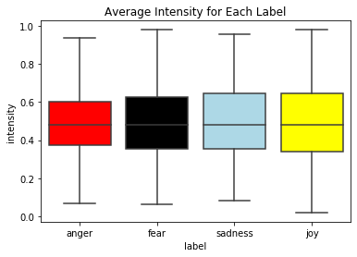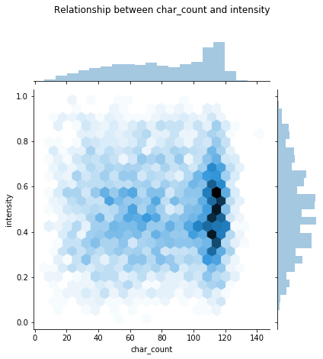

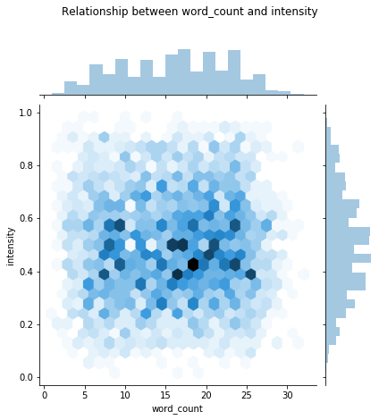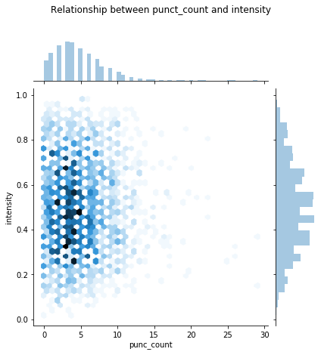

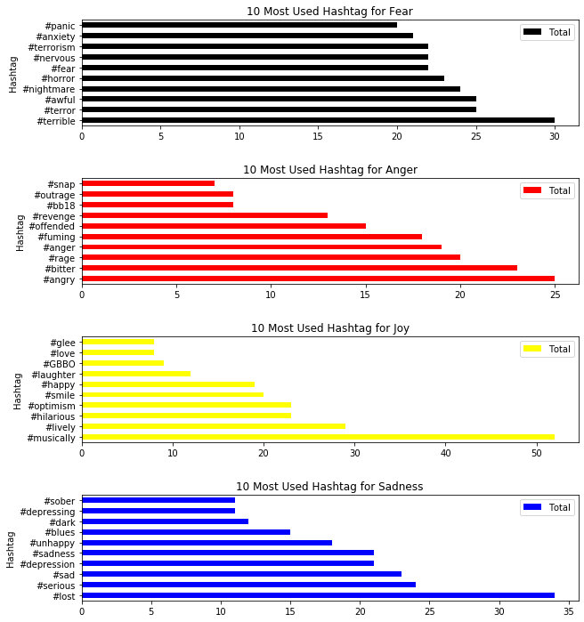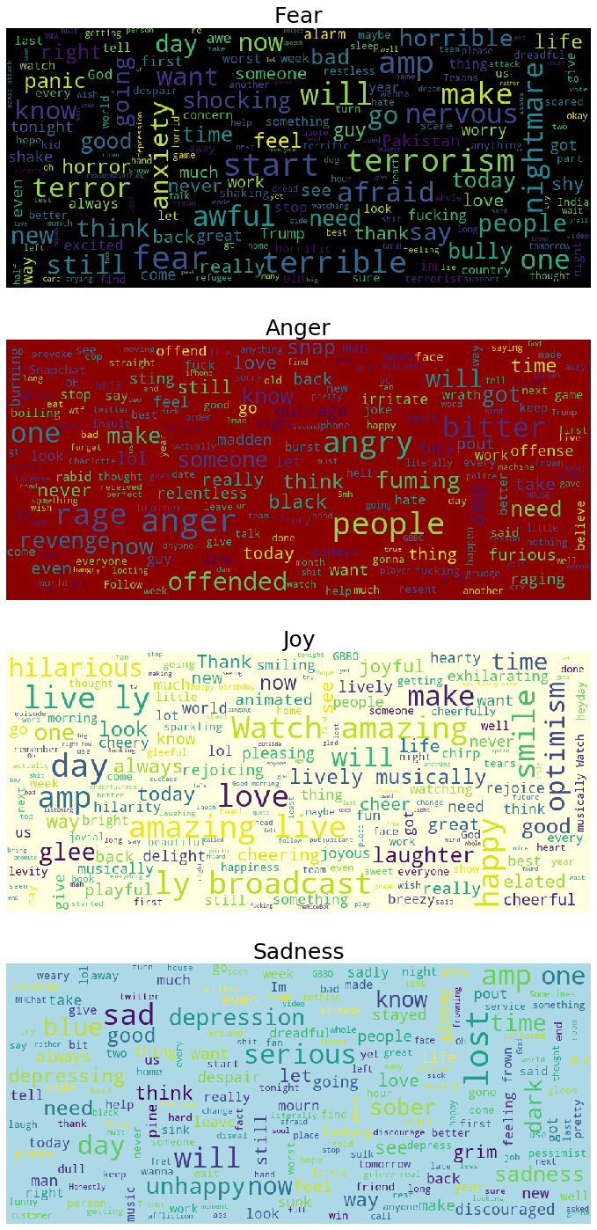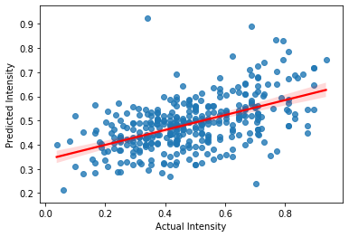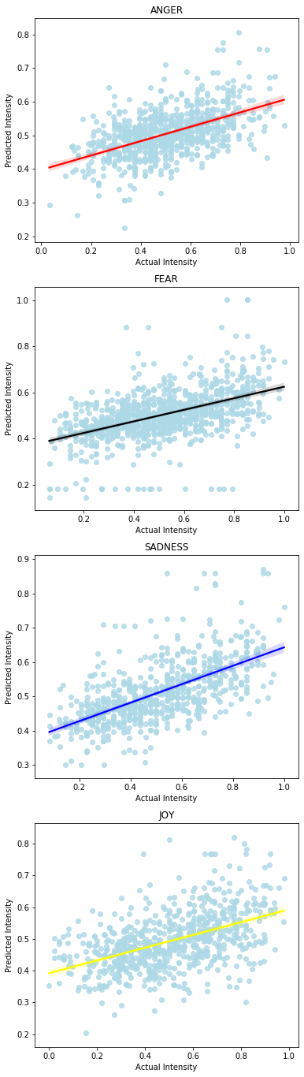

**7.Analysis**

Based on the findings from the Exploratory Data Analysis (EDA), it seems that there are no substantial variances in the average intensity across the four emotions. Additionally, there doesn't appear to be any discernible trend indicating a correlation between intensity and the metrics such as character count, word count, and punctuation count. Consequently, I've opted not to incorporate the features of char_count, word_count, and punct_count in the model training process.

In my attempts to build the regression model, I've experimented with various algorithms including linear regression and ridge regression.