1. Write a Python script to encrypt columnar transposition using keyword.

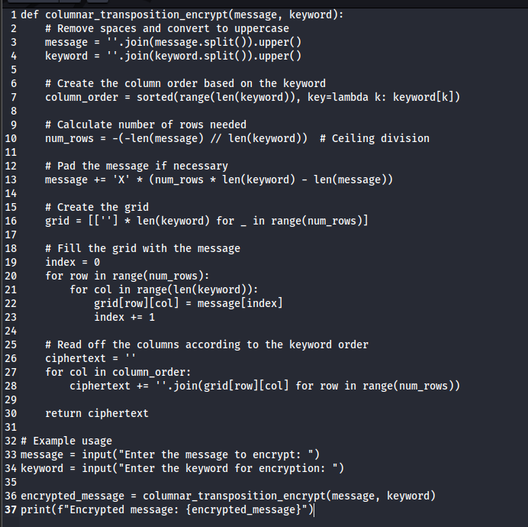

1. Write a Python script to encrypt double columnar transposition.

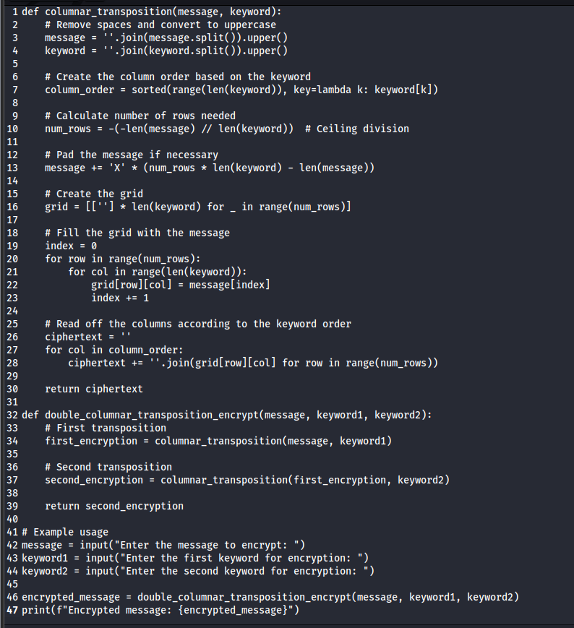 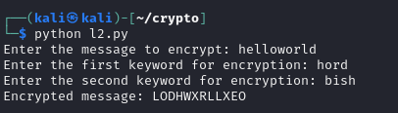

1. Write a Python script to encrypt the message “She is listening” using the 6-character keyword “PASCAL” with Vigenere cipher.

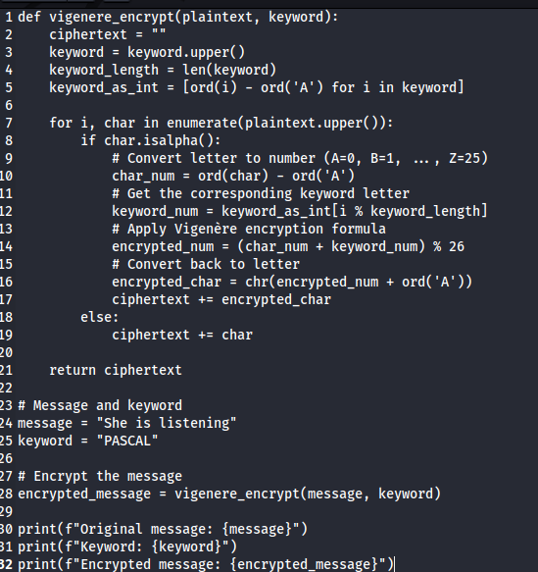 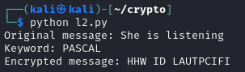

======================================================================================================================================

"Obstacles can't stop you. Problems can't stop you. Most of all, other people can't stop you. Only you can stop you." —Jeffrey Gitomer

======================================================================================================================================