Dublin City University
MSc Business Analytics
BAA1113 Group Project Report

Can Ireland’s Grid Hit 80% Renewable Electricity by 2030?
Power BI analysis of Ireland’s Electricity Transition

GROUP MEMBERS
Shreyas Patil
Sanjana Mahabal
Soham Gode
Sayali Chavan
Aditya Kadam

Contents
Executive Summary 1
1. Introduction 1
2. Problem Statement 2
3. Data and Approach 2
4. Analysis 3
4.1 Ireland’s trajectory and fuel mix 3
4.2 Ireland in a European context 4
4.3 Prices and the renewable share 5
4.4 What delivery requires by 2030 6
5. Recommendations 7
5.1 Scale wind and solar deployment 7
5.2 Strengthen grid and flexibility 7
5.3 Accelerate delivery and policy support 8
5.4 Treat affordability as a separate objective 8
6. Conclusion 8
7. Appendix
- Figure 1.........................................................................................................................3
- Figure 2.........................................................................................................................4
- Figure 3.........................................................................................................................5
- Figure 4.........................................................................................................................6
- Figure 5.........................................................................................................................7
- Figure 6.........................................................................................................................9
- Figure 7.........................................................................................................................9
- Figure 8.......................................................................................................................10
- Figure 9.......................................................................................................................10
8. Tables
- Table 1.........................................................................................................................11
- Table 2.........................................................................................................................12
- Table 3.........................................................................................................................13
9. References...........................................................................................................................14

Executive Summary
Ireland aims to generate 80% of its electricity from renewable sources by 2030 under the Climate Action Plan 2025. This report examines how realistic that target is, using a Power BI dashboard built from open Ember data. The dashboard follows Ireland’s electricity mix from 1990 to 2025, compares its performance with other European countries, looks at wholesale prices in Ireland and ten peer countries, and estimates the pace of change needed by 2030. In 2025, renewables accounted for 48.4% of Irish electricity generation. That leaves a gap of 31.63% to the dashboard’s 80% generation-based target. Closing it over five years would require an annual increase of 6.33 points, compared with the 1.25-point annual gain recorded since 2020. Ireland ranks 20th among the 36 countries compared, below the group average of 51.4%. Irish wholesale electricity was also €35.26/MWh more expensive than the ten-country peer average in 2025. However, a wider comparison shows almost no relationship between a country’s renewable share and its wholesale price. The report therefore recommends expanding wind and solar, improving grid flexibility, speeding up project delivery, and treating affordability as a separate policy objective. The target is to increase substantially.

Introduction
Cutting emissions from electricity is central to climate policy. It reduces emissions from power generation and makes it easier to electrify transport and heating. Ireland presents a particular challenge: it has strong wind resources, but its electricity system is an island grid, and gas provides almost half of its generation. The wider European transition is moving quickly. In 2025 solar energy and wind energy together made more electricity across Europe. And it was more than fossil fuels for the first time in European history. Ireland's Climate action has planned a target of 80% renewable electricity by 2030.
The key question is whether the country can increase renewable generation quickly enough, while also keeping electricity affordable for households and businesses. This report explains the problem first and then the data. After that describes the methodology and what it found before it presents recommendations and a conclusion.

Problem Statement
This report examines weather Ireland can reach its electricity target of renewability in 2030, If Current trend is sufficient and what changes are needed. Renewables accounted for 48.4% of generation in 2025. Compared with 80% target, this leaves a gap of 31.63% and requires an average annual increase of 6.33 points over five years to 2030. That’s guided by four questions:
- Where is Ireland today and how fast having its renewable share grown?
- How does Ireland compare with other European countries?
- Are Irish wholesale prices out of line with peers, and does a higher renewable share bring lower prices?
- What pace and fuel mix does the target require by 2030?
The analysis uses three main measures:
- Renewable share: Renewable electricity generation as a proportion of total electricity generation.
- Gap to target: Difference between 2030 target and latest renewable share.
- Required annual pace: Gap which is remaining is divided by the number of years to 2030

Data and Approach
The analysis uses two open datasets from Ember: annual electricity generation by fuel and country, and monthly European wholesale electricity prices. The generation series covers 1990–2025; 2025 figures may still be provisional. The price analysis compares Ireland with ten other European countries. Both datasets were brought into Power BI and organized into linked tables covering countries, dates, generation, prices, and targets. DAX measures were used to calculate renewable shares, the gap to target, the required annual pace, and the difference in prices. The dashboard is organized into four pages: Ireland Overview, Europe Comparison, Prices and Recommendations. Each page begins with KPI cards, while the chart types reflect the question being examined. Area and line charts show trends, bar charts compare countries, a histogram shows the distribution of renewable shares, and scatter plots explore relationships. Green highlights Ireland and positive results; blue is used to show gaps.

Analysis

4.1 Ireland’s trajectory and fuel mix
Ireland’s renewable share increased from 4.9% in 1990 to 48.4% in 2025, with most of the growth taking place after 2005 (Figure 1). Renewable share reached 42.1% in 2020, dropped to 36.7% in 2021, and then recovered. Therefore, the 2025 figure is 6.33 percentage points higher than in 2020, an average gain of 1.25 points per year. This is 1.70 points per year slower than the average annual increase between 2010 and 2015. The generation mix also shows how much of the transition still depends on a small number of sources (Figure 2). Of 31.0 TWh generated in 2025, gas accounted for 48.1% and wind for 38.2%. Solar has contributed 4.8%, with remainder which comes from bioenergy and other sources. Wind and solar together supplied 43.0%, but gas remained largest individual source. This means that increasing renewable share has largely involved replacing fossil fuels.
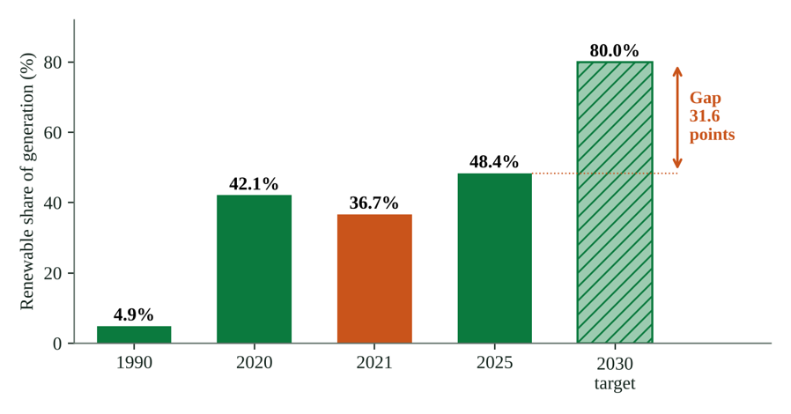 Figure 1

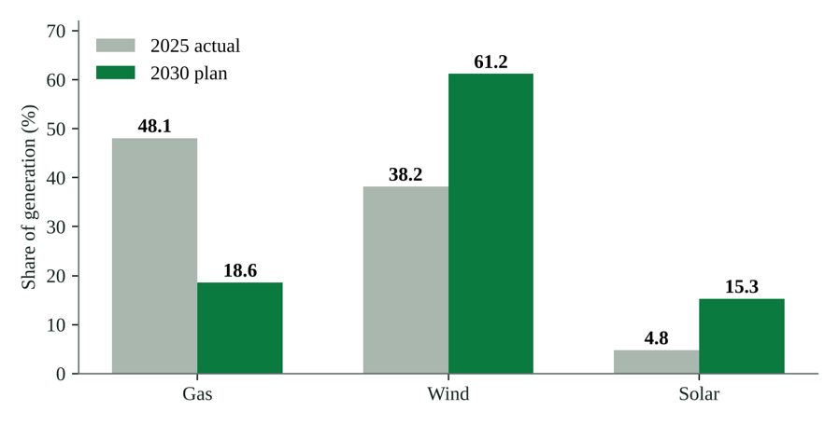
Figure 2

4.2 Ireland in a European context
Ireland’s renewable share of 48.4% is below 51.4% average across 36 countries in comparison, placing it 20th overall (Figure 3). It sits just below Italy at 48.7% and above Romania at 47.0%. Norway (98.8%), Luxembourg (91.5%), Denmark (91.2%) and Austria (84.1%) are leading countries, while several countries at bottom of the ranking remain below 40%. Ireland is therefore in the middle of the group rather than close to extreme. The comparison needs some context: 51.4% is a simple average of country shares. Ember’s generation-weighted estimate for the EU was 48% in 2025 (Petrovich, 2026), which is almost same as Ireland’s result. Ireland is below the average country in this dataset, but broadly in line with the EU-wide figure.
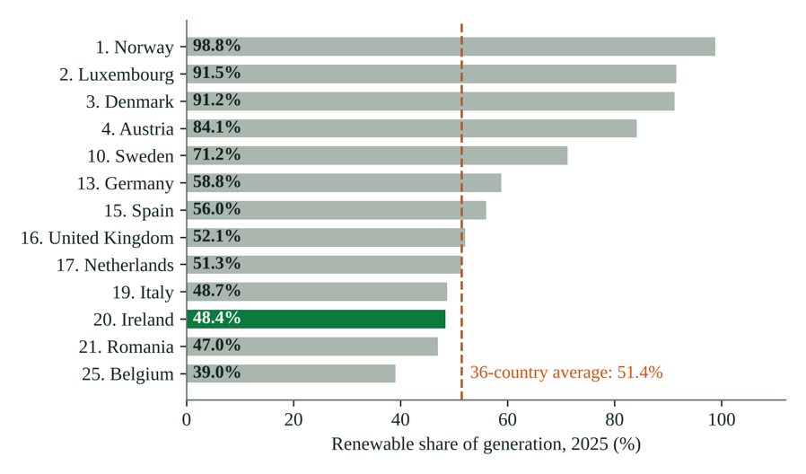
Figure 3

4.3 Prices and the renewable share
Irish wholesale electricity prices were higher than the ten-country peer average in 2025. Ireland’s average was €114.24/MWh, compared with €78.98/MWh for peer group. The difference was €35.26/MWh, or 44.6% (Figure 4). Ireland’s annual average was above the peer average in every year from 2019 to 2025, including during the 2022 energy crisis. Across the full period, only Italy had a higher average price among eleven countries. For 2025 alone, the relationship between renewable share and price was negative (r = −0.39 across 31 countries). When all available observations were pooled, however, the correlation was almost zero (r = 0.006). This suggests that other factors also influence wholesale prices. Ember reports that prices rose in 21 EU countries in 2025, largely because of price spikes in morning and evening when gas-fired generation is needed most (Petrovich, 2026). Since gas supplied 48.1% of Ireland’s electricity in 2025, this is a relevant exposure. It is consistent with possibility that gas contributes to Ireland’s price premium, but the analysis cannot establish causation.
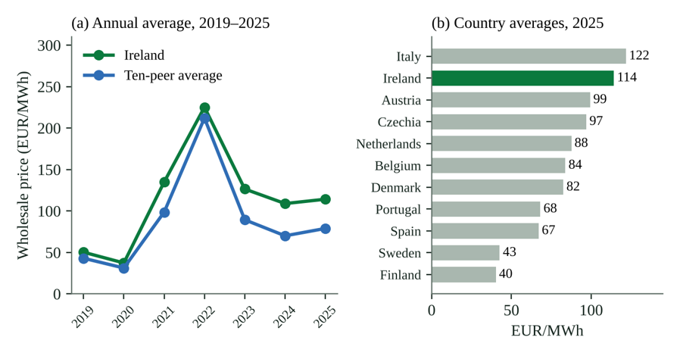
Figure 4

4.4 What delivery requires by 2030
The 2030 plan scenario needs substantial change in the electricity mix (Figure 2). Wind’s share rises from 38.2% to 61.2%, with generation increasing from 11.8 TWh to 29.2 TWh—around two and a half times the 2025 level. Solar rises from 4.8% to 15.3%, increasing from 1.5 TWh to 7.3 TWh, about 5x. Over the same period, gas falls from 48.1% to 18.6%. Total generation is also expected to grow by about 54% as more transport, heating and other activities are electrified. The challenge is therefore not limited to replacing gas; Ireland should build enough renewable generation to meet higher demand. The pace of progress is the main constraint (Figure 5). Reaching target requires an annual increase of 6.33 percentage points. That is about 5.1x, the 1.25-point annual gain recorded since 2020 and 2.2 times the 2.9-point annual gain since the post-2020 low. If the stronger 2.9-point rate continued, renewable share would reach roughly 63% by 2030. At the recent 1.25-point rate, it would reach about 55%. Both scenarios fall short of 80%.

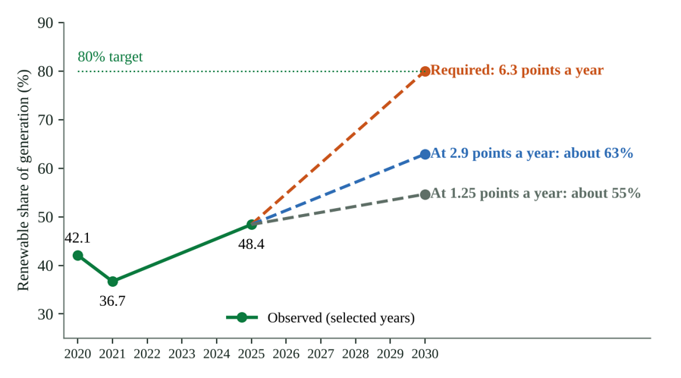
Figure 5

Recommendations

5.1 Scale wind and solar deployment
Ireland’s electricity generation already accounts for 43.0% of wind and solar. The shares need to reach 61.2% and 15.3%, respectively under 2030 planned scenario and new capacity should mainly focus on these two sources. Rather than installing capacity alone, progress should be done by amount of electricity, wind, and solar generated.

5.2 Strengthen grid and flexibility
In 2030, Grid will have to manage very large fluctuation in electricity supply if the wind and solar provide almost three-quarters of electricity according to the planned scenario. Better interconnections will be required to handle such supply.

5.3 Accelerate delivery and policy support
The figures show a huge gap between the progress achieved so far that 6.3% is needed each year as compared with annual point 1.25 since 2020. If projects are operational before 2030, grid connections, planning approvals, and renewable energy auction timelines need faster movements.

5.4 Treat affordability as a separate objective
The relationship between renewable share and wholesale price is weak, so lower prices should not be treated as an automatic result of decarbonization. Affordability needs to be monitored separately, including through Ireland’s €35.26/MWh premium over the ten-country peer average. Policymakers should investigate the reasons for this difference—particularly gas exposure, market design and network costs—before making claims about the effect of renewables on electricity bills.

Conclusion
Ireland's share of electricity from renewables has gone from 4.9% in 1990 to 48.4% in 2025 with wind alone providing over a third of the electricity. To achieve 80% target by 2030, the rate of increase will have to be vastly greater than it has been in recent years. Ireland is making good progress, but delivery challenge is huge and to get 80% will require a huge acceleration in the deployment of renewables and grid. Analysis has several caveats: 2025 generation data may be provisional, the wholesale price data cuts off in Feb 2026, and policy targets are not the same as the dashboard targets. Comparison is only with 10 peer countries; the wholesale prices are not retail bills. The projection’s benchmarks do not forecast, and correlation should not be taken as causation. Further work could be done on demand, interconnection, and capacity factors to explain the price premium.

Appendix
Figure 6: Ireland overview
Figure 7: Europe comparison: Renewable share by country, distribution of shares and renewable share against electricity price.
Figure 8: Prices: Yearly prices compared per Country
Figure 9: Recommendations: 2025 mix against the 2030 plan

Tables
Table 1: Key Indicators from the Dashboard

Indicator | Value
Renewable share of generation, 2025 | 48.4%
Target share, 2030 (generation basis) | 80%
Gap to target | 31.63 points
Required pace, 2025–2030 | 6.33 points a year
Achieved pace, 2020–2025 | 1.25 points a year
Pace compared to 2010-2015 | -1.7 points a year
Wholesale price, Ireland, 2025 | €114.24/MWh
Wholesale price, peer average, 2025 | €78.98/MWh
Irish price premium | €35.26/MWh
Projected 2030 share at 2.9 points a year | About 63%
Projected 2030 share at 1.25 points a year | About 55%
Correlation, renewable energy share are price, 2025 (31 countries) | r = -0.39

Table 2: Average wholesale electricity prices (EUR/MWh), Ireland and ten peers, 2019 to 2025

Country | 2019 | 2020 | 2021 | 2022 | 2023 | 2024 | 2025
Austria | 40.14 | 33.09 | 107.60 | 262.44 | 102.39 | 81.18 | 99.32
Belgium | 39.37 | 31.86 | 103.82 | 243.74 | 97.63 | 70.28 | 83.78
Czechia | 40.23 | 33.60 | 100.38 | 246.61 | 101.08 | 85.06 | 96.91
Denmark | 39.04 | 26.25 | 87.84 | 214.80 | 84.91 | 70.67 | 82.49
Finland | 44.04 | 28.01 | 72.17 | 153.48 | 56.61 | 45.62 | 40.22
Ireland | 50.31 | 37.35 | 134.97 | 225.17 | 126.51 | 108.97 | 114.24
Italy | 52.35 | 38.89 | 125.02 | 303.09 | 127.40 | 108.43 | 121.76
Netherlands | 41.22 | 32.23 | 102.65 | 241.20 | 96.13 | 77.24 | 87.55
Portugal | 47.90 | 33.99 | 111.48 | 168.00 | 88.62 | 63.32 | 68.12
Spain | 47.71 | 33.96 | 111.41 | 167.63 | 87.44 | 62.91 | 67.05
Sweden | 38.56 | 20.73 | 64.23 | 119.45 | 51.83 | 36.12 | 42.62
Ten-peer average | 43.06 | 31.26 | 98.66 | 212.04 | 89.40 | 70.08 | 78.98

Table 3: Measure Definitions

Measure | Definition
Renewable share (%) | Renewable generation is divided by total generation, by country and year.
Gap to target (points) | 2030 target share minus the latest renewable share.
Required pace (points/year) | Gap to target divided by the years remaining to 2030.
Pace, last 5 years | Change in renewable share between 2020 and 2025 divided by five.
Pace vs 2010–2015 | Pace over the last five years minus the average annual gain in 2010–2015.
Price difference (EUR/MWh) | Average Irish wholesale price minus the average price of ten peer countries.

References
“European Wholesale Electricity Price Data.” Ember, 31 Oct. 2026, ember-energy.org/data/european-wholesale-electricity-price-data.
“Yearly Electricity Data.” Ember, 30 Oct. 2026, ember-energy.org/data/yearly-electricity-data/.
“Climate Action Plan 2025 (CAP25) – Policies - IEA.” Climate Action Plan 2025 (CAP25), 8 Apr. 2026, www.iea.org/policies/31123-climate-action-plan-2025-cap25.
“European Electricity Review 2026.” Ember, 13 Apr. 2026, ember-energy.org/latest-insights/european-electricity-review-2026/.
Ashik, Khalid. “European Energy: Generation, Prices & 2030 Targets.” Kaggle, 5 Feb. 2026, www.kaggle.com/datasets/dkhalidashik/european-energy-generation-prices-and-2030-targets.
“Storytelling with Data: A Data Visualization Guide for Business Professionals.” Wiley.Com, Nov. 2015, www.wiley.com/en-nl/shop/general-introductory-mathematics/storytelling-with-data-a-data-visualization-guide-for-business-professionals-p-9781119002253.

