SVM
import zipfile
import os
import cv2
import numpy as np
import matplotlib.pyplot as plt
import shutil

from skimage.feature import graycomatrix, graycoprops
from sklearn.svm import SVC
from sklearn.model_selection import train_test_split
from sklearn.metrics import (
accuracy_score,
classification_report,
confusion_matrix,
ConfusionMatrixDisplay
)

# ================= PATHS =================
ZIP_PATH = r"C:\Users\prasa\Downloads\output_results(eye).zip"
EXTRACT_DIR = "dataset"
BASE_DIR = os.path.join(EXTRACT_DIR, "output_results(og1)")

# ================= FORCE EXTRACT ZIP =================
if os.path.exists(EXTRACT_DIR):
shutil.rmtree(EXTRACT_DIR)

with zipfile.ZipFile(ZIP_PATH, 'r') as z:
z.extractall(EXTRACT_DIR)

# ================= FEATURE EXTRACTION =================
def extract_features(img_path):
img = cv2.imread(img_path, cv2.IMREAD_GRAYSCALE)
if img is None:
return None

img = cv2.resize(img, (128, 64))

glcm = graycomatrix(img, [1], [0], symmetric=True, normed=True)
contrast = graycoprops(glcm, 'contrast')[0][0]
energy = graycoprops(glcm, 'energy')[0][0]
homogeneity = graycoprops(glcm, 'homogeneity')[0][0]
correlation = graycoprops(glcm, 'correlation')[0][0]

edges = cv2.Canny(img, 50, 150)
edge_density = np.count_nonzero(edges) / edges.size

mean_intensity = np.mean(img)
std_intensity = np.std(img)

_, thresh = cv2.threshold(
img, 0, 255, cv2.THRESH_BINARY + cv2.THRESH_OTSU
)
thickness_ratio = np.count_nonzero(thresh) / thresh.size

grad_x = cv2.Sobel(img, cv2.CV_64F, 1, 0, ksize=3)
grad_y = cv2.Sobel(img, cv2.CV_64F, 0, 1, ksize=3)
grad_mag = np.sqrt(grad_x**2 + grad_y**2)

grad_mean = np.mean(grad_mag)
grad_std = np.std(grad_mag)

return [
contrast, energy, homogeneity, correlation,
edge_density,
mean_intensity, std_intensity,
thickness_ratio,
grad_mean, grad_std
]

# =====================================================
# STAGE 1: NOT STRESSED vs STRESSED
# =====================================================
X1, y1 = [], []

for root, _, files in os.walk(BASE_DIR):
for f in files:
if f.lower().endswith((".jpg", ".png", ".jpeg")):
img_path = os.path.join(root, f)
feat = extract_features(img_path)
if feat is None:
continue

if "Not_Stressed" in root:
X1.append(feat)
y1.append(0)
elif "Stressed" in root:
X1.append(feat)
y1.append(1)

X1 = np.array(X1)
y1 = np.array(y1)

print("\n📸 STAGE 1 DATASET INFO")
print("Total images :", len(y1))
print("Not Stressed images:", np.sum(y1 == 0))
print("Stressed images :", np.sum(y1 == 1))

if len(X1) == 0:
raise ValueError("❌ No Stage-1 samples found")

X1_tr, X1_te, y1_tr, y1_te = train_test_split(
X1, y1, test_size=0.2, random_state=42, stratify=y1
)

print("\n🧪 STAGE 1 TRAIN / TEST SPLIT")
print("Training samples:", len(y1_tr))
print("Testing samples :", len(y1_te))

svm_stage1 = SVC(kernel="rbf", C=10, gamma="scale", class_weight="balanced")
svm_stage1.fit(X1_tr, y1_tr)

y1_pred = svm_stage1.predict(X1_te)

print("\n===== STAGE 1 RESULTS =====")
print("Accuracy:", accuracy_score(y1_te, y1_pred))
print(classification_report(
y1_te, y1_pred,
target_names=["Not Stressed", "Stressed"]
))

ConfusionMatrixDisplay(
confusion_matrix(y1_te, y1_pred),
display_labels=["Not Stressed", "Stressed"]
).plot(cmap="Blues")
plt.title("Stage 1 Confusion Matrix")
plt.show()

# =====================================================
# STAGE 2: LOW vs MEDIUM vs HIGH
# =====================================================
X2, y2 = [], []
level_map = {"Low": 0, "Medium": 1, "High": 2}

for root, _, files in os.walk(BASE_DIR):
for level in level_map:
if f"Stressed{os.sep}{level}" in root:
for f in files:
if f.lower().endswith((".jpg", ".png", ".jpeg")):
img_path = os.path.join(root, f)
feat = extract_features(img_path)
if feat is not None:
X2.append(feat)
y2.append(level_map[level])

X2 = np.array(X2)
y2 = np.array(y2)

print("\n📸 STAGE 2 DATASET INFO")
print("Total stressed images:", len(y2))
print("Low Stress images :", np.sum(y2 == 0))
print("Medium Stress images:", np.sum(y2 == 1))
print("High Stress images :", np.sum(y2 == 2))

if len(X2) == 0:
raise ValueError("❌ No Stage-2 samples found")

X2_tr, X2_te, y2_tr, y2_te = train_test_split(
X2, y2, test_size=0.2, random_state=42, stratify=y2
)

print("\n🧪 STAGE 2 TRAIN / TEST SPLIT")
print("Training samples:", len(y2_tr))
print("Testing samples :", len(y2_te))

svm_stage2 = SVC(kernel="rbf", C=10, gamma="scale", class_weight="balanced")
svm_stage2.fit(X2_tr, y2_tr)

y2_pred = svm_stage2.predict(X2_te)

print("\n===== STAGE 2 RESULTS =====")
print("Accuracy:", accuracy_score(y2_te, y2_pred))
print(classification_report(
y2_te, y2_pred,
target_names=["Low Stress", "Medium Stress", "High Stress"]
))

ConfusionMatrixDisplay(
confusion_matrix(y2_te, y2_pred),
display_labels=["Low", "Medium", "High"]
).plot(cmap="Greens")
plt.title("Stage 2 Confusion Matrix")
plt.show()

# =====================================================
# FINAL SUMMARY
# =====================================================
print("\n================ FINAL SUMMARY ================")
print(f"Stage 1 → Total: {len(y1)} | Train: {len(y1_tr)} | Test: {len(y1_te)} | Acc: {accuracy_score(y1_te, y1_pred):.4f}")
print(f"Stage 2 → Total: {len(y2)} | Train: {len(y2_tr)} | Test: {len(y2_te)} | Acc: {accuracy_score(y2_te, y2_pred):.4f}")
print("===============================================")

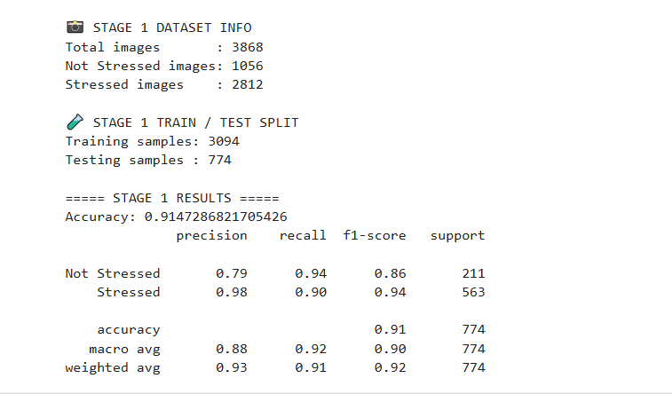
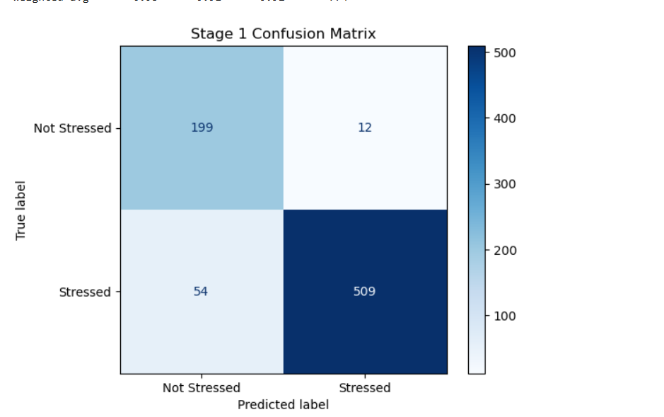
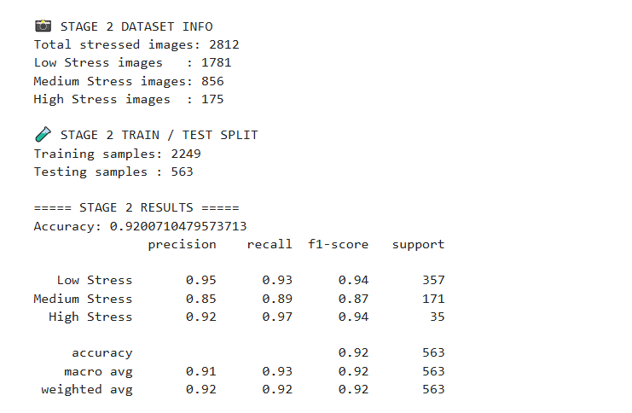
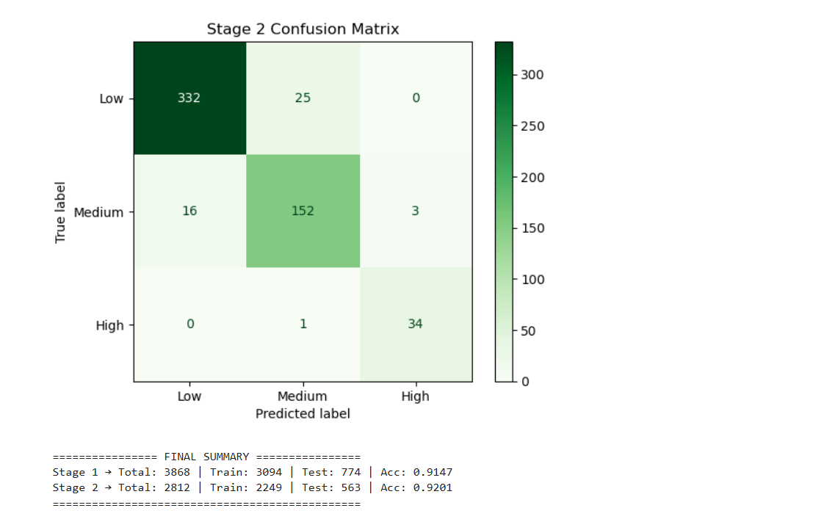
RF
import zipfile
import os
import cv2
import numpy as np
import matplotlib.pyplot as plt
import shutil

from skimage.feature import graycomatrix, graycoprops
from sklearn.ensemble import RandomForestClassifier
from sklearn.model_selection import train_test_split
from sklearn.metrics import (
accuracy_score,
classification_report,
confusion_matrix,
ConfusionMatrixDisplay
)

# ================= PATHS =================
ZIP_PATH = r"C:\Users\prasa\Downloads\output_results(eye).zip"
EXTRACT_DIR = "dataset"
BASE_DIR = os.path.join(EXTRACT_DIR, "output_results(og1)")

# ================= FORCE EXTRACT ZIP =================
if os.path.exists(EXTRACT_DIR):
shutil.rmtree(EXTRACT_DIR)

with zipfile.ZipFile(ZIP_PATH, 'r') as z:
z.extractall(EXTRACT_DIR)

# ================= FEATURE EXTRACTION =================
def extract_features(img_path):
img = cv2.imread(img_path, cv2.IMREAD_GRAYSCALE)
if img is None:
return None

img = cv2.resize(img, (128, 64))

glcm = graycomatrix(img, [1], [0], symmetric=True, normed=True)
contrast = graycoprops(glcm, 'contrast')[0][0]
energy = graycoprops(glcm, 'energy')[0][0]
homogeneity = graycoprops(glcm, 'homogeneity')[0][0]
correlation = graycoprops(glcm, 'correlation')[0][0]

edges = cv2.Canny(img, 50, 150)
edge_density = np.count_nonzero(edges) / edges.size

mean_intensity = np.mean(img)
std_intensity = np.std(img)

_, thresh = cv2.threshold(
img, 0, 255, cv2.THRESH_BINARY + cv2.THRESH_OTSU
)
thickness_ratio = np.count_nonzero(thresh) / thresh.size

grad_x = cv2.Sobel(img, cv2.CV_64F, 1, 0, ksize=3)
grad_y = cv2.Sobel(img, cv2.CV_64F, 0, 1, ksize=3)
grad_mag = np.sqrt(grad_x**2 + grad_y**2)

grad_mean = np.mean(grad_mag)
grad_std = np.std(grad_mag)

return [
contrast, energy, homogeneity, correlation,
edge_density,
mean_intensity, std_intensity,
thickness_ratio,
grad_mean, grad_std
]

# =====================================================
# STAGE 1: NOT STRESSED vs STRESSED
# =====================================================
X1, y1 = [], []

for root, _, files in os.walk(BASE_DIR):
for f in files:
if f.lower().endswith((".jpg", ".png", ".jpeg")):
img_path = os.path.join(root, f)
feat = extract_features(img_path)
if feat is None:
continue

if "Not_Stressed" in root:
X1.append(feat)
y1.append(0)
elif "Stressed" in root:
X1.append(feat)
y1.append(1)

X1 = np.array(X1)
y1 = np.array(y1)

print("\n📸 STAGE 1 DATASET INFO (Random Forest)")
print("Total images :", len(y1))
print("Not Stressed images:", np.sum(y1 == 0))
print("Stressed images :", np.sum(y1 == 1))

X1_tr, X1_te, y1_tr, y1_te = train_test_split(
X1, y1, test_size=0.2, random_state=42, stratify=y1
)

print("\n🧪 STAGE 1 TRAIN / TEST SPLIT")
print("Training samples:", len(y1_tr))
print("Testing samples :", len(y1_te))

rf_stage1 = RandomForestClassifier(
n_estimators=200,
max_depth=None,
random_state=42,
class_weight="balanced"
)

rf_stage1.fit(X1_tr, y1_tr)
y1_pred = rf_stage1.predict(X1_te)

print("\n===== STAGE 1 RESULTS (RANDOM FOREST) =====")
print("Accuracy:", accuracy_score(y1_te, y1_pred))
print(classification_report(
y1_te, y1_pred,
target_names=["Not Stressed", "Stressed"]
))

ConfusionMatrixDisplay(
confusion_matrix(y1_te, y1_pred),
display_labels=["Not Stressed", "Stressed"]
).plot(cmap="Blues")
plt.title("Stage 1 Confusion Matrix (RF)")
plt.show()

# =====================================================
# STAGE 2: LOW vs MEDIUM vs HIGH
# =====================================================
X2, y2 = [], []
level_map = {"Low": 0, "Medium": 1, "High": 2}

for root, _, files in os.walk(BASE_DIR):
for level in level_map:
if f"Stressed{os.sep}{level}" in root:
for f in files:
if f.lower().endswith((".jpg", ".png", ".jpeg")):
img_path = os.path.join(root, f)
feat = extract_features(img_path)
if feat is not None:
X2.append(feat)
y2.append(level_map[level])

X2 = np.array(X2)
y2 = np.array(y2)

print("\n📸 STAGE 2 DATASET INFO (Random Forest)")
print("Total stressed images:", len(y2))
print("Low Stress images :", np.sum(y2 == 0))
print("Medium Stress images:", np.sum(y2 == 1))
print("High Stress images :", np.sum(y2 == 2))

X2_tr, X2_te, y2_tr, y2_te = train_test_split(
X2, y2, test_size=0.2, random_state=42, stratify=y2
)

print("\n🧪 STAGE 2 TRAIN / TEST SPLIT")
print("Training samples:", len(y2_tr))
print("Testing samples :", len(y2_te))

rf_stage2 = RandomForestClassifier(
n_estimators=300,
max_depth=None,
random_state=42,
class_weight="balanced"
)

rf_stage2.fit(X2_tr, y2_tr)
y2_pred = rf_stage2.predict(X2_te)

print("\n===== STAGE 2 RESULTS (RANDOM FOREST) =====")
print("Accuracy:", accuracy_score(y2_te, y2_pred))
print(classification_report(
y2_te, y2_pred,
target_names=["Low Stress", "Medium Stress", "High Stress"]
))

ConfusionMatrixDisplay(
confusion_matrix(y2_te, y2_pred),
display_labels=["Low", "Medium", "High"]
).plot(cmap="Greens")
plt.title("Stage 2 Confusion Matrix (RF)")
plt.show()

# =====================================================
# FINAL SUMMARY
# =====================================================
print("\n================ FINAL SUMMARY (RANDOM FOREST) ================")
print(f"Stage 1 → Total: {len(y1)} | Train: {len(y1_tr)} | Test: {len(y1_te)} | Acc: {accuracy_score(y1_te, y1_pred):.4f}")
print(f"Stage 2 → Total: {len(y2)} | Train: {len(y2_tr)} | Test: {len(y2_te)} | Acc: {accuracy_score(y2_te, y2_pred):.4f}")
print("==============================================================")
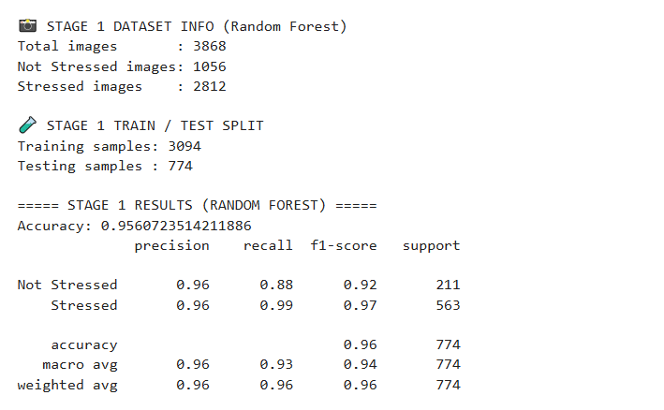
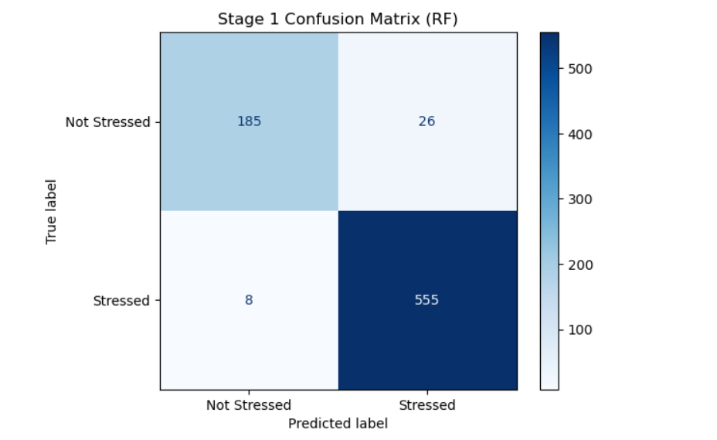
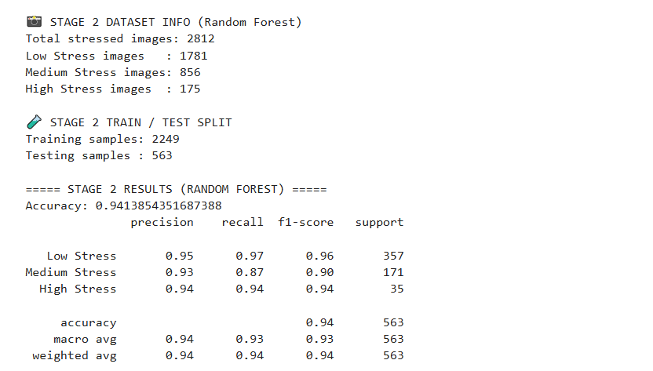
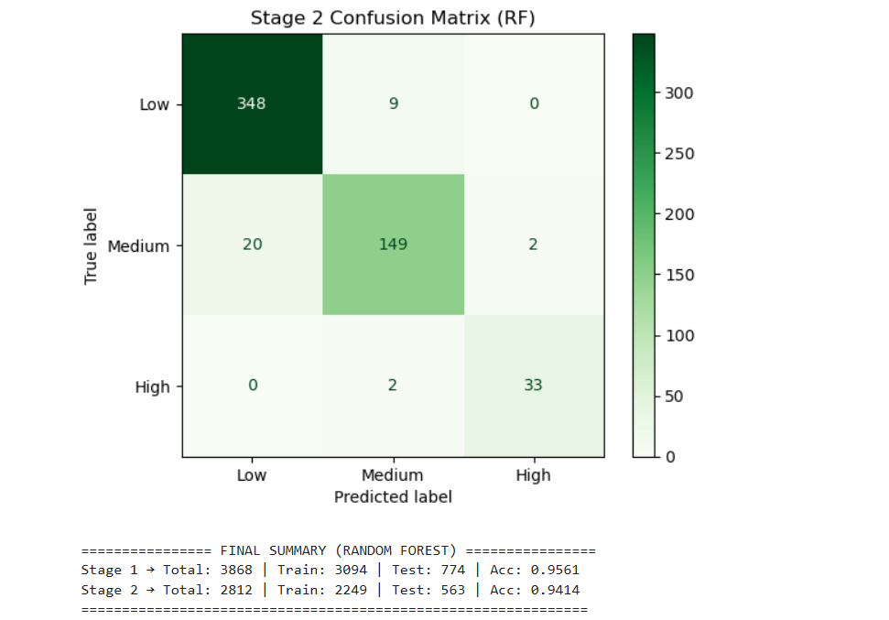
Xgboost
import zipfile
import os
import cv2
import numpy as np
import matplotlib.pyplot as plt
import shutil

from skimage.feature import graycomatrix, graycoprops
from xgboost import XGBClassifier
from sklearn.model_selection import train_test_split
from sklearn.metrics import (
accuracy_score,
classification_report,
confusion_matrix,
ConfusionMatrixDisplay
)

# ================= PATHS =================
ZIP_PATH = r"C:\Users\prasa\Downloads\output_results(eye).zip"
EXTRACT_DIR = "dataset"
BASE_DIR = os.path.join(EXTRACT_DIR, "output_results(og1)")

# ================= FORCE EXTRACT ZIP =================
if os.path.exists(EXTRACT_DIR):
shutil.rmtree(EXTRACT_DIR)

with zipfile.ZipFile(ZIP_PATH, 'r') as z:
z.extractall(EXTRACT_DIR)

# ================= FEATURE EXTRACTION =================
def extract_features(img_path):
img = cv2.imread(img_path, cv2.IMREAD_GRAYSCALE)
if img is None:
return None

img = cv2.resize(img, (128, 64))

glcm = graycomatrix(img, [1], [0], symmetric=True, normed=True)
contrast = graycoprops(glcm, 'contrast')[0][0]
energy = graycoprops(glcm, 'energy')[0][0]
homogeneity = graycoprops(glcm, 'homogeneity')[0][0]
correlation = graycoprops(glcm, 'correlation')[0][0]

edges = cv2.Canny(img, 50, 150)
edge_density = np.count_nonzero(edges) / edges.size

mean_intensity = np.mean(img)
std_intensity = np.std(img)

_, thresh = cv2.threshold(
img, 0, 255, cv2.THRESH_BINARY + cv2.THRESH_OTSU
)
thickness_ratio = np.count_nonzero(thresh) / thresh.size

grad_x = cv2.Sobel(img, cv2.CV_64F, 1, 0, ksize=3)
grad_y = cv2.Sobel(img, cv2.CV_64F, 0, 1, ksize=3)
grad_mag = np.sqrt(grad_x**2 + grad_y**2)

grad_mean = np.mean(grad_mag)
grad_std = np.std(grad_mag)

return [
contrast, energy, homogeneity, correlation,
edge_density,
mean_intensity, std_intensity,
thickness_ratio,
grad_mean, grad_std
]

# =====================================================
# STAGE 1: NOT STRESSED vs STRESSED
# =====================================================
X1, y1 = [], []

for root, _, files in os.walk(BASE_DIR):
for f in files:
if f.lower().endswith((".jpg", ".png", ".jpeg")):
img_path = os.path.join(root, f)
feat = extract_features(img_path)
if feat is None:
continue

if "Not_Stressed" in root:
X1.append(feat)
y1.append(0)
elif "Stressed" in root:
X1.append(feat)
y1.append(1)

X1 = np.array(X1)
y1 = np.array(y1)

print("\n📸 STAGE 1 DATASET INFO (XGBoost)")
print("Total images :", len(y1))
print("Not Stressed images:", np.sum(y1 == 0))
print("Stressed images :", np.sum(y1 == 1))

X1_tr, X1_te, y1_tr, y1_te = train_test_split(
X1, y1, test_size=0.2, random_state=42, stratify=y1
)

print("\n🧪 STAGE 1 TRAIN / TEST SPLIT")
print("Training samples:", len(y1_tr))
print("Testing samples :", len(y1_te))

xgb_stage1 = XGBClassifier(
n_estimators=200,
max_depth=5,
learning_rate=0.1,
subsample=0.8,
colsample_bytree=0.8,
objective="binary:logistic",
eval_metric="logloss",
random_state=42
)

xgb_stage1.fit(X1_tr, y1_tr)
y1_pred = xgb_stage1.predict(X1_te)

print("\n===== STAGE 1 RESULTS (XGBOOST) =====")
print("Accuracy:", accuracy_score(y1_te, y1_pred))
print(classification_report(
y1_te, y1_pred,
target_names=["Not Stressed", "Stressed"]
))

ConfusionMatrixDisplay(
confusion_matrix(y1_te, y1_pred),
display_labels=["Not Stressed", "Stressed"]
).plot(cmap="Blues")
plt.title("Stage 1 Confusion Matrix (XGBoost)")
plt.show()

# =====================================================
# STAGE 2: LOW vs MEDIUM vs HIGH
# =====================================================
X2, y2 = [], []
level_map = {"Low": 0, "Medium": 1, "High": 2}

for root, _, files in os.walk(BASE_DIR):
for level in level_map:
if f"Stressed{os.sep}{level}" in root:
for f in files:
if f.lower().endswith((".jpg", ".png", ".jpeg")):
img_path = os.path.join(root, f)
feat = extract_features(img_path)
if feat is not None:
X2.append(feat)
y2.append(level_map[level])

X2 = np.array(X2)
y2 = np.array(y2)

print("\n📸 STAGE 2 DATASET INFO (XGBoost)")
print("Total stressed images:", len(y2))
print("Low Stress images :", np.sum(y2 == 0))
print("Medium Stress images:", np.sum(y2 == 1))
print("High Stress images :", np.sum(y2 == 2))

X2_tr, X2_te, y2_tr, y2_te = train_test_split(
X2, y2, test_size=0.2, random_state=42, stratify=y2
)

print("\n🧪 STAGE 2 TRAIN / TEST SPLIT")
print("Training samples:", len(y2_tr))
print("Testing samples :", len(y2_te))

xgb_stage2 = XGBClassifier(
n_estimators=300,
max_depth=6,
learning_rate=0.1,
subsample=0.8,
colsample_bytree=0.8,
objective="multi:softmax",
num_class=3,
eval_metric="mlogloss",
random_state=42
)

xgb_stage2.fit(X2_tr, y2_tr)
y2_pred = xgb_stage2.predict(X2_te)

print("\n===== STAGE 2 RESULTS (XGBOOST) =====")
print("Accuracy:", accuracy_score(y2_te, y2_pred))
print(classification_report(
y2_te, y2_pred,
target_names=["Low Stress", "Medium Stress", "High Stress"]
))

ConfusionMatrixDisplay(
confusion_matrix(y2_te, y2_pred),
display_labels=["Low", "Medium", "High"]
).plot(cmap="Greens")
plt.title("Stage 2 Confusion Matrix (XGBoost)")
plt.show()

# =====================================================
# FINAL SUMMARY
# =====================================================
print("\n================ FINAL SUMMARY (XGBOOST) ================")
print(f"Stage 1 → Total: {len(y1)} | Train: {len(y1_tr)} | Test: {len(y1_te)} | Acc: {accuracy_score(y1_te, y1_pred):.4f}")
print(f"Stage 2 → Total: {len(y2)} | Train: {len(y2_tr)} | Test: {len(y2_te)} | Acc: {accuracy_score(y2_te, y2_pred):.4f}")
print("========================================================")
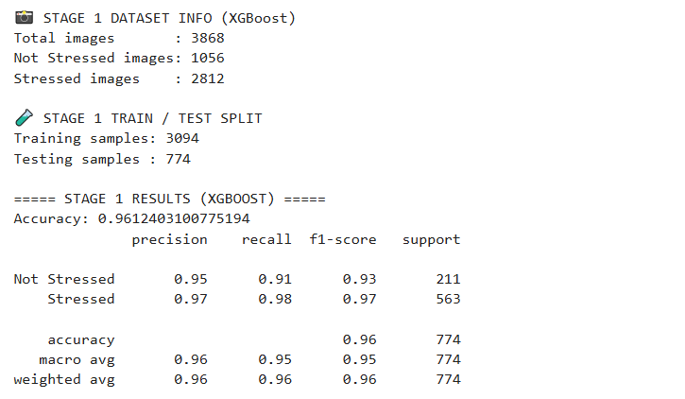
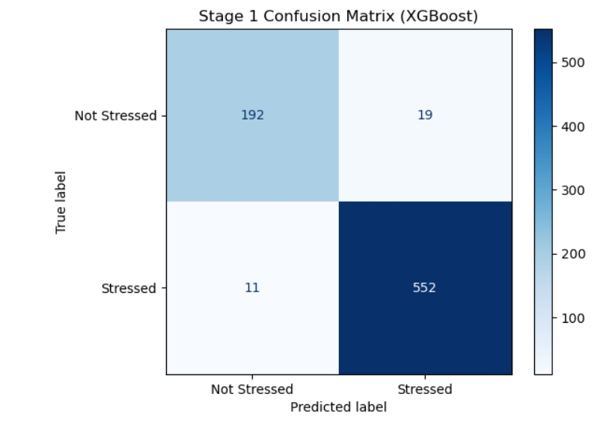
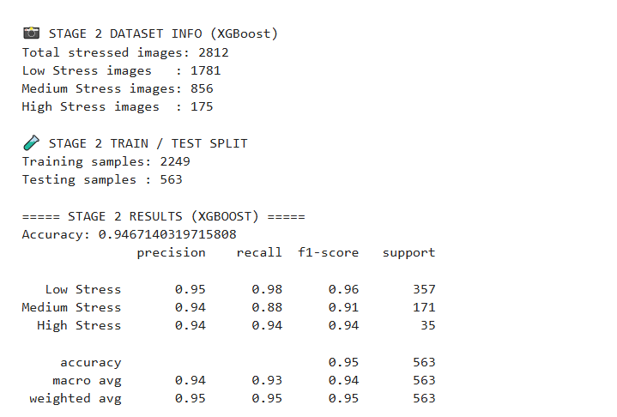
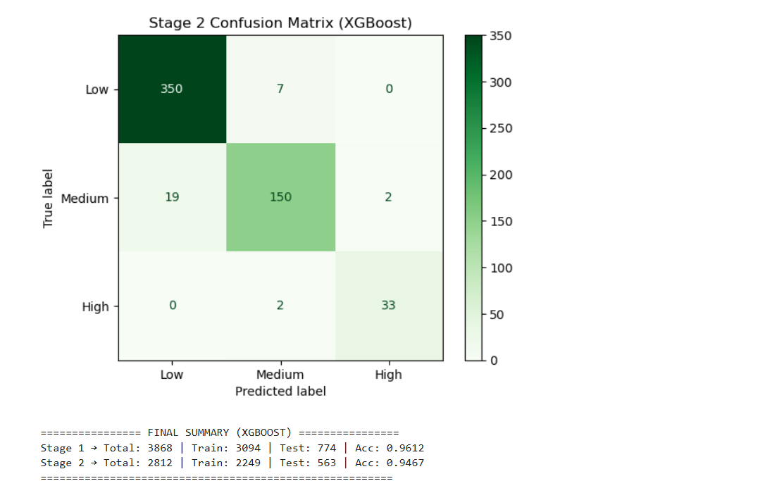
Gradient Boosting Classifier
import zipfile
import os
import cv2
import numpy as np
import matplotlib.pyplot as plt
import shutil

from skimage.feature import graycomatrix, graycoprops
from sklearn.ensemble import GradientBoostingClassifier
from sklearn.model_selection import train_test_split
from sklearn.metrics import (
accuracy_score,
classification_report,
confusion_matrix,
ConfusionMatrixDisplay
)

# ================= PATHS =================
ZIP_PATH = r"C:\Users\prasa\Downloads\output_results(eye).zip"
EXTRACT_DIR = "dataset"
BASE_DIR = os.path.join(EXTRACT_DIR, "output_results(og1)")

# ================= FORCE EXTRACT ZIP =================
if os.path.exists(EXTRACT_DIR):
shutil.rmtree(EXTRACT_DIR)

with zipfile.ZipFile(ZIP_PATH, 'r') as z:
z.extractall(EXTRACT_DIR)

# ================= FEATURE EXTRACTION =================
def extract_features(img_path):
img = cv2.imread(img_path, cv2.IMREAD_GRAYSCALE)
if img is None:
return None

img = cv2.resize(img, (128, 64))

glcm = graycomatrix(img, [1], [0], symmetric=True, normed=True)
contrast = graycoprops(glcm, 'contrast')[0][0]
energy = graycoprops(glcm, 'energy')[0][0]
homogeneity = graycoprops(glcm, 'homogeneity')[0][0]
correlation = graycoprops(glcm, 'correlation')[0][0]

edges = cv2.Canny(img, 50, 150)
edge_density = np.count_nonzero(edges) / edges.size

mean_intensity = np.mean(img)
std_intensity = np.std(img)

_, thresh = cv2.threshold(
img, 0, 255, cv2.THRESH_BINARY + cv2.THRESH_OTSU
)
thickness_ratio = np.count_nonzero(thresh) / thresh.size

grad_x = cv2.Sobel(img, cv2.CV_64F, 1, 0, ksize=3)
grad_y = cv2.Sobel(img, cv2.CV_64F, 0, 1, ksize=3)
grad_mag = np.sqrt(grad_x**2 + grad_y**2)

grad_mean = np.mean(grad_mag)
grad_std = np.std(grad_mag)

return [
contrast, energy, homogeneity, correlation,
edge_density,
mean_intensity, std_intensity,
thickness_ratio,
grad_mean, grad_std
]

# =====================================================
# STAGE 1: NOT STRESSED vs STRESSED
# =====================================================
X1, y1 = [], []

for root, _, files in os.walk(BASE_DIR):
for f in files:
if f.lower().endswith((".jpg", ".png", ".jpeg")):
img_path = os.path.join(root, f)
feat = extract_features(img_path)
if feat is None:
continue

if "Not_Stressed" in root:
X1.append(feat)
y1.append(0)
elif "Stressed" in root:
X1.append(feat)
y1.append(1)

X1 = np.array(X1)
y1 = np.array(y1)

print("\n📸 STAGE 1 DATASET INFO (Gradient Boosting)")
print("Total images :", len(y1))
print("Not Stressed images:", np.sum(y1 == 0))
print("Stressed images :", np.sum(y1 == 1))

X1_tr, X1_te, y1_tr, y1_te = train_test_split(
X1, y1, test_size=0.2, random_state=42, stratify=y1
)

print("\n🧪 STAGE 1 TRAIN / TEST SPLIT")
print("Training samples:", len(y1_tr))
print("Testing samples :", len(y1_te))

gb_stage1 = GradientBoostingClassifier(
n_estimators=200,
learning_rate=0.1,
max_depth=3,
random_state=42
)

gb_stage1.fit(X1_tr, y1_tr)
y1_pred = gb_stage1.predict(X1_te)

print("\n===== STAGE 1 RESULTS (GRADIENT BOOSTING) =====")
print("Accuracy:", accuracy_score(y1_te, y1_pred))
print(classification_report(
y1_te, y1_pred,
target_names=["Not Stressed", "Stressed"]
))

ConfusionMatrixDisplay(
confusion_matrix(y1_te, y1_pred),
display_labels=["Not Stressed", "Stressed"]
).plot(cmap="Blues")
plt.title("Stage 1 Confusion Matrix (GB)")
plt.show()

# =====================================================
# STAGE 2: LOW vs MEDIUM vs HIGH
# =====================================================
X2, y2 = [], []
level_map = {"Low": 0, "Medium": 1, "High": 2}

for root, _, files in os.walk(BASE_DIR):
for level in level_map:
if f"Stressed{os.sep}{level}" in root:
for f in files:
if f.lower().endswith((".jpg", ".png", ".jpeg")):
img_path = os.path.join(root, f)
feat = extract_features(img_path)
if feat is not None:
X2.append(feat)
y2.append(level_map[level])

X2 = np.array(X2)
y2 = np.array(y2)

print("\n📸 STAGE 2 DATASET INFO (Gradient Boosting)")
print("Total stressed images:", len(y2))
print("Low Stress images :", np.sum(y2 == 0))
print("Medium Stress images:", np.sum(y2 == 1))
print("High Stress images :", np.sum(y2 == 2))

X2_tr, X2_te, y2_tr, y2_te = train_test_split(
X2, y2, test_size=0.2, random_state=42, stratify=y2
)

print("\n🧪 STAGE 2 TRAIN / TEST SPLIT")
print("Training samples:", len(y2_tr))
print("Testing samples :", len(y2_te))

gb_stage2 = GradientBoostingClassifier(
n_estimators=300,
learning_rate=0.1,
max_depth=3,
random_state=42
)

gb_stage2.fit(X2_tr, y2_tr)
y2_pred = gb_stage2.predict(X2_te)

print("\n===== STAGE 2 RESULTS (GRADIENT BOOSTING) =====")
print("Accuracy:", accuracy_score(y2_te, y2_pred))
print(classification_report(
y2_te, y2_pred,
target_names=["Low Stress", "Medium Stress", "High Stress"]
))

ConfusionMatrixDisplay(
confusion_matrix(y2_te, y2_pred),
display_labels=["Low", "Medium", "High"]
).plot(cmap="Greens")
plt.title("Stage 2 Confusion Matrix (GB)")
plt.show()

# =====================================================
# FINAL SUMMARY
# =====================================================
print("\n================ FINAL SUMMARY (GRADIENT BOOSTING) ================")
print(f"Stage 1 → Total: {len(y1)} | Train: {len(y1_tr)} | Test: {len(y1_te)} | Acc: {accuracy_score(y1_te, y1_pred):.4f}")
print(f"Stage 2 → Total: {len(y2)} | Train: {len(y2_tr)} | Test: {len(y2_te)} | Acc: {accuracy_score(y2_te, y2_pred):.4f}")
print("===================================================================")
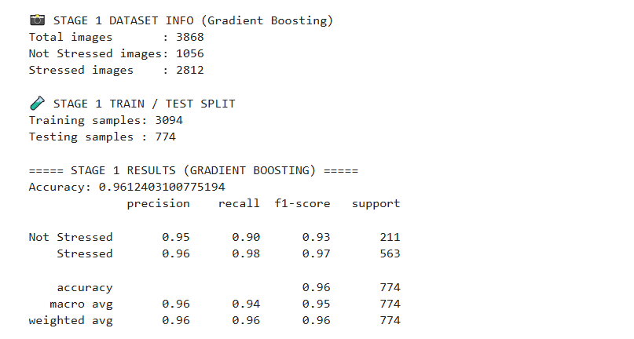
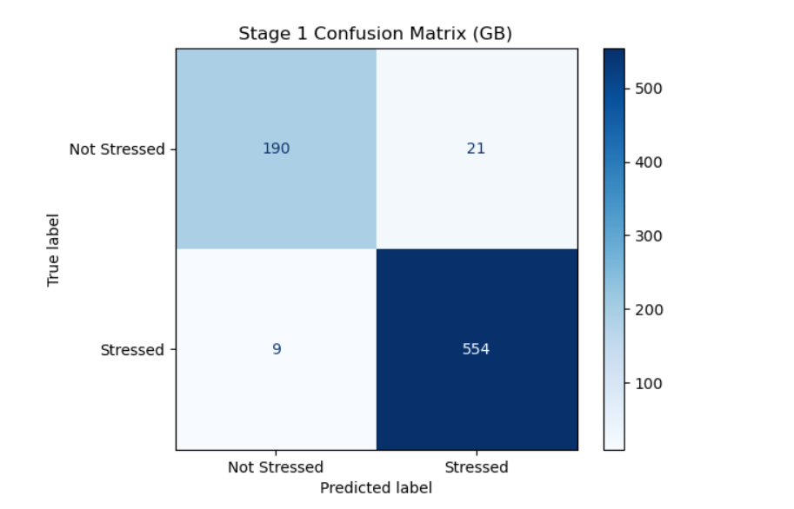
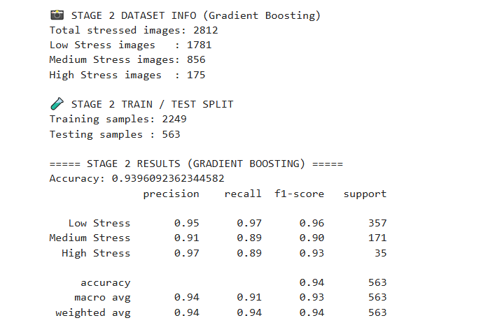
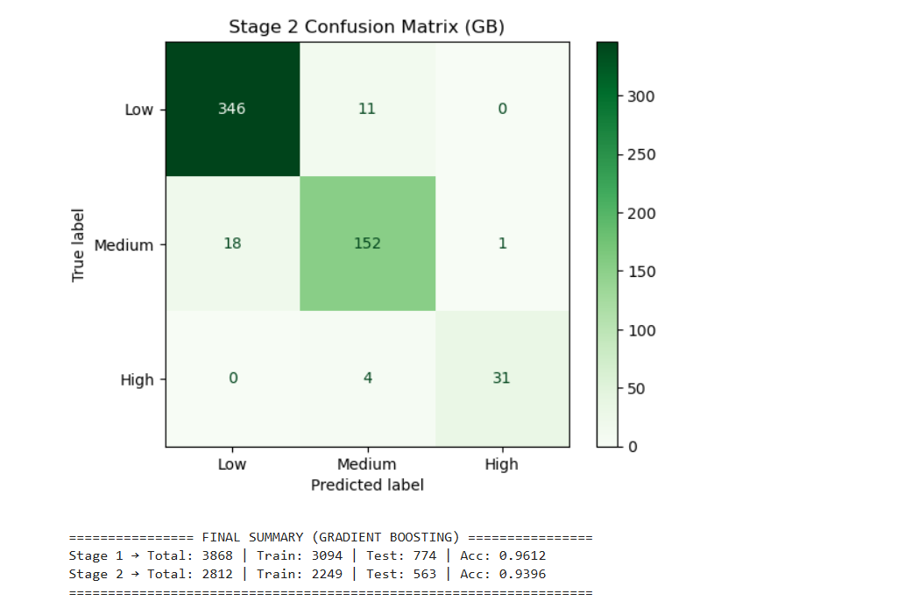
CNN
import zipfile
import os
import shutil
import cv2
import numpy as np
import matplotlib.pyplot as plt

from tensorflow.keras.models import Sequential
from tensorflow.keras.layers import Conv2D, MaxPooling2D, Flatten, Dense, Dropout
from tensorflow.keras.optimizers import Adam
from tensorflow.keras.utils import to_categorical

from sklearn.model_selection import train_test_split
from sklearn.preprocessing import LabelEncoder
from sklearn.metrics import classification_report, confusion_matrix
import seaborn as sns

# ================= PATHS =================
ZIP_PATH = r"C:\Users\prasa\Downloads\output_results(eye).zip"
EXTRACT_DIR = "dataset"
BASE_DIR = os.path.join(EXTRACT_DIR, "output_results(og1)")
IMG_SIZE = 128

# ================= EXTRACT ZIP =================
if os.path.exists(EXTRACT_DIR):
shutil.rmtree(EXTRACT_DIR)

with zipfile.ZipFile(ZIP_PATH, 'r') as z:
z.extractall(EXTRACT_DIR)

# ================= LOAD IMAGES =================
def load_images(stage=1):
X, y = [], []

for root, _, files in os.walk(BASE_DIR):
for f in files:
if f.lower().endswith((".jpg", ".png", ".jpeg")):
img_path = os.path.join(root, f)
img = cv2.imread(img_path, cv2.IMREAD_GRAYSCALE)
if img is None:
continue

img = cv2.resize(img, (IMG_SIZE, IMG_SIZE))
img = img / 255.0
img = np.expand_dims(img, axis=-1)

# Stage 1 labels
if stage == 1:
if "Not_Stressed" in root:
X.append(img)
y.append("Not_Stressed")
elif "Stressed" in root:
X.append(img)
y.append("Stressed")

# Stage 2 labels
else:
if "Low" in root:
X.append(img)
y.append("Low")
elif "Medium" in root:
X.append(img)
y.append("Medium")
elif "High" in root:
X.append(img)
y.append("High")

return np.array(X), np.array(y)

# =====================================================
# STAGE 1: NOT STRESSED vs STRESSED
# =====================================================
X1, y1 = load_images(stage=1)
print("Stage-1 total images:", len(y1))

le1 = LabelEncoder()
y1_enc = le1.fit_transform(y1)
y1_cat = to_categorical(y1_enc)

X1_tr, X1_te, y1_tr, y1_te = train_test_split(
X1, y1_cat, test_size=0.2, random_state=42, stratify=y1_enc
)

cnn_stage1 = Sequential([
Conv2D(32, (3,3), activation='relu', input_shape=(IMG_SIZE, IMG_SIZE, 1)),
MaxPooling2D(2,2),

Conv2D(64, (3,3), activation='relu'),
MaxPooling2D(2,2),

Flatten(),
Dense(128, activation='relu'),
Dropout(0.5),
Dense(2, activation='softmax')
])

cnn_stage1.compile(
optimizer=Adam(learning_rate=0.001),
loss='categorical_crossentropy',
metrics=['accuracy']
)

cnn_stage1.fit(
X1_tr, y1_tr,
epochs=10,
batch_size=32,
validation_data=(X1_te, y1_te),
verbose=1
)

y1_pred = np.argmax(cnn_stage1.predict(X1_te), axis=1)
y1_true = np.argmax(y1_te, axis=1)

print("\n===== STAGE 1 CNN RESULTS =====")
print(classification_report(y1_true, y1_pred, target_names=le1.classes_))

cm1 = confusion_matrix(y1_true, y1_pred)
sns.heatmap(cm1, annot=True, fmt="d",
xticklabels=le1.classes_,
yticklabels=le1.classes_,
cmap="Blues")
plt.title("Stage 1 CNN Confusion Matrix")
plt.show()

# =====================================================
# STAGE 2: LOW vs MEDIUM vs HIGH
# =====================================================
X2, y2 = load_images(stage=2)
print("Stage-2 total images:", len(y2))

le2 = LabelEncoder()
y2_enc = le2.fit_transform(y2)
y2_cat = to_categorical(y2_enc)

X2_tr, X2_te, y2_tr, y2_te = train_test_split(
X2, y2_cat, test_size=0.2, random_state=42, stratify=y2_enc
)

cnn_stage2 = Sequential([
Conv2D(32, (3,3), activation='relu', input_shape=(IMG_SIZE, IMG_SIZE, 1)),
MaxPooling2D(2,2),

Conv2D(64, (3,3), activation='relu'),
MaxPooling2D(2,2),

Flatten(),
Dense(128, activation='relu'),
Dropout(0.5),
Dense(3, activation='softmax')
])

cnn_stage2.compile(
optimizer=Adam(learning_rate=0.001),
loss='categorical_crossentropy',
metrics=['accuracy']
)

cnn_stage2.fit(
X2_tr, y2_tr,
epochs=10,
batch_size=32,
validation_data=(X2_te, y2_te),
verbose=1
)

y2_pred = np.argmax(cnn_stage2.predict(X2_te), axis=1)
y2_true = np.argmax(y2_te, axis=1)

print("\n===== STAGE 2 CNN RESULTS =====")
print(classification_report(y2_true, y2_pred, target_names=le2.classes_))

cm2 = confusion_matrix(y2_true, y2_pred)
sns.heatmap(cm2, annot=True, fmt="d",
xticklabels=le2.classes_,
yticklabels=le2.classes_,
cmap="Greens")
plt.title("Stage 2 CNN Confusion Matrix")
plt.show()
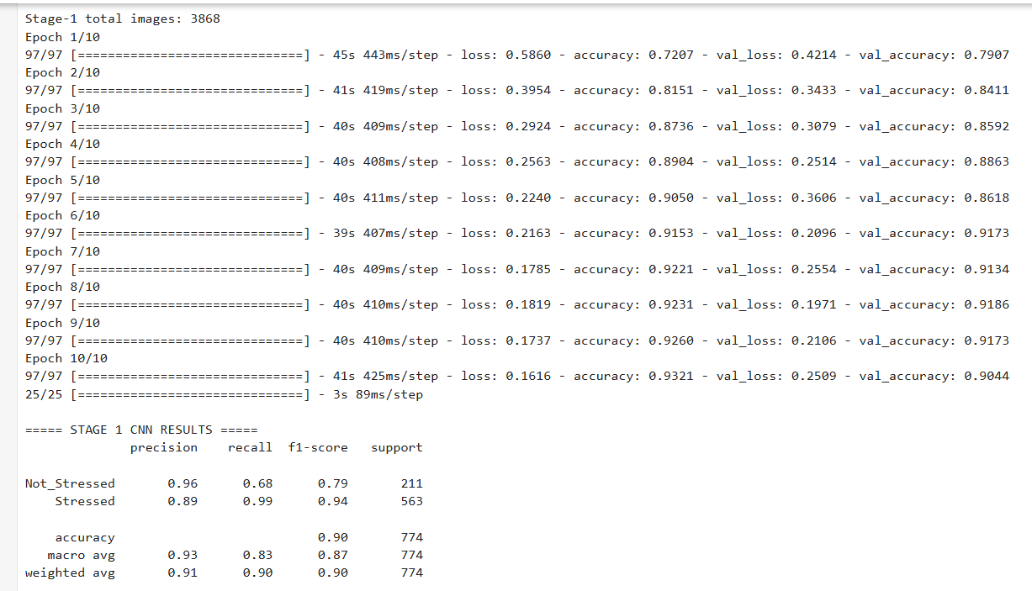
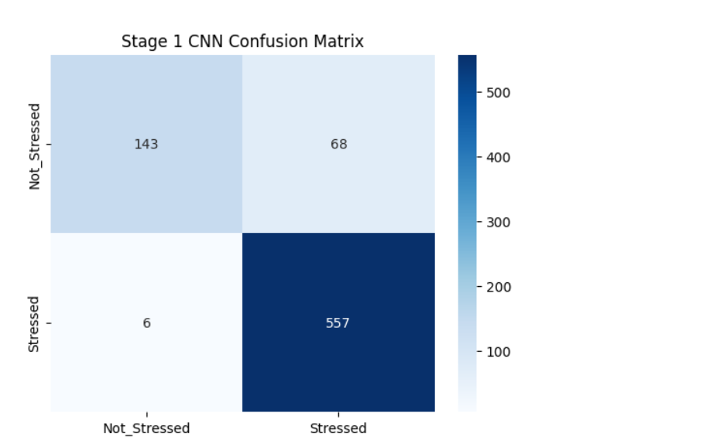
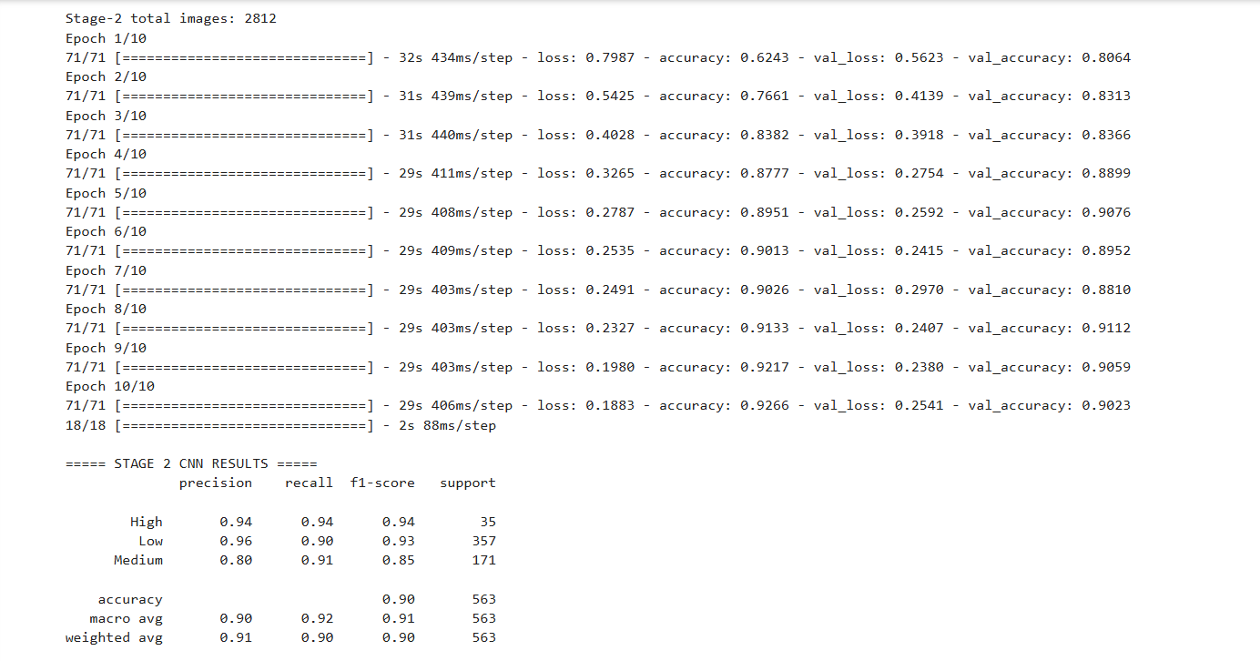
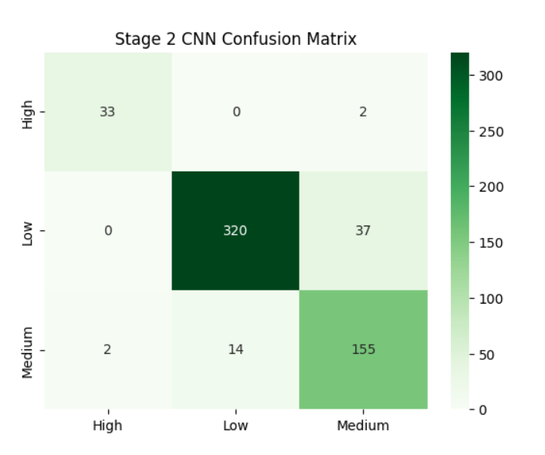
MobileNetV2
import zipfile
import os
import shutil
import cv2
import numpy as np
import matplotlib.pyplot as plt

from tensorflow.keras.applications import MobileNetV2
from tensorflow.keras.models import Model
from tensorflow.keras.layers import Dense, GlobalAveragePooling2D, Dropout
from tensorflow.keras.optimizers import Adam
from tensorflow.keras.utils import to_categorical
from tensorflow.keras.applications.mobilenet_v2 import preprocess_input

from sklearn.model_selection import train_test_split
from sklearn.preprocessing import LabelEncoder
from sklearn.metrics import classification_report, confusion_matrix
import seaborn as sns

# ================= PATHS =================
ZIP_PATH = r"C:\Users\prasa\Downloads\output_results(eye).zip"
EXTRACT_DIR = "dataset"
BASE_DIR = os.path.join(EXTRACT_DIR, "output_results(og1)")
IMG_SIZE = 224

# ================= EXTRACT ZIP =================
if os.path.exists(EXTRACT_DIR):
shutil.rmtree(EXTRACT_DIR)

with zipfile.ZipFile(ZIP_PATH, 'r') as z:
z.extractall(EXTRACT_DIR)

# ================= LOAD IMAGES =================
def load_images(stage=1):
X, y = [], []

for root, _, files in os.walk(BASE_DIR):
for f in files:
if f.lower().endswith((".jpg", ".png", ".jpeg")):
img_path = os.path.join(root, f)
img = cv2.imread(img_path)
if img is None:
continue

img = cv2.resize(img, (IMG_SIZE, IMG_SIZE))
img = cv2.cvtColor(img, cv2.COLOR_BGR2RGB)
img = preprocess_input(img)

if stage == 1:
if "Not_Stressed" in root:
X.append(img)
y.append("Not_Stressed")
elif "Stressed" in root:
X.append(img)
y.append("Stressed")
else:
if "Low" in root:
X.append(img)
y.append("Low")
elif "Medium" in root:
X.append(img)
y.append("Medium")
elif "High" in root:
X.append(img)
y.append("High")

return np.array(X), np.array(y)

# =====================================================
# STAGE 1: NOT STRESSED vs STRESSED
# =====================================================
X1, y1 = load_images(stage=1)
print("Stage-1 total images:", len(y1))

le1 = LabelEncoder()
y1_enc = le1.fit_transform(y1)
y1_cat = to_categorical(y1_enc)

X1_tr, X1_te, y1_tr, y1_te = train_test_split(
X1, y1_cat, test_size=0.2, random_state=42, stratify=y1_enc
)

base_model_1 = MobileNetV2(
input_shape=(IMG_SIZE, IMG_SIZE, 3),
include_top=False,
weights="imagenet"
)

base_model_1.trainable = False

x = base_model_1.output
x = GlobalAveragePooling2D()(x)
x = Dense(128, activation="relu")(x)
x = Dropout(0.5)(x)
output = Dense(2, activation="softmax")(x)

model_stage1 = Model(inputs=base_model_1.input, outputs=output)

model_stage1.compile(
optimizer=Adam(learning_rate=0.0001),
loss="categorical_crossentropy",
metrics=["accuracy"]
)

model_stage1.fit(
X1_tr, y1_tr,
epochs=10,
batch_size=16,
validation_data=(X1_te, y1_te),
verbose=1
)

y1_pred = np.argmax(model_stage1.predict(X1_te), axis=1)
y1_true = np.argmax(y1_te, axis=1)

print("\n===== STAGE 1 MobileNet RESULTS =====")
print(classification_report(y1_true, y1_pred, target_names=le1.classes_))

cm1 = confusion_matrix(y1_true, y1_pred)
sns.heatmap(cm1, annot=True, fmt="d",
xticklabels=le1.classes_,
yticklabels=le1.classes_,
cmap="Blues")
plt.title("Stage 1 MobileNet Confusion Matrix")
plt.show()

# =====================================================
# STAGE 2: LOW vs MEDIUM vs HIGH
# =====================================================
X2, y2 = load_images(stage=2)
print("Stage-2 total images:", len(y2))

le2 = LabelEncoder()
y2_enc = le2.fit_transform(y2)
y2_cat = to_categorical(y2_enc)

X2_tr, X2_te, y2_tr, y2_te = train_test_split(
X2, y2_cat, test_size=0.2, random_state=42, stratify=y2_enc
)

base_model_2 = MobileNetV2(
input_shape=(IMG_SIZE, IMG_SIZE, 3),
include_top=False,
weights="imagenet"
)

base_model_2.trainable = False

x = base_model_2.output
x = GlobalAveragePooling2D()(x)
x = Dense(128, activation="relu")(x)
x = Dropout(0.5)(x)
output = Dense(3, activation="softmax")(x)

model_stage2 = Model(inputs=base_model_2.input, outputs=output)

model_stage2.compile(
optimizer=Adam(learning_rate=0.0001),
loss="categorical_crossentropy",
metrics=["accuracy"]
)

model_stage2.fit(
X2_tr, y2_tr,
epochs=10,
batch_size=16,
validation_data=(X2_te, y2_te),
verbose=1
)

y2_pred = np.argmax(model_stage2.predict(X2_te), axis=1)
y2_true = np.argmax(y2_te, axis=1)

print("\n===== STAGE 2 MobileNet RESULTS =====")
print(classification_report(y2_true, y2_pred, target_names=le2.classes_))

cm2 = confusion_matrix(y2_true, y2_pred)
sns.heatmap(cm2, annot=True, fmt="d",
xticklabels=le2.classes_,
yticklabels=le2.classes_,
cmap="Greens")
plt.title("Stage 2 MobileNet Confusion Matrix")
plt.show()
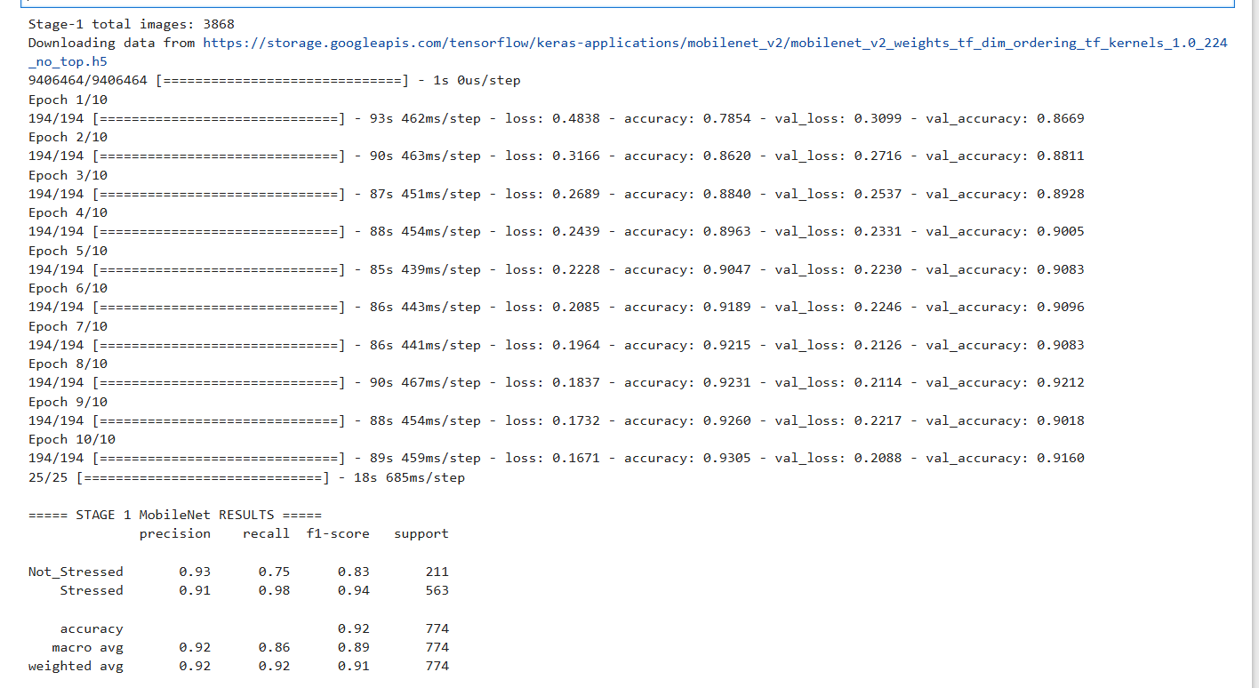
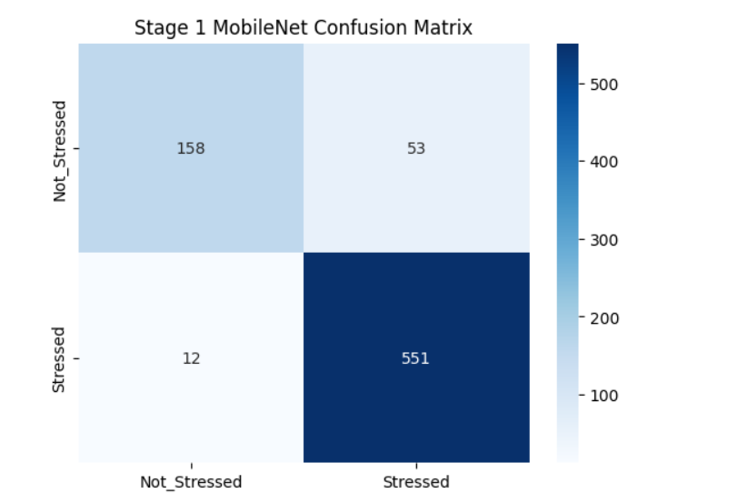
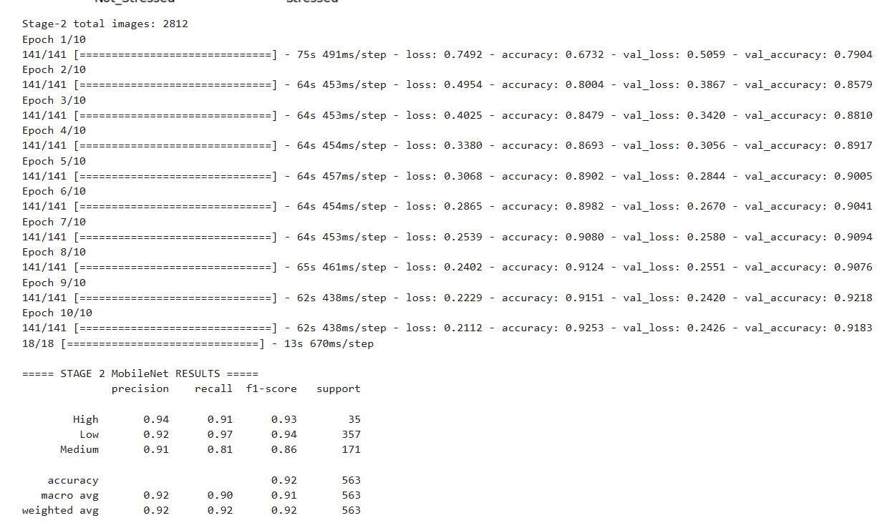
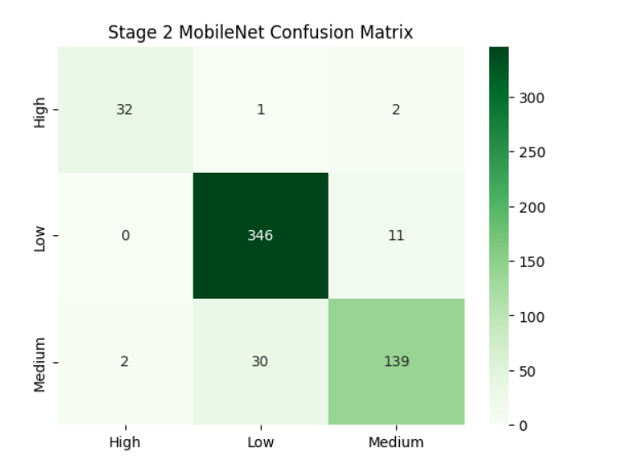
RESNET50

