Technical Datasheet TnH Sensor Modules with Modbus RTU
Protocol with RS485 Interface

The SN modules communicate via RS485. The port can drive distances up to max
700 meters without the use of any repeater (this feature however also depends
on the signal strength of the Modbus Master Device).
The RS485 SN-TnH module is sturdy, has low power usage and is easy to use.

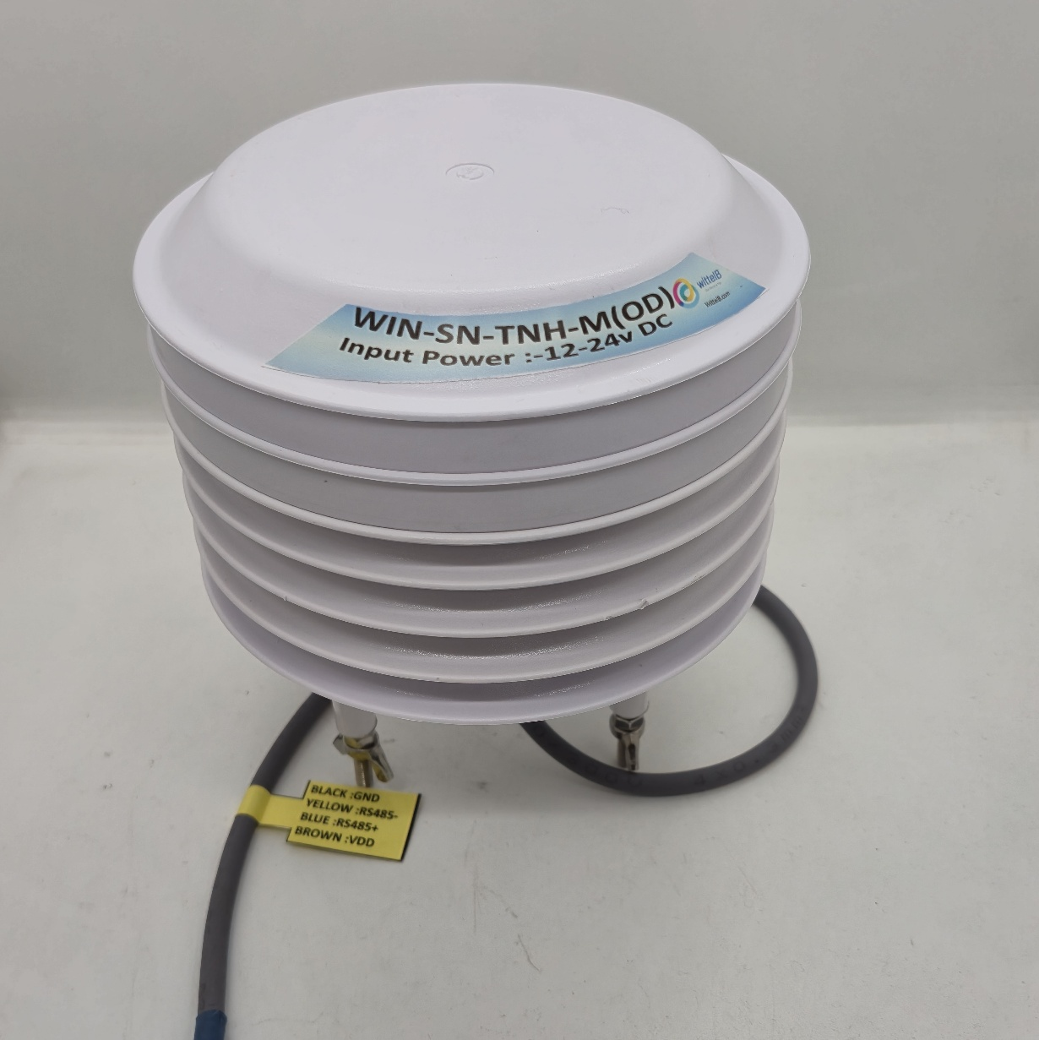
TnH Sensor Module: -

The SN modules can be mounted in Outdoor or Indoor environment. Soft setting for Modbus is available in the software. In Addition, it has reset switch for Slave ID reset if forgotten.

The design of the modules incorporates ‘resettable Fuses’ to safeguard against reverse polarity connection both for Power and Communication port.

Specifications
General –

Dimensions 158mm L x 139 mm D
Power Input Power – 12 - 24 V DC
Operating Temperature 0 – 60° C (32 ~ 140°F)
Storage Temperature -20 - 70° C (-4 ~ 158°F)
Storage Humidity 5 ~ 95 % RH, non – Condensing
Certifications 
Configuration Settings: -
Communication Speed Software Setting (9600 - 115200)
Data Bits 8
Parity None
CRC Yes
Slave ID Software setting(1-247)

ID | Function  Description | Register  Description | Modbus Function Code | Protocol | Data  Type
1 | Temperature | 40000 | 0X03 | RS485 | 16 Bit Unsigned int
2 | Humidity | 40001 | 0X03 | RS485 | 16 Bit Unsigned int
3 | Display Baud Rate (Default:960) | 40011 | 0x03 | RS485 | 16 Bit Unsigned int
4 | Enter New Baud Rate | 40012 | 0x03 | RS485 | 16 Bit Unsigned int
5 | Display Slave ID (Default:1) | 40013 | 0x03 | RS485 | 16 Bit Unsigned int
6 | Enter New Slave ID | 40014 | 0x03 | RS485 | 16 Bit Unsigned int
7 | Display Parity  (Default: None-3, Odd- 1, Even-2) | 40015 | 0x03 | RS485 | 16 Bit Unsigned int
8 | Enter New Parity | 40016 | 0x03 | RS485 | 16 Bit Unsigned int
9 | Display Stop Bit  (start-2/stop bit-1) | 40017 | 0x03 | RS485 | 16 Bit Unsigned int
10 | Enter New Start/ Stop Bit | 40018 | 0x03 | RS485 | 16 Bit Unsigned int

Note: -
For MODBUS communications, a shielded and twisted pair cable is used. One example of such cable is Belden 3105A.
Recommended Cable Electrical Characteristics: -
22 AWG Cable Shielded and twisted pair should be used.
Tinned Copper Recommended
Nominal Conductor DCR 14.7 ohm / 1000 ft
Nominal Capacitance 11 pf / feet (conductor to conductor)
High Frequency Non-Insertion Loss 0.5db / 100ft

Here is an example of receiving data on Mb poll software.
- Open Mb-poll software connect using configuration setting (Default baud rate is 9600 and Default slave id is 1).
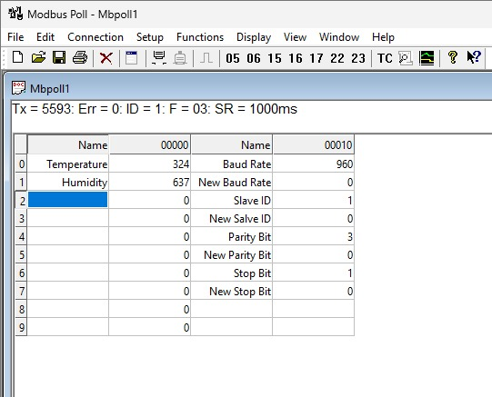
- After connecting you will get data as shown below.
- As you can see in the image above, resistor 40011 represents the present baud rate, resistor 40013 represents slave ID, resistor 40015 represents parity bit and resistor 40017 represents the Stop bit of the module.
- To change the baud rate and slave id you must enter a value on the 40012 resistor for the baud rate and 40014 for the slave id as shown in the image below
- Also, for changing the parity bit 40016 and stop bit 40018.

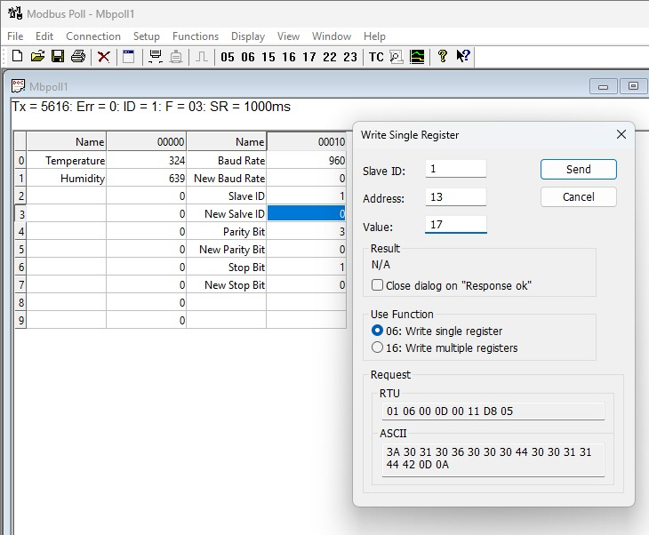
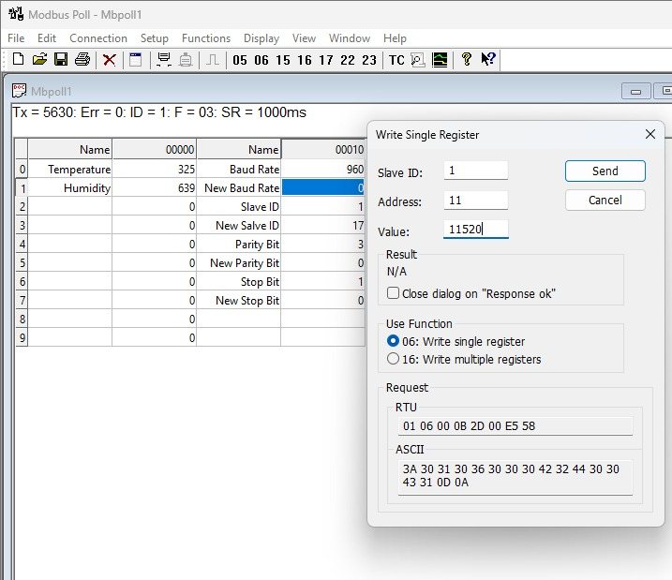
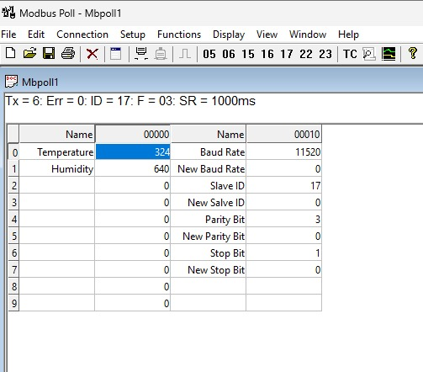
- After that press the reset button. Then the baud rate & slave ID will be changed.

- Somehow you forgot the modbus settings of the board, in that case press reset button for 5 sec. Then you will get the default values for the system.

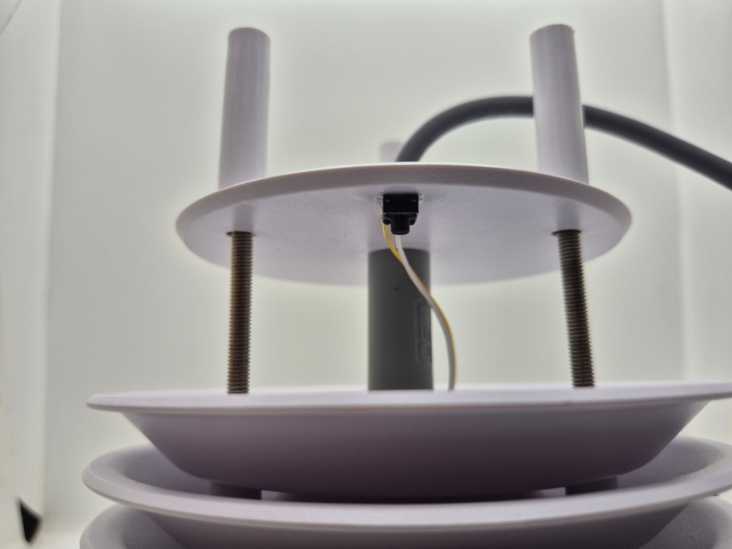

Sensor Name | Temperature  Measuring Range | Humidity  Measuring range | Operating Temperature | Measuring Accuracy
AHT20 | -20°C ~ 85°C. | 0~100% RH. | -40°C ~ 120°C. | 0.3°C, 2.0 %RH
AHT21 | -40°C ~ 120°C. | 0~100% RH. | -40°C ~ 120°C. | 0.3°C, 2.0 %RH

Contact us: -
Augmatic Technologies Pvt. Ltd.,
Plot no 6, Shah Industrial Estate II,
Kotambi,
Vadodara – 391510.
Email – Sales@wittelb.com
Support: support@wittelb.raiseaticket.com / +91 94038 92805

