WIN-SN-TNH-AOV Environmental Sensor with AOC(4-20mA)-AOV(0-10v) Datasheet

Product Overview
The WIN-SN-TNH-AOC-AOV Sensor Board is a versatile solution for measuring Temperature, Humidity, TVOC, and Barometric Pressure in various settings, including industrial applications and smart homes. It features precise sensors, as detailed in Table 1 and Table 2, and provides analog output options of 10-bit and 12-bit resolution, ranging from 0 to 10V or 4-20mA. The board's low power consumption and wide operating temperature range make it suitable for numerous applications, such as outdoor air quality monitoring, climate control in greenhouses, and environmental monitoring systems.

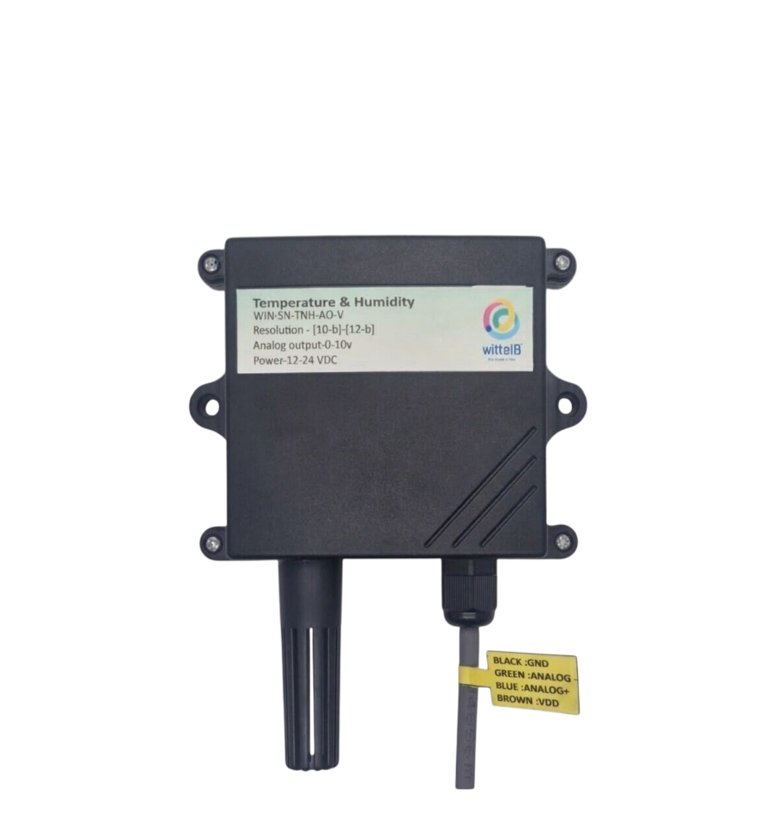

The sensor board offers data output through analog signals, making it easy to integrate with various devices and systems. It can be powered by a DC power supply, ensuring flexibility and convenience in deployment.
 | Sensor Name | Temperature  Measuring Range | Humidity  Measuring range | Operating Temperature | Measuring Accuracy
☐ | AHT21 | -40°C ~ 120°C. | 0~100% RH. | -40°C ~ 120°C. | 0.3°C, 2.0 %RH
☐ | AHT20 | -40°C ~ 85°C. | 0~80% RH. | -40°C ~ 85°C. | 0.3°C, 2.0 %RH
☐ | SHT21 | -40°C ~ 125°C. | 0~80% RH. | -40°C ~ 125°C. | 0.3°C, 2.0 %RH
☐ | SHT25 | -40°C ~ 125°C. | 0~80% RH. | -40°C ~ 125°C. | 0.2°C, 1.8 %RH
☐ | BME280 | -40°C ~ 85°C. | 0~100% RH. | -40°C ~ 85°C. | 1.0°C, 3.0 %RH
☐ | BME680 | -40°C ~ 85°C | 0~100% RH. | -40°C to 85°C | 1.0°C, 3.0 %RH
Table 1
Sensor Name | Measuring  Parameter | Measuring Operating Range Temperature |  | Measuring Accuracy
AGS10 | TVOC | 0 – 9999 ppb | 0°C~85°C | (25°C 50%RH) 25% FS
BME280 | Barometric Pressure | 300 - 1100 hPa | -40°C ~ 85°C. | ±1.0 hPa.
BME680 | Barometric Pressure | 300 - 1100 hPa | -40°C ~ 85°C. | ±1.0 hPa.
BME680 | IAQ | 0-500 IAQ | -40°C ~ 85°C. | ±1.0% IAQ
SCD 40 | Co2 | 0-40000ppm | -40°C ~ 85°C. | ±5%@2000ppm
Table 2

2. Technical Specifications
- Measured Parameters: Temperature and Humidity.
- Output Type: Analog Output-10-bit and 12-bit resolution.
- Output Range: AOV 0-10V / AOC 4-20mA.
- Wide temperature range: −20 °C to +85 °C.
- Full humidity range: 0 % to 100 % RH
- Product dimension: 85*85*40 mm.
- Power supply DC: 12-24V DC @1A (Type –C power USB).


- Certifications:

3. Applications
- Outdoor air quality monitoring.
- Climate control in greenhouses.
- Environmental monitoring systems.
- Smart home system.

4. Precautions
- Read all instructions before using the sensor board.
- Keep the sensor board away from water or moisture to prevent damage.
- Do not disassemble or modify the sensor board.
- Use only the specified power sources and mentioned.

5. Power Supply Connection
- DC Connection
- Use 12-24V DC @ 1A, Power supply.
- Ensure all connections are tight and secure, avoid loose connections.

- Wire diagram
AO1 | Brown- Temperature+
 | Black- Temperature-
AO2 | Yellow- Humidity+
 | White- Humidity-

- Range for mapping 0-10v or 4-20mA output.
Analog output | Parameter | Range
AO1 | Temperature | -40°C ~ 85°C.
AO2 | Absolute Humidity | 0~130g/m3

Contact Information:-
Augmatic Technologies Pvt. Ltd.,
Plot no 6, Shah Industrial Estate II, Kotambi, Vadodara – 391510.
Email – Sales@wittelb.com
Support: support@wittelb.raiseaticket.com / +91 94038 92805

