Product Overview:
The WIN-SN-TNH-UPOE is a versatile and reliable solution for precise temperature and humidity monitoring, offering robust communication capabilities. It is ideal for measuring environmental conditions in various settings, such as industrial facilities, greenhouses, and smart homes. It provides data transmission via Modbus through an Ethernet interface, ensuring seamless integration into IoT networks. The module offers flexible deployment options tailored to specific monitoring and control needs, ensuring accurate and reliable measurements over long distances with high resistance to electrical interference.
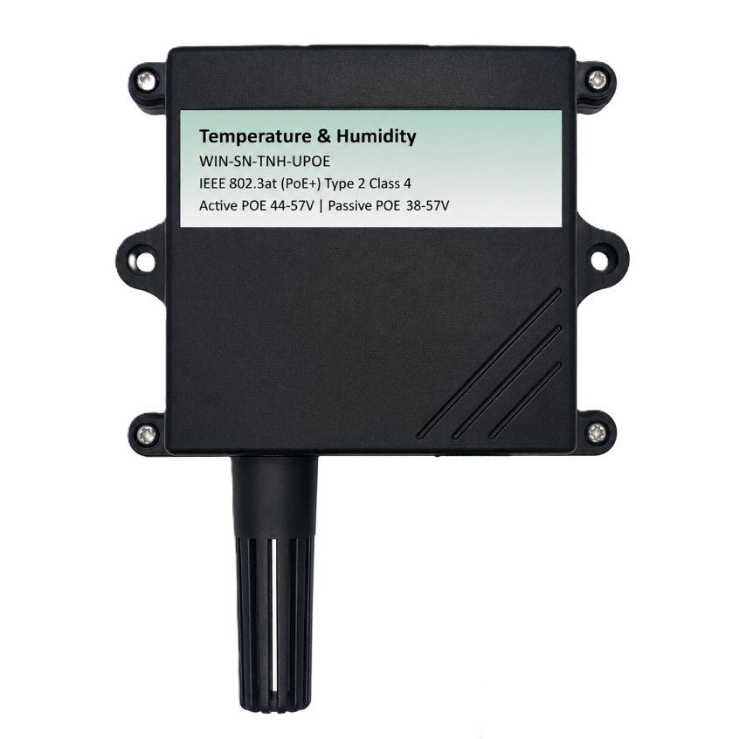
One of the key advantages of the WIN-SN-TNH-UPOE is its flexibility in sensor compatibility, supporting a variety of external sensors via an I2C interface. Powered directly via the network cable, this module eliminates the need for external wall adapters. It boasts IEEE 802.3at (PoE+) Type 2 Class 4 compliance with a power capability of up to 30W. For maximum deployment flexibility, the device supports a wide input voltage range, seamlessly accommodating both Active PoE (44V to 57V DC) and Passive PoE (38V to 57V DC) infrastructures.
It features internal galvanic isolation and a robust step-down converter, ensuring safe, reliable performance in diverse industrial IoT applications. The WIN-SN-TNH-UPOE supports the addition of multiple external sensors. This flexibility allows users to customize the module for various applications by integrating sensors suited to different measurement needs. Here are some examples of compatible I2C sensors listed in Table 1.
Technical Specifications:

 | Sensor Name | Measuring parameter | Temperature Measuring range | Humidity Measuring range | Measuring Accuracy
☐ | AHT21 | Temperature, Humidity | -40°C ~ 120°C. | 0 – 100 %RH | 0.3°C, 2.0 %RH
☒ | AHT20 | Temperature, Humidity | -40°C ~ 85°C. | 0 – 100 %RH | 0.3°C, 2.0 %RH
☐ | SHT21 | Temperature, Humidity | -40°C ~ 125°C. | 0 – 100 %RH | 0.3°C, 2.0 %RH
☐ | SHT25 | Temperature, Humidity | -40°C ~ 125°C. | 0 – 100 %RH | 0.2°C, 1.8 %RH
☐ | SHT40 | Temperature, Humidity | -40°C ~ 125°C. | 0 – 100 %RH | 0.2°C, 1.8 %RH
☐ | AM2315C | Temperature, Humidity | -40°C ~ 125°C. | 0 – 99.9 %RH | 0.3°C, 2.0 %RH
☐ | BME680 | Temperature,  Humidity | -40°C ~ 85°C | 0 – 100 %RH | ±1°C, 3.0%RH
☐ | BME280 | Temperature, Humidity | -40°C ~ 125°C | 0 – 100 %RH | ±0.3°C, ±2.0% RH
Table No.1

General Specification:
- Product dimension: 85*85*35 mm
- Active POE Operating Voltage: 44-57V DC
- Passive POE Operating Voltage: 38-57V DC

- Certifications:

Configuration setting:
Communication Speed Software Configurable
Data Bits 8
Parity None
Stop bit 1
CRC Yes
Slave ID Configurable via web interface
Function code 0X03 (Read Holding Register)

ID | Function Description | Register Description | Modbus Function Code | Protocol | Data Type
1 | Temperature | 40001 | 0x03 | TCP/IP | 16 bit int
2 | Humidity | 40002 | 0x03 | TCP/IP | 16 bit int

Additional Feature: SNMP Integration:
In addition to Modbus communication, this module supports SNMP (Simple Network Management Protocol) v2c. This allows an authorized Network Management System (NMS) to directly poll the device for real-time environmental data without relying on Modbus or MQTT push protocols.
SNMP Configuration Settings:
- Protocol Version: SNMP v2c
- Read-Only Community String: Public
- Read-Write Community String: Private
- Enterprise OID Base: .1.3.6.1.4.1.99999
SNMP OID Reference Table:
Because standard SNMP does not natively support floating-point (decimal) numbers, the sensor values are scaled by a factor of 10 before being transmitted. Just like the Modbus registers, you must divide the returned SNMP value by 10 to obtain the true reading.
- Example: An SNMP query returning 300 for Temperature equals 30.0°C.
How OIDs Work:
An OID (Object Identifier) functions as a value's specific "address"—much like a house number. When a network manager queries an OID, the sensor node looks up and returns just that specific value.
OIDs form a hierarchical tree, where each number represents a branch. Using the temperature OID (.1.3.6.1.4.1.99999.1.4.0) as an example.

Here is how the address is broken down:
OID Part | Meaning
.1.3.6.1 | Standard internet OID prefix — identical on every SNMP device.
.4.1 | "Private Enterprise" branch — everything following this is custom, device-specific data.
.99999 | Enterprise Number (Placeholder).
.1 | Custom sub-branch (e.g., "sensor data").
.4 | The specific value in that group (e.g., Temperature).
.0 | Marks this as a single scalar value, rather than a list (standard SNMP convention).

WIN-SN-TNH-UPOE OID Mapping:
OID Address | Variable | Meaning
.1.3.6.1.4.1.99999.1.2.0 | snmp_ModeFlag | 0 = TCP mode, 1 = WiFi mode
.1.3.6.1.4.1.99999.1.3.0 | snmp_MqttConnected | 1 = Connected, 0 = Disconnected
.1.3.6.1.4.1.99999.1.4.0 | snmp_Temperature | Temperature x 10
.1.3.6.1.4.1.99999.1.5.0 | snmp_Humidity | Humidity x 10

Configuration Process:-

- Power up the module by connecting a 5 Vdc 1A power supply and the RED led will be ON. After powering up wait for 20 Seconds.
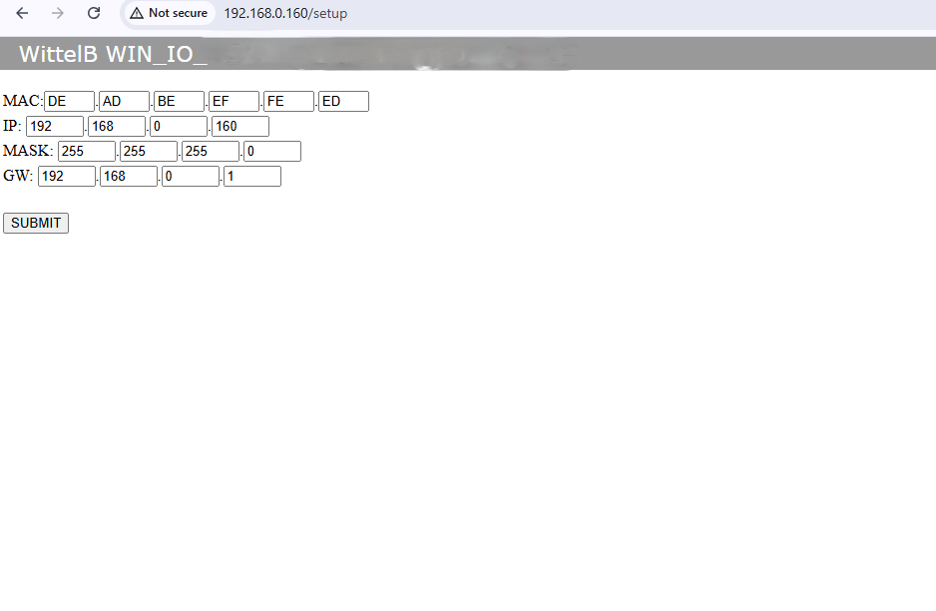
- Enter the http://192.168.0.160/ IP address on a web browser and a webpage with two configuration pages will be accessible.
- After submitting it on the webpage, you need to open MB/POLL or MBSCAN on your device. In the connection settings, select TCP/IP Connection and enter the following IP. You will receive data, and for more information, you can refer to the images below.
- Hardware Fail-Safe: To recover a lost IP address, simply short the onboard RST jumper and press the RESET button to instantly restore factory default configurations.

- Connection Setup:-

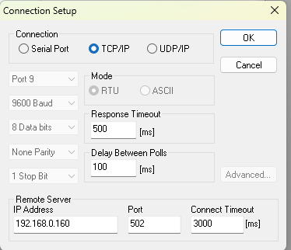
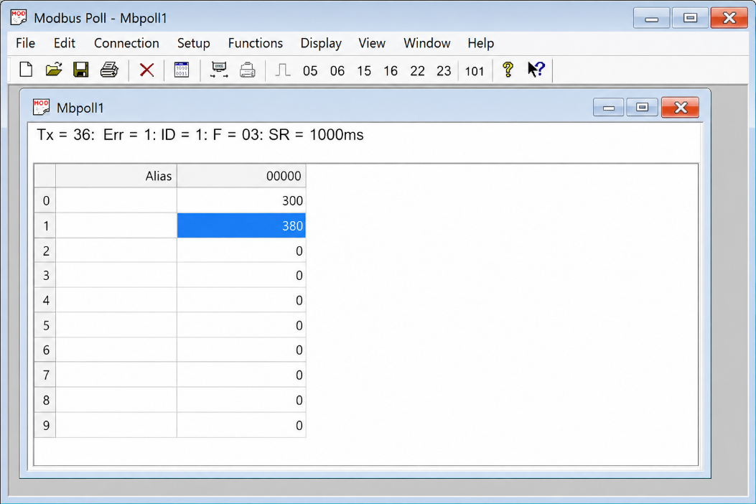
- Here is the data
- Important Note:
Temperature and humidity data are provided in multiples of 10 for higher resolution. To obtain the actual readings, you need to divide the values by 10. For example:
Temperature: 300 / 10 = 30.0°C
Humidity: 380 / 10 = 38.0%

MODBUS PORT
MCU RESET
ETHERNET
PORT
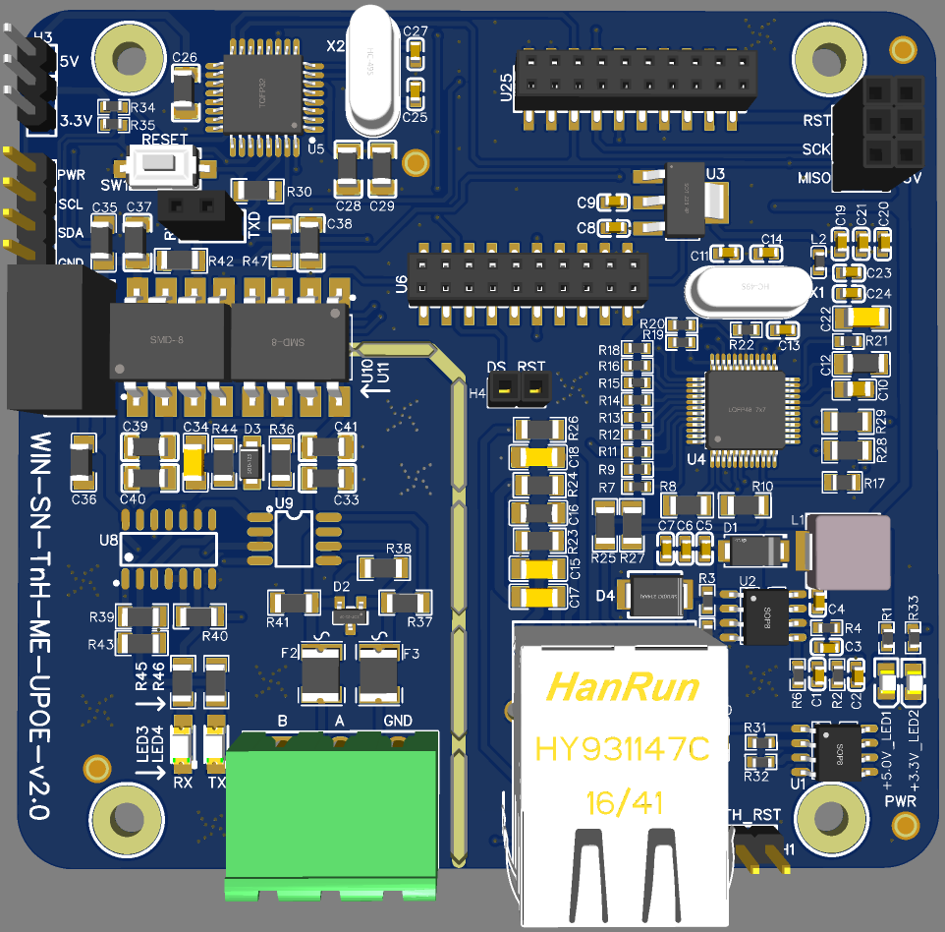
RESET JUMPER
POWER LED
I2C Sensor Connection

Contact Information
Augmatic Technologies Pvt. Ltd.,
Plot no 6, Shah Industrial Estate II,
Kotambi,
Vadodara – 391510.
Email – Sales@wittelb.com
Support: support@wittelb.raiseaticket.com / +91 94038 92805

