- Product Overview
The WIN-SN-UVM Sensor Board is designed for precise ultraviolet (UV) light monitoring, utilizing a photosensitive element that converts UV light into a measurable electrical signal for real-time detection. The circuit incorporates an industrial-grade microprocessor chip and a high-precision UV sensor, ensuring exceptional reliability and accuracy. Its integrated sensor design provides comprehensive measurement data, making it an ideal solution for various UV monitoring applications.
The sensor board features RS485 output using the standard Modbus-RTU protocol, allowing communication over distances up to 2000 meters and supporting secondary development for advanced applications. Housed in a rugged, wall-mounted IP67-rated enclosure, the board is built to withstand harsh environmental conditions.
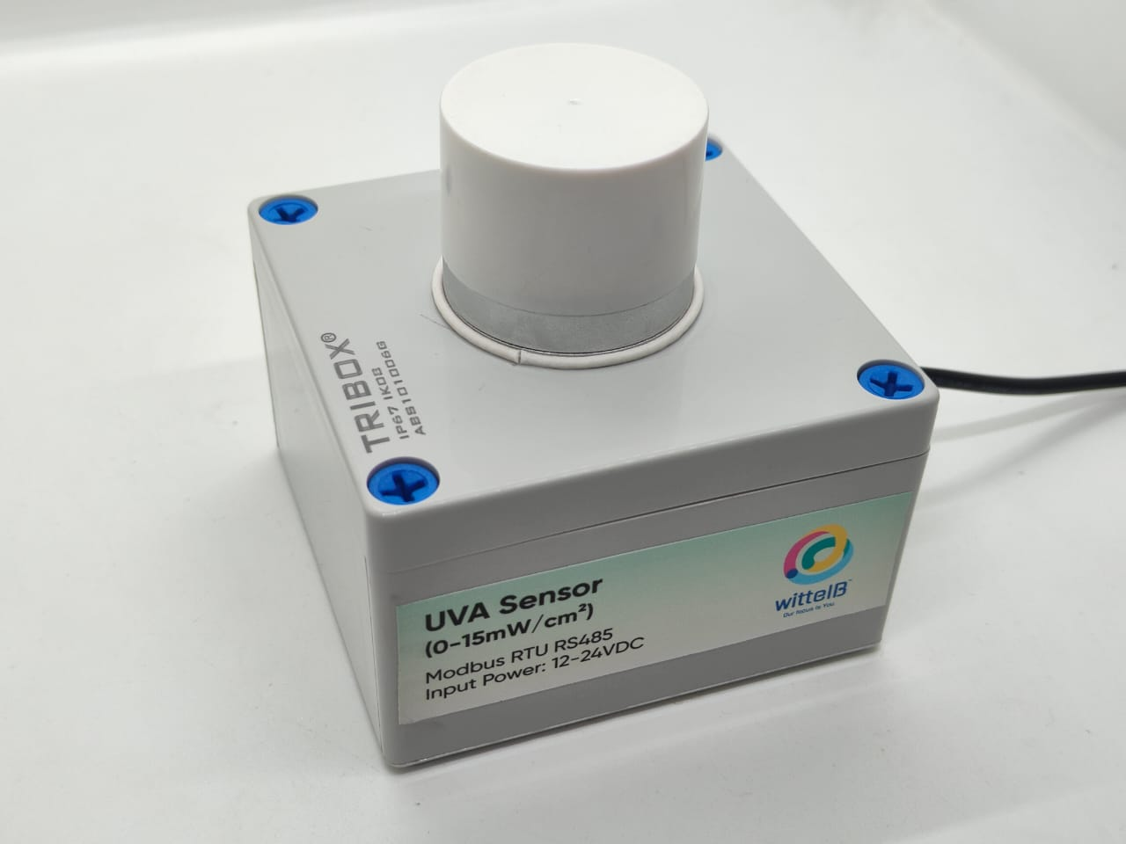

- Using a UV measuring device that is highly sensitive to 290-390 nm to accurately measure the UV intensity
- Operating range -10°C to 60°C for temperature and 0% to 80% RH for humidity
- Fully calibrated and processed digital RS485 Output
- Excellent long-term stability.
- Wall-mounted waterproof case, high protection level, can be used in outdoor rain and snow environment for a long time.
2. Sensor Communications
- Accuracy: ±10% FS.
- UV intensity range: 0~15 mW/ cm²
- Resolution: 0.01 mW/ cm²
- UV index range: 0-15
- Measuring wavelength range: Wavelength 290-390 nm.
- Protocol: 485(Modbus-RTU protocol)
- Operating Temperature 0 – 60° C (32 ~ 140°F)
- Storage Temperature -20 - 70° C (-4 ~ 158°F)
- Storage Humidity 5 ~ 95 % RH, non – Condensing

3. Power Supply Connection
- Power supply DC: 12-24V@1A.
- Product dimension: 100*100*60 mm.

- Certifications:

4. Configuration Settings
- Communication Speed 9600 – 115200 Kbps (SW Selectable)
- Data Bits 8
- Parity None
- CRC Yes
- Slave ID 1, DIP (SW Selectable)
- Function Code 0X03 (Read Holding Register)

Recommended Cable Electrical Characteristics
22 AWG Cable Shielded and twisted pair should be used.
Tinned Copper Recommended
Nominal Conductor DCR 14.7 ohm / 1000 ft
Nominal Capacitance 11 pf / feet (conductor to conductor)
High Frequency Non-Insertion Loss 0.5db / 100ft

5. Modbus RS485 Data Storage register
ID | Function  Description | Register  Description | Modbus Function Code | Protocol | Data  Type
1 | UV Voltage | 40001 | 0x03 | RS485 | 16-bit int
2 | UV Intensity | 40002 | 0x03 | RS485 | 16-bit int
3 | UV Index | 40003 | 0x03 | RS485 | 16-bit int
4 | UV Wavelength | 40004 | 0x03 | RS485 | 16-bit int
1 | Display Baud Rate (Default: 960) | 40011 | 0x03 | RS485 | 16-bit int
2 | Enter New Baud Rate | 40012 | 0x03 | RS485 | 16-bit int
3 | Display Slave ID (Default: 1) | 40013 | 0x03 | RS485 | 16-bit int
4 | Enter New Slave ID | 40014 | 0x03 | RS485 | 16-bit int
5 | Display Parity (Default: None-3 And for Odd-1, Even-2) | 40015 | 0x03 | RS485 | 16-bit int
6 | Enter New Parity | 40016 | 0x03 | RS485 | 16-bit int
7 | Display Stop Bit (start-2/stop bit-1) | 40017 | 0x03 | RS485 | 16-bit int
8 | Enter New Start/ Stop Bit | 40018 | 0x03 | RS485 | 16-bit int

6. Modbus Configuration

Here is an example of receiving data on Mb poll software.
- Open Mb-poll software connect using configuration setting (Default baud rate is 9600 and slave id is 1).
- After connecting you will get data as shown below.
Important Note
- If you want to enter the baud rate 9600/19200/38400/57600/115200etc, enter it like this 960/1920/3840/5760/11520etc.
- After that press the reset button or reboot the system.
- Then you will get the present value of 11520 at 40011 baud rate (115200) and 2 at 40013 slave id.
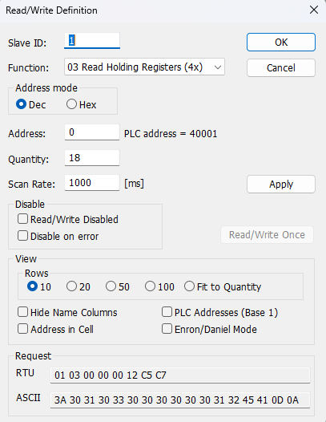
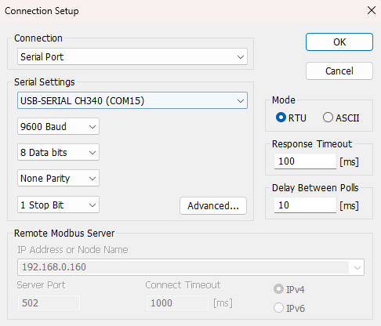

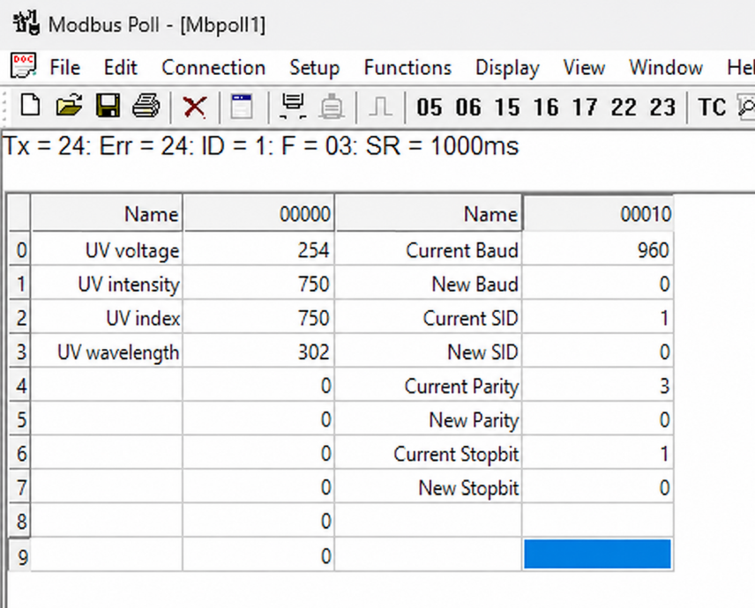

- Above image Shows sensor data over Modbus with default Modbus settings
- At the register 40001 shows UV Voltage, register 40002 shows UV Intensity, register 40003 shows UV Index, and register 40004 shows UV Wavelength.
- Internally UV voltage, UV Intensity, UV Index are multiplied by 100 for 0.1% accuracy, if the value is 254 then its 2.54, if the value is 750 then its 7.50.
- As you can see in the image above, the resistor 40011 – 960 represents the present bund rate (9600) of the board and 40013 – 1 represents the present slave id of the board.
- To change the baud rate and slave id Jumper should be in single/removed then, you must enter a value on the 40012 resistors for the baud rate and 40014 for the slave id as shown in the image below and restart the board.
- Now you can see data below image set 115200 baud rate and slave ID 10.

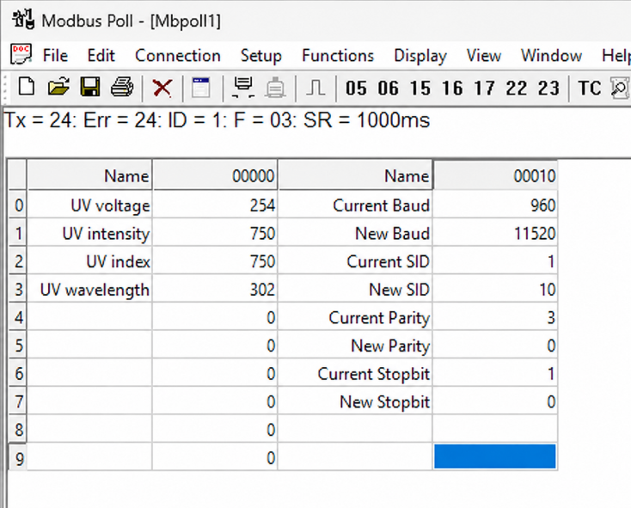
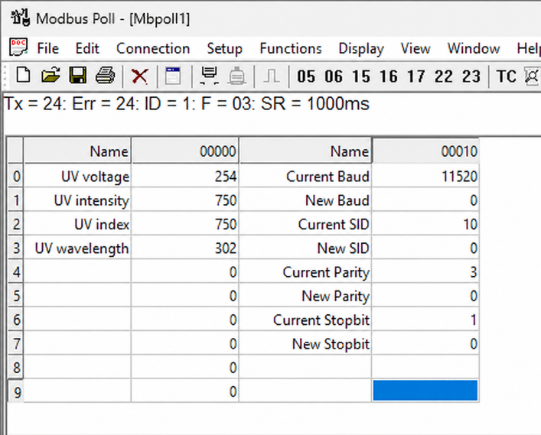

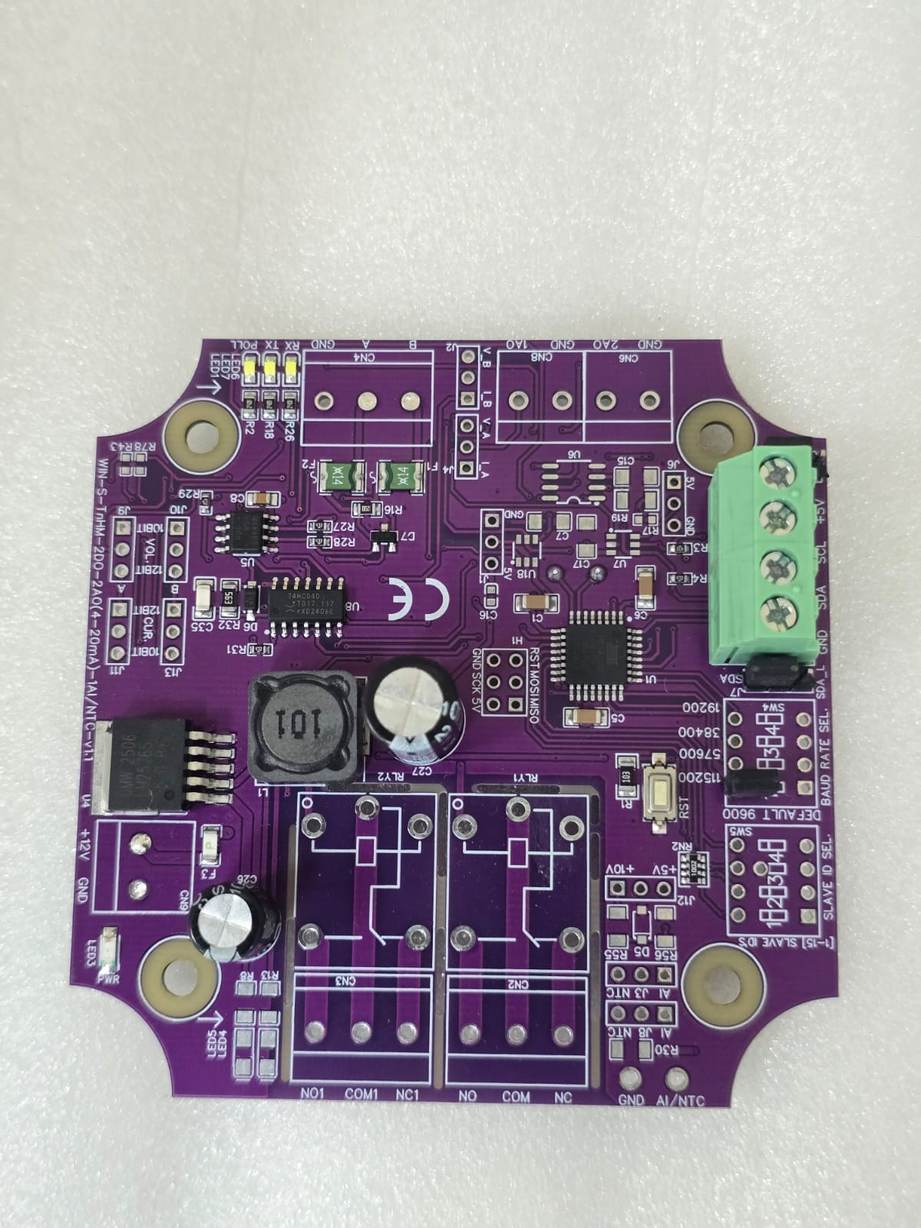
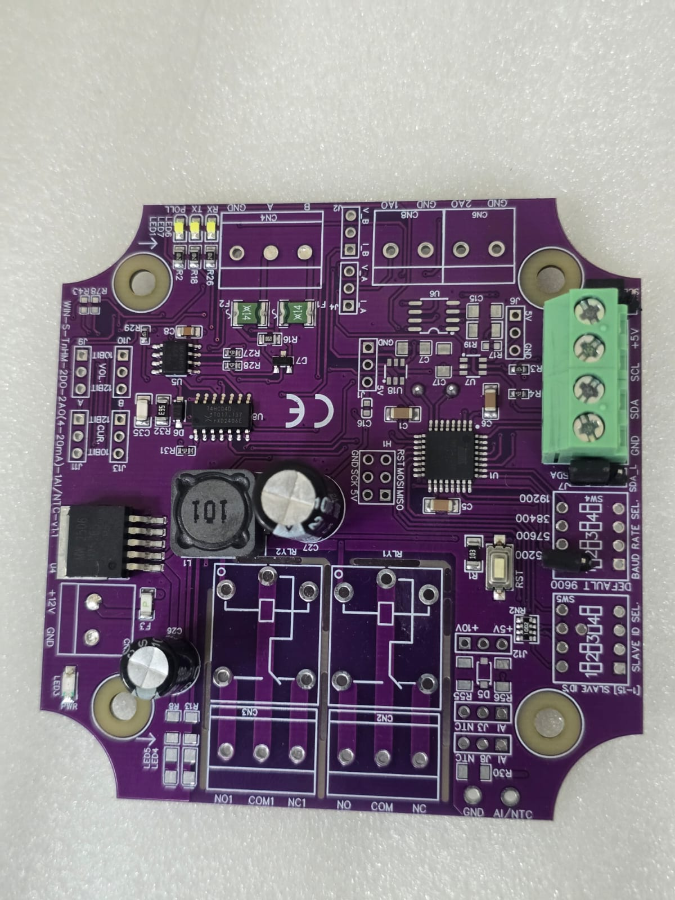

Closed
Open/Remove

Image1.1 Image1.2

Hard reset Setting
- Somehow you forgot the baud rate or slave id of the board then Place the jumper (as shown in the image 1.2) from the board reboot the system or press the reset button (given on the board). Then you will get the default baud rate of 9600 and slave id 1.

Contact Information
Augmatic Technologies Pvt. Ltd.,
Plot no 6, Shah Industrial Estate II,
Kotambi,
Vadodara – 391510.
Email – Sales@wittelb.com
Support: support@wittelb.raiseaticket.com / +91 94038 92805

