LUMINOUS INTENSITY SENSOR
1. Product Overview
WIN-SN-LUX-200K-2DO-M is a compact, high-precision Light intensity sensor designed for applications requiring low power consumption and small form factors. It ensures reliable measurements over a wide range. Its RS485 communication interface simplifies integration into small, embedded systems, making it ideal for IOT. The sensor's long-term stability ensures consistent performance in harsh environments, making it a cost-effective solution for long-term deployment. In-built DO can be used for ON/OFF control of any 3rd Party system based on intensity of light.
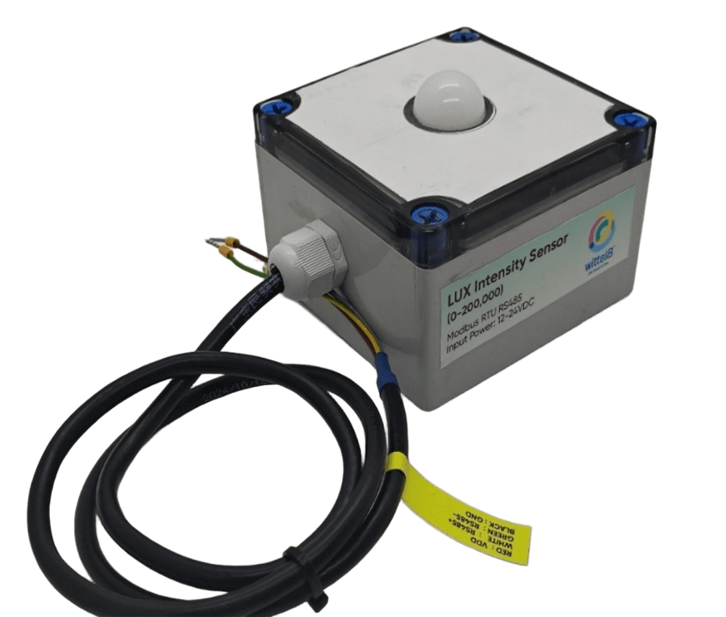
Threshold of the LUX can be set through Modbus. Exceeding threshold will operate a Digital output using relay.

Fig.1 - Product Image
• Luminance to Digital Converter ranging 1 LUX to 200000 LUX.
• Superior sensor performance.
• Operating range -20°C to 60°C and 0% to 70% RH for humidity
• Fully calibrated and processed digital, RS485 Output
• Wide Input voltage options 12-24V DC / 230V AC (optional)
• Excellent long-term stability

Measuring Parameter | Measuring Range | Operating Temperature
Luminous intensity | 1-200000 LUX | -20°C ~ 60°C.

2. Sensor Specifications
- Wide temperature range: −40 °C to +125 °C
- Full humidity range: 0 % to 100 % RH
- Power supply DC: 12-24V@1A.
- Product dimension: 100*100*60 mm.

- Certifications:

3. Power Supply Connection
DC Connection
- Use 12-24V@ 1A, Power supply.
- Don’t make loose connection.

4. Configuration Settings
- Communication Speed 9600 – 115200 Kbps (SW Selectable)
- Data Bits 8
- Parity None
- CRC Yes
- Slave ID 1, DIP (SW Selectable)
- Function Code 0X03 (Read Holding Register)
Recommended Cable Electrical Characteristics
22 AWG Cable Shielded and twisted pair should be used.
Tinned Copper Recommended
Nominal Conductor DCR 14.7 ohm / 1000 ft
Nominal Capacitance 11 pf / feet (conductor to conductor)
High Frequency Non-Insertion Loss 0.5db / 100ft

6. Modbus RS485 Data Storage register

ID | Function  Description | Register  Description | Modbus Function Code | Protocol | Data  Type
1 | Intensity (Lux) | 40001 | 0x03 | RS485 | 32 bit unsigned big endian
 |  | 40002
2 | Lux range | 40003 | 0x03 | RS485 | 32 bit unsigned big endian
 |  | 40004
3 | Read & Write Negative offset value | 40002 | 0x03 | RS485 | 16-bit int
4 | Read & Write Positive offset value | 40003 | 0x03 | RS485 | 16-bit int
5 | Read & Write Lower lux threshold | 40007 | 0x03 | RS485 | 16-bit int
6 | Read & Write Higher lux threshold | 40008 | 0x03 | RS485 | 16-bit int
1 | Display Baud Rate (Default: 960) | 40011 | 0x03 | RS485 | 16-bit int
2 | Enter New Baud Rate | 40012 | 0x03 | RS485 | 16-bit int
3 | Display Slave ID (Default: 1) | 40013 | 0x03 | RS485 | 16-bit int
4 | Enter New Slave ID | 40014 | 0x03 | RS485 | 16-bit int
5 | Display Parity (Default: None-3 And for Odd-1, Even-2) | 40015 | 0x03 | RS485 | 16-bit int
6 | Enter New Parity | 40016 | 0x03 | RS485 | 16-bit int
7 | Display Stop Bit (start-2/stop bit-1) | 40017 | 0x03 | RS485 | 16-bit int
8 | Enter New Start/ Stop Bit | 40018 | 0x03 | RS485 | 16-bit int

7. Modbus Configuration
Here is an example of receiving data on Mb poll software.
- Open Mb-poll software connect using configuration setting (Default baud rate is 9600 and slave id is 1).
- After connecting you will get data as shown below.

Important Note
- If you want to enter the baud rate 9600/19200/38400/57600/115200etc, enter it like this 960/1920/3840/5760/11520etc.
- After that press the reset button or reboot the system.
- Then you will get the present value of 11520 at 40011 baud rate (115200) and 2 at 40013 slave id.
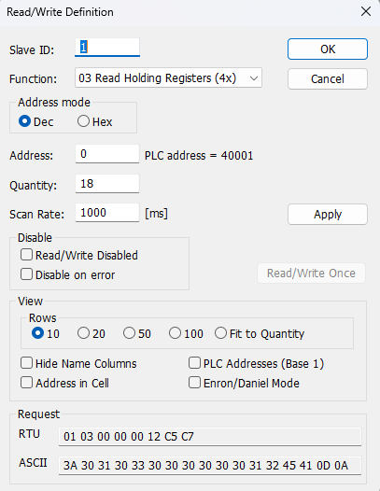
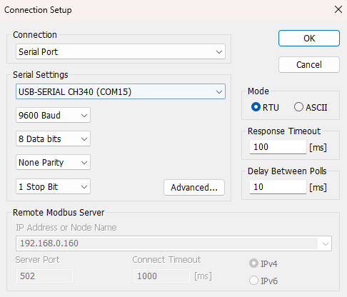

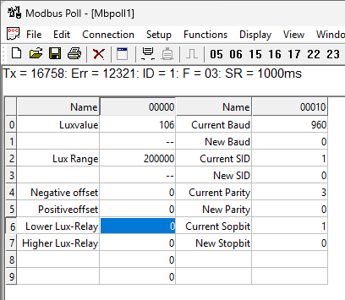

- Above image Shows sensor data over Modbus with default Modbus settings
- Make the register 40001 and 40002 as 32 bit unsigned big endian then at the register 40001 shows lux intensity.
- As you can see in the image above, the resistor 40011 – 960 represents the present bund rate (9600) of the board and 40013 – 1 represents the present slave id of the board.
- To change the baud rate and slave id Jumper should be in single/removed then you must enter a value on the 40012 resistors for the baud rate and 40014 for the slave id as shown in the image below and restart the board.
- Now you can see data below image set 115200 baud rate and slave ID 10.

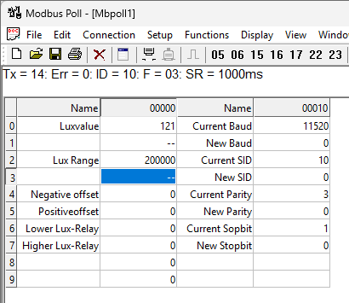
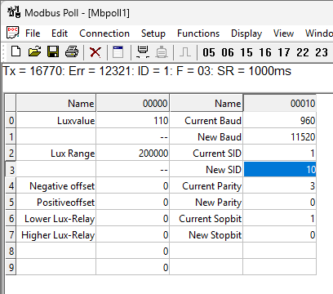

- To set the maximum lux range, configure registers 40003 and 40004 as a 32-bit unsigned big-endian value. Enter the desired maximum lux value starting at register 40003. The new value is applied immediately.
- To set the lux negative offset, enter the desired negative offset value in register 40005. The new value is applied immediately, and the updated lux value is reflected in register 40001.
- To set the lux positive offset, enter the desired positive offset value in register 40006. The new value is applied immediately, and the updated lux value is reflected in register 40001.
- Set the lower lux threshold at register 40007. Digital Output 1 is activated when the measured lux value is lower than the threshold value.
- Set the higher lux threshold at register 40008. Digital Output 2 is activated when the measured lux value is higher than the threshold value.

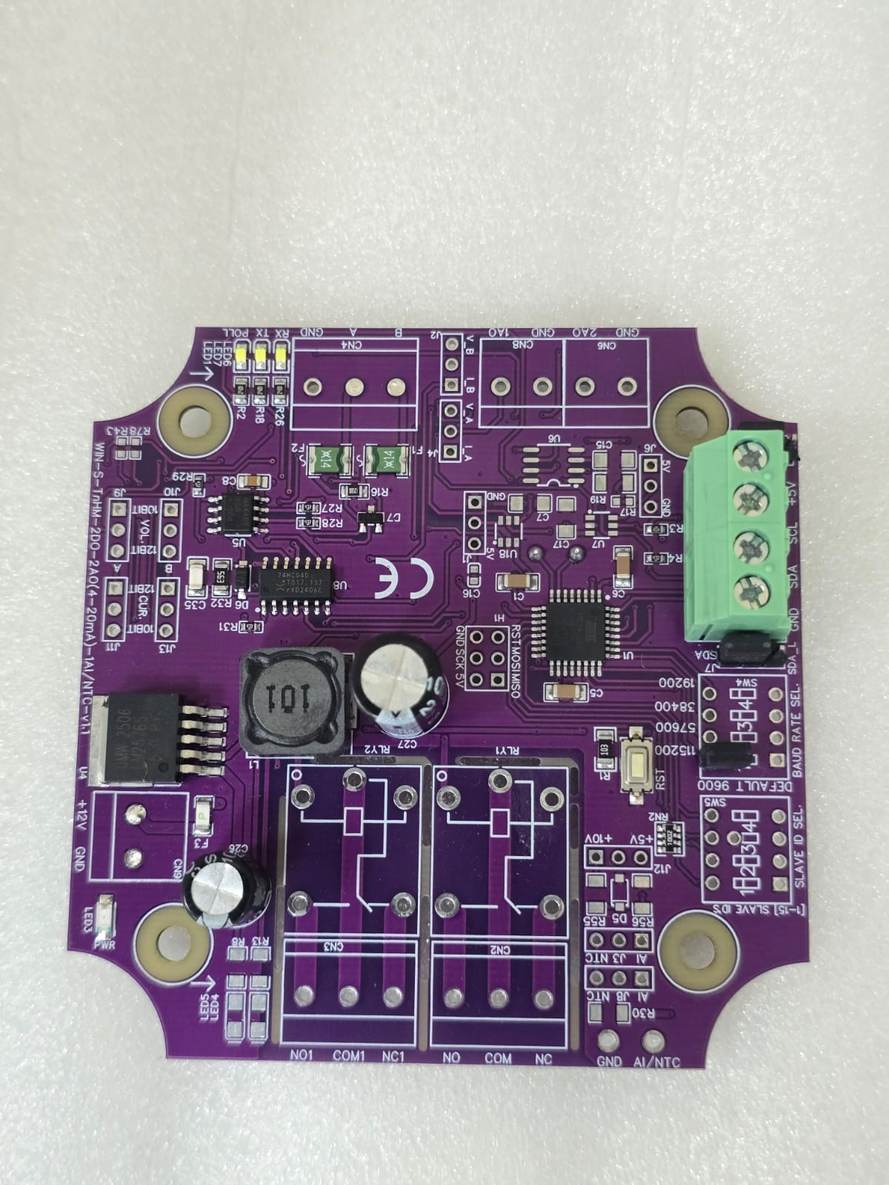
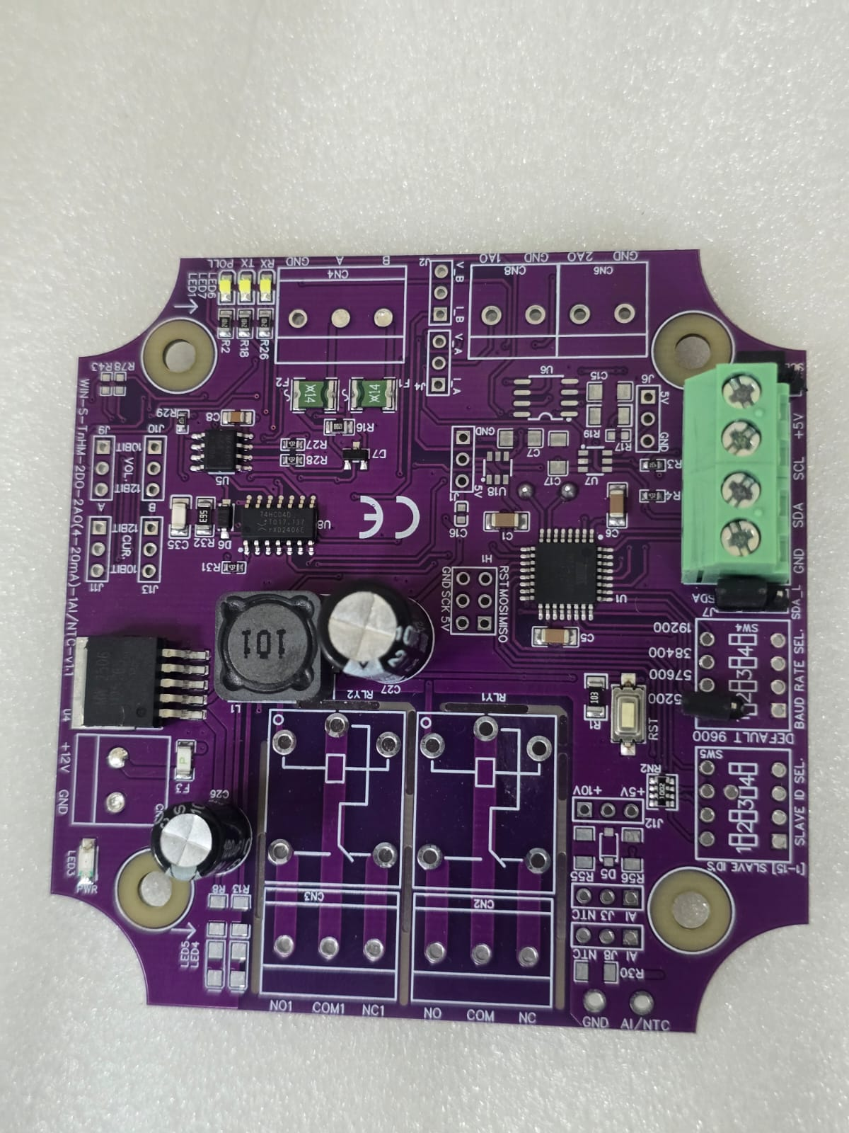

Closed
Open/Remove

Image1.1 Image1.2

Hard reset Setting
- Somehow you forgot the baud rate or slave id of the board then Place the jumper (as shown in the image 1.2) from the board reboot the system or press the reset button (given on the board). Then you will get the default baud rate of 9600 and slave id 1.

Contact Information
Augmatic Technologies Pvt. Ltd.,
Plot no 6, Shah Industrial Estate II,
Kotambi,
Vadodara – 391510.
Email – Sales@wittelb.com
Support E.: support@wittelb.raiseaticket.com / M.: 9403892805

