LUMINOUS INTENSITY SENSOR
1. Product Overview
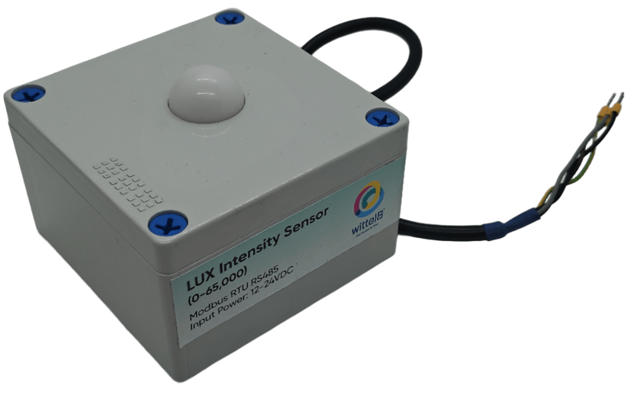
WIN-SN-LUX-65K-AOC-AOV is a compact, high-precision Light intensity sensor designed for applications requiring low power consumption and small form factors. It ensures reliable measurements over a wide range. Its Analog output with 4-20mA or 0-10v interface simplifies integration into small, embedded systems, making it ideal for IOT. The sensor's long-term stability ensures consistent performance in harsh environments, making it a cost-effective solution for long-term deployment.

• Luminance to Digital Converter ranging 1 LUX to 65000 LUX.
• Superior sensor performance.
• Operating range -20°C to 60°C and 0% to 70% RH for humidity
• Fully calibrated and processed digital, Analog Output
• Wide Input voltage options 12-24V DC / 230V AC (optional)
• Excellent long-term stability
Measuring Parameter | Measuring Range | Operating Temperature
Luminous intensity | 1-65000 LUX | -20°C ~ 60°C.

2. Sensor Specifications
- Wide temperature range: −40 °C to +125 °C
- Full humidity range: 0 % to 100 % RH
- Power supply DC: 12-24V@1A.
- Product dimension: 100*100*60 mm.

- Certifications:

3. Power Supply Connection
DC Connection
- Use 12-24V@ 1A, Power supply.
- Don’t make loose connection.
Recommended Cable Electrical Characteristics
22 AWG Cable Shielded and twisted pair should be used.
Tinned Copper Recommended
Nominal Conductor DCR 14.7 ohm / 1000 ft
Nominal Capacitance 11 pf / feet (conductor to conductor)
High Frequency Non-Insertion Loss 0.5db / 100ft

4. Technical Specifications
Measured Parameters: lux
Output Type: Analog Output-10-bit or 12-bit resolution
Output Range: 0-5V, 0 – 10V, 4-20mA (Jumper selectable).

Contact Information
Augmatic Technologies Pvt. Ltd.,
Plot no 6, Shah Industrial Estate II,
Kotambi, Vadodara – 391510.
Email – Sales@wittelb.com
Support E.: support@wittelb.raiseaticket.com / M.: 9403892805

