LUMINOUS INTENSITY SENSOR
1. Product Overview
WIN-SN-LUX-65K-ME is a compact, high-precision Light intensity sensor designed for applications requiring low power consumption and small form factors. It ensures reliable measurements over a wide range. Its Modbus TCP communication interface simplifies integration into small, embedded systems, making it ideal for IOT. The sensor's long-term stability ensures consistent performance in harsh environments, making it a cost-effective solution for long-term deployment.
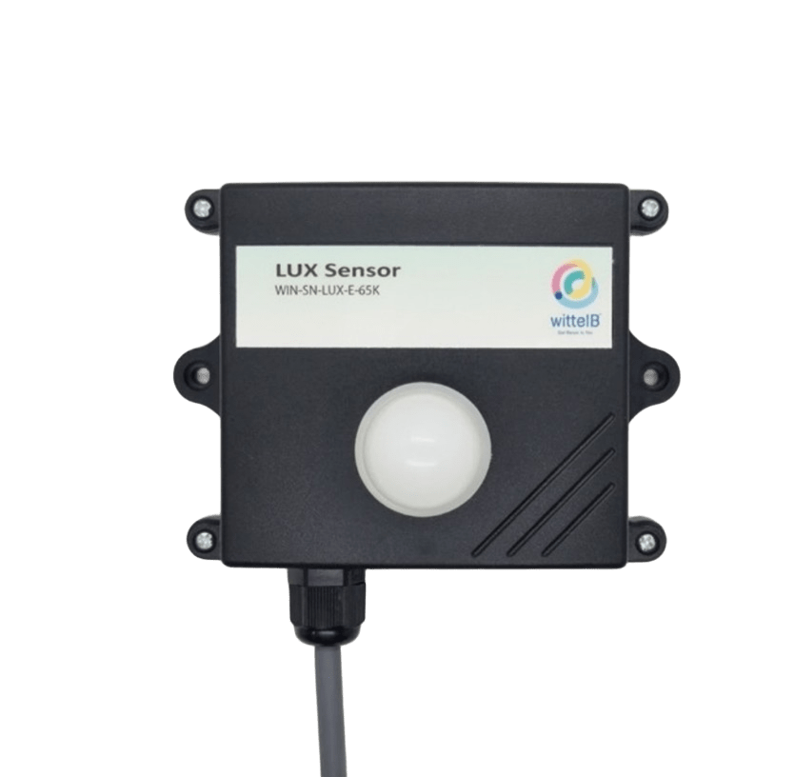
Threshold of the LUX can be set through Modbus. Exceeding threshold will operate a Digital output using relay.

Fig.1 - Product Image
• Luminance to Digital Converter ranging 1 LUX to 65000 LUX.
• Superior sensor performance.
• Operating range -20°C to 60°C and 0% to 70% RH for humidity
• Fully calibrated and processed digital, Modbus TCP Output
• Wide Input voltage options 12-24V DC / 230V AC (optional)
• Excellent long-term stability

Measuring Parameter | Measuring Range | Operating Temperature
Luminous intensity | 1-65000 LUX | -20°C ~ 60°C.

2. Sensor Specifications
- Wide temperature range: −40 °C to +125 °C
- Full humidity range: 0 % to 100 % RH
- Power supply DC: 12-24V@1A.
- Product dimension: 85*85*40 mm.

- Certifications:

3. Power Supply Connection
DC Connection
- Use 12-24V@ 1A, Power supply.
- Don’t make loose connection.

4. Configuration Settings
- Communication IP 192.168.0.160
- CRC Yes
- Function Code 0X03 (Read Holding Register)

Recommended Cable Electrical Characteristics
22 AWG Cable Shielded and twisted pair should be used.
Tinned Copper Recommended
Nominal Conductor DCR 14.7 ohm / 1000 ft
Nominal Capacitance 11 pf / feet (conductor to conductor)
High Frequency Non-Insertion Loss 0.5db / 100ft

5. Modbus TCP Data Storage register

ID | Function  Description | Register  Description | Modbus Function Code | Protocol | Data  Type
1 | Intensity (Lux) | 40001 | 0x03 | TCP-IP | 16-bit Unsigned int
2 | Lux Range | 40003 | 0x03 | TCP-IP | 16-bit Unsigned int
3 | Read & Write Negative offset value | 40004 | 0x03 | TCP-IP | 16-bit int
4 | Read & Write Positive offset value | 40005 | 0x03 | TCP-IP | 16-bit int
6. Modbus Configuration
Here is an example of receiving data on Mb poll software.
- Open Mb-poll software connect using configuration setting (Default TCP/IP 192.168.0.160).
- After connecting you will get data as shown below.
Important Note
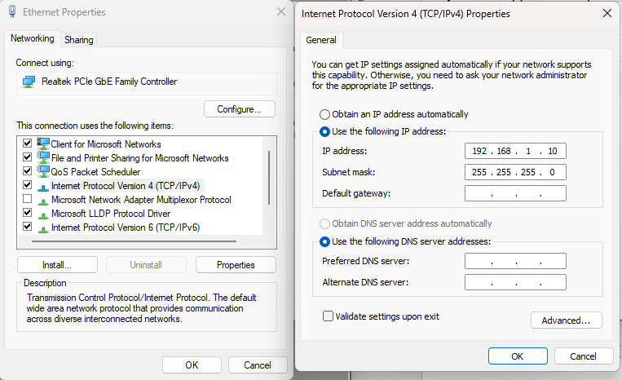
Before connecting to the Modbus TCP network, ensure that the Ethernet IP address is configured in the 192.168.0.xx subnet as shown below.

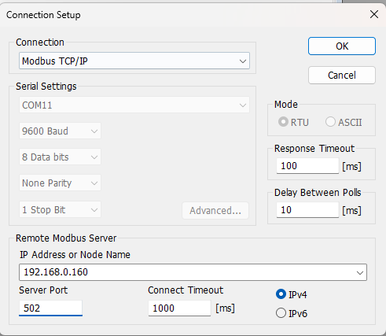
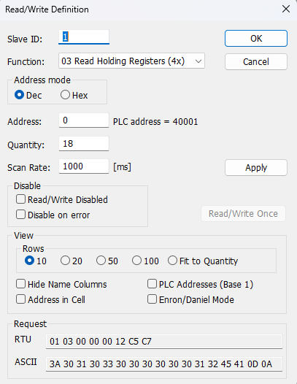
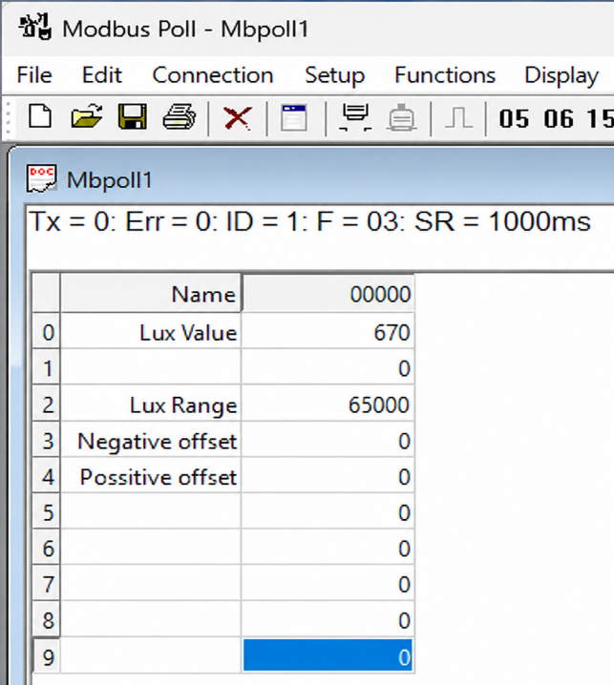

- Above image shows sensor data over Modbus with default Modbus TCP settings.
- At the register 40001 shows lux intensity.
- To set the maximum lux range, enter the desired maximum lux value in register 40003. The new value is applied immediately.
- To set the lux negative offset, enter the desired negative offset value in register 40004, to set the lux positive offset, enter the desired positive offset value in register 40005. The new value is applied immediately, and the updated lux value is reflected in register 40001.

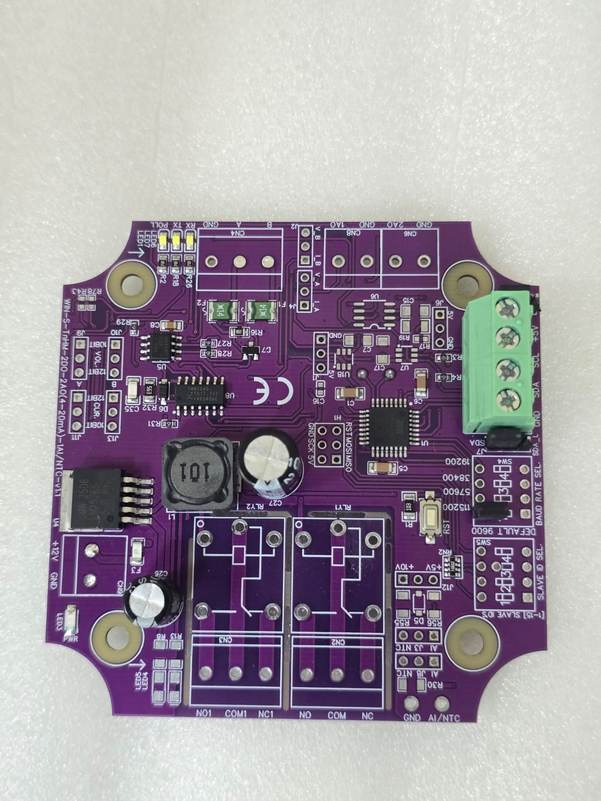
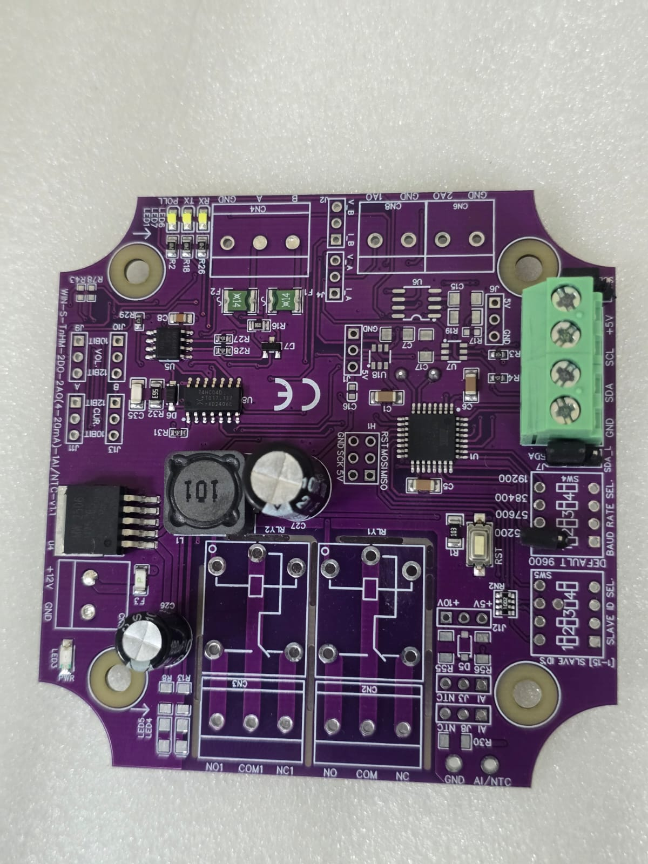

Closed
Open/Remove

Image1.1 Image1.2

Hard reset Setting
- Somehow you forgot the baud rate or slave id of the board then Place the jumper (as shown in the image 1.2) from the board reboot the system or press the reset button (given on the board). Then you will get the default baud rate of 9600 and slave id 1.

Contact Information
Augmatic Technologies Pvt. Ltd.,
Plot no 6, Shah Industrial Estate II,
Kotambi,
Vadodara – 391510.
Email – Sales@wittelb.com
Support E.: support@wittelb.raiseaticket.com / M.: 9403892805

