Technical Datasheet Input / Output Modules with Modbus RTU Protocol with RS485 Interface

The IO modules communicate via RS485. The port can drive distances up to max 700 meters without the use of any repeater (this feature however also depends on the signal strength of the Modbus Master Device).
The RS485 Digital IO module is sturdy, low power usage and easy to use.

16 Port DI and 16 Port DO Module: -
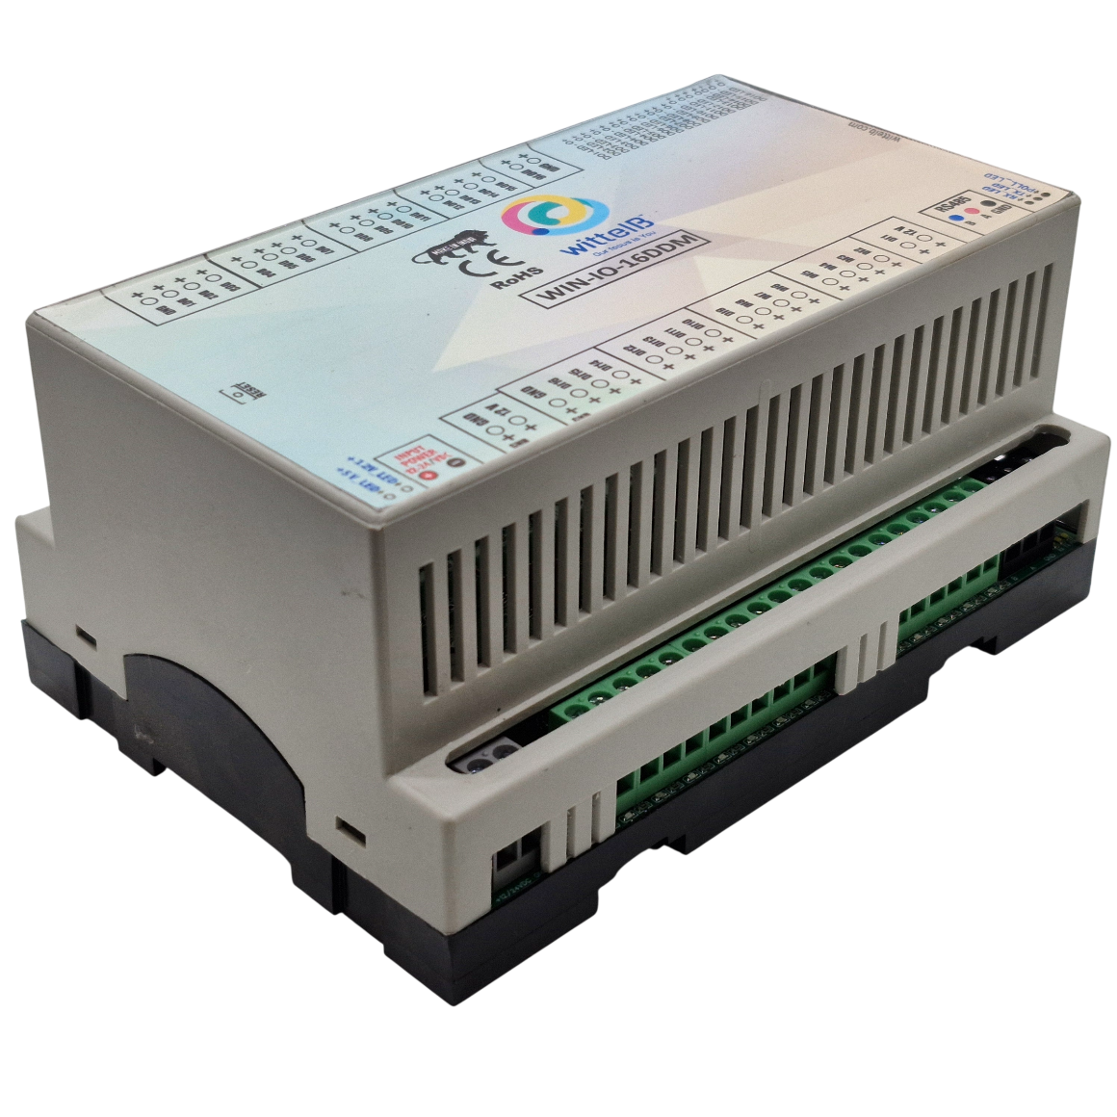

The IO modules are mounted on DIN rail mountable casing and with exposed connectors and LED indicators. The Soft Setting for Slave ID and Baud rate, parity bit, stop bit.
The design of the modules incorporates ‘resettable Fuses’ to safeguard against reverse polarity connection both for Power and Communication port.

Specifications
General –
I/O Connectors 12 Pin 5.08 mm and 2 Pin 5.08 mm pitch pluggable screw Terminal Block
Dimensions 110 mm L x 110 mm B x 50mm H
Power Input Power – 15-40V DC or 24 V AC/DC
Typical – 12V DC @ 150mA
Operating Temperature 0 – 60° C (32 ~ 140°F)
Storage Temperature -20 - 70° C (-4 ~ 158°F)
Storage Humidity 5 ~ 95 % RH, non – Condensing
Certifications  

Digital Output
Channels 16
Output Type P-Channel MOSFET
Channel Voltage 12 VDC
Channel Current 20A
Channel Power 240 W (max)
Operating Time 2.8ns.
Turn Off delay Time 33.5ns.
Operating Temperature -55℃~+150℃

DI Inputs –
Channels 16
Sense Voltage 3.3 – 30 VDC
Sense Logic Logic ‘0’ = <1 VDC, Logic ‘1’ = >3.3 VDC
Isolation Optically isolated
Response Time 2 msec, Max 6 Msec

Additional Features -
All inputs and communication port isolated
Input power reverse polarity safety
ESD Safety IEC 61000-4-2, ± 30KV contact, ± 30KV air
EFT IEC 61000-4-4, 50A (5/50ms)
400V isolation.
CRC Error check.
No configuration needed on the IO board
ID | Function  Description | Register  Description | Modbus Function Code | Protocol | Data  Type
1 | DI 1(With & Without Potential) | 00001 | 0X02 | RS485 | 1 Bit Boolean
2 | DI 2(With & Without Potential) | 00002 | 0X02 | RS485 | 1 Bit Boolean
3 | DI 3(With & Without Potential) | 00003 | 0X02 | RS485 | 1 Bit Boolean
4 | DI 4(With & Without Potential) | 00004 | 0X02 | RS485 | 1 Bit Boolean
5 | DI 5(With & Without Potential) | 00005 | 0X02 | RS485 | 1 Bit Boolean
6 | DI 6(With & Without Potential) | 00006 | 0X02 | RS485 | 1 Bit Boolean
7 | DI 7(With & Without Potential) | 00007 | 0X02 | RS485 | 1 Bit Boolean
8 | DI 8(With & Without Potential) | 00008 | 0X02 | RS485 | 1 Bit Boolean
9 | DI 9(With & Without Potential) | 00009 | 0X02 | RS485 | 1 Bit Boolean
10 | DI10(With & Without Potential) | 00010 | 0X02 | RS485 | 1 Bit Boolean
11 | DI11(With & Without Potential) | 00011 | 0X02 | RS485 | 1 Bit Boolean
12 | DI12(With & Without Potential) | 00012 | 0X02 | RS485 | 1 Bit Boolean
13 | DI13(With & Without Potential) | 00013 | 0X02 | RS485 | 1 Bit Boolean
14 | DI14(With & Without Potential) | 00014 | 0X02 | RS485 | 1 Bit Boolean
15 | DI15(With & Without Potential) | 00015 | 0X02 | RS485 | 1 Bit Boolean
16 | DI16(With & Without Potential) | 00016 | 0X02 | RS485 | 1 Bit Boolean
17 | DO1 | 00017 | 0X05,0X0F | RS485 | 1 Bit Boolean
18 | DO2 | 00018 | 0X05,0X0F | RS485 | 1 Bit Boolean
19 | DO3 | 00019 | 0X05,0X0F | RS485 | 1 Bit Boolean
20 | DO4 | 00020 | 0X05,0X0F | RS485 | 1 Bit Boolean
21 | DO5 | 00021 | 0X05,0X0F | RS485 | 1 Bit Boolean
22 | DO6 | 00022 | 0X05,0X0F | RS485 | 1 Bit Boolean
23 | DO7 | 00023 | 0X05,0X0F | RS485 | 1 Bit Boolean
24 | DO8 | 00024 | 0X05,0X0F | RS485 | 1 Bit Boolean
25 | DO9 | 00025 | 0X05,0X0F | RS485 | 1 Bit Boolean
26 | DO10 | 00026 | 0X05,0X0F | RS485 | 1 Bit Boolean
27 | DO11 | 00027 | 0X05,0X0F | RS485 | 1 Bit Boolean
28 | DO12 | 00028 | 0X05,0X0F | RS485 | 1 Bit Boolean
29 | DO13 | 00029 | 0X05,0X0F | RS485 | 1 Bit Boolean
30 | DO14 | 00030 | 0X05,0X0F | RS485 | 1 Bit Boolean
31 | DO15 | 00031 | 0X05,0X0F | RS485 | 1 Bit Boolean
32 | DO16 | 00032 | 0X05,0X0F | RS485 | 1 Bit Boolean
Soft Setting Configuration in function code 3
10 | Display Baud Rate (Default:960) | 40011 | 0X03 | RS485 | 16 Bit Unsigned int
11 | Enter New Baud Rate | 40012 | 0X03 | RS485 | 16 Bit Unsigned int
12 | Display Slave ID | 40013 | 0X03 | RS485 | 16 Bit Unsigned int
13 | Enter New Slave ID | 40014 | 0X03 | RS485 | 16 Bit Unsigned int
14 | Display Parity | 40015 | 0X03 | RS485 | 16 Bit Unsigned int
15 | Enter New Parity | 40016 | 0X03 | RS485 | 16 Bit Unsigned int
16 | Display Stop Bit | 40017 | 0X03 | RS485 | 16 Bit Unsigned int
17 | Enter New Stop Bit. | 40018 | 0X03 | RS485 | 16 Bit Unsigned int

Configuration Settings -
Communication Speed 9600 - 115200(Soft Setting)
Data Bits 8
Parity None
Stop bit 1
CRC Yes
Slave ID Soft Setting
Function code DO 0x05 and 0x0F (5 Single coil & 15 multiple coil)
DO Register Address 16,17,18,19,20,21,22,23,24,25,26,27,28,29,30,31
Function code DI 0x02 Read Discrete Input
DI Register Address 0,1,2,3,4,5,6,7,8,9,10,11,12,13,14,15.
Function Code Soft Serial 0x03 Read Holding Registers
Soft Serial Register Address 11,12,13,14,15,16,17,18.

Note: -
For MODBUS communications, a shielded and twisted pair cable is used. One example of such cable is Belden 3105A.
Recommended Cable Electrical Characteristics: -
22 AWG Cable Shielded and twisted pair
Tinned Copper Recommended
Nominal Conductor DCR 14.7 ohm / 1000 ft
Nominal Capacitance 11 pf / feet (conductor to conductor)
High Frequency Non-Insertion Loss 0.5db / 100ft
BAUD RATE and SLAVE ID DESCRIPTION:

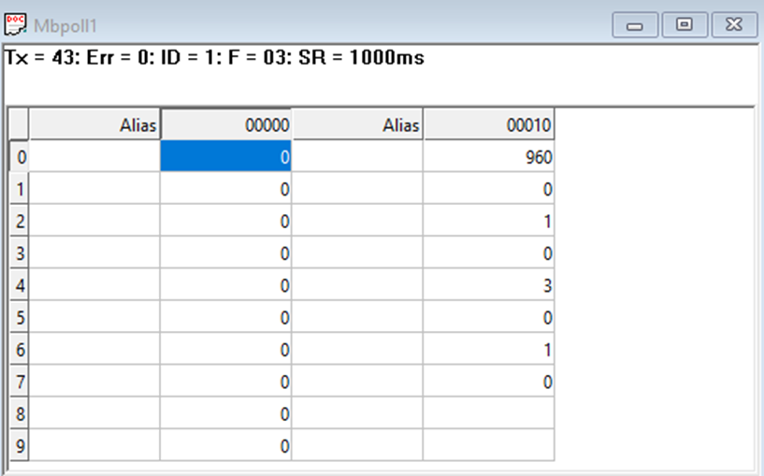
- As you can see in the image above, the resistor 40011 – 960 represents the present bund rate
- (9600) of the board and 40013 – 1 represents the present slave id of the board.

- To change the baud rate and slave id you have to enter a value on the 40012 resistor for the baud rate and 40014 for the slave id as shown in the image below
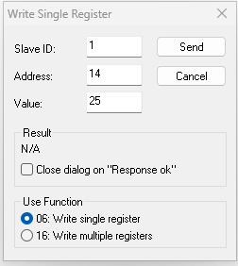
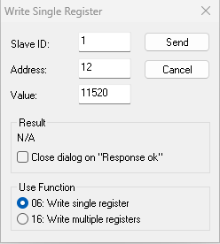

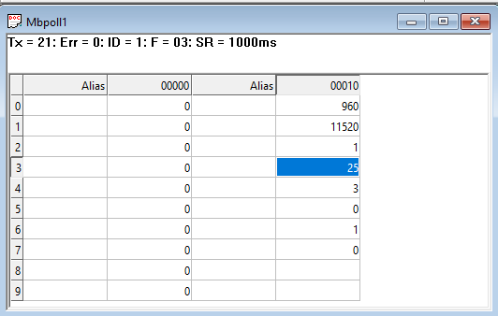
As you can see in the image above I set 115200 baud rate and slave ID 25.

Note:
1. If you want to enter the baud rate 9600/19200/38400/57600/115200etc.
Enter it like this 960/1920/5760/11520etc.
2. After that press the reset button or reboot the system.
3. Then you will get the present value of 11520 at 40011 baud rate(115200) and 25 at 40013 slave id.
4. You can Change Parity Bit , stop bit Of the device with same way.

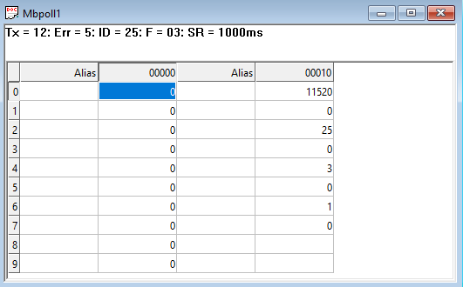
As you can see in image, baud rate and slave id are changed.

- To reset Modbus settings to default, remove the reset jumper and press the reset button. The device will enter default mode.
- Configuration i.e. Baud rate - 9600, Stop bit - 1, Parity - None, e.g. 12v & DI1+ve terminal.
DI
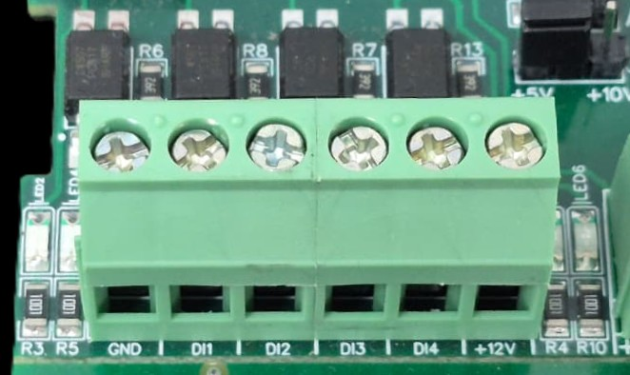
I/p device
I/p device
I/p device
I/p device

- Operation: The module provides four isolated input channels (DI1–DI4) for sensing external signals or dry contacts. These inputs are opto-isolated for circuit protection.
- Terminal Layout:
  - GND: Common Ground reference.
  - DI1 – DI4: Individual Digital Input channels.
  - +12V: Internal reference voltage for sourcing "Dry Contact" switches.
- Wiring Options:
  - Dry Contact: Connect a switch between the +12V terminal and any DI pin.
  - External Voltage: Connect the external signal to a DI pin and the external ground to the GND terminal.
- Voltage Rating: The input circuitry is rated for a maximum of 80VDC. Ensure external signals do not exceed this limit to prevent damage to the isolation ICs.

DO

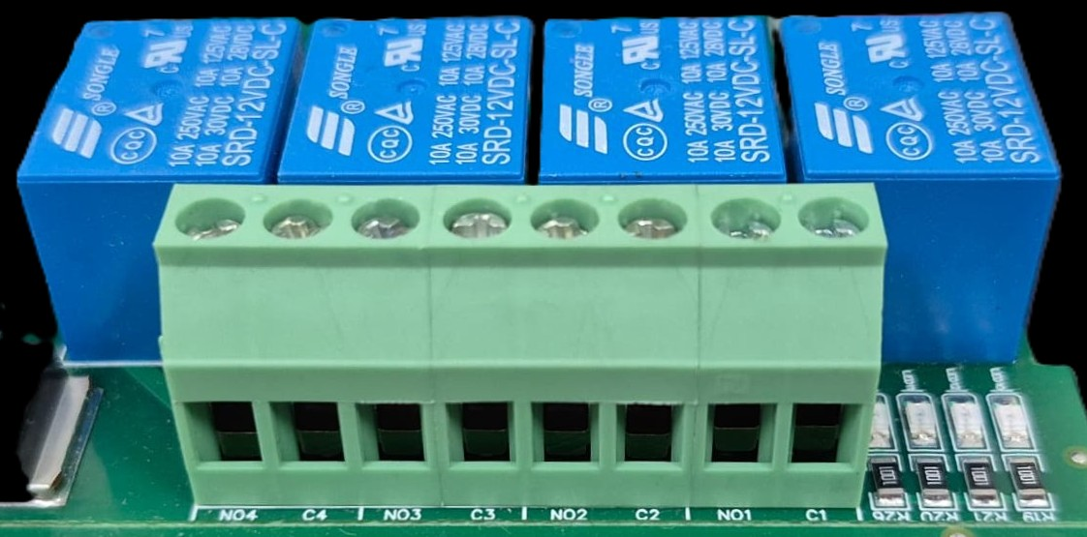





L
O
A
D
N

P
L
O
A
D
N

P
L
O
A
D
N

P
L
O
A
D
N

P

- Digital Output (DO) operation: Each channel provides two terminals: C (Common) and NO (Normally Open). When the relay coil is energized, terminal C is internally connected to NO, allowing current to flow. When the relay is de-energized, the connection between C and NO remains open, and the load stays OFF.
- Load Wiring Connections:
  - AC Load Connection: The AC Live (Phase) wire should be connected to terminal C. The load is connected between terminal NO and Neutral (N).
  - DC Load Connection: The positive supply (+V) should be connected to terminal C. The load is connected between terminal NO and Ground (GND).
- Crucial Safety Recommendation and Rating: It is strongly recommended to switch the Live (Phase) conductor in AC applications to ensure the load is safely de-energized when the relay is off.
Note: Ensure that the connected load does not exceed the relay’s contact rating of 10A @ 250VAC (or 10A @ 125VAC) or 10A @ 30VDC (or 10A @ 28VDC).

Common GND
+12V Reference Voltage
Modbus Rs485
+24 Volt Input Supply
Digital Input
1 2 3 4 5 6 7 8 9 10 11 12 13 14 15 16
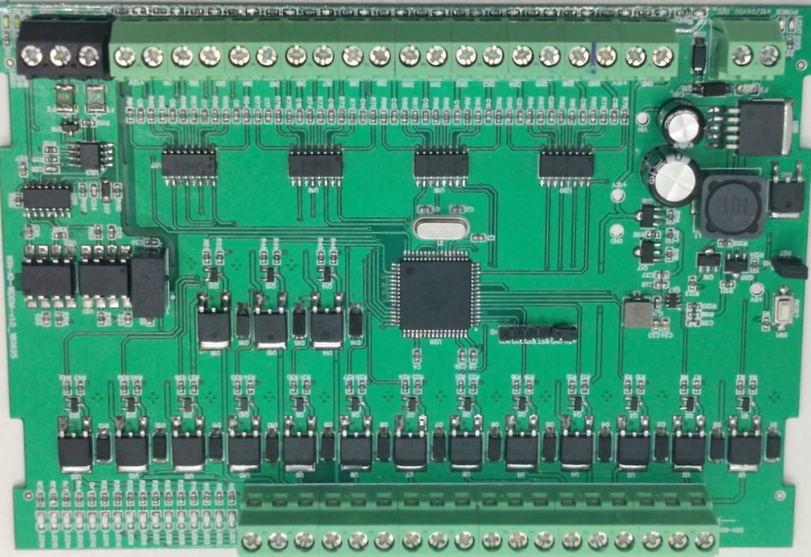
Reset Jumperr
1 2 3 4 5 6 7 8 9 10 11 12 13 14 15 16
Common GND
Digital Output
Common GND

Contact us: -
Augmatic Technologies Pvt. Ltd.,
Plot no 6, Shah Industrial Estate II,
Kotambi,
Vadodara – 391510.
Email – Sales@wittelb.com
Support: support@wittelb.raiseaticket.com / +91 94038 92805

